Event Log 12:22:38 PM 12/10/2010
Spreadsheet: Verfiry_Sources_Page.xls
Spreadsheet Row: 3
Expected value:
TheNCITermBrowserprovidesaccesstotheterminologysourceslistedbelow,someofwhichareproprietaryandincluded,bypermission,fornon-commercialuseonly.
Did not match actual value:
Found in page text: ExactMatchBeginsWithContainsName/CodePropertyRelationshipHome|Sources|HelpEVSHomeNCIMetathesaurusBrowserNCIThesaurusBrowserNCITermBrowserNCITerminologyResourcesSelectNCIhostedterminologiestosearch,orclickonasourcenametogotoitsbrowserhomepage.(WARNING:SelectAllsearcheswiththousandsofhitsmaybeslow;tryNCIMetathesaurusseparately.)NCIMetathesaurus(201004)NCIThesaurus(10.10a)*BiomedGT:BiomedicalGridTerminology(09.11b)CTCAE:CommonTerminologyCriteriaforAdverseEvents(4.03)GO:GeneOntology(October2010)*HL7RIM:HL7ReferenceInformationModel(V02-31)HUGO:HumanGenomeOrganization(July2010)ICD-10:InternationalClassificationofDiseases,TenthRevision(2009)*ICD-9-CM:InternationalClassificationofDiseases,NinthRevision,ClinicalModification(2010)*LOINC:LogicalObservationIdentifiersNamesandCodes(224)*MedDRA:MedicalDictionaryforRegulatoryActivitiesTerminology(12)*MGEDOntology:MicroarrayGeneExpressionDataOntology(1.3.1)NanoParticleOntology:NanoParticleOntology(1.0_Jan_29_2010)NCIThesaurusDraft:NationalCancerInstituteThesaurusDraft(10.10d)NDF-RT:NationalDrugFileReferenceTerminologyPublicInferredEdition(NDFRT_1009)OBI:OntologyforBiomedicalInvestigations(rc1)PDQ:PhysicianDataQuery(Apr_2010)RadLex:RadiologyLexicon(2.01)*SNOMEDCT:SystematizedNomenclatureofMedicine-ClinicalTerms(2010_01_31)*UMLSSemanticNetwork:UMLSSemanticNetwork(3.2)Zebrafish:ZebrafishModelOrganismDatabase(1.2_June_14_2010)*caBIGapproved.NCIHome|ContactUs|Policies|Accessibility|FOIAAServiceoftheNationalCancerInstitute
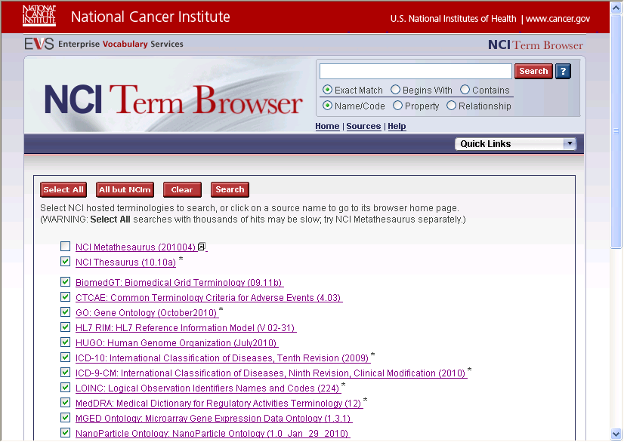
Failed

Event Log 12:27:45 PM 12/10/2010
Spreadsheet: Verfiry_Sources_Page.xls
Spreadsheet Row: 3
Expected value:
TheNCITermBrowserprovidesaccesstotheterminologysourceslistedbelow,someofwhichareproprietaryandincluded,bypermission,fornon-commercialuseonly.
Did not match actual value:
Found in page text: ExactMatchBeginsWithContainsName/CodePropertyRelationshipHome|Sources|HelpEVSHomeNCIMetathesaurusBrowserNCIThesaurusBrowserNCITermBrowserNCITerminologyResourcesSelectNCIhostedterminologiestosearch,orclickonasourcenametogotoitsbrowserhomepage.(WARNING:SelectAllsearcheswiththousandsofhitsmaybeslow;tryNCIMetathesaurusseparately.)NCIMetathesaurus(201004)NCIThesaurus(10.10a)*BiomedGT:BiomedicalGridTerminology(09.11b)CTCAE:CommonTerminologyCriteriaforAdverseEvents(4.03)GO:GeneOntology(October2010)*HL7RIM:HL7ReferenceInformationModel(V02-31)HUGO:HumanGenomeOrganization(July2010)ICD-10:InternationalClassificationofDiseases,TenthRevision(2009)*ICD-9-CM:InternationalClassificationofDiseases,NinthRevision,ClinicalModification(2010)*LOINC:LogicalObservationIdentifiersNamesandCodes(224)*MedDRA:MedicalDictionaryforRegulatoryActivitiesTerminology(12)*MGEDOntology:MicroarrayGeneExpressionDataOntology(1.3.1)NanoParticleOntology:NanoParticleOntology(1.0_Jan_29_2010)NCIThesaurusDraft:NationalCancerInstituteThesaurusDraft(10.10d)NDF-RT:NationalDrugFileReferenceTerminologyPublicInferredEdition(NDFRT_1009)OBI:OntologyforBiomedicalInvestigations(rc1)PDQ:PhysicianDataQuery(Apr_2010)RadLex:RadiologyLexicon(2.01)*SNOMEDCT:SystematizedNomenclatureofMedicine-ClinicalTerms(2010_01_31)*UMLSSemanticNetwork:UMLSSemanticNetwork(3.2)Zebrafish:ZebrafishModelOrganismDatabase(1.2_June_14_2010)*caBIGapproved.NCIHome|ContactUs|Policies|Accessibility|FOIAAServiceoftheNationalCancerInstitute
Failed

