Vision
protExpress
Last Revised: | August 25, 2007
Produced By: | NCICB Development
Version: | 0.1

Document Approvals
The list contains the name and contact information for the core project team and any key stakeholders who have an interest in the success of the project. An “S” identifies persons responsible for approval from the stakeholder groups. Sign off of the document would be required when a decision is made not to take action for defined gaps.

S | Name | Role | Signature | Date
S | Anand Basu | NCICB Engineering Manager
S | Carl Schaefer
S | Liming Yang | Project Manager
 | Brent Gendleman | Development Project Manager
 | Nonna Rabinovich | Independent QA
 | Krishna Kanchinadam | Development Architect
Revision History
When you make a change to a document, you must add an entry to this Revision History table and you must manually type the Last Revised Date on the front cover.

Date | Version | Description | Revised by
8/25/07 | 0.1 | Initial Draft – Basic Flow | Krishna Kanchinadam
Copyrights and Trademarks
© Copyright 2007 by NCICB, caBIGTM. All rights reserved.

Table of Contents
1. Brief Description 1
1.1. References 1
1.2. Unaddressed Issues 1
1.2.1. Requirements Confirmation 1
2. Preconditions 1
2.1. User is Logged In 1
3. Basic Flow of Events 2
4. Alternate Flows 2
5. Exception Flow 2
6. Post-conditions 2
7. Special Requirements 2
8. Data Fields 2

Brief Description
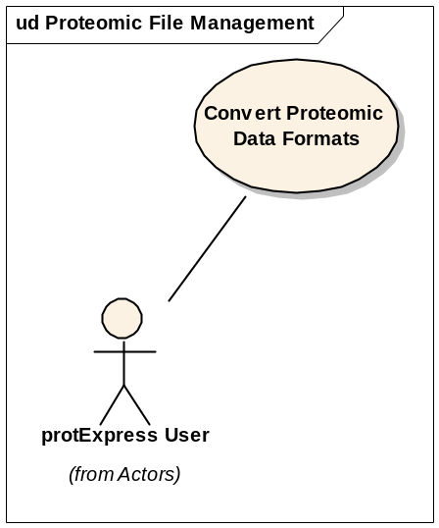
Initiated by a registered and logged-in protExpress User, this use case allows the user to:
- Select a XAR or Pride XML file(containing proteomics experimental data) from the local drive.
- Upload the file.
- Choose a format for the output data.
- Perform conversion between the formats.

NOTE: This use case has been deferred.

References
protExpress Vision – functional requirements
protExpress Use Case Summary – actor definitions and context

Unaddressed Issues

Requirements Confirmation
The use case needs to be confirmed by the stakeholders.

Preconditions

User is Logged In
In order to execute this use case, the user should be logged in.

Basic Flow of Events
Sequence of Steps:
- Logged in user chooses the action “Export”.
- A screen is displayed to the user. User selects the input source file format.
- User selects the appropriate data file from the local drive.
- User selects the output format and specifies the file name to save the output file.
- User selects to perform conversion.

Alternate Flows

Exception Flow

None identified at this time.

Post-conditions

Special Requirements

Data Fields

