Register User Use Case Specification
protExpress
Last Revised: | October 6th, 2008
Produced By: | NCICB Development
Version: | 0.4

Document Approvals
The list contains the name and contact information for the core project team and any key stakeholders who have an interest in the success of the project. An “S” identifies persons responsible for approval from the stakeholder groups. Sign off of the document would be required when a decision is made not to take action for defined gaps.

S | Name | Role | Signature | Date
S | Anand Basu | NCICB Engineering Manager
S | Carl Schaefer
S | Liming Yang | Project Manager
 | Brent Gendleman | Development Project Manager
 | Nonna Rabinovich | Independent QA
 | Krishna Kanchinadam | Development Architect
Revision History
When you make a change to a document, you must add an entry to this Revision History table and you must manually type the Last Revised Date on the front cover.

Date | Version | Description | Revised by
6/18/07 | 0.1 | Initial Draft – Basic Flow | Krishna Kanchinadam
11/13/2007 | 0.2 | Updates to the flow. | Krishna Kanchinadam
03/26/2008 | 0.3 | Separated the Login and Register User use cases. | Krishna Kanchinadam
10/06/2008 | 0.4 | Updated the registration process for LDAP and non-LDAP users. | Krishna Kanchinadam
Copyrights and Trademarks
© Copyright 2007 by NCICB, caBIGTM. All rights reserved.

Table of Contents
1. Brief Description 1
1.1. References 1
1.2. Unaddressed Issues 1
1.2.1. Requirements Confirmation 1
2. Preconditions 1
3. Basic Flow of Events 1
4. Exception Flow 3
5. Post-conditions 3
6. Special Requirements 3

Brief Description
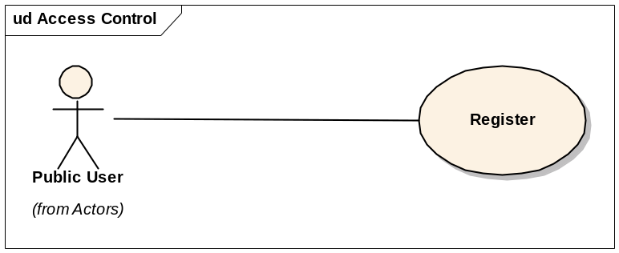
This use case allows a user to:
- Register and request access to the system.
- Create a new account in the system.
- Provide a way for the newly created user to login to the application.

References
protExpress Vision – functional requirements
protExpress Use Case Summary – actor definitions and context
protExpress Data Fields document – documents the database types, field lengths etc.

Unaddressed Issues

Requirements Confirmation
The use case needs to be confirmed by the stakeholders.

Preconditions

User is not registered in the system.

User provisioning tool is configured and functional.

Basic Flow of Events
This flows works for both LDAP and non-LDAP users. If and LDAP server is configured to work against the application, all user accounts are maintained in the LDAP directory server. Application required user information is maintained in the application via the user of NCI CBIIT’s User Provisioning Tool (UPT).
- User navigates to the main/home page of the application, and selects an option to register/request access to the application. The Registration page is displayed.
- User indicates if they have an LDAP account or not.
  - If already an LDAP user, user provides the LDAP username and password. The system authenticates the provided user credentials on submit.
  - If user does not have an LDAP account, the username/password fields are not displayed to them.
- User enters the desired information:
    - Username – Only applicable for an existing LDAP user.
    - LDAP Password – Only applicable for an existing LDAP user.
    - First Name
    - Last Name
    - Email address
    - Organization
    - Address Line 1
    - Address Line 2
    - City
    - Country
    - State/Province
    - Postal Code
    - Phone
    - Fax
- User attempts to submit the registration request. .
- System performs the following validations:
  - For an existing LDAP user, validates the provided username/password against a configured LDAP directory server.
  - Ensures that the username is unique across both LDAP and Database users.
  - Validates the information input by the user.
- If the input data is successfully validated, an appropriate message is displayed to the user. Simultaneously, the following actions take place:
  - User is sent an automated email from the system administrator (configured as a database configuration parameter).
  - System administrator receives an automated email, notifying them that the a user has requested access to the protExpress application.
  - System administrator logs into the User Provisioning Tool to provision the user.
  - System administrator checks against the LDAP to check if the user exists:
    - Existing LDAP user: System Administrator specifies the LDAP username, First Name and Last Name (at least) in UPT to push the appropriate information to the protExpress database. In this scenario, the password need not be specified as it is stored in LDAP.
    - Non-LDAP user: System Administrator specifies the new username, password, First Name, Last Name and other information as appropriate. If appropriate, an LDAP account will be created for the new user by the System Administrator.
  - Once the user credentials are propagated to the application (via UPT), System Administrator will notify the user via email that they can now access the system. Any login information (example, username/password for a non-LDAP user) will be included in the email (or as appropriate).
- User attempts to login to the application.

Exception Flow

None identified at this time.

Post-conditions

Special Requirements

