Login and Register User Use Case Specification
protExpress
Last Revised: | June 18, 2007
Produced By: | NCICB Development
Version: | 0.1

Document Approvals
The list contains the name and contact information for the core project team and any key stakeholders who have an interest in the success of the project. An “S” identifies persons responsible for approval from the stakeholder groups. Sign off of the document would be required when a decision is made not to take action for defined gaps.

S | Name | Role | Signature | Date
S | Anand Basu | NCICB Engineering Manager
S | Carl Schaefer
S | Liming Yang | Project Manager
 | Brent Gendleman | Development Project Manager
 | Nonna Rabinovich | Independent QA
 | Krishna Kanchinadam | Development Architect
Revision History
When you make a change to a document, you must add an entry to this Revision History table and you must manually type the Last Revised Date on the front cover.

Date | Version | Description | Revised by
6/18/07 | 0.1 | Initial Draft – Basic Flow | Krishna Kanchinadam
11/13/2007 | 0.2 | Updates to the flow. | Krishna Kanchinadam
Copyrights and Trademarks
© Copyright 2007 by NCICB, caBIGTM. All rights reserved.

Table of Contents
1. Brief Description 1
1.1. References 1
1.2. Unaddressed Issues 1
1.2.1. Requirements Confirmation 1
2. Preconditions 2
3. Basic Flow of Events 2
4. Alternate Flows 2
4.1. Register New User 2
4.2. Forgot Password 3
5. Exception Flow 3
6. Post-conditions 3
7. Special Requirements 3

Brief Description
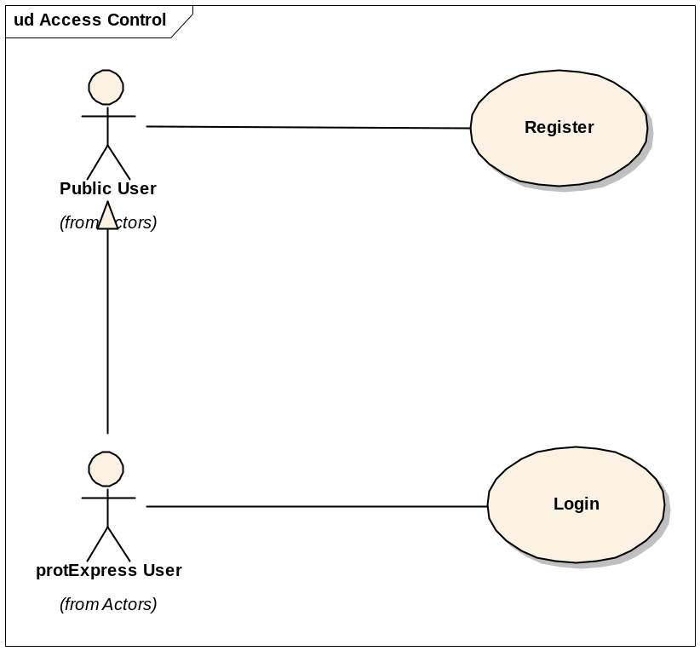
This use case allows a user to :
- Register and create a new account in the system.
- Login to the application.
- Retrieve password if forgotten.

References
protExpress Vision – functional requirements
protExpress Use Case Summary – actor definitions and context

Unaddressed Issues

Requirements Confirmation
The use case needs to be confirmed by the stakeholders.

Preconditions

Basic Flow of Events
- User navigates to the main/home page of the application.
- User enters the username and password.
- System validates the user credentials. If not validated, an error message is displayed to the user.
- If validated, the user is logged in and redirected to allowed access to the Welcome page.
- The Welcome page displays the following options:
  - Option to create a new experiment.
  - Option to search for existing experiments and/or protocols (Search protExpress).
  - The most recent 3 experiments that the user has worked on, with the following columns:
    - Experiment Name
    - Description
    - Date & Time of last update
    - Status – Icons to indicate whether Incomplete or Complete
    - Edit icon
    - Icon to download the XAR file. Available only if the status of the experiment is Complete.

Alternate Flows

Register New User
- User navigates to the main page of the application.
- A link to create a new user account is displayed to the user.
- User clicks on the “Register” link and is displayed the Registration page.
- User enters the desired information:
  - Username – Required. Must be a unique value and at least 6 characters long.
  - First Name
  - Last Name
  - Email address
  - Password and Confirm Password fields.
- User attempts to save information to the database.
- The system validates the entered information. If the information is valid, then a successful message is displayed to the user and the user is provided an option to login to the application.

Forgot Password
TBD

Exception Flow

None identified at this time.

Post-conditions

Special Requirements

