Search Repository Use Case Specification
protExpress
Last Revised: | March 15, 2008
Produced By: | NCICB Development
Version: | 0.1

Document Approvals
The list contains the name and contact information for the core project team and any key stakeholders who have an interest in the success of the project. An “S” identifies persons responsible for approval from the stakeholder groups. Sign off of the document would be required when a decision is made not to take action for defined gaps.

S | Name | Role | Signature | Date
S | Anand Basu | NCICB Engineering Manager
S | Carl Schaefer
S | Liming Yang | Project Manager
 | Brent Gendleman | Development Project Manager
 | Nonna Rabinovich | Independent QA
 | Krishna Kanchinadam | Development Architect
Revision History
When you make a change to a document, you must add an entry to this Revision History table and you must manually type the Last Revised Date on the front cover.

Date | Version | Description | Revised by
03/15/2008 | 0.1 | Updates as per the new UI Flow | Krishna Kanchinadam
Copyrights and Trademarks
© Copyright 2007 by NCICB, caBIGTM. All rights reserved.

Table of Contents
1. Brief Description 1
1.1. References 1
1.2. Unaddressed Issues 1
1.2.1. Requirements Confirmation 1
2. Preconditions 2
3. Basic Flow of Events 2
4. Alternate Flows 2
4.1. Search protExpress – Search for Experiments 2
4.2. Search protExpress – Search for Protocols 3
5. Exception Flow 3
6. Post-conditions 3
7. Special Requirements 3

Brief Description
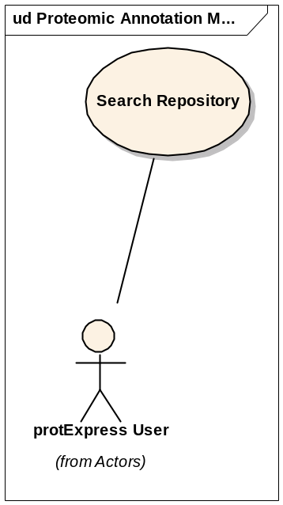

This is a generalized use case that describes how a logged-in user will be able to search the repository for Experiments and/or Protocols that exist in the system. This use case allows a logged in user to:
- Search for Protocols existing in the repository.
- Search for Experiments existing in the repository.
- Provide options to view/edit the protocol and/or experiment information.

References
protExpress Vision – functional requirements
protExpress Use Case Summary – actor definitions and context
protExpress Data Fields document – documents the database types, field lengths etc.

Unaddressed Issues

Requirements Confirmation
The use case needs to be confirmed by the stakeholders.

Preconditions
User is logged in successfully to the application.

Basic Flow of Events
- User navigates to the main/home page of the application.
- User is presented with an option to login by entering the username and password. User enters the information and attempts to login to the website.
- System validates the user credentials. If not validated, an error message is displayed to the user.
- If validated, the user is allowed access to the Welcome page.
- The Welcome page displays the following options:
  - The most recent 3 experiments that the user has worked on, with the following columns:
    - Experiment Name
    - Description
    - Date & Time of last update
    - Status – Icons to indicate whether Incomplete or Complete
    - Edit icon
    - Option to download the XAR file. Available only if the status of the experiment is Complete.

Alternate Flows

Search protExpress – Search for Experiments
- User navigates to the main/home page of the application.
- User chooses to Search experiments in the repository.
- User enters a search criteria and opts to search the repository.
- A filtered set of results matching the search criteria are displayed. The following information is displayed:
- Experiment Name – Links to the View Experiment screen.
- Description
- Username of the experiment owner
- Date & Time experiment was last updated.
- Status
    - Incomplete – Status is incomplete when:
      - Experiment does not have any protocols, or
      - Contains at least one protocol without any input, or
      - Contains at least one protocol without any output
    - Complete – This implies that:
      - Experiment has at least one protocol
      - All protocols have at least one input.
      - All protocols have at least one output.
- Edit icon – only available if the experiment owner is the same as the currently logged in user.
- Download XAR file – Only available if the experiment status is Complete

Search protExpress – Search for Protocols
- User navigates to the main/home page of the application.
- User chooses to Search experiments in the repository.
- User enters a search criteria and opts to search the repository.
- A filtered set of results matching the search criteria are displayed. The following information is displayed:
- Protocol Name – Links to the View Protocol screen.
- Protocol Description
- Username of the protocol owner
- Date & Time protocol was last updated.
- Edit option – only available if the protocol owner is the same as the currently logged in user.

Exception Flow

None identified at this time.

Post-conditions

Special Requirements

