Vision
protExpress
Last Revised: | August 25, 2007
Produced By: | NCICB Development
Version: | 0.1

Document Approvals
The list contains the name and contact information for the core project team and any key stakeholders who have an interest in the success of the project. An “S” identifies persons responsible for approval from the stakeholder groups. Sign off of the document would be required when a decision is made not to take action for defined gaps.

S | Name | Role | Signature | Date
S | Anand Basu | NCICB Engineering Manager
S | Carl Schaefer
S | Liming Yang | Project Manager
 | Brent Gendleman | Development Project Manager
 | Nonna Rabinovich | Independent QA
 | Krishna Kanchinadam | Development Architect
Revision History
When you make a change to a document, you must add an entry to this Revision History table and you must manually type the Last Revised Date on the front cover.

Date | Version | Description | Revised by
6/18/07 | 0.1 | Initial Draft – Basic Flow | Krishna Kanchinadam
Copyrights and Trademarks
© Copyright 2007 by NCICB, caBIGTM. All rights reserved.

Table of Contents
1. Brief Description 1
1.1. References 1
1.2. Unaddressed Issues 1
1.2.1. Requirements Confirmation 1
2. Preconditions 1
2.1. User is Logged In 1
3. Basic Flow of Events 2
4. Alternate Flows 3
4.1. View Experiment Details 3
4.2. Edit Experiment Details 3
4.3. Copy Experiment 4
4.4. Create/Edit Experiment Runs 5
4.5. Cancel 8
5. Exception Flow 8
6. Post-conditions 8
7. Special Requirements 8
8. Data Fields 8
8.1. Experiment Data Fields 8
8.2. Experiment Run Data Fields 9
8.3. Protocol Application Fields 9
8.4. Protocol Application Input & Output Data Fields 9
8.5. Contact Data Fields 10

Brief Description
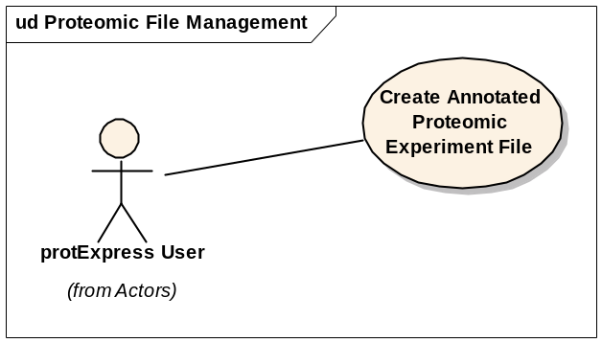
Initiated by a registered and logged-in protExpress User, this use case allows them to:
- Search for an experiment in the system.
- Export the experiment information from either the Experiment List screen or the Experiment Edit Screen.

References
protExpress Vision – functional requirements
protExpress Use Case Summary – actor definitions and context
protExpress Use Cases:
- Manage Protocols
- Manage Experiments

Unaddressed Issues

Requirements Confirmation
The use case needs to be confirmed by the stakeholders.

Preconditions

User is Logged In
In order to execute this use case, the user should be logged in.

Basic Flow of Events
Sequence of Steps:
- Logged in user chooses the action “Manage Experiments”.
- A Search screen is displayed, which allows the user to search for existing experiments. The screen also displays an option for creating a new experiment.
- User can enter the search criteria, based on which the existing experiments will be filtered:
  - Name
  - Description
- User chooses the Search option.
- A list of matching experiments is displayed to the user. If no search criteria were specified, all experiments in the system will be displayed. The following information is displayed:
  - Name of the Experiment
  - Owner/Creator of the experiment
  - Date the Experiment was created
  - Icons for:
    - View Experiment Details
    - Edit Experiment Details – Only if the logged-in user is the owner/creator of the experiment
    - Copy Experiment
    - Export experiment information.
- User chooses to export the experiment information by clicking on the export icon, which is hyperlinked to the Export screen.
- User selects the output format for the experimental data.
- User specifies the name of the output file.
- User selects to export the information.
- System will generate a file in the appropriate output format.

Alternate Flows

View Experiment Details
Sequence of Steps:
- Logged in user chooses the action “Manage Experiments”.
- A Search screen is displayed, which allows the user to search for existing experiments. The screen also displays an option for creating a new experiment.
- User can enter the search criteria, based on which the existing experiments will be filtered:
  - Name
  - Description
- User chooses the Search option.
- A list of matching experiments is displayed to the user. If no search criteria were specified, all experiments in the system will be displayed. The following information is displayed:
  - Name of the Experiment
  - Owner/Creator of the experiment
  - Date the Experiment was created
  - Icons for:
    - View Experiment Details
    - Edit Experiment Details – Only if the logged-in user is the owner/creator of the experiment
    - Copy Experiment
    - Export experiment information.
- User chooses to edit the the experiment information by clicking on the edit icon.
- On the Edit Experiment screen, there will be an option to Export the experiment data.
- User chooses to export the experiment information by selecting the Export option, which is hyperlinked to the Export screen.
- User selects the output format for the experimental data.
- User specifies the name of the output file.
- User selects to export the information.
- System will generate a file in the appropriate output format.

Exception Flow

None identified at this time.

Post-conditions

Special Requirements

Data Fields

