protExpress
Use Case Summary

Last Revised: | 06/23/2007
Produced By: | protExpress Development Team
Version: | 1.0

Document Approvals
The list contains the name and contact information for the core project team and any key stakeholders who have an interest in the success of the project. An “S” identifies persons responsible for approval from the Business and Development. Sign off of the document would be required when a decision is made not to take action for defined gaps.

S | Name | Role
S | Anand Basu | NCICB Engineering Manager
S | Carl Schaefer
S | Liming Yang | NCICB Project Manager
 | Brent Gendleman | Development Project Manager
 | Krishna Kanchinadam | Development Architect
Revision History
When you make a change to a document, you must add an entry to this Revision History table and you must manually type the Last Revised Date on the front cover.

Date | Version | Description | Revised by
04/29/2007 | 0.1 | Initial Draft with a focus on Stakeholder descriptions and identification. Detailed the Problem Statement and Product Positioning. Contains information captured from Internal Requirement Session/Team Meetings. | Krishna Kanchinadam
06/23/2007 | 1.0 | Incorporated name changes, additional descriptions. | Krishna Kanchinadam
Copyrights and Trademarks
© Copyright 2007 by NCICB, caBIGTM. All rights reserved.

Table of Contents
1. Introduction 1
1.1. Purpose 1
1.2. Overview 1
2. Actors 2
2.1. Public User 2
2.2. protExpress User 2
2.3. External System 2
2.4. CPAS 2
2.5. NCI LDAP 2
2.6. Ontology Provider 3
2.7. PSI 3
2.8. NCI-CPTAC 3
2.9. EVS 3
3. Use Cases 3
3.1. Access Control 3
3.1.1. Login 4
3.1.2. Register 4
3.2. Proteomic Annotation Management 4
3.2.1. Manage Experiments 4
3.2.2. Manage Protocols 4
3.2.3. Search Repository 4
3.3. Proteomic File Management 5
3.3.1. Convert Proteomic Data Formats 5
3.3.2. Created Annotated Proteomic Experiment File 5
3.3.3. Validate Proteomic Experiment File 5
3.4. CPAS Integration 6
3.4.1. Export XAR Files from CPAS 6
3.4.2. Load XAR Files into CPAS 6

Introduction

Purpose
The purpose of this document is to collect, analyze, and define high-level needs and features of protExpress. It focuses on the capabilities needed by the stakeholders and the target users, and why these needs exist. The details of how protExpress fulfills these needs are detailed in the use-case and supplementary specifications.
This document serves to identify the user cases for protExpress. It is intended that this document serve as a living document, modified throughout the iterative development life cycle.

Overview
CPAS (Computational Proteomics Analysis System) is an open source web-based system for processing, storing, and analyzing MS/MS experimental results. This project is developed by the Fred Hutchinson Cancer Research Center and funded by NCI. A proteomics repository, based on CPAS, is currently hosted at NCICB and serves valuable data from NCI-funded cancer proteomics initiatives to the scientific community.
CPAS uses a custom format, known as XAR (eXperimental ARrchive), to encapsulate proteomics experimental data along with descriptions of the materials, experimental procedures and analysis parameters. However, the current NCICB proteomics repository lacks appropriate tools to create the XAR-formatted file from proteomics experimental data. These XAR files, currently, are manually created by data curators.
The primary goal(s) of protExpress will be to:
- Provide a Graphical User Interface to allow input of proteomics experimental data (protocols and experiments) in the repository.
- Provide for authoring of proteomics experimental information into xar.xml format and Pride XML Format. Additional formats can be supported in the future.
- Ability to read external proteomics experimental information files and perform conversion to any supported format, or vice versa.
- Provide programmatic API to achieve the above-mentioned functionality.

Actors
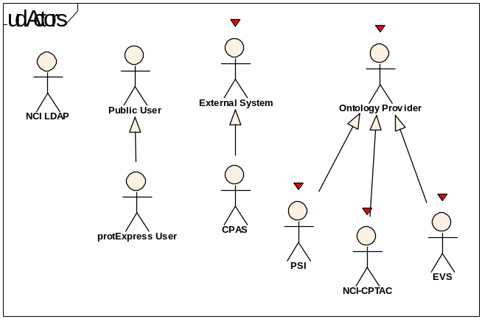
Figure: Actors

Public User
This actor represents a public user who can view the protExpress website. This user can browse the public portion of the website without login credentials.

protExpress User
This actor represents a registered user of the protExpress system. This actor has acquired the minimum credentials for accessing the non-public areas and functions of the system.

External System

A generalized Actor intended to represent those applications/systems that programmatically communicate with protExpress. Examples of external systems we know who want to interact with protExpress include CPAS (Computation Proteomics Analysis System).Examples of programmatic access might include an API, web service, or grid -- specific mechanisms that will be supported have not been solidified.CPAS
This actor represents the CPAS system. The current version is 2.1

NCI LDAP
LDAP (Lightweight Directory Access Protocol) is a software protocol for enabling anyone to locate organizations, individuals, and other resources such as files and devices in a network (either public internet or a corporate intranet). LDAP is a "lightweight" (smaller amount of code) version of Directory Access Protocol (DAP), which is part of X.500, a standard for directory services in a network. LDAP is lighter because in its initial version it did not include security features. LDAP originated at the University of Michigan and has been endorsed by at least 40 companies.

Ontology Provider
A generalized actor that represents applications/systems that will provide ontology lookup services utilized by protExpress. Examples of such systems that we know protExpress will use are PSI, NCI-CPTAC and EVS.

PSI
This actor represents the Proteomics Standards Initiative (PSI) Controlled Vocabulary and Ontology. Background can be found from the following sources:http://psidev.sourceforge.net/mod/http://www.psidev.info/

NCI-CPTAC
This actor represents the NCI-CPTAC Ontology

EVS
This actor represents the NCI Enterprise Vocabulary Service. Additional information can be found at the URL:http://ncicb.nci.nih.gov/NCICB/infrastructure/cacore_overview/vocabulary

Use Cases

Access Control
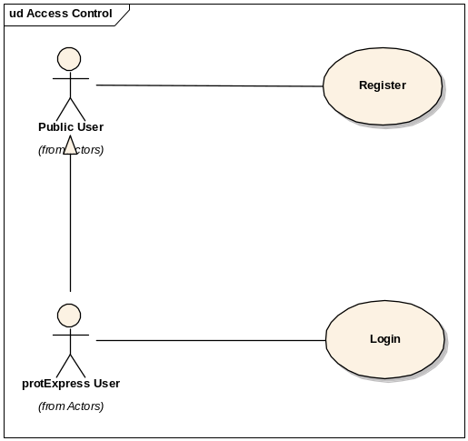
Figure:: Access Control

Login
Initiated by protExpress User, this use case allows access to the conents owned by the logged in user. Action:Verify that passwords are allowed to be sent per NCI conventions

Register
Initiated by a public user, this use case allows for a new user to be registered on the system. Validation will be done to prevent duplicate registrations.

Proteomic Annotation Management
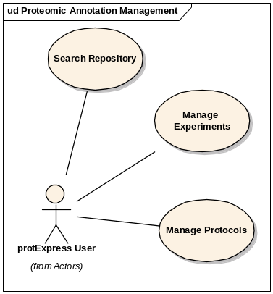
Figure:: Proteomic Annotation Management

Manage Experiments
Initiated by a protExpress user, this use case allows for the creation, editing, deletion and copying of experiment information.

Manage Protocols
Initiated by a protExpress user, this use case allows for the creation, editing, deletion and copying of protocol information.

Search Repository
Initiated by a protExpress user, this use case provides the ability to search for experiment information and protocols owned by the logged in user.

Proteomic File Management
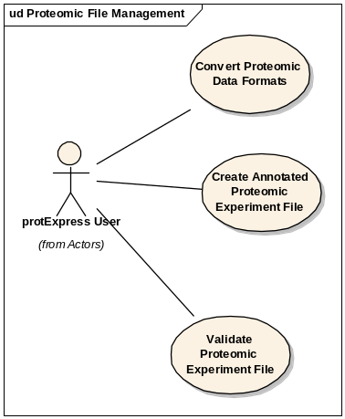
Figure:: Proteomic File Management

Convert Proteomic Data Formats
Initiated by a protExpress user, this use case is responsible for converting proteomics experiment information (protocol and experiment information) from one format to another. The current set of formats include Pride XML format, xar.xml format and a custom format.

Created Annotated Proteomic Experiment File

Initiated by a protExpress user, this use-case should be able to:1. Read and parse data entered by the user in the Graphical User Interface;2. Format the data entered via the GUI into a custom format (tab delimited and/or a custom XML format - .protx?) and/or into other formats supported by the system. The current plans include supporting xar.xml and Pride XML Formats.3. Ability to read and parse an existing file (xar.xml format, Pride XML and/or the custom Format) and validate it4. Experiment information will be annotated using a supported ontology. Validate Proteomic Experiment File
Initiated by a protExpress user, this use case is for verifying that the contents of a file containing proteomics experiment information is syntactically correct.

CPAS Integration
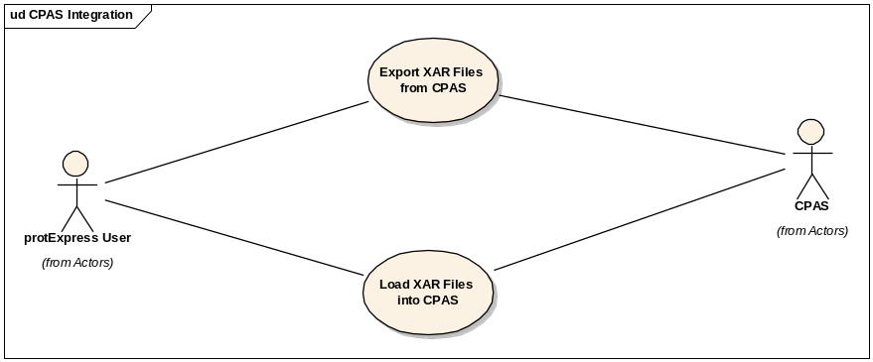
Figure:: CPAS Integration

Export XAR Files from CPAS
This use case is to retrieve experiment information from CPAS in a xar.xml file. Further details will be determined in a future phase.

Load XAR Files into CPAS
This use case is to import/load xar.xml files into CPAS. Further details will be determined in a future phase.

