Login User Use Case Specification
protExpress
Last Revised: | June 18, 2007
Produced By: | NCICB Development
Version: | 3

Document Approvals
The list contains the name and contact information for the core project team and any key stakeholders who have an interest in the success of the project. An “S” identifies persons responsible for approval from the stakeholder groups. Sign off of the document would be required when a decision is made not to take action for defined gaps.

S | Name | Role | Signature | Date
S | Anand Basu | NCICB Engineering Manager
S | Carl Schaefer
S | Liming Yang | Project Manager
 | Brent Gendleman | Development Project Manager
 | Nonna Rabinovich | Independent QA
 | Krishna Kanchinadam | Development Architect
Revision History
When you make a change to a document, you must add an entry to this Revision History table and you must manually type the Last Revised Date on the front cover.

Date | Version | Description | Revised by
6/18/07 | 0.1 | Initial Draft – Basic Flow | Krishna Kanchinadam
11/13/2007 | 0.2 | Updates to the flow. | Krishna Kanchinadam
03/26/2008 | 0.3 | Separated the specifications for Login and Register Usr | Krishna Kanchinadam
Copyrights and Trademarks
© Copyright 2007 by NCICB, caBIGTM. All rights reserved.

Table of Contents
1. Brief Description 1
1.1. References 1
1.2. Unaddressed Issues 1
1.2.1. Requirements Confirmation 1
2. Preconditions 1
3. Basic Flow of Events 1
4. Alternate Flows 2
4.1. Register and then Login 2
4.2. Forgot Password 2
5. Exception Flow 3
6. Post-conditions 3
7. Special Requirements 3

Brief Description
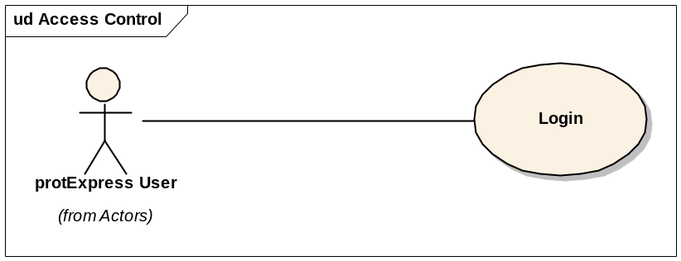

This use case allows:
- A registered protExpress user to login to the application.
- A guest user to register for a new account and login to the application.
- Retrieve forgotten password of a registered protExpress User.

References
protExpress Vision – functional requirements
protExpress Use Case Summary – actor definitions and context
protExpress Data Fields document – documents the database types, field lengths etc.

Unaddressed Issues

Requirements Confirmation
The use case needs to be confirmed by the stakeholders.

Preconditions

Basic Flow of Events
- User navigates to the main/home page of the application.
- User enters the username and password.
- System validates the user credentials. If not validated, an error message is displayed to the user.
- If validated, the user is logged in and redirected to allowed access to the Welcome page.
- The Welcome page displays the following options:
  - Option to create a new experiment.
  - Option to search for existing experiments and/or protocols (Search protExpress).
  - The most recent 3 experiments that the user has worked on, with the following columns:
    - Experiment Name
    - Description
    - Date & Time of last update
    - Status – Icons to indicate whether Incomplete or Complete
    - Edit icon
    - Icon to download the XAR file. Available only if the status of the experiment is Complete.

Alternate Flows

Register and then Login
- A non-registered user navigates to the main page of the application.
- User selects the option to create a new account.
- User creates a new account successfully. Please refer to the “Register User Use Case Specifications” for more details.
- After successfully creating a new account, user is provide an option to login to the application.
- User selects the option to login and is redirected to the Login page.

Forgot Password
TO BE DETERMINED.

Exception Flow

None identified at this time.

Post-conditions

Special Requirements

