Manage Protocols Use Case Specification
protExpress
Last Revised: | March 19, 2008
Produced By: | NCICB Development
Version: | 0.3

Document Approvals
The list contains the name and contact information for the core project team and any key stakeholders who have an interest in the success of the project. An “S” identifies persons responsible for approval from the stakeholder groups. Sign off of the document would be required when a decision is made not to take action for defined gaps.

S | Name | Role | Signature | Date
S | Anand Basu | NCICB Engineering Manager
S | Carl Schaefer
S | Liming Yang | Project Manager
 | Brent Gendleman | Development Project Manager
 | Nonna Rabinovich | Independent QA
 | Krishna Kanchinadam | Development Architect
Revision History
When you make a change to a document, you must add an entry to this Revision History table and you must manually type the Last Revised Date on the front cover.

Date | Version | Description | Revised by
6/18/07 | 0.1 | Initial Draft – Basic Flow | Krishna Kanchinadam
11/13/2007 | 0.2 | Updates to the flow. | Krishna Kanchinadam
03/19/2008 | 0.3 | Updates to reflect the new UI. | Krishna Kanchinadam
Copyrights and Trademarks
© Copyright 2007 by NCICB, caBIGTM. All rights reserved.

Table of Contents
1. Brief Description 1
1.1. References 1
1.2. Unaddressed Issues 1
2. Preconditions 1
3. Basic Flow – Search Protocols 1
4. Alternate Flows 2
4.1. View Protocol 2
4.2. Edit Protocol 2
4.3. Create New Protocol 3
4.4. Copy Existing Protocol 3
5. Exception Flow 3
6. Post-conditions 3
7. Special Requirements 3

Brief Description
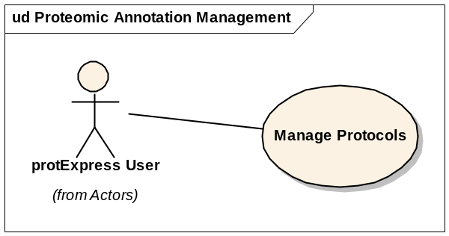
This use case allows a user to:
- Search protocol data in the repository
- Edit and update protocol information in the repository.
- Create new protocols as part of experiment creation.
- Copy existing protocols

References
protExpress Vision – functional requirements
protExpress Use Case Summary – actor definitions and context
protExpress Data Fields document – documents the database types, field lengths etc.

Unaddressed Issues

Preconditions
User is successfully logged into the system.

Basic Flow – Search Protocols
- User navigates to the welcome page for the application and enters appropriate username and password.
- On successful login, the user is displayed the home page.
- User chooses the option to search protExpress, and is then presented with the option to search for protocols existing in the system.
- User enters appropriate search criteria and chooses to retrieve the search results.
- A filtered set of results matching the search criteria are displayed. The following information is displayed:
  - Protocol Name – Links to the View Protocol screen.
  - Protocol Description
  - Username of the protocol owner
  - Date & Time protocol was last updated.
  - Edit option – only available if the protocol owner is the same as the currently logged in user.

Alternate Flows

View Protocol
- User navigates to the main page of the application, and logs in successfully.
- User searches for protocols existing in the repository.
- User clicks on the protocol name and is displayed the View Protocols screen.
- View Protocols screen displays the following:
  - Protocol information
  - Protocol contact information
  - Edit button – only if currently logged in user is the same as the protocol owner.
  - Delete button – only if the currently logged in user is same as the protocol owner.

Edit Protocol
- User navigates to the main page of the application, and logs in successfully.
- User searches for protocols existing in the repository.
- For each search result, if the currently logged in user is the owner of the protocol, an Edit option is displayed in the row.
- User chooses to edit the protocol and is displayed the edit screen, with the following data:
  - Protocol information
  - Protocol contact information.
  - Options to save/update and/or delete the protocol

Create New Protocol
A new protocol can be created as part of the Experiment Create Process. Please refer to the Manage Experiments Use Case Specification for more details.

Copy Existing Protocol
An existing protocol may be copied to a new protocol owned by the currently logged in user. This functionality is achieved as part of the Experiment Create Process. Please refer to the Manage Experiments Use Case Specification for more details.

Exception Flow

None identified at this time.

Post-conditions

Special Requirements

