Forgot Password Use Case Specification
protExpress
Last Revised: | October 19th, 2008
Produced By: | NCICB Development
Version: | 0.1

Document Approvals
The list contains the name and contact information for the core project team and any key stakeholders who have an interest in the success of the project. An “S” identifies persons responsible for approval from the stakeholder groups. Sign off of the document would be required when a decision is made not to take action for defined gaps.

S | Name | Role | Signature | Date
S | Anand Basu | NCICB Engineering Manager
S | Carl Schaefer
S | Liming Yang | Project Manager
 | Brent Gendleman | Development Project Manager
 | Nonna Rabinovich | Independent QA
 | Krishna Kanchinadam | Development Architect
Revision History
When you make a change to a document, you must add an entry to this Revision History table and you must manually type the Last Revised Date on the front cover.

Date | Version | Description | Revised by
10/06/2008 | 0.1 | Initial flow. | Krishna Kanchinadam
Copyrights and Trademarks
© Copyright 2007 by NCICB, caBIGTM. All rights reserved.

Table of Contents
1. Brief Description 1
1.1. References 1
1.2. Unaddressed Issues 1
1.2.1. Requirements Confirmation 1
2. Preconditions 1
3. Basic Flow of Events 1
4. Exception Flow 2
5. Post-conditions 2
6. Special Requirements 2

Brief Description
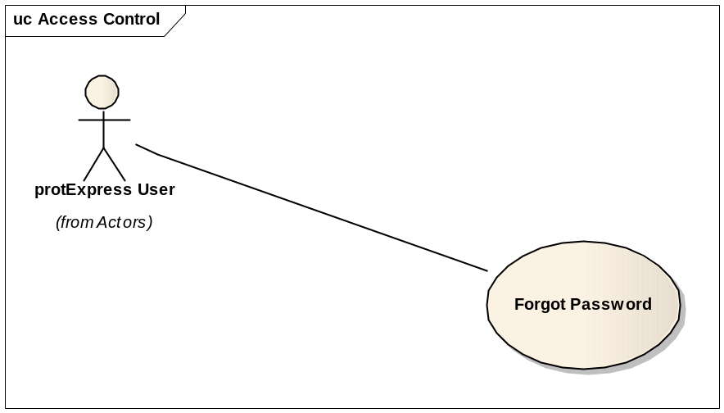
This use case allows a user to:
- Request the System Administrator to reset their password.

References
protExpress Vision – functional requirements
protExpress Use Case Summary – actor definitions and context

Unaddressed Issues

Requirements Confirmation
The use case needs to be confirmed by the stakeholders.

Preconditions

User provisioning tool is configured and functional.

Basic Flow of Events
This flows works for both LDAP and non-LDAP users. Application required user information is maintained in the application via the user of NCI CBIIT’s User Provisioning Tool (UPT).
- User navigates to the main/home page of the application, and clicks on the link “Forgot Password”.
- User enters the following information:
  - protExpress Username/Login Id.
  - E-Mail Address
- User submits the Password Reset request.
- The following actions take place:
  - User is sent an automated email from the system administrator (configured as a database configuration parameter).
  - System administrator receives an automated email, notifying them that a user has requested a reset of their password.
  - System administrator logs into the User Provisioning Tool and checks against LDAP to check if the user exists:
    - Existing LDAP user: In this scenario, the password is stored in LDAP. System Administrator sends an email to the user with appropriate instructions to reset their LDAP password.
    - Non-LDAP user: In this scenario, the password is stored in the database and can be modified via UPT. System Administration confirms that the email address is the one specified during the password reset request, and then updates the user’s password via UPT. Then, the System Administrator emails the user notifying them that their password has been modified. The password will be included in the email or as appropriate.

Exception Flow

None identified at this time.

Post-conditions

Special Requirements

