Register User Use Case Specification
protExpress
Last Revised: | June 18, 2007
Produced By: | NCICB Development
Version: | 0.3

Document Approvals
The list contains the name and contact information for the core project team and any key stakeholders who have an interest in the success of the project. An “S” identifies persons responsible for approval from the stakeholder groups. Sign off of the document would be required when a decision is made not to take action for defined gaps.

S | Name | Role | Signature | Date
S | Anand Basu | NCICB Engineering Manager
S | Carl Schaefer
S | Liming Yang | Project Manager
 | Brent Gendleman | Development Project Manager
 | Nonna Rabinovich | Independent QA
 | Krishna Kanchinadam | Development Architect
Revision History
When you make a change to a document, you must add an entry to this Revision History table and you must manually type the Last Revised Date on the front cover.

Date | Version | Description | Revised by
6/18/07 | 0.1 | Initial Draft – Basic Flow | Krishna Kanchinadam
11/13/2007 | 0.2 | Updates to the flow. | Krishna Kanchinadam
03/26/2008 | 0.3 | Separated the Login and Register User use cases. | Krishna Kanchinadam
Copyrights and Trademarks
© Copyright 2007 by NCICB, caBIGTM. All rights reserved.

Table of Contents
1. Brief Description 1
1.1. References 1
1.2. Unaddressed Issues 1
1.2.1. Requirements Confirmation 1
2. Preconditions 1
3. Basic Flow of Events 1
4. Alternate Flows 2
4.1. Register New User Account in LDAP 2
5. Exception Flow 2
6. Post-conditions 2
7. Special Requirements 2

Brief Description
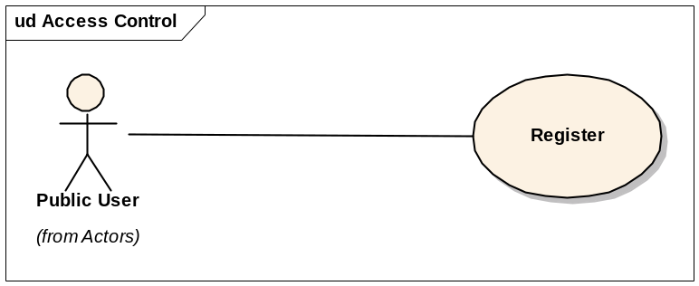
This use case allows a user to:
- Register and create a new account in the system.
- Provide a way for the newly created user to login to the application.

References
protExpress Vision – functional requirements
protExpress Use Case Summary – actor definitions and context
protExpress Data Fields document – documents the database types, field lengths etc.

Unaddressed Issues

Requirements Confirmation
The use case needs to be confirmed by the stakeholders.

Preconditions

Basic Flow of Events
This flow assumes that the application is not configured with LDAP. Hence, all user accounts are maintained in the application database.
- User navigates to the main/home page of the application.
- User selects an option to create a new user account, and is displayed the Registration page.
- User enters the desired information:
    - Username – Required. Must be a unique value and at least 6 characters long.
    - First Name
    - Last Name
    - Email address
    - Password and Confirm Password fields.
- User attempts to save the entered information.
- System validates the entered information. If the entered data is validated, then a successful message is displayed to the user. User is provided an option to login to the application. If not validated, an error message is displayed to the user.

Alternate Flows

Register New User Account in LDAP
TO BE DETERMINED

Exception Flow

None identified at this time.

Post-conditions

Special Requirements

