Conceptual Functional Service Specification

Planned Calendar

0.1

10/21/2010

Architecture Inception Team | Kalpesh Patel
Editor | Santosh Joshi, Kunal Modi, Brian McIndoe
Authors | Brian McIndoe

Document Version | Date | Author | Changes
0.0.1 | 12/17/2009 | Brian McIndoe | Initial Draft
0.0.2 | 12/29/2009 | Brian McIndoe | Revised to incorporate review feedback from the ESST.
0.0.3 | 12/30/2009 | Brian McIndoe | Included State Diagram
0.1 | 10/21/2010 | Sean Whitaker | Revised as per changes to scope document

Table of Contents
1 Overview and Business Case 4
1.1 Service Description and Purpose 4
1.2 Scope 4
1.3 Assumptions 4
2 Business Storyboards 5
2.1 Storyboards Overview 5
2.2 Primary Actors 5
2.2.1 People Actors 5
2.3 Story Boards 5
2.3.1 PC-SB1 – Initiate a Planned Calendar Template 5
2.3.2 PC-SB2 – Create Arms, Epochs, StudyCells, StudySegments and Activities 5
2.3.3 PC-SB3 – Assign Activities to StudySegments 5
2.3.4 PC-SB4 – Approve a Calendar Template and Provide to Sites 5
2.3.5 PC-SB5 – Query and Amend the Planned Calendar Template 5
2.3.6 PC-SB6 – Clone a Planned Calendar Template 5
3 Detailed Functional Model 6
3.1 Structure of the Service 6
3.2 Detail of the Capabilities 6
4 Profiles 8
4.1 Functional Profiles 8
4.2 Semantic Profiles 8
4.3 Conformance Profiles 8
5 System Implementation Details 10
5.1 System Runtime Interaction Details 10
5.2 Implementation/Deployment Considerations 10
6 Conformance and Compliance 11
6.1 Compliance and Conformance Statements 11
7 Appendix A - Relevant Standards 12
8 Appendix B - References 13
9 Appendix C - Glossary 14
10 Appendix D – Cross Reference Tables 15
10.1 List of Storyboards 15
10.2 Storyboards to Capabilities Mapping 15
10.3 List of Profiles 15
10.4 Actors 15

Overview and Business Case

Service Description and Purpose
[NOTE: This document uses PSC semantics as expressed in the PSC use case model available at the following location:
https://cabig-kc.nci.nih.gov/CTMS/KC/index.php/PSC_Use_Cases#Background.2FSummary
This document will need to be revised to either BRIDG 2.1 or 3.0 semantics once a decision has been made on which one to use. Major differences in study calendar semantics exist between BRIDG 2.1 and 3.0.]
The purpose of this service is to provide a set of interfaces that enable the creation, updating, amending, approving and cloning of Planned Calendar templates. A Planned Calendar template is a construct which can be applied to a registered study subject to create a personalized calendar (see Scheduled Calendar CFSS for details).
A Planned Calendar template is composed of the schedulable activities for a study subject participating in a clinical trial. The template reflects the design of the study in that it is a temporal representation of the components of a trial in relation to each other.
This service will be used by staff involved in the planning of a study such as principal investigators, study administrators and coordinators.
To comprehend this specification it is necessary to have an appreciation for the components of a clinical trial and the ways in which they can be related. The following diagram provides an example of a simple trial design.
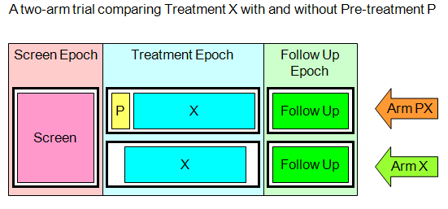
In the diagram above the large rectangular columns are called epochs. There are three shown here, however, a study may have from one to many epochs. In this example, the first epoch is a screening epoch where subjects are typically placed during pre-registration while testing is performed to determine their eligibility to participate in a trial. If a subject is found to be eligible then their registration is completed and they are placed onto the treatment epoch. The follow up epoch is typically used for observation and testing of subjects to determine treatment efficacy and safety.
The horizontal rows marked by arrows are called arms. This example shows a trial with two arms, however, a study can have from one to many arms. The black rectangles with heavy lines are known as study cells. The smaller rectangles within study cells are called study segments. It is within a study segment that an activity is scheduled. An activity can be a onetime event, or an event which happens periodically according to a defined cycle, e.g., administer 40mg of Study Agent X every 2 days until condition Y occurs.
Once a template has been built then it needs to be reviewed for compliance to the protocol and approved for release to study sites if found satisfactory. Only sites that are approved to participate in the trial should have access to the template.
Once a template has been approved, it is possible that amendments to the protocol may generate a need for corresponding amendments to be made to the template and subsequent approvals. Template amendments may be either mandatory or optional. If an amendment is optional then it will be up to site management to determine whether it should be implemented.
The intention is that once created, a template can be shared and leveraged on future studies that have the same or a similar design. This service will include the ability to create a clone of a template that is no longer associated with the study or sites that it was originally created for.
The development of a common, reusable set of interfaces provided by this service will facilitate standardization; integration and interoperability between various systems that need Planned Calendar template functionality, or need access to authoritative template information.
The vision is that any organization or vendor who wants to be compliant with the NCI Planned Calendar template service can implement the Planned Calendar template service specifications.
This service specification provides a key infrastructure component for NCI to support Calendar management and integration with other systems. This service serves as a main platform for integrating Planned Calendar template management needs among all heterogeneous systems/components independent of platform within the clinical domain.

Scope
The scope document for this service is found here:
http://gforge.nci.nih.gov/svnroot/ent-services/trunk/documents/ServicesScope/Planned_Calendar_Service_scope.doc
The scope of this service is the creation and management of Planned Calendar templates. The actual assignment of a template to a subject is out of scope and is addressed in the CFSS for the Scheduled Calendar service.
Items | Scope / Out of Scope | Source
Create a complete Planned Calendar for a study | Scope | Planned Calendar Service Scope Document
Approve a Planned Calendar and manage updates and amendments to it. | Scope | Planned Calendar Service Scope Document
Clone a Planned Calendar for usage on a different study. | Scope | Planned Calendar Service Scope Document
Query and retrieve a Planned Calendar. | Scope | Planned Calendar Service Scope Document
Planned Calendars for Patient “Standard of Care” are out of scope. | Out of Scope

Assumptions
Assumption | Affects | Source
It is assumed that this service will be used for creating and managing a Planned Calendar based on the trial design. Thus the pre-condition of an approved Study Protocol must be met. | Information about the approved Study protocol must be available at the time of initiation of the Planned Calendar. | Planned Calendar storyboard
Creation and management of Planned Calendars will be a Coordinating Center function and not a Study Site function. | The security role definitions need to reflect that this is a Coordinating Center function only. | Planned Calendar storyboard
Multi-site and Multi-Institutional studies will have one Coordinating Center only. | Multiple Coordinating Centers per study are not supported. | Planned Calendar Conceptual Functional Service Specification
It is assumed that a study will have one planned calendar. | There will be a one to one mapping of studies to planned calendars. | Planned Calendar Conceptual Functional Service Specification

Business Storyboards

Storyboards Overview
The design of a clinical trial is captured in the study protocol. The protocol describes the trial objectives, methodology, eligibility criteria, registration procedures, statistical considerations, and the study calendar. The study calendar section provides details on the schedule of tests, procedures, medications, and dosages to be applied to subjects during the course of the trial.
In this scenario, Dr David Jones is the Principal Investigator and Study Administrator for a Phase III randomized Lung Cancer trial. The Coordinating Center for the trial is at Georgetown and study sites will be located at Cancer Centers throughout America. Dr Jones has just completed the study calendar section of the protocol and is working with Sally Smith, the Study Coordinator on development of a Planned Calendar template which will be made available to study sites for application to subjects as they register on the trial.
The idea behind the Planned Calendar template is that it contains all of the schedulable activities for subjects during a trial. Once registered, the subject’s start date can be plugged into the template to generate a personalized calendar. This process is described in the Scheduled Calendar companion storyboard.

Primary Actors

People Actors
Name | Role | Notes
Dr. David Jones | Principal Investigator and Study Administrator | Based at the Coordinating Center at Georgetown. Approves the Planned Calendar template.
Sally Smith | Study Coordinator for the Lung Cancer Study at Georgetown | Based at the Coordinating Center at Georgetown. Creates the Planned Calendar template.
Joe Brown | Study Coordinator for other study that wants to leverage the Planned Calendar created at Georgetown | Based at the Coordinating Center at Mayo.

Story Boards

PC-SB1 – Create a Planned Calendar
Outline | A Planned Calendar is created.
Detail | Sally views the study calendar section of the protocol document and begins to analyze it. She notes that this particular study is divided into three major sections called epochs. An epoch is an expanse of time usually named according to the type of activity that occurs within it.  The first epoch is called the screening epoch and consists of a series of tests to determine eligibility of a subject. The second epoch is the treatment epoch during which one set of subjects receives treatment and another receives a placebo. The final epoch is the follow-up epoch where subjects are evaluated with lab tests and observation.  From the treatment epoch onwards, subjects are assigned to one of two arms by a randomization process. Sally notes that the treatment epoch contains one studycell per arm, which is further subdivided into study segments. It is within a studysegment that activities are positioned relative to the start of the segment.  Sally takes the result of her analysis and builds the Planned Calendar for the trial.

PC-SB2 – Retrieve a planned calendar
Outline | A Planned Calendar is retrieved for use or reuse.
Detail | Now that Sally has finished building the Planned Calendar, she wants to share it with other Coordinating Centers. She retrieves the completed Planned Calendar and then distributes it to the other Coordinating Centers.

    - PC-SB3 – Approve a Planned Calendar and Provide to Sites
Outline | The Planned Calendar is reviewed for adherence to the study protocol, approved and then made accessible to the participating study sites.
Detail | After she has finished constructing the planned calendar she asks Dr Jones to review and approve it. Dr Jones reviews the planned calendar and ensures that it follows the protocol design. Should any discrepancies be found, he works with Sally to resolve them. Once the planned calendar is verified as an accurate representation of the protocol, Dr Jones approves it for use on the study.  Once approved, Dr. Jones grants access to the planned calendar to the sites participating in the trial. A notification is sent to each participating site informing them that they have access to the template and can begin to accrue subjects.

PC-SB4 – Amend the Planned Calendar
Outline | Planned calendars can be amended.
Detail | As the trial proceeds and results are evaluated, an amendment is issued to the Study Protocol that impacts the order of activities in the approved planned calendar.  Sally makes the necessary changes, notes whether the new planned calendar should apply to all subjects or only certain ones, saves the new version of the planned calendar and submits it to Dr Jones for review and approval.  Dr Jones reviews the amendment, approves the change and makes the new version available to the participating study sites. A notification message is sent to the site coordinator at each site informing them of the amendment to the planned calendar and whether it is mandatory or optional.

Detailed Functional Model

Structure of the Service
Name | Description
Create planned calendar | This capability enables the creation of a planned calendar for a study protocol. The definition of the planned calendar will include the required epochs, study segments, periods, and activities.
Amend planned calendar | This capability enables the formal amendment of a planned calendar.
Retrieve planned calendar | This capability enables the retrieval of a planned calendar.
Manage the status of a planned calendar | This capability enables changing various aspects of the state of the planned calendar. The state includes the release status of the planned calendar and each amendment and the acceptance of each revision at each participating site.

Detail of the Capabilities
In the following tables, [M] signifies a mandatory section; [O] signifies an optional section.
Name [M] | Create planned calendar
Description [M] | This capability enables the creation of a planned calendar for a study protocol. This includes protocol identification information as well as the complete structure of the planned calendar.
Pre-Conditions [M] | An approved Study Protocol. The names of epochs, arms, and studycells are known.
Security Pre-Conditions [M] | Access control mechanism needs to be in place to ensure that the user is a Study Calendar Template Builder and has valid privileges to execute Create planned calendar.
Inputs [M] | The completed planned calendar, including Study Identifier, structure of the template, and the activities.
Outputs [M] | Successful creation message
Post-Conditions [O] | The planned calendar is created
Exception Conditions [M] | The Study Identifier is invalid  Invalid data type or code value for any attribute
Aspects left for Technical Bindings [O]
Notes [O] | The future evolution of this service is likely to include the automatic generation of a Planned Calendar from an approved Study Protocol. In this future scenario, the details of a study calendar (arms, epochs, activities, etc.) would be retrieved by calling the Protocol Management service. This will require development of a standardized computable means of expressing the details of the study calendar.

Name [M] | Amend planned calendar
Description [M] | This capability enables the amendment of an existing planned calendar. This occurs by replacing the existing planned calendar with an amended version.
Pre-Conditions [M] | A planned calendar has been created in the planned calendar service. Changes have been made to the planned calendar externally to the planned calendar service and now need to be made available through the service.
Security Pre-Conditions [M] | Access control mechanism needs to be in place to ensure that the user is logged in as a Study Calendar Template Builder or Data Importer and has valid privileges to execute Amend planned calendar.
Inputs [M] | The complete, amended planned calendar, including Study Identifier, structure of the template, and the activities.
Outputs [M] | Successful amendment message
Post-Conditions [O] | The newly-amended planned calendar is available
Exception Conditions [M] | The Template Identifier is invalid  Invalid data type or code value for any attribute
Aspects left for Technical Bindings [O]
Notes [O] | Planned calendars are structured in such a way that each contains its original iteration plus all amendments. This frees the service from having to calculate changes.

Name [M] | Retrieve planned calendar
Description [M] | This capability enables the retrieval of a planned calendar at a specified amendment level. If no amendment level is specified, the most recent version of the template will be returned.
Pre-Conditions [M] | The planned calendar has been created.
Security Pre-Conditions [M] | Access control mechanism needs to be in place to ensure that the user is logged in with valid privileges to view the planned calendar.
Inputs [M] | Identifier of the planned calendar  Amendment level (optional)
Outputs [M] | Complete planned calendar at the requested amendment level
Post-Conditions [O]
Exception Conditions [M] | Unrecognized identifier  Unrecognized amendment level
Aspects left for Technical Bindings [O]
Notes [O]

Name [M] | Manage the status of a planned calendar
Description [M] | This capability enables changing various aspects of the state of the planned calendar. The state includes the release status of the planned calendar and each amendment and the acceptance of each revision at each participating site.
Pre-Conditions [M] | The planned calendar exists
Security Pre-Conditions [M] | Access control mechanism needs to be in place to ensure that the user is logged in as a Study QA Manager from a managing or participating site.
Inputs [M] | Planned calendar identifier  Amendment identifier (optional)  Status
Outputs [M] | Acknowledgement that status change has been successful
Post-Conditions [O] | The status of the planned calendar has been changed
Exception Conditions [M] | Invalid planned calendar identifier  Amendment identifier (optional)  Invalid status
Aspects left for Technical Bindings [O]
Notes [O] | The status will be set to “development” at the creation of the template. This can be changed to “released.” A list of sites that have access to the template will also be maintained. If no sites are listed, any site will have access.

Profiles

Functional Profiles
Functional Profile No. | Functional Profile Name | Functional Profile Description | Capability Name
PC-FP1 | PC Retrieve | This profile provides ability to retrieve a template or activity. | - Retrieve Template
PC-FP2 | PC Build | This profile provides the ability to build a planned calendar template for a study. | - Create Template  - Update Template  - Amend Template  - Update Amendment
PC-FP3 | PC Quality Assurance | This profile provides the ability to approve a planned calendar template. | - Approve Template  - Accept Template at participating sites

Semantic Profiles
Semantic Profile No. | Semantic Profile Name | Constrained Information Model | Operations using the Semantic Profile
PC-SP1 | BRIDG V3.0 | BRIDG V3.0 | - All

The diagram on the next page is a logical model of the PSC. This logical model needs to be harmonized both with the PSC Use Cases and with BRIDG (version 2.1 or 3.0 when decided by the CTMS CAT).

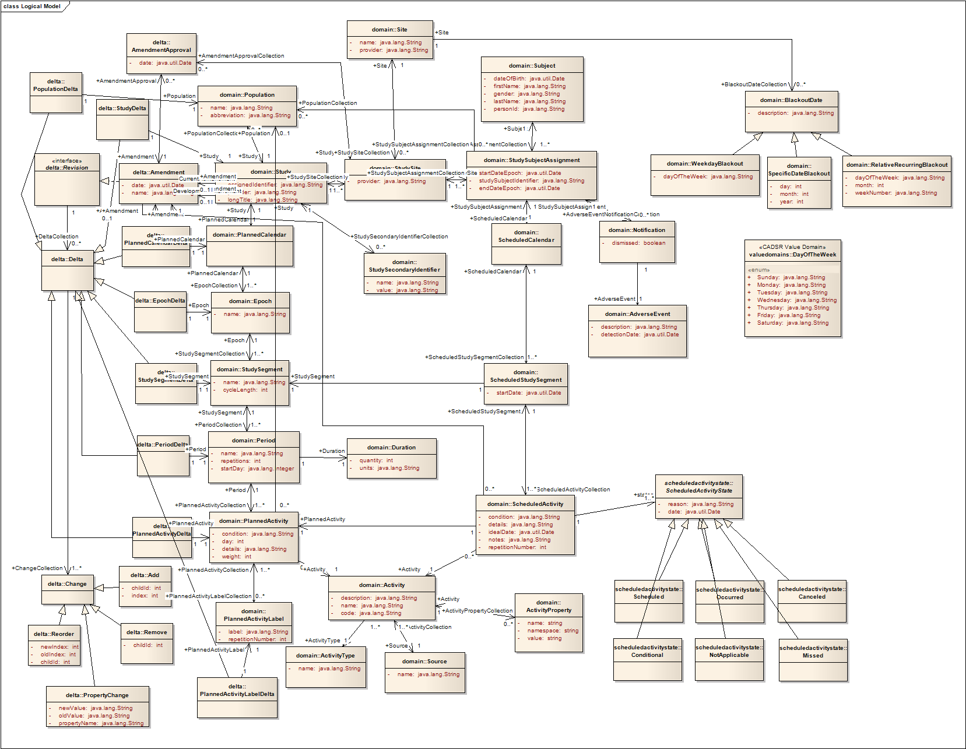

Conformance Profiles
Name | PC Retrieve BRIDG V3.0
Version | V1.0
Description | This is the minimum conformance profile defined for the Planned Calendar Service
Usage Context | This profile could have multiple uses where information about a Planned Calendar template is required.
Functional Profile(s) | PC-FP1 : PC Retrieve
Semantic Profile(s) | PC-SP1 : BRIDG V3.0
Security | Yes

Name | PC Build BRIDG V3.0
Version | V1.0
Description | This is the conformance profile required for a coordinating center creating, updating, deactivating and cloning templates.
Usage Context | A Coordinating Center building a planned calendar template is part of the trial start up activities and is required prior to registering study subjects on to a trial.
Functional Profile(s) | PC-FP2 : PC Build
Semantic Profile(s) | PC-SP1 : BRIDG V3.0
Security | Yes

Name | PC Quality Assurance BRIDG V3.0
Version | V1.0
Description | This is the conformance profile required for approving and releasing templates to sites.
Usage Context | Once the template has been built to reflect the protocol, it needs to be approved and then released to the study site(s) so they can begin to accrue subjects.
Functional Profile(s) | PC-FP3 : PC Quality Assurance
Semantic Profile(s) | PC-SP1 : BRIDG V3.0
Security | Yes

System Implementation Details

System Runtime Interaction Details

TODO: Out of date – de/activate is out of scope
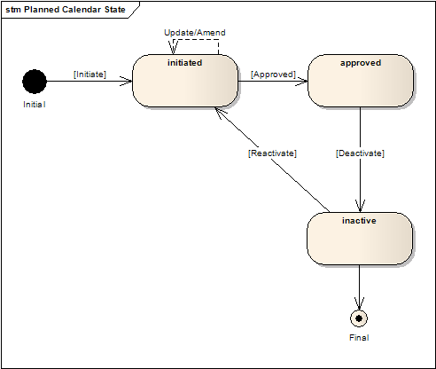

Implementation/Deployment Considerations
Implementation Considerations | Impacts
- This service is currently envisioned as a centralized service. Federation of this service will be considered in future versions.

Conformance and Compliance

Compliance and Conformance Statements
Name | Type | Viewpoint | Description | Test method
Multiple Jurisdictions | Obligation | Enterprise | The Planned Calendar Service is currently envisioned to be a centralized service. | Test cases include central domain scenarios.
Query Performance | Obligation | Enterprise | The query for a Planned Calendar should return results in 15 seconds | Test cases to include performance testing.
Conformance Profiles | Obligation | Computational / Information | In order to claim a minimal level of conformance to the Planned Calendar specification, designers/implementers are obligated to support the following mandatory Conformance Profiles (i.e. their contained functional and semantic profiles): PC Retrieve BRIDG V3.0 | Test cases to be defined to test each specified profile.
Optional Functional Profiles | Permission | Computational | Designers/implementers may implement the additional functional profiles identified in section 4.1 not included in the mandatory conformance profiles. | Test cases to be defined to test each specified profile.
ISO Data types | Obligation | Information | Designers/implementers are obliged to support ISO 21090 data types in all operations. | Test cases to include processing of each relevant data type
Auditing | Obligation | Engineering | Designers/implementers are obligated to decide on and document the approach for logging or auditing of operation calls. | Design Review
Operation Behavior Issues / Assumptions | Obligation | Computational / Information / Engineering | Architects/Designers/Developers are obligated to confirm (or refute) all Assumptions made in the Notes for Service Realization sections of each operation and the overall Assumptions section. | Design Review

Appendix A - Relevant Standards

Name | Description | Location
BRIDG v3.0 | BRIDG model used for modeling the Service | http://gforge.nci.nih.gov/frs/download.php/8831/BRIDG_Release_3.0.2_Package.zip
HL7v3 | Health Level 7 version 3 | http://www.hl7.org/implement/standards/v3messages.cfm
ISO 20190 | ISO 20190 Data Type Standard | https://wiki.nci.nih.gov/display/EAWiki/ISO+21090+Data+Types

Appendix B - References
Name | Description | Location
BRIDG v3.0 | BRIDG model | http://gforge.nci.nih.gov/frs/download.php/8831/BRIDG_Release_3.0.2_Package.zip
PSC Use Case Document | Document containing use cases for the PSC application | https://cabig-kc.nci.nih.gov/CTMS/KC/index.php/PSC_Use_Cases#Background.2FSummary
BAM v1.1 | Business Architecture Model | https://cabig-kc.nci.nih.gov/CTMS/KC/index.php/Biomedical_Research_Business_Architecture_Modeling

Appendix C - Glossary
Term | Description
BRIDG | The Biomedical Research Integrated Domain Group (BRIDG) has developed a comprehensive domain analysis model representing biomedical/clinical research.
PSC | Patient Study Calendar

Appendix D – Cross Reference Tables

List of Storyboards
# | Name | Description | Source
PC-SB1 | Create a Planned Calendar | A Planned Calendar is created. | Storyboard Document
PC-SB2 | Retrieve a Planned Calendar | A planned Calendar is retrieved for use or reuse. | Storyboard Document
PC-SB3 | Approve a Planned Calendar and Provide to Sites | The Planned Calendar is reviewed for adherence to the study protocol, approved and then made accessible to the participating study sites. | Storyboard Document
PC-SB4 | Amend the Planned Calendar | Planned calendars can be amended. | Storyboard Document

Storyboards to Capabilities Mapping
# | Storyboard | Profiles | Actors | Capabilities
PC-SB1 | Create a Planned Calendar | PC Build BRIDG Vx.x | Study Coordinator | Create planned calendar
PC-SB2 | Retrieve a Planned Calendar | PC Build BRIDG Vx.x | Study Coordinator | Retrieve planned calendar
PC-SB3 | Approve a Planned Calendar and Provide to Sites | PC Approve BRIDG Vx.x | Study Administrator | Manage the status of a planned calendar
PC-SB4 | Amend the Planned Calendar | PC Build BRIDG Vx.x, PC Retrieve BRIDG Vx.x | Study Coordinator | Amend planned calendarTemplate

List of Profiles
Functional Profile No. | Functional Profile Name | Storyboard No. | Storyboards Supported
PC-FP1 | PC Retrieve BRIDG Vx.x | PC-SB2 | Retrieve a Planned Calendar
PC-FP2 | PC Build BRIDG Vx.x | PC-SB1  PC-SB4 | Create a Planned Calendar  Amend the Planned Calendar
PC-FP3 | PC Approve BRIDG Vx.x | PC-SB3 | Approve a Calendar Template and Provide to Sites

Actors
Actors | Profile | Type | Operations used
Study Administrator | PC QA, PC Retrieve | Person | - Approve Template  - Make Template Available to Sites  - Retrieve Template
Study Coordinator | PC Build, PC Retrieve | Person | - Create Template  - Amend Template  - Retrieve Template

