Installation Guide
V 2.3

CTMS Patient Study Calendar Module
Robert H. Lurie Comprehensive Cancer Center of Northwestern University

Document Change History
Version Number | Date | Contributor | Description
V1.0 | 2006-09-15 | Sean Whitaker | Initial submission
V1.1 | 2006-12-5 | Sean Whitaker | Revised as per BAH
V2.0 | 2006-12-12 | Sean Whitaker | Revised as per Training WS
V2.0.1 | 2007-1-17 | Sean Whitaker | Corrections as per BAH
V2.1 | 2007-9-13 | John Dzak | Revised per new security
V2.1.1 | 2007-10-23 | Sean Whitaker | Address comments
V2.1.2 | 2007-11-1 | Sean Whitaker | Update with Release 2 links
V2.2 | 2007-12-5 | Sean Whitaker | New install and initial configuration process
V 2.3 | 2008-1-18 | Sean Whitaker | Fonts and note to Oracle users

caBIG™ is an initiative of the National Cancer Institute, NIH, DHHS

Table of Contents

Introduction 1
This installation guide outlines the supported configurations and instructions for installing, setting up and configuring the Patient Study Calendar (PSC). 1
Overview of Patient Study Calendar 1
Client 1
Tomcat 1
psc.war 1
PostgreSQL/Oracle 1
Minimal System Requirements 2
Minimal Client System Requirements 2
Server Software and Technology Requirements 2
Software Requirements 2
Required Software 2
Database Requirements 3
Database Software 3
Installation 3
Preliminary Considerations 3
1. Configure Database 4
2. Download and Unzip installation folder 4
3. Create Database Configuration File 4
4. Configure Security Settings 6
5. Install PSC 6
6. Complete configuration of PSC 6
Contacting Technical Support 7
Application Support 7

Introduction

This installation guide outlines the supported configurations and instructions for installing, setting up and configuring the Patient Study Calendar (PSC).
Overview of Patient Study Calendar | The Patient Study Calendar (PSC) is an open source, standards-compliant software application that can be used by organizations that manage patients on cancer clinical trials. The PSC is a standalone, web-based application providing the ability to create and edit study calendar templates, generate and view prospective calendars of patient activities, track activities as they occur, and manage calendars as they change during a study.

PSC Deployment:
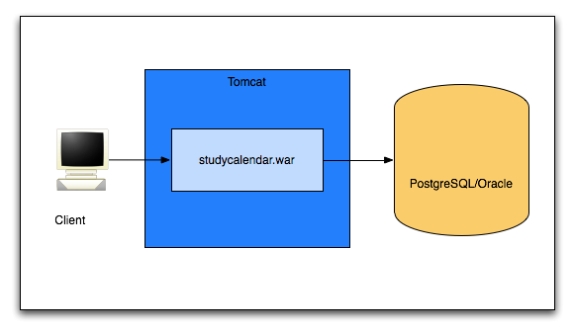
Diagram 1 PSC Deployment

Client | Web browser, preferably Internet Explorer 6 or Firefox 1.5
Tomcat | Web server and servlet container, Apache Tomcat 5.5.17
psc.war | Contains the files of the PSC application
PostgreSQL/Oracle | PSC requires a database to hold security and application data

Minimal System Requirements

Minimal Client System Requirements | - Internet connection  - Firefox 1.5 or higher or Internet Explorer 6 or higher

The Patient Study Calendar server has been tested on the platforms shown in Table 1.
 | Macintosh | Windows
Model | Xserve G4 | Dell Dimension 8200
CPU | 2 x 1 GHz PowerPC G4 | 1 x Intel® Pentium™ Processor 1.80GHz
Memory | 2 GB | 1 GB
Local Disk | System 2 x 180 GB | System 1 x 36GB
OS | OS X 10.4 | Windows XP
Table 1 Platform Testing Environment

Server Software and Technology Requirements

Software Requirements
Required Software | You must download and install the required software that is not included with the Study Calendar (listed in Table 2 ) before installing PSC. The software name, version, description, and URL hyperlinks (for download) are indicated in the table.

Required Software:
Software Name | Version | Description | URL
Java SE Development Kit | JDK 5.0 | The Java SE development kit with JRE, compilers and debuggers | http://java.sun.com/javase/downloads/index.jsp
Apache Tomcat | 5.5.17 or higher | Servlet container for JSP | http://tomcat.apache.org/download-55.cgi
Table 2 Required software and technology

Database Requirements

Database Software | The PSC requires access to a properly-configured database. JDBC drivers for HSQLDB and PostgreSQL have been included. If the user will run a database not compatible with those drivers, including Oracle, the user should obtain the drivers and place them in the db/lib directory. The PSC is built with database-independence in mind and has been tested on the following:

Database Name | Version | Description | URL
PostgreSQL | 8.1.x | PostgreSQL is a powerful, open source relational database system. | http://www.postgresql.org/download/
Oracle | 10g | Industry-leading, commercial database product. | http://www.oracle.com/technology/software/products/oracle9i/index.html
Table 3 Database software
Oracle users please note: Due to licensing restrictions, we are not permitted to distribute Oracle JDBC drivers. You may download the appropriate driver directly from Oracle for free. 10g users should download “ojdbc14.jar”.

Installation

Preliminary Considerations
BEFORE YOU BEGIN | The PSC has been tested with the operating systems and hardware specified on page 1 of this guide. Although we have made an effort to develop PSC as a platform-independent application, we cannot guarantee that it will work If you are using variations of these operating systems and/or hardware. Although installing PSC on a system already setup with the proper versions of the JDK, database, and Tomcat should require only about 30 minutes, installation from scratch could take several hours.

1. Configure Database
Complete the following steps to prepare the database for Study Calendar:

Step | Action
1 | Install preferred database product (tested on PostgreSQL 8 and Oracle 9i)
2 | Configure an empty database for PSC to use. You are free to give your database any valid name, but this guide will use “study_calendar” as the name in each example.

2. Download and Unzip installation folder
Complete the following steps to download the Patient Study Calendar:

Step | Action
3 | Go to the download website: http://gforge.nci.nih.gov/plugins/scmcvs/cvsweb.php/studycalendar/PhaseII/Construction/Iteration3/psc-1.3-beta-bin.zip?cvsroot=studycalendar
4 | Download “psc-1.3-beta-bin.zip”.
5 | Unzip the installation folder. It will contain the file “psc.war” and a folder called “conf-samples”.

Diagram 2 psc-1.3-beta-bin contents

3. Create Database Configuration File
Complete the following steps to tell Study Calendar about your database setup:

Step | Action
6 | Find “datasource.properties” in the “conf-samples” directory.
7 | Move “datasource.properties” to one of three locations:  1. $CATALINA_HOME/conf/psc  2. ~/.psc  3. /etc/psc  If you’re not sure which to use, use (1).
8 | Enter the proper JDBC connection values as described in Table 4 below.
9 | Uncomment the line (delete the ‘#’ symbol) that corresponds to your database. See Diagram 3 below.

JDBC Connection Parameter | Value
datasource.url | Use the proper JDBC url for your database. For PostgreSQL with a database named “study_calendar,” this value would be “jdbc:postgresql:study_calendar”.
datasource.username | The username to connect to the database from Step 2.
datasource.password | The password to connect to the database from Step 2.
Table 4 JDBC connection parameters in datasource.properties

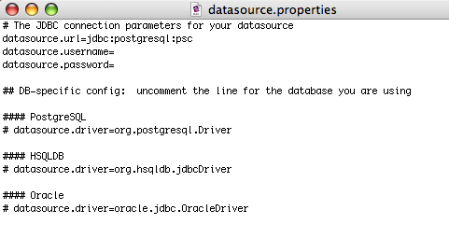
Diagram 3 Contents of datasource.properties

4. Configure Security Settings
Complete the following steps to setup your security:

Step | Action
10 | Move csm_jaas.conf to $CATALINA_HOME/conf/cabig. Please note that if you are also installing other caBIG CTMS applications, you will need to merge the contents of all of the csm_jaas.conf files into one file.
11 | Find catalina.properties in the directory $CATALINA_HOME/conf/. Add the following line to the end of catalina.properties:  java.security.auth.login.config=${catalina.home}/conf/cabig/csm_jaas.config

5. Install PSC
Complete the following steps to install PSC:

Step | Action
12 | Move “psc.war” from the psc-1.3-beta-bin directory that you unzipped to $CATALINA_HOME/webapps.
13  11 | Start Tomcat.

6. Complete configuration of PSC
Complete these steps and PSC will be ready to use:

Step | Action
14 | Using a web browser, go to the PSC URL as determined by your Tomcat configuration. This will most likely be similar to: https://hostname.domain:portnumber/psc
15 | Follow the on-screen instructions to create your first user and site. You are now ready to use PSC. For more instructions regarding what to do next, please see the Administration Guide and End User Manual.

Contacting Technical Support
Application Support | Please direct any concerns to the Project Manager of the Study Calendar Development team, Sean Whitaker.

