Installation Guide
V 2.1

CTMS Patient Study Calendar Module
Robert H. Lurie Comprehensive Cancer Center of Northwestern University

Document Change History
Version Number | Date | Contributor | Description
V1.0 | 2006-09-15 | Sean Whitaker | Initial submission
V1.1 | 2006-12-5 | Sean Whitaker | Revised as per BAH
V2.0 | 2006-12-12 | Sean Whitaker | Revised as per Training WS
V2.0.1 | 2007-1-17 | Sean Whitaker | Corrections as per BAH
V2.1 | 2007-9-13 | John Dzak | Revised per new security

caBIG™ is an initiative of the National Cancer Institute, NIH, DHHS

Table of Contents

Introduction 1
Minimal System Requirements 2
Minimal Client System Requirements 2
Server Software and Technology Requirements 2
Software Requirements 2
Required Software 2
Database Requirements 3
Database Software 3
Installation 3
Preliminary Considerations 3
1. Configure Database 4
2. Download and Unzip source tree 4
3. Create Database Configuration File 5
4. Setup Database Schema 6
5. Configure Security Settings 6
Diagram 3 Contents of tomcat.properties.example 7
6. Generate Study Calendar war file and deploy 7
Contacting Technical Support 8
Application Support 8

Introduction

This installation guide outlines the supported configurations and instructions for installing, setting up and configuring the Patient Study Calendar (PSC).
Overview of Patient Study Calendar | The Patient Study Calendar (PSC) is an open source, standards-compliant software application that can be used by organizations that manage patients on cancer clinical trials. The PSC is a standalone, web-based application providing the ability to create and edit study calendar templates, generate and view prospective calendars of patient activities, track activities as they occur, and manage calendars as they change during a study.

PSC Deployment:
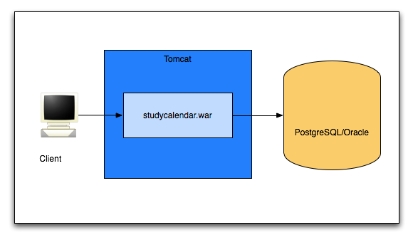
Diagram 1 PSC Deployment

Client | Web browser, preferably Internet Explorer 6 or Firefox 1.5
Tomcat | Web server and servlet container, Apache Tomcat 5.5.17
studycalendar.war | Contains the files of the PSC application
PostgreSQL/Oracle | A single database supports the PSC

Minimal System Requirements

Minimal Client System Requirements | - Internet connection  - Firefox 1.5 or higher or Internet Explorer 6 or higher

The Patient Study Calendar server has been tested on the platforms shown in Table 1.
 | Macintosh | Windows
Model | Xserve G4 | Dell Dimension 8200
CPU | 2 x 1 GHz PowerPC G4 | 1 x Intel® Pentium™ Processor 1.80GHz
Memory | 2 GB | 1 GB
Local Disk | System 2 x 180 GB | System 1 x 36GB
OS | OSX 10.4 | Windows XP
Table 1 Platform Testing Environment

Server Software and Technology Requirements

Software Requirements
Required Software | You must download and install the required software that is not included with the Study Calendar (listed in Table 2 .) The software name, version, description, and URL hyperlinks (for download) are indicated in the table.

Required Software:
Software Name | Version | Description | URL
Java SE Development Kit | JDK 5.0 | The Java SE development kit with JRE, compilers and debuggers | http://java.sun.com/javase/downloads/index.jsp
Apache Tomcat | 5.5.17 or higher | Servlet container for JSP | http://tomcat.apache.org/download-55.cgi
Apache Ant | 1.6 or higher | Java-based build tool | http://ant.apache.org/bindownload.cgi
Table 2 Required software and technology

Database Requirements

Database Software | The PSC requires access to a properly-configured database. JDBC drivers for HSQLDB and PostgreSQL have been included. If the user will run a database not compatible with those drivers, including Oracle, the user should obtain the drivers and place them in the db/lib directory. The PSC is built with database-independence in mind and has been tested on the following:

Database Name | Version | Description | URL
PostgreSQL | 8.1.x | PostgreSQL is a powerful, open source relational database system. | http://www.postgresql.org/download/
Oracle | 9i | Industry-leading, commercial database product. | http://www.oracle.com/technology/software/products/oracle9i/index.html
Table 3 Database software

Installation

Preliminary Considerations
BEFORE YOU BEGIN | The PSC has been tested with the operating systems and hardware specified on page 1 of this guide. Although we have made an effort to develop PSC as a platform-independent application, we cannot guarantee that it will work If you are using variations of these operating systems and/or hardware. Although installing PSC on a system already setup with the proper versions of the JDK, database, Tomcat and Ant should require only about 30 minutes, installation from scratch could take several hours.

1. Configure Database
Complete the following steps to prepare the database for Study Calendar:

Step | Action
1 | Install preferred database product (tested on PostgreSQL 8 and Oracle 9i)
2 | Configure an empty database for PSC to use. You are free to give your database any valid name, but this guide will use “study_calendar” as the name in each example.

2. Download and Unzip source tree
Complete the following steps to download the Study Calendar:

Step | Action
3 | Go to the download website: https://gforge.nci.nih.gov/plugins/scmcvs/cvsweb.php/studycalendar/PhaseII/Construction/Iteration1/?cvsroot=studycalendar
4 | Download the most recent version of “PSC-phase2-R1_source.tar.gz”.
5 | Extract source tree (see diagram below) to a holding location using tar xvfj “PSC-phase2-R1_source.tar.gz” or your preferred extraction mechanism.
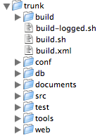Diagram 2 PSC source tree

3. Create Database Configuration File
Complete the following steps to tell Study Calendar about your database setup:

Step | Action
6 | Find studycalendar.properties.example in the “db” directory.
7 | Uncomment the block of code that corresponds to your database and save the changed file as “studycalendar.properties” back into the “db” directory. You will not need to change the DB-specific config values, but you will need to specify JDBC connection parameters as per Table 4, below.

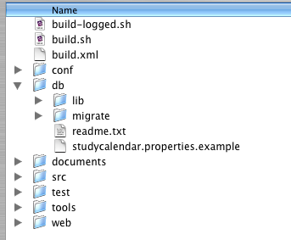
Diagram 3 Location of studycalendar.properties.example

JDBC Connection Parameter | Value
datasource.url | Use the proper JDBC url for your database. For PostgreSQL with a database named “study_calendar,” this value would be “jdbc:postgresql:study_calendar”.
datasource.username | The username to connect to the database from Step 2.
datasource.password | The password to connect to the database from Step 2.
Table 4 JDBC connection parameters

4. Setup Database Schema
Complete the following step to setup your database schema for Study Calendar:

Step | Action
8 | From a command prompt, change directory to the directory to which the source code was extracted. All of the following commands should be run from this directory.
9 | Run: ant migrate  You will see SQL commands being executed as the database schema is created. When this task has finished running, you may check your database to see that all of the tables have been created. The database structure is documented in the Technical Architecture Guide.
10 | Run: ant insert-csm-policy  When this task has finished running, you may check your database to see that all the default user accounts have been created. These are listed in Section 3.2 of the Administration Guide.

5. Configure Security Settings
Complete the following steps to setup your security:

Step | Action
11 | Make sure that Tomcat is not running (stopped).
12  11 | In the /tools/tomcat directory of the source code, locate a file called “tomcat.properties.example”. Add the proper parameters for your Tomcat installation, and then rename the file to “tomcat.properties”. See Diagram 4 below.
13 | Run: ant –Dcatalina.home=/path/to/tomcat tomcat.security  After generating security configuration files, this command will present a set of on-screen instructions.
14 | Follow the on-screen instructions to finalize your security settings. These instructions describe a manual change to the catalina.properties file and the location of a sql file containing security information that should be run against the database.

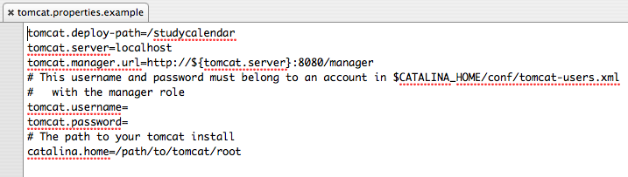

Diagram 4 Contents of tomcat.properties.example

6. Generate Study Calendar war file and deploy
Complete the following steps to generate the Study Calendar war file and allow Tomcat to deploy it:

Step | Action
15 | Run: ant clean war
16 | Step 13 creates a directory called “dist” which contains a file called “studycalendar.war”. Copy this file to your Tomcat installation’s “webapps” directory.

Contacting Technical Support
Application Support | Please direct any concerns to the Project Manager of the Study Calendar Development team, Sean Whitaker.

