Administration Guide
V 1.5

CTMS Patient Study Calendar Module
Robert H. Lurie Comprehensive Cancer Center of Northwestern University

Document Change History
Version Number | Date | Contributor | Description
V1.0 | 2006-09-18 | Padmaja Vedula | Initial revision
V1.1 | 2006-11-02 | Cal Collins | Incorporate feedback and comments from training workspace
V1.2 | 2006-12-12 | Sean Whitaker | Formatting and slight revisions
V1.3 | 2007-09-11 | Nataliya Shurupova | Revised for Phase II (removal of UPT)
V1.3.1 | 2007-10-23 | Sean Whitaker | Address BAH comments
V 1.4 | 2007-10-26 | Nataliya Shurupova | Revised for Phase II
V 1.4.1 | 2007-12-12 | Sean Whitaker | Update UPT reference
V 1.5 | 2008-1-22 | Sean Whitaker | Fill in all Administrative functions

Table of Contents

1 Introduction 3
2 Overview of the Software 3
3 User Management 4
3.1 Create user account 4
3.2 Modify user account 5
4 Site Management 6
4.1 Create site 6
4.2 Describe when a site is closed 6
5 Application Configuration 7
5.1 caAERS base url 7
5.2 Deployment name 7
5.3 LabViewer base url 7
5.4 Mail exceptions to 7
5.5 Reply-to address 7
5.6 Show debugging information 8
5.7 Show developer error messages 8
5.8 Outgoing mail (SMTP) server name 8
5.9 Outgoing mail (SMTP) server port 8
6 System Operation 8
6.1 Startup 8
6.2 Termination 8
6.3 Backup and Restore Strategy 8
6.3.1 Backup 9
6.3.1.1.1 System Configuration Settings 9
6.3.1.1.2 Application Data 9
6.3.2 Restore 9
6.3.2.1.1 System Configuration Settings 9
6.3.2.1.2 Application Data 9
7 Appendix A. Abbreviations and Acronyms 10

Introduction
This administration guide outlines user management, site management, and system configuration for the Patient Study Calendar. These functions are to be performed by a user with the System Administrator role.

After logging in to PSC as a user with the System Administrator role, click on the Administration tab to see the available tasks for this user as per this screen shot:

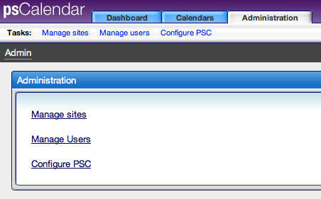

Overview of the Software
The caBIG CTMS Patient Study Calendar Module is an open source, standards-compliant software application that can be used by organizations that manage patients on cancer clinical trials. The caBIG CTMS Study Calendar Module supports the application of a study template to study participants and enables the prospective forecasting of visit information and provide a framework for reviewing historical study calendar events. The caBIG CTMS Study Calendar supports studies that include therapeutic, observational, correlative, ancillary, and biobanking aspects. The standalone Study Calendar module integrates with the components necessary to create study calendar templates (protocol authoring), can instantiate a template for a study participant and represent study events for that participant. These study events are uniquely identified at a study participant and event level, enabling the stable linking to external systems such as patient scheduling systems, laboratory interfaces, adverse event reporting modules, case report forms, and other event-based data that are specified by a study.
The study calendar can serve as an event-centric hub for linking these data, but the study calendar module itself does not model or extend into these domains.
Functionally, the Study Calendar includes features to support patient screening and registration, adaptable schedule definitions and a comprehensive security model that is suitable for multi-site protocols,

User Management
The Patient Study Calendar interface for administering users and roles is handled within the application itself rather than using the User Provisioning Tool (UPT).

Authorization within Patient Study Calendar is based upon both the user’s role and site assignments. The roles define which features are available to a given user. Access to specific data (study templates and subject schedule information) is then limited by a user’s association with a site. Both role and site assignments are managed by the System Administrator.

Roles are pre-defined in the Patient Study Calendar distribution:

System Administrator  (SysAd) | - Manages user access to the application  - Approves and manages user registration process  - Assigns users to roles and sites within the application
Study Administrator  (SA) | - Review study templates to determine if tthathey are complete and correct.  - Determines which study templates will be available at each site
Study Coordinator  (SC) | - Creates new Study Templates  - Marks Templates as being ready for review by Study Administrator
Site Coordinator  (SiC) | - Determines which Subject Coordinators belong to the site  - Determines which Templates are accessible to each Subject Coordinator
Subject Coordinator  (SubC) | - Assigns Subjects to Studies for which approval has been granted  - Generates Calendars for each Subject

Figure 1 Roles

Create user account
Selecting “Manage users” from the Administration tab will display the user accounts which already exist within PSC:
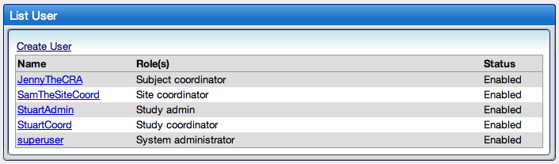

Clicking “Create User” will display the screen used for creating new users:
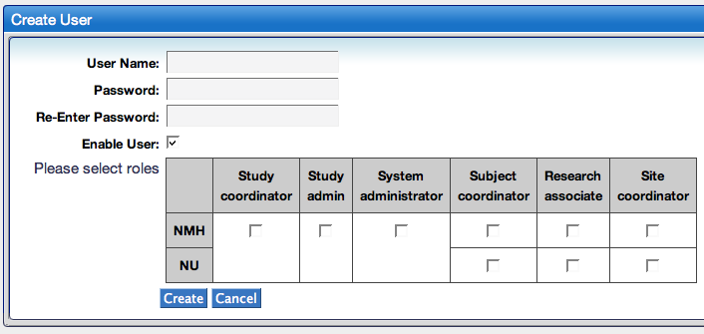

After entering the user name and password, check the boxes within the role/site grid that correspond to the appropriate role(s) and site(s) for the user. Please note that the Study Coordinator, Study Administrator, and System Administrator do not belong to a particular site. The functions of these roles are independent of sites.

Click “Create” to save changes and return to the list of users.

Modify user account
Click on the desired user name from the list of users in order to bring up the details of that account. These details will look exactly like the Create User screen except that the current role and site information will be prepopulated.

- To disable a user account, simply uncheck the box next to “Enable User.”
- Change site and role assignment by checking or unchecking the appropriate boxes.
- Click “Create” to save the changes and return to the list of users.

Site Management
A “site” is an organization that performs clinical research. From a PSC perspective, a “site” can be either physical or logical and will be interested in managing access to the schedules of subjects on its trials and in ensuring IRB approval has been granted for its study protocols.

A single instance of PSC may serve one or more sites. The first site will be created when the application is launched for the first time. If no additional sites are created, PSC will assume all users and studies belong to that site.

Create site
To create a new site, select “Manage sites” from the Administration tab and then click “Create new site.” Enter a name for the site and click “Create.”

Describe when a site is closed
From “Manage sites,” click the “Manage Holidays and Weekends” link that is displayed beside the desired site. You will then be presented with a page for describing when the site closed or not able to see subjects. When these days are described, PSC will automatically reschedule subject activities that would have fallen on one of these days.

Here is a screenshot of that page:
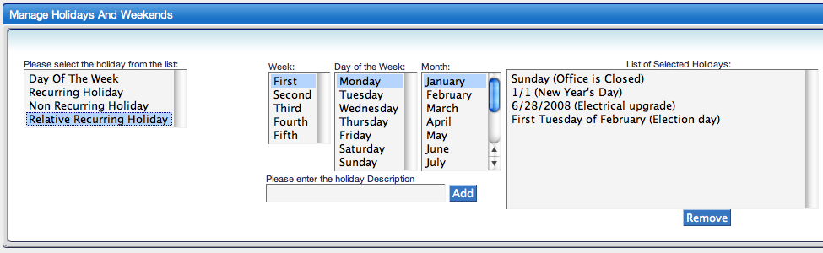

There are four different types of days that can be specified:
- Day of the Week – Select one of the seven days of the week if the site will always be closed on that day.
- Recurring Holiday – Select the month and day of any holidays for which the site closes each year
- Non Recurring Holiday – Enter the month, day, and year of any specific dates on which the site will be closed.
- Relative Recurring Holiday – Enter the week number (within the context of a month), day of the week, and the month for any days that the site will be closed. For example, the site may be closed on Thanksgiving day, which is the fourth Thursday of November.

Enter as many of these as needed for each site.

Application Configuration

The “Administration” tab also presents a “Configure PSC” task. Clicking on this link will bring you to a page for configuring many different application-level options for PSC. Each of these options is described below.

caAERS base url

If PSC is being installed as part of CCTS 1.0, enter the base URL for the caAERS installation here. A link will be generated on the subject’s schedule so that the Subject Coordinator can go directly to caAERS to view adverse event data for the subject.

Deployment name

This is the name by which you will refer to PSC within your organization. When debugging emails are generated by PSC, this name will appear in the subject of the email so that the administrator knows which application is experiencing difficulties. The default value for this name is “Study Calendar.”

LabViewer base url

If PSC is being installed as part of CCTS 1.0, enter the base URL for the LabViewer installation here. A link will be generated on the subject’s schedule so that the Subject Coordinator can go directly to LabViewer to see lab data for the subject.

Mail exceptions to

If PSC encounters an error that is does not know how to handle, it will send a copy of the error to the email address listed here. To enter multiple recipients, place a comma between each email address.

Reply-to address

Specify the email address that should appear in the “Reply-to” section of emails generated by PSC. If PSC is being managed by multiple system administrators, we recommend creating a listserv for this group and specifying that address here.

Show debugging information

To show all of the debugging output on each page, select “Yes.” This information will only be of interest to software developers or system administrators. For production installations, you should most likely select “No.” The default value is “No.”

Show developer error messages

In the unlikely event that PSC encounters an internal server error, this option determines whether the detailed error will be shown or hidden. Since this information will also exist in the PSC logs, we recommend only showing developer error messages on test installations and not on production systems.

Outgoing mail (SMTP) server name

For emails generated by PSC, specify the IP address or fully qualified domain name of the mail server that should be used to send the messages.

Outgoing mail (SMTP) server port

For emails generated by PSC, specify the port number of the mail server that should be used to send the messages.

System Operation
Operation of the Patient Study Calendar system depends on two main layers of application infrastructure: A data persistence backend (a relational database - either PostgreSQL or Oracle) and an application server (Apache Tomcat). Please see the Patient Study Calendar Install and Technical Architecture Guides for more information on system requirements and components.

Startup
To start the Patient Study Calendar application, ensure the database server is running and start Tomcat. The Patient Study Calendar will then be started.

Termination
To stop the Patient Study Calendar application, stop Tomcat

Backup and Restore Strategy
System backups should be conducted on a regular basis in order to ensure continuity in the event of a crash or corruption of the system.
    - Backup

System Configuration Settings
The file studycalendar.properties in the db folder of the source code should be backed up to a secure location according to local IT administration policies.

Application Data
It is recommended that system data backups should be conducted on a regular basis according to local organization policies. There are multiple ways to conduct database backups on both Oracle and Postgres and the appropriate approach should be determined based on the size of the Patient Study Calendar database, system availability requirements, and local database and IT administration policies.
The database can be identified by looking at the database connection parameters in the studycalendar.properties in the db folder. The default name for the Patient Study Calendar database is ‘study_calendar’, but this may have been changed during installation. All data and tables in this database should be backed up.
Below basic backup methods for both Oracle and Postgres are provided as examples:

Oracle Database Backup and Recovery Operations
Please see ‘Oracle Backup & Recovery ’ at http://www.oracle.com/technology/deploy/availability/htdocs/BR_Overview.htm

Postgres Database Backup and Recovery Operations
Please see Postgres 8.1.5 Manual ‘Chapter 23. Backup and Restore’ at
http://www.postgresql.org/docs/8.1/static/backup.html
.
    - Restore

In the event of a crash or corruption of the system, recovery allows continuity by rebuilding the application to a recent ‘good’ state using system backups.

System Configuration Settings
To restore system configuration after a serious problem, copy the file studycalendar.properties from the backup location into the db folder of the source code and rebuild the application according to the instructions found in the Installation Guide:
http://gforge.nci.nih.gov/plugins/scmcvs/cvsweb.php/studycalendar/Final/PSC_Final_Install_Guide.doc?cvsroot=studycalendar

Application Data
The procedure for restoring the database from a backup is dependent on the chosen backup methodology. Please consult documentation for the chosen backup strategy

References:

Oracle Backup & Recovery
http://www.oracle.com/technology/deploy/availability/htdocs/BR_Overview.htm

Postgres 8.1.5 Manual ‘Chapter 23. Backup and Restore’ http://www.postgresql.org/docs/8.1/static/backup.html
http://www.postgresql.org/docs/8.1/static/backup.html#BACKUP-DUMP-RESTORE

Appendix A. Abbreviations and Acronyms

Term | Definition
CSM | Common Security Module
NCICB | The National Cancer Institute’s Center for Bioinformatics

