1 Introduction 1
1.1 Features 2
1.2 Roles 2
1.3 Workflow 3
1.4 Documents 3
2 Manage Templates 4
2.1 Create template 4
2.1.1 Populations 5
2.1.2 Epochs 6
2.1.3 Study segments 6
2.1.4 Periods 6
2.1.5 Activities 6
2.2 Release template 6
2.3 Amend template 6
2.3.1 Mandatory amendments 6
2.3.2 Optional amendments 6
2.4 Import/export templates 6
3 Manage Study Personnel 6
3.1 Site Coordinator dashboard 6
3.2 Associate Subject Coordinators with study 6
3.3 Change ownership of subject schedules 6
4 Manage Subjects 6
4.1 Create/assign subjects 6
4.2 Assign/unassign to populations 6
4.3 Subject Coordinator dashboard 6
4.4 Schedule segments 6
4.4.1 As per protocol 7
4.4.2 Immediate 7
4.5 Manage activities 7
4.5.1 Reschedule 7
4.5.2 Activity states 7
4.6 Schedule reconsent 7
4.7 Download calendar file 7
4.8 Off study 7

Introduction
The Patient Study Calendar (PSC) is an open source, standards-compliant software application that can be used by organizations that manage patients on clinical trials. The PSC is a stand-alone, Web-based application providing the ability to create and edit study calendar templates, generate and view prospective calendars of patient activities, track activities as they occur, and manage calendars as they change during a study. PSC also provides the ability to control access to this data across a multi-site environment.

This Patient Study Calendar (PSC) End User Guide is intended for use by clinical trials personnel who are involved with managing the schedules of subjects on those clinical trials. This guide will explain how to use PSC to simplify and standardize the management subject activities.

Features
The core features of PSC are:
1. Create and amend templates that represent activities of a study and release templates to sites as per IRB approval.
2. Apply template to subject to generate calendar.
3. Schedule the collection of reconsent forms.
4. Manage activities for special subject populations.
5. Manage state and schedule of subject activities.
6. Provide access control to subject calendars within a multi-site environment.
7. Export patient calendar in ICS format.
8. Provide aggregate view of upcoming patient activities for coordinators.
9. Allow coordinators to view upcoming activities of their colleagues.
10. Allow managers to balance workload of coordinators.

Roles
The following table lists each of the roles to which a user of PSC can be assigned. The End User Guide will describe the functions of each of these except for the System Administrator, whose functions are described in the System Administration Guide.

System Administrator  (SysAd) | - Creates user accounts  - Grants users to role(s) and site(s) within the application  - Configures the application
Study Administrator  (SA) | - Reviews completed study templates and approves them  - Imports and exports study templates  - Makes studies available to each site
Study Coordinator  (SC) | - Creates new study templates  - Marks templates as being ready for review by Study Administrator
Site Coordinator  (SiC) | - Determines which study templates are accessible by each Subject Coordinator  - Reassigns subject calendars to appropriate Subject Coordinator
Subject Coordinator  (PC) | - Assigns subjects to studies  - Generates and manages calendars for subjects

Workflow
The following diagram illustrates the basic workflow of activities within PSC and the roles that perform those activities.
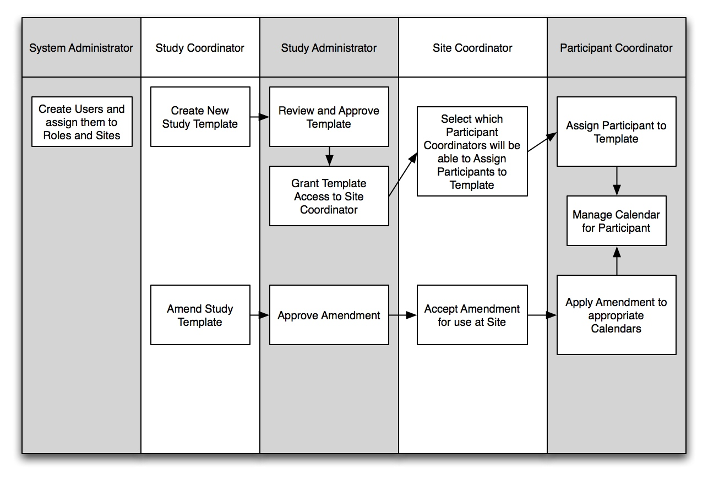

Documents
For additional information, please consult the documents listed below:

Document Name | Version | Location
Vision & Scope Document | 1.0 | http://gforge.nci.nih.gov/plugins/scmcvs/cvsweb.php/studycalendar/PhaseII/Inception/PSC2_VandS.doc?cvsroot=studycalendar
Use Case Document | 1.1 | http://gforge.nci.nih.gov/plugins/scmcvs/cvsweb.php/studycalendar/PhaseII/Construction/Iteration3/PSC_Use_Case.doc?cvsroot=studycalendar
Project Management Plan | 1.5 | http://gforge.nci.nih.gov/plugins/scmcvs/cvsweb.php/studycalendar/PhaseII/Inception/PSC2_PMP.doc?cvsroot=studycalendar
Technical/Architecture Guide | 1.2 | http://gforge.nci.nih.gov/plugins/scmcvs/cvsweb.php/studycalendar/PhaseII/Construction/Iteration3/PSC_Tech_Arch_Guide.doc?cvsroot=studycalendar
Implementation Model | 1.3 | http://gforge.nci.nih.gov/plugins/scmcvs/cvsweb.php/studycalendar/PhaseII/Construction/Iteration3/PSC_UML-P2-R3.EAP?cvsroot=studycalendar

Manage Templates
Before any calendars can be generated, a template must be created. A template is a representation of all of the activities prescribed by the study protocol for subjects.
The template creation process is flexible in order to accommodate each of the wide variety of study designs. The template shows the study divided into large sections called “epochs.” An epoch is a section of the trial during which activities for subjects have the same goal. Some commonly-used epochs are “Screening,” “Treatment,” and “Follow-up.”
Each epoch contains one or more study segments. A study segment is a portion of the trial that has a definable beginning and ending and within which activities can be defined. A study segment could be a set of cycles, a run-in to a transplant, or even a set of follow-up phone calls. Another way of describing study segments would be to say that they last from one decision point to the next. When the time comes to decide what set of activities should happen next for a subject, one study segment will end and the next will begin. The study segments can be listed in any order within an epoch. This order does not determine the execution order for a given subject.
Time within a study segment is defined by “periods.” A period is a set of consecutive days that has a start day, duration, and number of repetitions. Activities are assigned to days within a period. If a period is one week long and occurs twice, an activity assigned to the first day will happen on the first day and again on the eighth day. A study segment may have multiple periods, and the periods may run serially or in parallel. A period can begin on any day, including day 0 or a day with a negative number. The beginning of the study segment is defined by the period with the lowest value as its start day.

Create template
Once logged in to PSC as a user with the Study Coordinator role, click “Create a new template” as shown below:
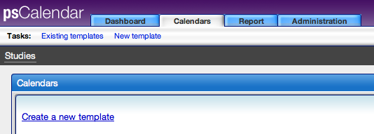

You will then see the template design page:
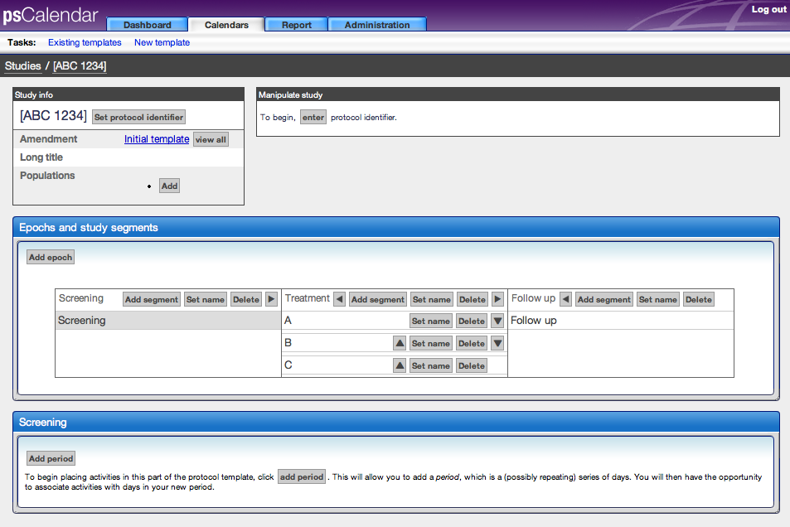

As the on-screen instructions say, begin by entering the protocol identifier for the study.

Populations
If the study protocol specifies activities that should only take place for certain subject populations (older than 65, female, hepatitis positive, etc…), add those populations by pressing the “Add” button in the “Study info” box. Follow the onscreen instructions for naming the population and creating an abbreviation for them. You will see how to create activities for populations in section 2.1.5.4.

Epochs
By default, the initial template is created with three epochs: Screening, Treatment, and Follow-up. You may add, delete, rename, or reorder the epochs at any time during template creation. Please note that deleting an epoch will remove any study segments that have been created within it.

The following diagram shows the various controls for editing epochs:
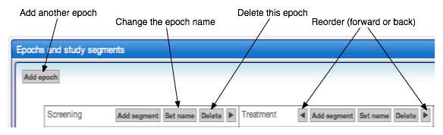

Study segments
As with epochs, you may add, delete, rename, or reorder the study segments at any time during template creation. Deleting an epoch will remove any periods and activities that you have created.

The following diagram shows the various controls for editing study segments:
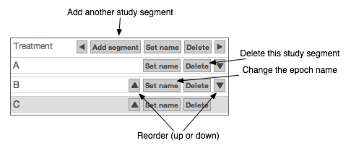

Periods
When a study segment in the template is selected, the box below it will show the periods and activities that have been setup within it. With a new study segment, begin by clicking the “Add period” button. The following screen will appear:
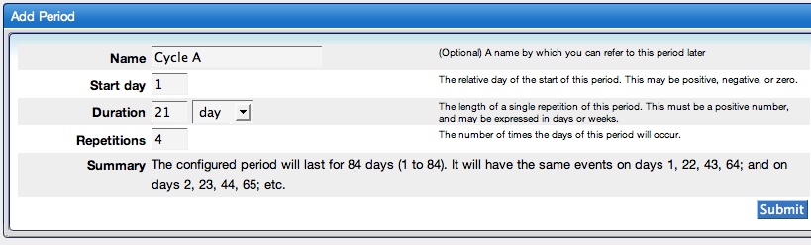

The “Name” field is optional, but a well-chosen name will be useful when tracking subjects after the template is in use. Because PSC counts the repetitions of periods, particularly with studies that have cycles, naming the period after the cycle will in effect allow PSC to display the cycle number that the subject is currently on.

In the example above, the period is named “Cycle A,” begins on day one of the study segment, is twenty-one days long, and will occur four times. The “Summary” section helps to confirm that you have entered the information correctly. Pressing “Submit” will add the period.

Once added to the study segment, it will appear in the study segment details box with new controls:

Activities

Add/remove

Scheduled

Conditional

Populations

Multiple

Release template

Amend template

Mandatory amendments

Optional amendments

Import/export templates

Manage Study Personnel

Site Coordinator dashboard

Associate Subject Coordinators with study

Change ownership of subject schedules

Manage Subjects

Create/assign subjects

Assign/unassign to populations

Subject Coordinator dashboard

Schedule segments

As per protocol

Immediate

Manage activities

Reschedule

Activity states

Schedule reconsent

Download calendar file

Off study

