Introduction
The purpose of this submission form is to provide the information needed by the Semantic Annotation and Loading Teams to register a model in the caDSR. To ensure that your model is correctly registered in the caDSR, please answer these questions carefully. If you do not understand something in this form, please send an email to NCICB Application Support at ncicb@pop.nci.nih.gov to request clarification.

Pre-Submission Checklist
To create the model submission package required to validate semantic annotations and register the model to caDSR, please follow these steps.

- Export the model in Enterprise Architect (EA) or ArgoUML XMI format, using default export settings.

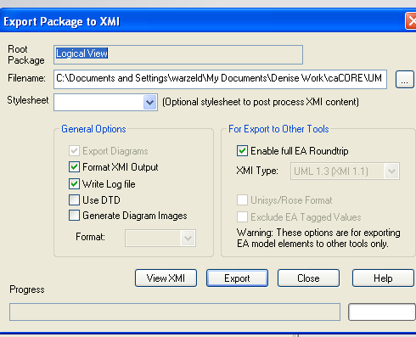
Figure 1: Sample EA Export Dialog Box

*NOTE: ArgoUML does not require exporting. Simply save the UML model in ArgoUML and it will create a .UML file that is in the appropriate XMI format.

- Open the XMI/UML file in “Review Unannotated XMI File” in SIW (http://cadsrsiw.nci.nih.gov) and check the error log. Note that the error log can be exported if desired.
  - Review all errors and warnings in the error log. Errors must be corrected prior to submitting the model. Warnings should be reviewed, but are not required to be corrected.
  - If you wish to save the error log as a file, right click on the error log.
  - Pay particular attention to invalid data types and association errors, as these errors must be corrected directly in the UML model using the UML tool (EA or ArgoUML).
  - Correct any errors in your UML model, re-export to a XMI/UML file and repeat.
- (Optional) Run the Roundtrip process in SIW to map existing data elements to class attributes in your model.
- To run Roundtrip, launch SIW and select the “Perform XMI Roundtrip” option.
- You will want to run the Roundtrip process, if:
  - This is a new version of a model already loaded into caDSR on the production environment and you expect to reuse data elements created when the prior version of the model was registered.
  - This model includes part of another model already registered in caDSR on the production environment and your model uses the same Package, Class and attribute names.

- After running Roundtrip, open the XMI/UML file once again in SIW, “Review Unannotated XMI File” to review the results (CDE reuse), and look for any remaining errors (see step 2 above).
- Run the Semantic Connector in SIW to perform a first pass at concept annotation of classes and attributes that were not matched to CDEs in step 3.
- To run the Semantic Connector, launch SIW and select the “Run Semantic Connector” option.

Submission Information
Please fill in the following information to transform your model into ISO 11179 compatible metadata that will be entered into caDSR. It will also be used by the EVS and Model Loading Teams if a problem is encountered during processing.

NOTE: For ease of reading this document, please input your information using a contrasting font color.

- Curation Account
  - Do you have a caDSR Curator Account? (yes or no)
no

If yes, what is your account name?

- Model Review Options
  - Which version of SIW did you use to annotate this model?
4.0.1.1

  - Have you reviewed the model using the “Review Unannotated XMI File” option in the Semantic Integration Workbench (SIW) http://cadsrsiw.nci.nih.gov? (yes or no)
yes

*NOTE: Performing this task before submitting your model will speed up processing.

  - Did you run the Roundtrip process on your model? (yes or no)
yes

  - Did you run the Semantic Connector on your model? (yes or no)
yes

  - Have you made any edits to the concept mappings in the XMI/UML file after running “Roundtrip” or the “Semantic Connector”? (yes or no)
Yes, as per my own review and that of our VCDE mentor, all concepts have been reviewed

*NOTE: If you explicitly map concepts to classes or attributes in your model, please use the “Review Annotated XMI File” option in SIW to mark these classes/attributes as “Model Owner Verified”. This will indicate to the EVS Team that they should not change these mappings without discussing the changes with you first.

  - Have you made any edits to the XMI/UML file using any tool other than the UML modeling tool or the SIW? (yes or no)
no

If yes, please explain what tool you used and what you edited:

- Contact Information
  - Model Owner
    - Name: Sean Whitaker

    - Organization: Northwestern University

    - Email: s-whitaker@northwestern.edu

    - Phone: 312-503-2310

  - Primary Point of Contact (if different from Model Owner)
    - Name:

    - Organization:

    - Email:

    - Phone:

  - Secondary Point of Contact (if applicable):
    - Name:

    - Organization:

    - Email:

    - Phone:

- How to Display the Project in the Browser Tree (refer to Appendix A for details)
  - caDSR Context where model should be loaded (e.g. caBIG (recommended), CTEP, CIP, NHLBI, etc.):
caBIG

*NOTE: Available contexts are listed in the CDE Browser and UML Model Browser trees. You must use one of the existing contexts listed in these browser trees.

  - Project Description (brief description of the project and intended usages; this displays as a pop-up box in the Browser Tree):
Application Patient Study Calendar (PSC) is based on this model.

  - Please fill in the names to register the model and its packages. These names will be displayed in the CDE and UML Model Browser Trees as:

>>Folder Name (optional; visually groups several separate projects together in the browser tree):

>>>Project Name:
Patient Study Calendar

>>>>>Subproject Name(s) (optional):

*NOTE: Subproject names provide a way to group packages within a project. When using Subproject names, please indicate the names of the packages to be displayed under each subproject, minimum 1 package per subproject. If no subprojects are listed, by default all packages are grouped directly under the Project Name.

  - Project Short Name (optional): PSC

*NOTE: Project short names do not show up in the Browser tree. They can be used by the caGrid to identify the project. By default, project short names are set to the Project name (or an abbreviation of the Project name if it exceeds the number of characters allowed in the short name). If you wish to use a specific short name, you should enter it here.

  - Project Version (e.g., 1.0): 2.6

*NOTE: Versions are stored as numbers in the caDSR, and can only have one decimal point. Version numbers such as 4.0.0.1 cannot be registered.

    - Previously loaded version number (if applicable): 2.0

    - Do you wish to retire the previous version (if applicable)? (yes or no)
yes

*NOTE: If you retire the previous version, it will no longer be visible in the Browser trees.

  - Please list any packages in your UML model you wish to exclude from loading:

*NOTE: If you wish to exclude a package and all its sub-packages, you must list each package separately. If you list only the top level package, classes within that package will not be loaded, but all classes within the sub-packages will still be loaded.

  - URL to project documentation to be linked to your project (optional):

*NOTE: Model documentation should be produced from Enterprise Architect (EA) in HTML format, if possible. Otherwise a similar model owner supplied document should be created. The URL will be linked to your Project in the caDSR as a Project Reference Document. This will allow end users to easily browse your model from the UML Model Browser. Please be sure that your URL is not behind a firewall that would limit access.

- Miscellaneous
  - Which UML modeling tool did you use to create your UML model (product name and version)?
EA 6.5

*NOTE: Currently the SIW/UML Loader only support files from Enterprise Architect or ArgoUML. If you use a different UML modeling tool, you are responsible to ensure that the resulting XMI/UML file is compatible with the SIW/UML Loader.

  - Do you plan to use the caCORE SDK Code Generator to generate your APIs? (yes, no, or have not decided)
no

  - Do you plan to submit your model for the caBIG Silver Compatibility Review? (yes, no, or have not decided)
yes

  - Do you plan to add your service to the Grid? (yes, no, or have not decided)
no

  - Who is funding your project (e.g., NCICB, caBIG, etc.)?
caBIG

Appendix A
This Appendix provides you with additional information to help fill out this submission form.

Training
NCICB provides caCORE and caBIG training. Completion of training helps model owners understand the process, purpose, methodologies and results of model registration.

We highly recommend all model owners complete the relevant caCORE courses and, when possible, attend the caBIG Developer’s Boot Camp prior to submitting a model for registration in caDSR. Additionally, model owners wishing to curate their registered models are required to complete caCORE training in order to receive a curation account necessary to modify content in caDSR.

For more information and to register for these courses or boot camp, go to http://ncicbtraining.nci.nih.gov/TPOnline/TPOnline.dll/NCICBTraining.

Contacts
Fill out all the relevant information for each contact. This information is planned to be entered into caDSR as the contact information for this UML model and thus become available for people who are browsing UML models using the UML Model Browser available at http://umlmodelbrowser.nci.nih.gov/umlmodelbrowser/.

Browser Tree Parameters

Model vs. Project vs. Folder
You will often hear the words model and project used interchangeably. In this submission document, however, there is a distinction. A model is a single UML model that exists in one XMI/UML file. A project can be thought of as an individual service on the Grid. Most often one model represents one project. However, it is possible to split a project up into multiple models. For example, you can define a single service using multiple models; perhaps with one model containing generic classes and another model containing disease-specific classes.

When multiple models describe a single project, those models can be loaded at separately. Each load will add more packages, classes, etc. to the final project. Each of these models must be loaded in the same context, project and project version and contain the same project description. See the screen shots below for an example of multiple models that create one project. The project is caCORE. The models are caBIO, caDSR, caMOD, etc.

You may have several separate projects that you wish to appear together in the CDE Browser tree. To group projects, you will use folders. A folder is only recognized in the caDSR browser tools. It does not have any meaning in the Grid. It is simply a way to group projects together in the browser trees. If you wish to have several projects grouped together, each of those projects will need to be registered in the same context, and be given the same folder name. Refer to the screen shots below for an example of the Imaging folder that contains the projects ACRIN, AIM, DICOM, etc.

Context
This is the name of the context under which your model resides. Contexts can be found in the UML Model Browser and CDE Browser trees as the nodes that are directly under the root node caDSR Contexts. Your model will be placed into a project folder in that context in the caDSR.

Folder Name
This is an optional container that groups several registered models together in the browser tree. Each project is still versioned separately. The folder is for Browser tree presentation purposes only.

Project Name: The caDSR uses Classification Scheme (CS) of type “Project” as a mechanism to group together all the parts of your UML model. This may be either a new Project name, or the name of a previously loaded Project. The Project Name, (aka CS long name), is used as the name of the node in the UML Model Browser and CDE Browser trees.

*HINT: If you do not see the model in the CDE Browser or UML Model Browser trees, check that the Workflow Status of the CS is set to “Released”.

Project Version: When models are versioned, contacts and Project name information is carried over to the new version. The Project Name is part of the default heuristic for generating schema namespaces by the SDK. The schema correlating to your UML Model can be uploaded into the Global Model Exchange (GME) on caGrid.

Sub-Project Name: Under the Project, you can optionally include a Sub-Project Name that is created as a Classification Scheme Item (CSI) of type “UML Package Alias.” This alias is used as a container for all packages in a Sub-Project within a Project in the caDSR Browsers.

Sometimes a project is split into several separate models that can then be loaded separately as Sub-Projects to create the final Project. The caCORE project in the caCORE context contains an example of the use of Sub-Projects. See the screen snapshot below. Subproject names are not part of the GME namespace names.

*NOTE: The caGrid expects each individual service to be registered on the Grid as a separate Project in caDSR.

Package Name: Under the Sub-Project, there will be a node corresponding to each UML package, containing all of the data elements in that package. Each Package is created as a caDSR Classification Scheme Item (CSI) of type “UML Package Name” and associated with the Project (CS). UML Package Names (CSIs) are used to keep track of all the model specific information, such as the specific classes and attributes in the model, as well as model owner supplied class and attribute names and definitions. (The CS/CSI construct for organizing metadata in the caDSR is a standard ISO 11179 metadata construct.) Package names are part of the default heuristic for GME schema namespaces.

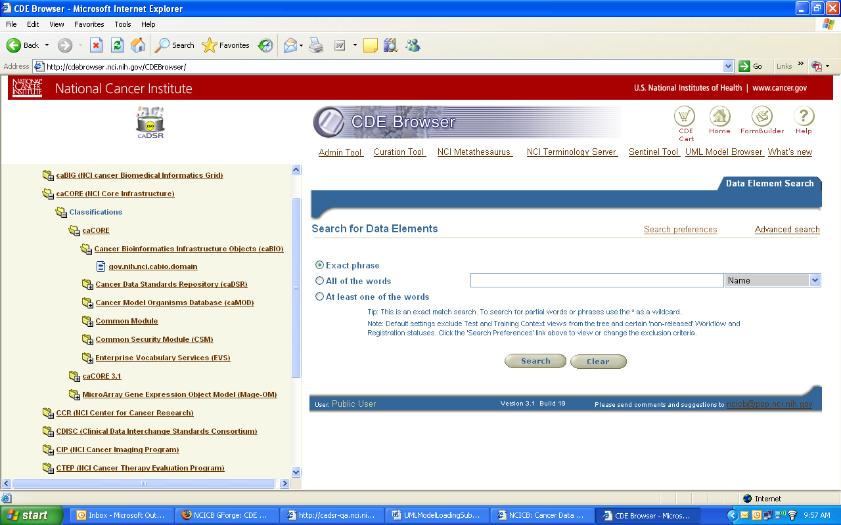
UML Project →
UML Sub-Project →
UML Package →

Figure 2: Projects, subprojects and packages in the Browser tree

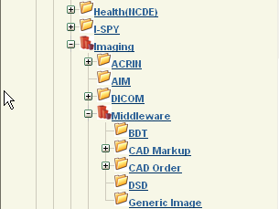
Folder
Folder
UML Projects
UML Projects
Figure 2: Folder containing multiple projects

Code Generation
Indicate whether or not you plan to use the code generator provided by the caCORE SDK to generate your API. Different validation rules apply for your model if you plan to use the SDK code generator.
Submission Package
Please create a zipped file that contains the following files from your model.

  - UML Model .EAP file if using EA.

  - The First Pass XMI/UML file produced by running the Semantic Connector step in SIW, if submitting the model to be annotated and verified by the EVS team, OR,
  - The approved (“Model Owner Verified”) Annotated XMI/UML file, if submitting the model to be loaded to the caDSR
  - The completed Submission Form

When complete, send the zipped file to NCICB Application Support (ncicb@pop.nci.nih.gov). Please specify the step in the process to be completed (e.g., verify concept mappings, load to sandbox, load to production).

