Participant Off Study
Technical Specification

Technical Specification

Version History
Version | Date Modified | Author
1.0 | 9/13/2007 | John Dzak
1.0.1 | 10/23/2007 | John Dzak, Sean Whitaker

Contacts and Support
John Dzak | j-dzak@northwestern.edu

LISTSERV Facilities Pertinent to software teams
LISTSERV | URL | Name
Table of Contents
1 Scope and Purpose 4
2 Overview 4
2.1 Features 4
2.2 Assumptions 4
3 5
3 Design Approach 5
3.1 Domain Objects 5
3.2 Persistence Layer 5
3.3 Service Layer 5
3.4 Controller Layer 5
3.5 View Layer 5
4 Implementation 6
4.1 Domain Model 6
4.2 Sequence Diagram 6
4.3 Activity Diagram 6
5 7
5 Testing 7
5.1 Domain Layer 7
5.2 Persistence Layer 7
5.3 Service Layer 7
5.4 Web Layer 7

List of Figures
Figure 1 4
Figure 2 6

Scope and Purpose
The “Participant Off Study” functionality gives the Participant Coordinator the ability to take a participant off of a study the participant was assigned to. Some of the reasons for a participant to be taken off study would be because of an adverse event, participant’s request, or any number of other reasons.

Overview
The purpose of this document is to outline the proposed technical of the “Participant Off Study” feature in PSC. Where appropriate, the accompanying UML models and documentation have been included as part of this document.

Features
This feature allows the ability to remove a participant from a study based on a specified date. All the remaining scheduled events for that participant after the specified date will be cancelled.

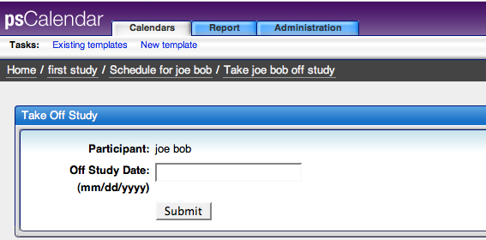
Figure 1

Assumptions
We are capturing the date the participant goes off study, but not the reason. That should be captured in the participant registry. No activities should be scheduled for the participant after the off study date.

Design Approach

Domain Objects
StudyParticipantAssignment will be modified to have an expiration date. This date will be added to keep track when the assignment of the participant to the study is not valid.

ScheduledCalendar will be modified to include a method which returns whether reconsent is allowed or not based upon the off study date set for the participant, if it exists. A reconsent will not be scheduled for a participant after the off study date.

ScheduledEvent will be modified to include a method to check if state changes are allowed based on if the scheduled event actual date is before the off study date set for the participant.

Persistence Layer
There will be no changes made to the persistence layer.

Service Layer
The ParticipantService class will be changed to add functionality to prevent a new arm from being scheduled after the off study date set for the participant.

Controller Layer
A ParticipantOffStudyController will be created to let the view communicate with the model.

The DisplayTemplateController and the DisplayScheduleController were modified to create lists to hold on study and off study participants. These lists are used for the view to display which participants are on study and which are off study.

View Layer
A JSP page to specify when the participant will go off study will be created.

A JSP change to the template and scheduled calendar view will be made to show both off study and on study participants.

A JSP change to the scheduled calendar view will be made to prevent arms from being scheduled if the participant is off study.

Implementation

Domain Model
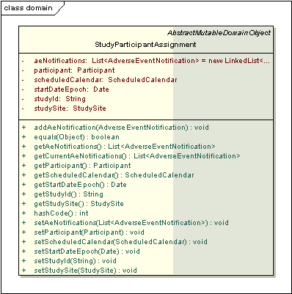
Figure 2

Sequence Diagram

N/A

Activity Diagram

N/A

Testing

Domain Layer

Test Class Name | Target
StudyParticipantAssignmentTest | StudyParticipantAssignment

Persistence Layer

Test Class Name | Target
StudyParticipantAssignmentDaoTest | StudyParticipantAssignmentDaoTest

Service Layer
ParticipantServiceTest will have tests added to test the off study functionality

Web Layer
ParticipantOffStudyControllerTest and ParticipantOffStudyCommandTest will be created to test the ParticipantOffStudyController and ParticipantOffStudyCommand components.

