CBIIT Platform Independent Model and Service Specification

Planned Calendar

0.0.1

11/1/10

Authors | John Dzak
Editor
Reviewers
Architecture Inception Team
Template Version | Initial Version

Version Number | Date | Contributor | Description
0.0.1 | 11/1/10 | John Dzak | Initial Draft

** Following section to be removed from the final document **

Template Version | Effective Date | Description
2.0 | 5/14/2010 | Updated based on input from other teams
3.0 | 09/06/2010 | Updated to aligned with CBIIT SAIF IG

Legend
Type of text | Color | Font | Style
Instructions | Red | Times New Roman Size 12 pt. | Italics
Examples | Blue | Courier New Size 12 pt. | Regular
Content | Black | Times New Roman Size 12 pt. | Regular

Note:
- Red: Represents all the instruction provided to the user of the document to follow
- Blue: Represents notional examples provided for the user’s understanding
  - Example UML Diagram are provided with a blue border
- Neither Instructions nor Examples should appear in the final specifications created
- All the text in the final specifications document should be on black only (unless highlighting is specifically needed)

TABLE OF CONTENTS

1 Overview 4
1.1 Service Description and Purpose 4
1.2 Scope 4
1.3 Referenced Standards 4
1.4 Relationship to the planned calendar Computational Independent Model Service Specification 4
1.4.1 Conformance and Compliance 5
1.4.2 Deviations 5
2 Platform Independent Model 6
2.1 Overview 6
2.2 Assumptions 6
2.3 Information model 7
2.3.1 Planned Calendar Type 7
2.3.2 Error Information Model 9
2.3.3 Control Data Type Definitions 10
2.3.4 Value Set Definitions 10
2.4 Interface Model 12
2.4.1 UML Model of Interfaces 12
2.4.2 List of Operations (Enumeration) 12
2.4.3 Operation Behavior Descriptions 13
3 Dynamic Model 14
3.1 Relationship with other services 14
4 Non Functional Requirements 16
4.1 Jurisdictional Domains 16
4.2 Auditing 16
4.3 Privacy 17
4.4 Additional Security Considerations 17
4.5 Implementation Considerations 18
4.6 Deployment Considerations 18
5 Conformance Statements 20
5.1 Conformance Statements 20
6 Appendix A - References 23
7 Appendix B - Glossary 23
8 Appendix C - Cross Reference Tables 23
8.1 Interface to Profile Mapping 24
8.2 Interface Operations to Profile Operations 24

Planned Calendar Platform Independent Model and Service Specification

Overview

Service Description and Purpose
The purpose of this service is to provide a set of interfaces that enable the creation, updating, amending, approving and cloning of Planned Calendar templates. A Planned Calendar template is a construct which can be applied to a registered study subject to create a personalized calendar (see Scheduled Calendar PIM for details).
A Planned Calendar template is composed of the schedulable activities for a study subject participating in a clinical trial. The template reflects the design of the study in that it is a temporal representation of the components of a trial in relation to each other.
This service will be used by staff involved in the planning of a study such as principal investigators, study administrators and coordinators.
To comprehend this specification it is necessary to have an appreciation for the components of a clinical trial and the ways in which they can be related. The following diagram provides an example of a simple trial design.
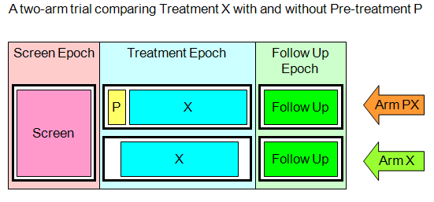
In the diagram above the large rectangular columns are called epochs. There are three shown here, however, a study may have from one to many epochs. In this example, the first epoch is a screening epoch where subjects are typically placed during pre-registration while testing is performed to determine their eligibility to participate in a trial. If a subject is found to be eligible then their registration is completed and they are placed onto the treatment epoch. The follow up epoch is typically used for observation and testing of subjects to determine treatment efficacy and safety.
The horizontal rows marked by arrows are called arms. This example shows a trial with two arms, however, a study can have from one to many arms. The black rectangles with heavy lines are known as study cells. The smaller rectangles within study cells are called study segments. It is within a study segment that an activity is scheduled. An activity can be a onetime event, or an event which happens periodically according to a defined cycle, e.g., administer 40mg of Study Agent X every 2 days until condition Y occurs.
Once a template has been built then it needs to be reviewed for compliance to the protocol and approved for release to study sites if found satisfactory. Only sites that are approved to participate in the trial should have access to the template.
Once a template has been approved, it is possible that amendments to the protocol may generate a need for corresponding amendments to be made to the template and subsequent approvals. Template amendments may be either mandatory or optional. If an amendment is optional then it will be up to site management to determine whether it should be implemented.
The intention is that once created, a template can be shared and leveraged on future studies that have the same or a similar design. This service will include the ability to create a clone of a template that is no longer associated with the study or sites that it was originally created for.
The development of a common, reusable set of interfaces provided by this service will facilitate standardization; integration and interoperability between various systems that need Planned Calendar template functionality, or need access to authoritative template information.
The vision is that any organization or vendor who wants to be compliant with the NCI Planned Calendar template service can implement the Planned Calendar template service specifications.
This service specification provides a key infrastructure component for NCI to support Calendar management and integration with other systems. This service serves as a main platform for integrating Planned Calendar template management needs among all heterogeneous systems/components independent of platform within the clinical domain.

Scope
The scope document for this service is found here:
http://gforge.nci.nih.gov/svnroot/ent-services/trunk/documents/ServicesScope/Planned_Calendar_Service_scope.doc

The scope of this service is the creation and management of Planned Calendar templates. The actual assignment of a template to a subject is out of scope and is addressed in the Scheduled Calendar service.
Items | Scope / Out of Scope | Source
Create a complete Planned Calendar for a study | Scope | Planned Calendar Service Scope Document
Approve a Planned Calendar and manage updates and amendments to it. | Scope | Planned Calendar Service Scope Document
Clone a Planned Calendar for usage on a different study. | Scope | Planned Calendar Service Scope Document
Query and retrieve a Planned Calendar. | Scope | Planned Calendar Service Scope Document
Planned Calendars for Patient “Standard of Care” are out of scope. | Out of Scope

Referenced Standards

Standards | Description
BRIDG v3.0 | The Biomedical Research Integrated Domain Group (BRIDG) Model is a collaborative effort engaging stakeholders from the Clinical Data Interchange Standards Consortium (CDISC), the HL7 Regulated Clinical Research Information Management Technical Committee (RCRIM TC), the National Cancer Institute (NCI) and its Cancer Biomedical Informatics Grid (caBIG®), and the US Food and Drug Administration (FDA). The BRIDG model is an instance of a Domain Analysis Model (DAM). The goal of the BRIDG Model is to produce a shared view of the dynamic and static semantics for the domain of protocol-driven research and its associated regulatory artifacts.

Relationship to the Planned Calendar Computational Independent Model Service Specification

Computational Independent Model and Service Specification Name | Computational Independent Model and Service Specification Version | Description & Link to the Computational Independent Model and Service Specification
Planned Calendar Computational Independent Model | 0.0.3 | https://ncisvn.nci.nih.gov/svn/psc/documents/eccf/CFSS-Planned-Calendar-Service.doc
Service Specification | 0.0.2 | http://gforge.nci.nih.gov/svnroot/ent-services/trunk/documents/ServicesScope/Planned_Calendar_Service_scope.doc

Conformance and Compliance

Conformance Profile No. | PC-CP1
Conformance Profile Name | PC Retrieve BRIDG Vx.x
Functional Profiles
  Functional Profile No. | Functional Profile Name
  PC-FP1 | PC Retrieve
Semantic Profiles
  Semantic Profile No. | Semantic Profile Name
  PC-SP1 | BRIDG Vx.x

Conformance Profile No. | PC-CP2
Conformance Profile Name | PC Build BRIDG Vx.x
Functional Profiles
  Functional Profile No. | Functional Profile Name
  PC-FP2 | PC Build
Semantic Profiles
  Semantic Profile No. | Semantic Profile Name
  PC-SP1 | BRIDG Vx.x

Conformance Profile No. | PC-CP3
Conformance Profile Name | PC Quality Assurance BRIDG Vx.x
Functional Profiles
  Functional Profile No. | Functional Profile Name
  PC-FP3 | PC Quality Assurance
Semantic Profiles
  Semantic Profile No. | Semantic Profile Name
  PC-SP1 | BRIDG Vx.x

Deviations

Deviation from the Computational Independant Service Specification | Reason for Deviation

Platform Independent Model

Overview
The purpose of this service is to provide a set of interfaces that enable the creation, updating, amending, and approving of Planned Calendars.

Assumptions
Assumption | Affects
Audit & Logging is assumed to be handled by supporting infrastructure | As a result it is not explicitly referenced in individual operations and assumed to be done automatically
Authorization checks are enforced | Only authorized users will be allowed access

Information model
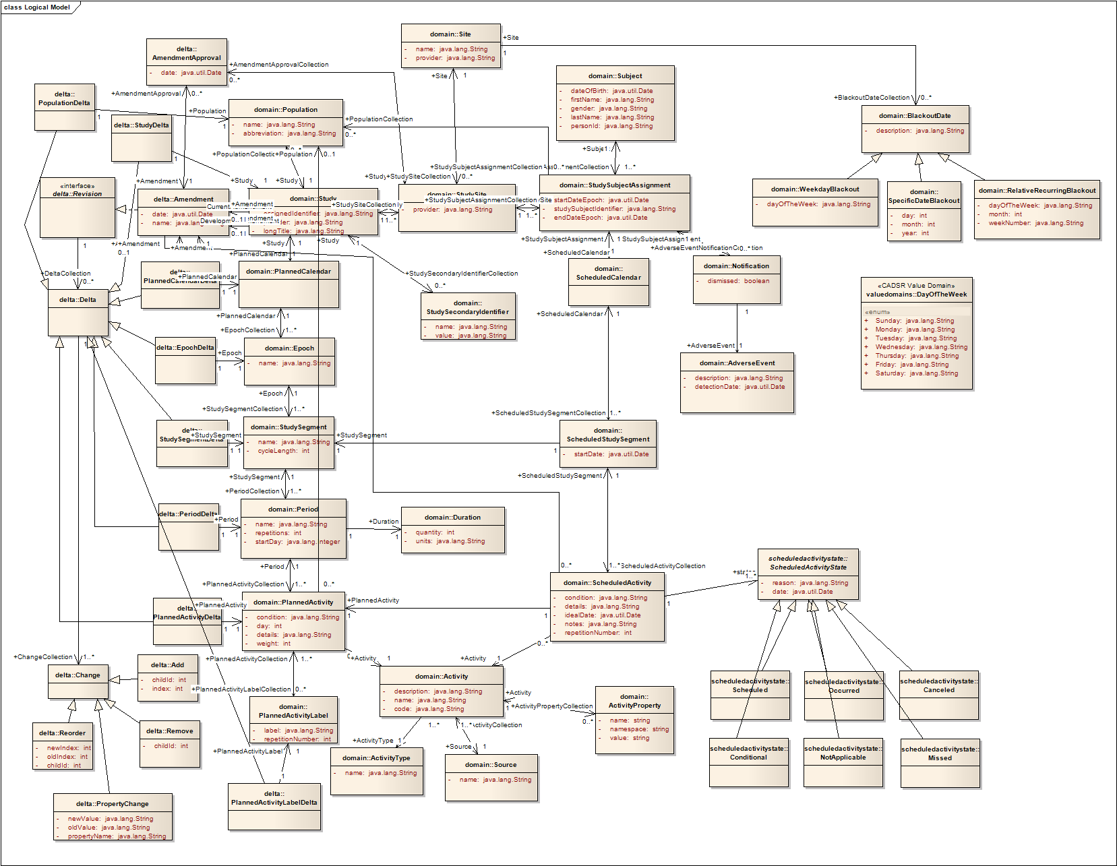

Planned Calendar Type
The Planned Calendar object is the focus of the PC Retrieve, PC Build, and PC Quality Assurance profiles.
Planned Calendar Object derived from BRIDG v3.0.1

Planned Calendar State Model
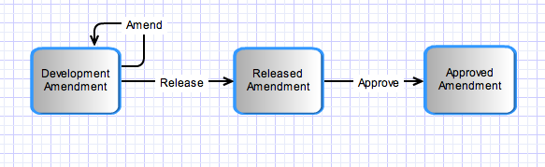

Error Information Model
Same as in section 2.3.4.1

Control Data Type Definitions

Value Set Definitions

Data Element | Attribute | Defined Value Set (code system and code system number) | Valid Values

Status/Return Values/Exceptions

Data Type | Type (Status / Return Value / Exception) | Data Type Description
Invalid Planned Calendar Identifier | Exception | Exception thrown when a planned calendar could not be found using the provided identifier.
Invalid Amendment Level | Exception | Exception thrown when an Amendment Level could not be found for a provided Planned Calendar.
Invalid Planned Calendar Status | Exception | Exception thrown when trying to change the status of a Planned Calendar to anything other than “released.”
Invalid Study Identifier | Exception | Exception thrown when a study could not be found using the provided identifier.
Invalid Attribute | Exception | Exception thrown when an invalid attribute exists on an element.
Invalid Value | Exception | Exception thrown when an invalid value exists for an attribute on an element.

Query Parameters and Result Sets

Data Type | Type (Query Search Criteria / Search Result Limiter / Query Result Set) | Data Type Description
Study Identifier | Parameter | Identifier for a Study.
Planned Calendar | Parameter | The completed planned calendar, including Study Identifier, structure of the template, all amendments, and the activities.
Amendment | Parameter | A development amendment for the planned calendar, containing all changes to the template structure for the amendment.
Planned Calendar Identifier | Parameter | Identifier for a Planned Calendar.
Amendment Identifier | Parameter | Identifier for an Amendment.
Planned Calendar Status | Parameter | The status of a planned calendar. Initially it will be set to “development” but can be changed to “released” once the Study QA Manager approves the planned calendar.

Interface Model

UML Model of Interfaces

Interface No | Interface Name | Interface Description
PC-INF1 | Planned  Calendar  Interface | Planned calendars can be created, updated, and retrieved using this interface.
PC-INF2 | Planned Calendar Status Interface | Planned calendar status can be updated to “Released” using this interface.
PC-INF3 | Planned Calendar Approval Interface | Planned calendars can be approved for a site using this interface.
PC-INF4 | Amendment Interface | Amendments for planned calendars can be created, updated, and retrieved using this interface.

List of Operations (Enumeration)

Operation No. | Operation Name | Interface Name | Operation Description
PC-INF1-OP1 | Create | Planned Calendar Interface | Create a new planned calendar.
PC-INF1-OP2 | Retrieve | Planned Calendar Interface | Retrieve a planned calendar.
PC-INF2-OP1 | Update | Planned Calendar Status Interface | Update a planned calendar release status to “Released.”
PC-INF3-OP1 | Create | Planned Calendar Approval Interface | Create an approval for a planned calendar at a site.
PC-INF4-OP1 | Create | Amendment Interface | Create an amendment for a planned calendar.

Operation Behavior Descriptions

Planned Calendar Interface

Create
Behavior Description | Create a new planned calendar.
Pre-Conditions | An approved study protocol.
Security Conditions | Access control mechanism needs to be in place to ensure that the user is logged in and has valid credentials.
Inputs | A planned calendar
Outputs
Post-Conditions | The planned calendar should be created.
Exception Conditions | The Study Identifier is invalid  Invalid data type or code value for any attribute
Additional Implementation Details
Notes

Retrieve
Behavior Description | Retrieve a planned calendar.
Pre-Conditions | The planned calendar exists.
Security Conditions | Access control mechanism needs to be in place to ensure that the user is logged in and has valid credentials.
Inputs | Planned calendar identifier  Amendment identifier (optional – default is latest)
Outputs | A planned calendar at the requested amendment level
Post-Conditions
Exception Conditions | Invalid planned calendar identifier  Invalid amendment level
Additional Implementation Details
Notes

Planned Calendar Status

Update
Behavior Description | Update a planned calendar release status to “Released.”
Pre-Conditions | The planned calendar exists.
Security Conditions | Access control mechanism needs to be in place to ensure that the user is logged in and has valid credentials.
Inputs | Planned calendar identifier  Amendment identifier (optional)  Planned calendar status
Outputs
Post-Conditions
Exception Conditions | Invalid planned calendar identifier  Invalid amendment identifier  Invalid planned calendar status
Additional Implementation Details

Planned Calendar Approval Interface

Create
Behavior Description | Create an approval for a planned calendar at a site.
Pre-Conditions | A planned calendar exists and needs to be approved for a site.
Security Conditions | Access control mechanism needs to be in place to ensure that the user is logged in and has valid credentials.
Inputs | Planned calendar Identifier  Amendment identifier (optional)
Outputs
Post-Conditions
Exception Conditions | Invalid planned calendar identifier  Invalid amendment identifier
Additional Implementation Details
Notes

Amendment Interface

Create
Behavior Description | Create an amendment for a planned calendar.
Pre-Conditions | A released planned calendar exists.
Security Conditions | Access control mechanism needs to be in place to ensure that the user is logged in and has valid credentials.
Inputs | Study identifier  The amendment
Outputs
Post-Conditions
Exception Conditions | Invalid study identifier  Invalid data type or code value for any attribute
Additional Implementation Details
Notes

Dynamic Model
All service interactions are internal to the application.

Non Functional Requirements

Jurisdictional Domains

Jurisdictional Domains | Boundary
NCI’s OCIO | The service may be deployed within NCI network
Institutional IRB | The service will be deployed at various institutions that comes within their boundary
Coordinating Center | The service may be deployed by a coordinating center for use by participating institutions

Auditing

Operation Name | Auditing Details
[ALL] | Authorized User  Time stamp of action  Parameters

Entity Name | Auditing Details
[ALL] | All operations are audited.
… | …

Privacy
Data Element | Privacy Regulation | Access Requirement | Public Information
None | N/A | This service contains no patient data.

Additional Security Considerations

Security Consideration | Description
Authentication | Service should accept only Level Of Assurance 2 credentials and above for authentication
Authorization | Service should employ a Role Based Authorization framework
Encryption | Service should transmit data over an encrypted channel

Implementation Considerations
The following sub-sections provide details significant to the service implementers and the Platform Specific Model (PSM) generators.

Implementation Consideration | Impact

Deployment Considerations

Deployment Consideration | Impact
Local Deployment Mode | Service should be able to run locally in the same container as the client application

Conformance Statements

Conformance Statements
No. | Name | Type | Compliance Profile | Viewpoint | Description | Test method
CS1 | Multiple Jurisdictions | Obligation | ALL | Enterprise | The Planned Calendar Service is currently envisioned to be a centralizable service. | 1. Test cases include multiple domain scenarios
CS2 | Query Performance | Obligation | ALL | Enterprise | The query for a Planned Calendar should return results in 15 seconds | 1. Test cases to include performance testing.
CS3 | Conformance Profiles | Obligation | ALL | Computational / Information | In order to claim a minimal level of conformance to the Planned Calendar specification, designers/implementers are obligated to support the following mandatory Conformance Profiles (i.e. their contained functional and semantic profiles): PC Retrieve BRIDG V3.0 | 1. Test cases to be defined to test each specified profile
CS4 | Optional Functional Profiles | Permission | ALL | Computational | Designers/implementers may implement the additional functional profiles identified in section 4.1 not included in the mandatory conformance profiles. | 1. Design review
CS5 | ISO Datatypes | Obligation | ALL | Information | Designers/implementers are obliged to support the ISO 21090 datatypes in all operations | 1. Test cases to include processing of each relevant data type
CS6 | Auditing | Obligation | ALL | Engineering | Designers/implementers are obligated to decide on and document the approach for logging or auditing of the operation calls. | 1. Design Review
CS7 | Operation Behavior Issues / Assumptions | Obligation | ALL | Computational / Information / Engineering | Architects/Designers/Developers are obligated to confirm (or refute) all Assumptions made in the Notes for the Service Realization sections of each operation and the overall Assumptions section. | 1. Design Review

Appendix A - References
Name | Description | Location
BRIDG v3.0 | BRIDG model used for modeling the Service | http://gforge.nci.nih.gov/frs/download.php/8831/BRIDG_Release_3.0.2_Package.zip
PSC Use Case Document | Document containing use cases for the PSC application | https://cabig-kc.nci.nih.gov/CTMS/KC/index.php/PSC_Use_Cases#Background.2FSummary
BAM v1.1 | Business Architecture Model | https://cabig-kc.nci.nih.gov/CTMS/KC/index.php/Biomedical_Research_Business_Architecture_Modeling

Appendix B - Glossary
Term | Description
BRIDG | The Biomedical Research Integrated Domain Group (BRIDG) has developed a comprehensive domain analysis model representing biomedical/clinical research.
PSC | Patient Study Calendar

Appendix C - Cross Reference Tables

Interface to Profile Mapping
Interface No. | Interface | Profile No. | Profile
PC-INF1 | Planned Calendar Interface | PC-FP2 | PC Build
PC-INF1 | Planned Calendar Interface | PC-FP1 | PC Retrieve
PC-INF2 | Planned Calendar Status Interface | PC-FP3 | PC Quality Assurance
PC-INF3 | Planned Calendar Approval Interface | PC-FP3 | PC Quality Assurance
PC-INF4 | Amendment Interface | PC-FP2 | PC Build

Interface Operations to Profile Operations
Operation No. | Operation Name | Capability No. | Profile Capability
PC-INF1-OP1 | PC Create | PC-FP2 | PC Build
PC-INF1-OP2 | PC Retrieve | PC-FP1 | PC Retrieve
PC-INF2-OP1 | PC Status Update | PC-FP3 | PC Quality Assurance
PC-INF3-OP1 | PC Approval Create | PC-FP3 | PC Quality Assurance
PC-INF4-OP1 | Amendment Create | PC-FP2 | PC Build

