Conditional Events
Technical Specification

Technical Specification

Version History
Version | Date Modified | Author
Elaboration Iteration -2 | 07/30/2007 | Nataliya Shurupova

Contacts and Support
Nataliya Shurupova | n-shurupova@northwestern.edu

LISTSERV Facilities Pertinent to software teams
LISTSERV | URL | Name
Table of Contents
1 Scope and Purpose 4
2 Overview 4
2.1 Features 4
2.2 Assumptions 4
3 Design Approach 4
3.1 Domain Objects 4
3.2 Persistence Layer 4
3.3 Service Layer 5
3.4 Controller Layer 5
3.5 View Layer 5
4 Implementation 5
4.1 Domain Model 5
4.2 Sequence Diagram 6
4.3 Activity Diagram 6
5 Testing 7
5.1 Domain Layer 7
5.2 Persistence Layer 7
5.3 Service Layer 7
5.4 Web Layer 7

List of Figures
Figure 1 5
Figure 2 6

Scope and Purpose
Allow creation of a conditional activity that will be scheduled only if the specified condition is met.

Overview
Some events have to be scheduled only if a certain condition has been achieved. The Site Coordinator (SC) will be able to define these conditional events as part of the template so that a Participant Coordinator (PC) can later schedule them, if appropriate.

Features
PSC provides a mechanism for helping SC’s to manage conditional events. If some activity has to be marked as conditional, SC will have to check a checkbox and add the condition (conditional details) under what the events within this activity have to occur.

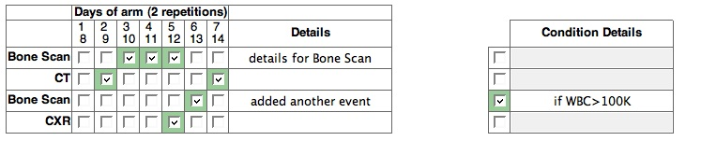
Within a period conditional events will have an identifier with provided details.
The period displays conditional events as following:

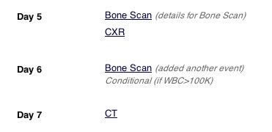
If the conditional activity has to be a non-conditional, the conditional checkmark should be unchecked. The change will be automatically applied to all the events in this activity.

(TODO – need to apply conditional changes for the scheduled page.)

Assumptions

Design Approach

Domain Objects
Affected part for this particular implementation is PlannedEvents. The planned_events table was changed to have new additional columns to hold the conditional state. Also, conditional description is displayed on the period page.

Persistence Layer

Service Layer

Controller Layer

View Layer

Implementation

Domain Model

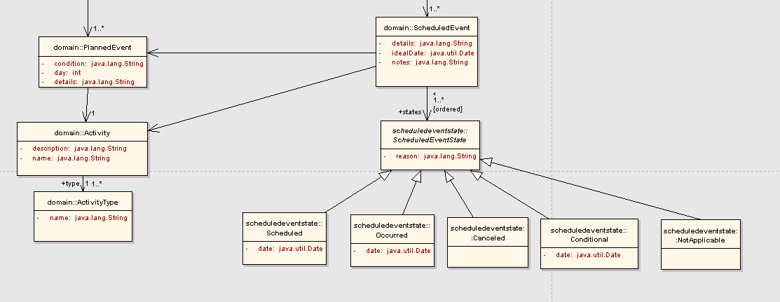Figure 1

Sequence Diagram

<<screensnap of Sequence diagram>>

Activity Diagram

<<screensnap of Activity diagram>>
Figure 2

Testing

Domain Layer

Test Class Name | Target
ManagePeriodEventsCommandTest
ManagePeriodEventsControllerTest

Persistence Layer

Test Class Name | Target

Service Layer

Web Layer

