Software Requirement Specifications Document
V3.5

Patient Study Calendar – Robert H. Lurie Comprehensive Cancer Center

DOCUMENT CHANGE HISTORY
Version Number | Date | Contributor | Description
V1.0 | 8/7/06 | Sean Whitaker | First Draft
V1.1 | 8/22/06 | Sean Whitaker | Revision of First Draft
V2.0 | 9/11/06 | Sean Whitaker | Release 2 – update roles and requirements
V3.0 | 10/30/06 | Sean Whitaker | Release 3
V3.5 | 11/14/06 | Sean Whitaker | Final release as per feedback from adopters and BAH

TABLE OF CONTENTS
1. Background/Summary 3
2. Introduction 4
Document Overview 4
Related documents 5
Application System Diagram 6
Application Core Data 7
Release Overview 7
Definitions 7
3. caBIG requirements 8
Vocabularies and Data Elements 8
Environment 8
4. Application Functional Requirements 9
New user creation and login 9
New User Registration 9
Assign User to proper role or roles via UPT 10
Logging into the System 10
Forgotten Password 10
Contacting Administrator 11
Creating and Using the Study Template 11
Study Template example 11
Create Basic Study Template 11
View Current Study Templates 12
Populate the Arms of the Study Template with the necessary Activities 12
Mark Study Template Complete 13
Generating Study Calendars for Participants 13
Assign User Permissions to Completed Study Template 13
Assign Participant to Study Template and Generate Study Calendar 14
View Calendar and Manage Scheduled Events 15
Creating Reports 15
5. APPLICATION NON-functional requirements 16
GUI Specifications 16
Security Requirements 16
Audit 16
Database schema 17
Performance criteria 17
Availability 17
Completeness 18
Correctness 18
Cost of ownership 18
Compatibility 18
Environment 19
Extensibility 19
Installation complexity 19
Portability 19
Regulatory 20
Reusability 20
Scalability 20
Time to market 20
Training complexity 20
Usability 21
6. Requirement Change Management 21
Chronographic list of changes to ticket 22
7. GLOSSARY 23

Background/Summary
The business driver behind the caBIG CTMS Study Calendar Module is the creation of an open source, standards-compliant software application that can be used by organizations that manage patients on cancer clinical trials. The caBIG CTMS Study Calendar Module will support the application of a study template to study participants and enable the prospective forecasting of visit information and provide a framework for reviewing historical study calendar events. The caBIG CTMS Study Calendar will support studies that include therapeutic, observational, correlative, ancillary, and biobanking aspects. The standalone Study Calendar module will integrate with the components necessary to create study calendar templates (protocol authoring), be able to instantiate a template for study participant and represent study events for that participant. These study events will be uniquely identified at a study participant and event level, enabling the stable linking to external systems such as patient scheduling systems, laboratory interfaces, adverse event reporting modules, case report forms, and other event-based data that are specified by a study.
The study calendar will serve as an event-centric hub for linking these data, but the study calendar module itself will not model or extend into these domains.
Functionally, the Study Calendar will include features to support patient screening and registration, adaptable schedule definitions and security model implemented using the CSM that is suitable for multi-site protocols, alerts for upcoming events and missed events, ability to track and report on dates of anticipated versus actual events, and complete reporting of patient accrual, missed events, and schedule deviations. The Patient Study Calendar will support the accrual definitions necessary for CCSG reporting.

2. Introduction

Document Overview
The System Requirements Document (SRS) includes detailed functional requirements for the system on ‘what’ are the behaviors based on specified end-user use cases as well as non-functional requirements such as GUI, quality &performance, usability and system behavior requirements that directly or indirectly impact the system.
The Patient Study Calendar module will have three functional components that reflect the three aspects of the data model: a template view, a prospective view, and a retrospective view.
- The template view of the Patient Study Calendar module is an electronic representation of the eligibility/treatment/monitoring/follow-up lifecycle for a specific study, as typically listed in the study parameters table of the study protocol.
- The prospective view is the result of applying the template view to a specific participant with a start date. The prospective view is an instantiation of the template for a study participant and by combining the start date of that participant with the days specified in the template view, discrete dates for future events can be calculated.
- The third component to the Patient Study Calendar module is the retrospective view. Once the date of an event created by the prospective component has passed, details about that event must be entered to reconcile if it happened, when it happened, and provide a unique, stable identifier for these events that can be used by other modules and systems.
The Study Calendar Module is being developed with significant input from groups that have been identified as Primary Stakeholders in the project. These stakeholders are key contributors in defining system requirements and associated use cases. They include:
- A user group from the Robert H. Lurie Comprehensive Cancer Center of Northwestern University Clinical Research Office. This group meets as needed to provide information and feedback to the development team and is key in the development of use cases.
- A Requirements Group that includes representatives from several cancer center and development team members. This group holds weekly teleconferences and focuses on requirement specifications.
The Study Calendar SIG, which has twice-monthly teleconferences. The focus of calls mirrors the activities underway in the development project, with the discussion of use cases and requirements as key agenda items.

Related documents
Document Name | Version | Location
Vision & Scope Document | 1.0 | http://gforge.nci.nih.gov/plugins/scmcvs/cvsweb.php/studycalendar/Prelude/Vision and Scope.doc?cvsroot=studycalendar
Use Case Document | 3.5 | http://gforge.nci.nih.gov/plugins/scmcvs/cvsweb.php/studycalendar/Final/PSC_Use_Case.doc?cvsroot=studycalendar
Project Management Plan | 1.5 | http://gforge.nci.nih.gov/plugins/scmcvs/cvsweb.php/studycalendar/Release1/Study Calendar PMP.doc?cvsroot=studycalendar
Technical/Architecture Guide | 1.0 | http://gforge.nci.nih.gov/plugins/scmcvs/cvsweb.php/studycalendar/Release2/PSC_draft_tech_arch_guide.doc?cvsroot=studycalendar

Application System Diagram

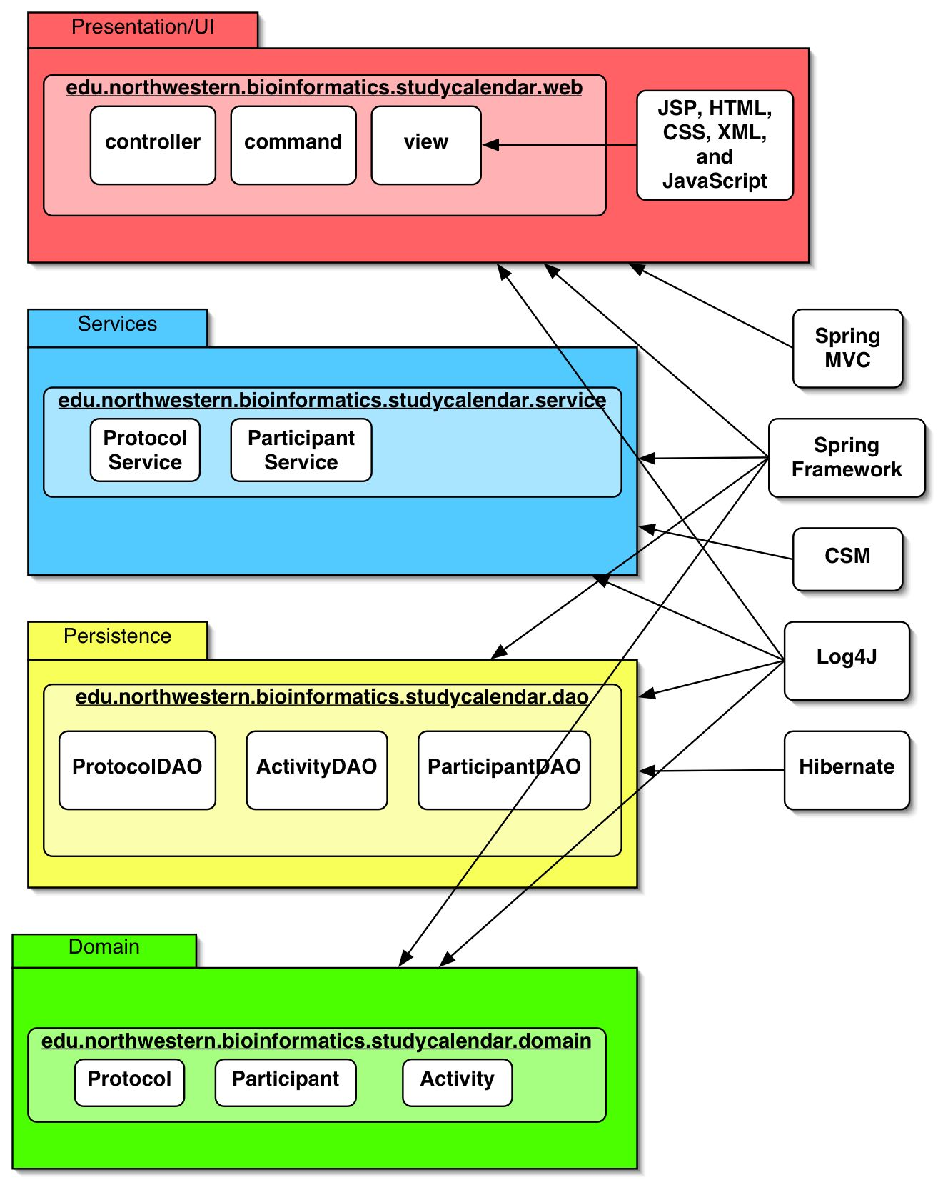

Application Core Data
Please see Implementation Model.

Release Overview

Release | Date Released | Version comments
Prelude | 6/26/06 | Planning documentation and development environment
Release 1 | 8/7/06 | First software release and documentation
Release 2 | 9/18/06 | Software and documentation refinements
Release 3 | 10/30/06 | Software and documentation refinements
Release 4 | 12/04/06 | Final software release

Definitions
Developers and Adopters are expected to clearly understand on the definitions and agree upon the ranking of the definitions used with any given requirement.
MUST - This word means that the definition is an absolute requirement of the specification.
MUST NOT - This phrase means that the definition is an absolute prohibition of the specification.
WILL - This word means that the definition is an absolute future requirement of the specification.
WILL NOT - This phrase mean that the definition is an absolute future prohibition of the specification.
SHOULD - This word means that there may exist valid reasons in particular circumstances to ignore a particular item, but the full implications must be understood and carefully weighed before choosing a different course.
SHOULD NOT - This phrase means that there may exist valid reasons in particular circumstances when the particular behavior is acceptable or even useful, but the full implications should be understood and the case carefully weighed before implementing any behavior described with this label.
MAY - This word means that a requirement is truly optional. The developer may choose to include the item based on the needs of their design.

3. caBIG requirements

Vocabularies and Data Elements

One of the main goals of caBIG is to ensure that all applications use the same vocabulary and data elements for similar concepts across the grid. This will eliminate any inconsistency in data descriptors (metadata) and make it possible to pass semantically equivalent data with confidence across various applications within the grid
R# | Req. Name | Requirement details
NFR026 | Ensure caDSR compliance | Patient Study Calendar must use Enterprise Vocabulary Services (EVS) and Cancer Data Standards Repository (caDSR) for each and every data element and concept which will be exposed to the grid.

Environment
All caBIG projects must be platform and database-independent applications. The Patient Study Calendar should be able to run on any operating system, support any database and work on any web browser. However, considering the large number of combinations of test scenarios, Patient Study Calendar must at least be certified on the following scenarios:
Operating system | Mac OS X
Operating system | Windows XP, 2003 Server
Operating system | Linux
Database | Oracle 9i, 10g
Database | PostGRES 8
Browser | Firefox 1.5
Browser | Internet Explorer 6
Java | 1.5

Roles
System Administrator  (SysAd) | - Manages user access to the application  - Approves and manages user registration process  - Grants users to a role within the application
Study Administrator  (SA) | - Reviews completed Study Templates to determine if they are complete and correct.  - Enters new sites into the system  - Determines studies will be available at each site  - Determines which Site Coordinates will be able to manage access for each site
Study Coordinator  (SC) | - Creates new Study Templates  - Marks Templates as being ready for review by Study Administrator
Site Coordinator  (SiC) | - Determines which Participant Coordinators belong to the site  - Determines which Templates are accessible by each Participant Coordinator
Participant Coordinator  (PC) | - Assigns Participants to Studies for which approval has been granted  - Generates Calendars for each Participant
Research Associate  (RA) | - Views Calendars and reports

4. Application Functional Requirements
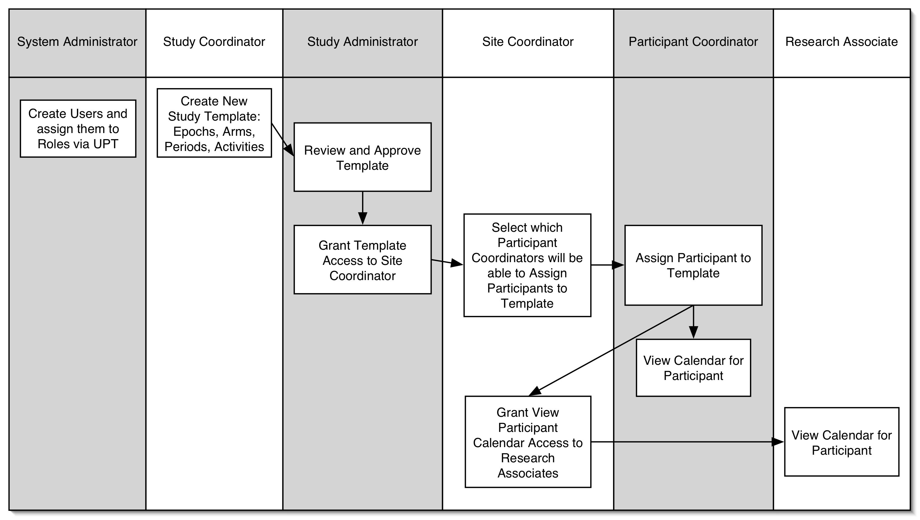

New user creation and login
This section describes the requirements for the following four functionalities:
- Registration of new users
- Logging into the system
- Retrieving forgotten password
- Reporting a problem without logging into the system

New User Registration
The new user registration process will rely on the User Provisioning Tool of the NCICB Common Security Module.
The following requirements describe this process of New User Registration

R # | Req. Name | Requirement details
FR001 | New User Registration | User is registered and granted appropriate rights by the System Administrator through the UPT.

Assign User to proper role or roles via UPT
The System Administrator, after creating a user’s account, will be able to assign that user to a pre-defined role within the UPT. A user may be assigned to more than one role.

The following requirements describe this process

R # | Req. Name | Requirement details
FR006 | Assign User Permissions via UPT | After creating a user account, the System Administrator will be able to assign the user to pre-defined roles using the UPT.

Logging into the System
Once a User’s access has been setup in the UPT, the user can login to the system using their username and password.

The following requirements describe this process of Logging into the System:

R# | Req. Name | Requirement details
FR002 | Login and Authentication | The user logs on to the application through a Study Calendar login page. The user will have received their username and password from the System Administrator
FR022 | Logout | The user clicks a link available at the bottom of each page in order to logout. After logging out, any attempt to access a page of the application will produce a login screen.

Forgotten Password
If a user forgets his or her password, he or she will need to contact the System Administrator to reset the password.

The following requirements describe this process of Resetting Forgotten Password

R# | Req. Name | Requirement details
FR003 | Forgotten Password | If a user forgets his or her password, he or she will be able follow a link at the bottom of each page to contact the System Administrator to reset the password.

Contacting Administrator
A user should be able to follow a link to send an email to an administrator to report problems with any page.

The following requirements describe this process

R # | Req. Name | Requirement details
FR004 | Contact Administrator Link | If problems with a page arise, the user will be able to contact the System Administrator by following a link at the bottom of the page.

Creating and Using the Study Template

This section lists the Functional Requirements for creating and using study templates. A study template is a visual representation of activities and the relative timing of those activities as described in a study protocol. The template divides the study into large pieces called “epochs.” Within each epoch, one or more time segments, called “arms,” describe a particular set of activities.

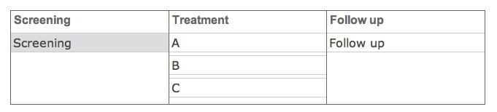 Study Template example

Create Basic Study Template

After a Study Coordinator (SC) follows a link to create a new Study Template, he or she will be presented with a page that allows for the creation of the basic form of the Study Template. When the information entered on this page is submitted, the Study Template will have a name, Epochs, and Arms within those Epochs.
The following requirements describe this process

R # | Req. Name | Requirement details
FR019 | Supply name for Study Template | The Create Study Template page will prompt the SC to enter the Protocol Short Name as a name for this Study Template. The system will verify that this name is unique and generate an error if it is not.
FR009 | Add Epochs to Study | The next detail of the Study will be the creation of Epochs. The SC can create as many Epochs as necessary, each with a name that is unique within the Study Template. These will usually be called something like “Screening,” “Treatment,” “Treatment 2,” “Follow-up,” etc…
FR008 | Add Arms to Epochs | By default, each Epoch will only have one Arm. The SC may then add any number of Arms to each Epoch. Each Arm can have any name, but must be unique within each Epoch.

View Current Study Templates
After successfully supplying login credentials, a user will be shown a Study Menu that lists all of the Study Templates that he or she is authorized to view/use. The authorization process is described in “Assign User Permission to Completed Study Template” section (FR014, FR024-27). Basically, Study Administrators determine which Templates are viewable by each Site Coordinator, and Site Coordinators determine which Templates will be usable by each Participant Coordinator.

The following requirements describe this process

R # | Req. Name | Requirement details
FR005 | View Current Templates | After login, system checks user’s access to templates and displays those for which access has been granted. The user will be able access and use the template as determined by the user’s role. If the number of templates will be very large, a search box or drop box will need to be implemented within the view.

Populate the Arms of the Study Template with the necessary Activities
The Study Protocol will define a certain sequence of Activities that should take place during each Arm of the Study. A Study Coordinator (SC) will define this series of Activities on the Study Template one Arm at a time. First, the SC will select the Arm. Then the SC will configure the repeating intervals of time during each Arm as “Periods.” Finally, the SC will define the Activities that happen during these periods. When the addition of Activities to the Periods is saved, the Study Template will show all of the Activities according to when they occur within the Period and within the Arm.

The following requirements describe this process

R # | Req. Name | Requirement details
FR020 | Display Study Template | After a Study Template has been created, the application will present a view of the Epochs and Arms. From this Template view, the SC will be able to select Arms to edit the details of those Arms.
FR010 | Add Periods to Arms | The SC will select an arm to add periods to it. Multiple periods may be added, but they will be added one at a time. Each period will have a name, a duration, an indicator of when on the arm it will start, and a number of repetitions.
FR011 | Add Activities to Periods | The SC will select a Period on an Arm in order to add Activities to it. The interface should allow the SC to narrow the choice of available activities by first selecting an “Activity Type” (Intervention, Lab Test, Disease Measurement, Procedure, Other). The list of activities will be automatically populated according to the type. The SC will select an activity, then determine how many times this activity will happen on each day of the period. The activities will automatically populate the Arm as defined by the duration and repetition of the period to which they are assigned.
FR012 | Create New Activities | During the process of adding activities to periods, if a SC finds that an activity is missing from the list, he or she will follow a link to a “Create Activity” page. This page will allow for creation of an activity with an Activity Name and Activity Type.

Mark Study Template Complete
The Study Administrator (SA) or Study Coordinator (SC) will logon to the application, review any completed templates that are still in-progress, and mark the accepted templates as complete. The SA should be a domain expert in Clinical Trials management and will be responsible for determining that the Study Template created within the Patient Study Calendar application accurately represents the trial sponsor’s protocol.

The following requirements describe this process

R # | Req. Name | Requirement details
FR013 | Approve Study Calendar Template | After successful logon, SA or SC will be presented a Study Menu that includes list of templates that are in-progress. After reviewing a template, the SA or SC will be able to mark the template as being complete and accurate.

Generating Study Calendars for Participants

This section lists the Functional Requirements for assigning Participants to a Study Template and generating Study Calendars for those Particpants.

Assign User Permissions to Completed Study Template
A Study Administrator (SA) and Site Coordinator (SiC) will assign user permissions to a completed, approved study template to determine which Sites and Participant Coordinators (PC) will be able to assign participants and manage participant calendars.

The following requirements describe this process

R # | Req. Name | Requirement details
FR014 | Assign Template to Site | After a Template has been marked as complete, SA can assign the Template to one or more Sites.
FR024 | Create Sites | The SA will add a Site to the system if it does not already exist.
FR025 | Assign Site Coordinator to Site | The SA will assign Site Coordinator (SiC) to a Site. This designates the SiC as being able to manage Template access for that Site. SiC can be assigned to multiple Sites, and a Site can have multiple SiCs.
FR026 | Assign Participant Coordinator to Site | SiC will be able to determine which Participant Coordinators are able to access Templates and manage Calendars for a Site.
FR027 | Assign Participant Coordinator to Template | SiC will be able to determine which Participant Coordinators (PCs) are able to access each Template at a Site. PC1 and PC2 may both be assigned to SiteA, but only PC1 is able to access TemplateA at SiteA.

Assign Participant to Study Template and Generate Study Calendar
A Participant Coordinator (PC) will be able to assign a participant to a study template that has been approved by a Study Administrator.

The following requirements describe this process

R # | Req. Name | Requirement details
FR015 | Assign Participant to Study | PC logs in to system and is able to see the completed templates that have been approved and assigned by the Study Admin. The PC is then able to assign participants to the study calendar template. The PC will select the Participant from an available list and select which Arm the Participant will be assigned to initially.
FR018 | Create Participant | If a Participant needs to be assigned to a Study Template but PC will create a participant if not already present within the system. The system will capture but not require: first name, last name, DOB, and gender. A unique identifier will also be required.
FR021 | Generate Calendar | When a Participant has been assigned to the Study Template, as per FR015, PC will be able to generate a Calendar of Events by assigning Arms and showing the start date of each.

View Calendar and Manage Scheduled Events
After a Participant Coordinator has assigned participants to a study, PCs and Research Associates are able to view the participant calendars for approved studies. PCs will also be able to manage the scheduled events within the calendar to track the participant’s progress through the study.

The following requirements describe this process

R # | Req. Name | Requirement details
FR016 | View Calendar | PC or RA logs on to system and is able to see calendars for the participants on studies to which access been granted by Study Admin.
FR028 | Reschedule Events | PC will be able to reschedule individual events and make notes about the changes.
FR029 | Cancel Events | PC will be able to cancel individual events and make notes about the cancellation.
FR030 | Mark Events as Occurred | PC will be able to mark individual events as having occurred and make notes about them.

Creating Reports
Participant Coordinators will be able to generate aggregate reports about Scheduled Events. These can be sorted by Site, Study, or Participant and limited by start and end dates as well as the type of event.

The following requirements describe this process

R # | Req. Name | Requirement details
FR031 | Create Reports | PC navigates to page for creating reports. The report can be aggregate activities for Site, Study at a Site, or Participant, and can be given a start and end date as well as the desired type of event.

5. APPLICATION NON-functional requirements

GUI Specifications
The National Cancer Institute Center for Bioinformatics NCICB has published User Interface (UI) guidelines to promote visual and functional consistency across all applications comprising the NCI e-community so that the user can have a consistent foundation of navigation, behavior, and appearance. They have also published a UI library intended to be used in conjunction with the UI guidelines.
The following is a list GUI requirements to include the design, layout and usability.
R# | Req. Name | Requirement details
NFR001 | UI Setup | GUI specifications will be compliant w/ NCICB UI guidelines

Security Requirements
The following table contains the different kinds of user groups:
System Administrator | - Manages user access to the application  - Approves and manages user registration process  - Grants users to a role within the application
Study Administrator | - Reviews completed Study Templates to determine if they are complete and correct.  - Enters new sites into the system  - Determines studies will be available at each site  - Determines which Site Coordinates will be able to manage access for each site
Study Coordinator | - Creates new Study Templates  - Marks Templates as being ready for review by Study Administrator
Site Coordinator | - Determines which Participant Coordinators belong to the site  - Determines which Templates are accessible by each Participant Coordinator
Participant Coordinator | - Assigns Participants to Studies for which approval has been granted  - Generates Calendars for each Participant
Research Associate | - Views Calendars and reports

The following is a list of security requirements:
R# | Req. Name | Requirement details
NFR002 | Role-based Security Set-up | System Administrator will assign user to role (see table above) using UPT
NFR003 | Enforcement of Role-based Security | Role-based security must be enforced throughout the PSC

Audit
The system must be possible to audit each and every user action that results in database access (read or write). Examples include: add/edit administrative or patient treatment data, user login, query, distribution, and so forth.
The audit information must contain the following information:
- User who performed the action
- IP address of the computer from which the action is performed
- Timestamp of action
- Object and data element (i.e. table name and column name)
- Previous value and current value of the data element
- Action

R# | Req. Name | Requirement details
NFR004 | Audit user actions | PSC will capture required audit information (see list above)
NFR029 | Audit logon attempts | PSC will capture logon attempts and store the username, IP address, time, and whether or not the attempt was successful.

Database schema
Database schema will be recreated using an Ant task and Bering. PSC will be designed to be as database-independent as possible and will be tested with both Oracle and PostgreSQL.
The following are the requirements for the database schema:
R# | Req. Name | Requirement details
NFR005 | Reproduce Database Schema | Using Ant and Bering w/ a properly configured database, any site will be able to recreate the database schema automatically. Details will be provided in the Installation Guide. <insert link when available>
NFR006 | Database Compatibility | PSC will be tested to function correctly with both Oracle and PostgreSQL.

Performance criteria
The below table will contain the performance criteria based on the application functions and result output. It includes internal and external dependencies that may impact the application performance.
R# | Req. Name | Requirement details
NFR007 | Performance Data | The PSC relies on relatively small datasets. We currently do not foresee a scenario in which any transaction requires more than 5-10 seconds to complete. We will update this estimate as the module matures.

Availability
The following is a list of Availability requirements
R# | Req. Name | Requirement details
NFR010 | Availability | The PSC will be able to run 24/7 except for scheduled software updates.

Completeness
The following is a list of Completeness requirements
R# | Req. Name | Requirement details
NFR011 | Completeness | The PSC will be able to ensure that the primary pieces of the template exist and will provide the Study Administrator with the opportunity for manual review.

Correctness
The following is a list of Correctness requirements
R# | Req. Name | Requirement details
NFR012 | Correctness | The PSC will be able to accurately represent all data entered into the system as it was entered and will provide the Study Administrator with the opportunity for manual review.

Cost of ownership
The following is a list of Cost of Ownership requirements
R# | Req. Name | Requirement details
NFR013 | Cost of ownership | All required components to run PSC and the PSC itself will be open source and freely available. The only Cost of Ownership will be the time required to install and maintain the PSC.

Compatibility
The following is a list of Compatibility requirements
R# | Req. Name | Requirement details
NFR014 | Compatibility | The PSC will be BRIDG harmonized.
NFR026 | Messaging Compatibility | For communication with other modules, it is anticipated that Study Calendar will use HL7 messaging. Future details will be decided as these modules come online.

Environment
The following is a list of Environment requirements
R# | Req. Name | Requirement details
NFR015 | Environment | The PSC will run on systems as detailed in Section 3 above.

extensibility
The following is a list of Extensibility requirements
R# | Req. Name | Requirement details
NFR016 | Extensibility | The PSC is being developed in an iterative, extensible way. Each release builds upon and extends the functionality of the last. With the source code and UML models being freely available, any Java developer should be able to extend the PSC in any way he or she requires.

installation complexity
The following is a list of Installation Complexity requirements
R# | Req. Name | Requirement details
NFR017 | Open Source Installation | The PSC will be installable using only open-source components.
NFR018 | Complexity of Install | The PSC will provide an installation package and manual, but knowledge of deploying Java-based web apps will be assumed.

Portability
The following is a list of Portability requirements
R# | Req. Name | Requirement details
NFR019 | Portability | The PSC is a stand-alone module and can be installed in any environment.
NFR027 | API Portability | Published APIs will be accessible through any platform that can run a JVM.

regulatory
The following is a list of Regulatory requirements
R# | Req. Name | Requirement details
NFR020 | Regulatory | Transactional auditing will assist organizations in compliance w/ various regulations.

reusability
The following is a list of Reusability requirements
R# | Req. Name | Requirement details
NFR021 | Reusability | The PSC should be able to function as a patient study calendar for any cancer clinical research institution.

Scalability
The following is a list of Scalability requirements
R# | Req. Name | Requirement details
NFR022 | Scalability | The PSC will be able to accommodate the number of templates and protocols of any cancer center.
NFR028 | Scalability using APIs | The PSC will be scalable across the caBIG grid leveraging its published APIs.

Time to market
The following is a list of Time to Market requirements
R# | Req. Name | Requirement details
NFR023 | Time to Market | The development cycle of the PSC ends December 4, 2006.

Training complexity
The following is a list of Training Complexity requirements
R# | Req. Name | Requirement details
NFR024 | Training Complexity | A Clinical Research Coordinator should find the system intuitive and easy to learn.

usability
The following is a list of Scalability requirements
R# | Req. Name | Requirement details
NFR025 | Usability | Must be user-friendly and intuitive for clinical trial professionals to use.

6. Requirement Change Management

All changes in requirements are managed and recorded in our ticket tracking system. This ticket system allows us to link tickets to our wiki and version control system. All developers, testers, and QA personnel have the ability to create and edit tickets, others are granted this right by request.
In addition to the required fields of Date, Submitted By, Change Type, Change ID, Change Details, and Status, our change management system also allows us to track Priority, Completion Time Estimate, Assigned To, Associated Component, Associated Release, and Change History. Project managers receive an automated notification anytime a ticket is added or modified. We review open tickets each week during our development meetings and reach consensus about who will complete each ticket. This community review process ensures that each member of our development team has work to complete that he or she understands, and that progress is being made on each ticket.
Sample Ticket:
Field | Sample Data
Date | 6/26/06
Submitted By | Mmhohman
Change type | Enhancement
Change ID | Ticket #19
Change Details | Create an activity, providing a name, activity type, and text description, shared across all studies
Status | Closed
Priority | Major
Completion Time Estimate | 20 hours
Assigned To | Jaron
Associated Component | Software
Associated Release | Release 1
Change History | Chronographic list of changes to ticket

Change Workflow:

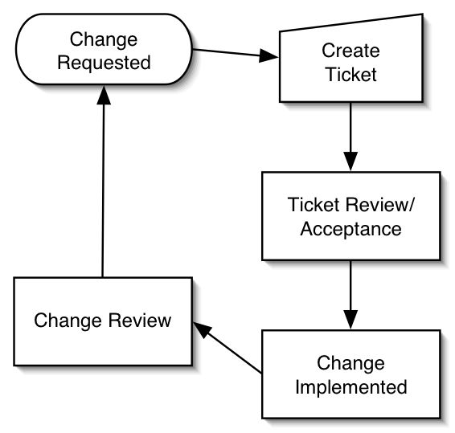

7. GLOSSARY
Screening: The process of evaluating a subject for eligibility and potential participation in a clinical trial. The formal screening process begins at the time that consent is obtained and prior to the initiation and performance of any procedures identified as being research-related. The screening period ends when a subject is registered to the study or determined to be ineligible.

Note: Identification of patients as potential subjects (pre-screening) can occur prior to consent as long as no procedures or assessments determined by the protocol to be research-related are performed.

Registration: This is a formal method of entering a patient onto a given trial. The timing and method of registering a patient onto a study is typically described in the protocol or per the corresponding organizational SOPs.

Note: the decision was made not to use the term enrollment, due to inconsistencies in this definition at various sites. Some sites, for example, define enrollment as occurring when a consent form is signed, while others do not define it as occurring until registration.

Arm: A branch of the protocol design to which study participants are assigned a specific treatment schedule as defined in the protocol. Every protocol has at least one arm. When there is more than one arm, the subject will receive an ARM ASSIGNMENT upon registration.

Randomization: The process of assigning trial subjects to treatment or control groups (a study Arm) using an element of chance to determine the assignments in order to reduce the bias (ICH 1.48). This can occur at the time of subject registration to a trial or at protocol defined time points after initial registration (e.g., when a subject finishes one treatment regimen and will be moving on to 1 of 2 new regimens).

Active Monitoring: The process of monitoring that tests, procedures and other evaluations associated with an arm regimen are appropriately conducted as defined by the protocol. This period begins with subject registration and ends when all study activities (tests, procedures, face-to-face evaluations, etc.) as defined by the protocol schedule have been completed. Active monitoring may involve active assessment of the participant with or without continuance of the research intervention (therapeutic or other) - the constant is that the participant is still managed, i.e., is having tests, procedures and face-to-face evaluations, according to a pre-defined, protocol-specific schedule.

Long Term Follow Up: The period that begins when the subject has completed active monitoring until such time that no further information is being collected regarding the subject. Typically, subjects in long-term follow up are being monitored for events – death, possibly disease progression, etc. but there are no scheduled test/procedures or evaluations.

Epoch: An interval of time in the planned conduct of a study during which the treatment is consistent. NOTE: Consistent treatment of subjects across arms during an epoch does not mean that the treatment in all arms is the same; rather that the treatment, whatever it is, is to be consistent during the epoch for each arm. [from CDISC, Clinical Terminology V. 4]

