Patient Study Calendar Phase II
Design Document
Feature | Date
Reconsent patients on a protocol. | June, 2007
Real-world scheduling | June 2007

1. Overview – Reconsent
Patients on a protocol may need to be reconsented. This means that a Participant Coordinator (PC) such as a CRA will need to collect a reconsent form from the patient on the patient’s next visit to the clinic. Sometimes, all patients on a particular protocol will need to be reconsented. At other times, only certain patients will need to be reconsented.
PSC will provide a mechanism for helping PC’s manage reconsent activities. If all patients need to be reconsented, a Study Administrator (SA) will be able to push a reconsent activity to every patient on a protocol. If the reconsent is only required for some, a notification that a reconsent is required will be sent to the sites. A Site Coordinator (SC) will then push the reconsent activity to the appropriate patients on the protocol.
In either case, an activity called “Reconsent” will be automatically added to the appropriate patient’s calendar to coincide with the timing of whatever the next visit of the patient happens to be.

2. Details
Within PSC, we have PlannedEvents and ScheduledEvents. Generally, ScheduledEvents are created by PlannedEvents. However, since reconsent activities are not planned in advance, they will be the first example of an activity in PSC that goes directly to being a ScheduledEvent.

See Reconsent Diagram below:
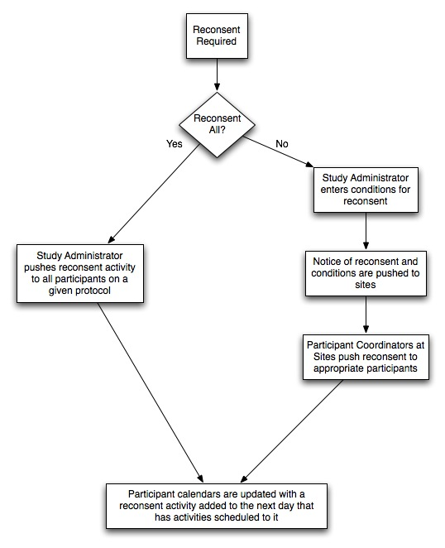

1. Overview – Real-world scheduling
A patient’s schedule is generated automatically by applying parts of the template to a start date. However, in the real world, the site may not be able to treat a patient on some of those days due to weekend schedules, holidays, etc… In order to reduce the amount of time that Participant Coordinators spend adjusting patient schedules, PSC will allow the Site Coordinator to define when the site will be open.

2. Details
A clinic may be closed because of the day of the week (e.g. closed on Sundays), an annually occurring event (e.g. closed December 25), a single occurrence (e.g. closed for instrument maintenance on June 13, 2007), or a relative recurring event (e.g. closed Thanksgiving, the fourth Thursday of November. The UI should allow entry of each of these types of events, allow the user to see all of the entries, and then the system should automatically adjust the schedules at creation. If a change is automatically applied, the history of the event should show this change.

Samples from the UI:

Day of Week:

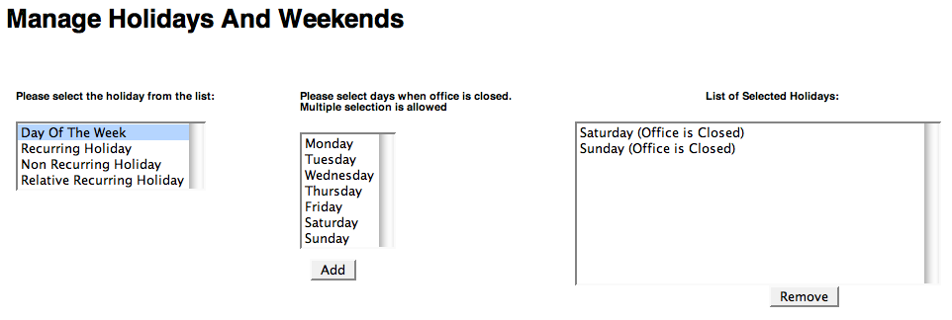

Recurring Holiday:
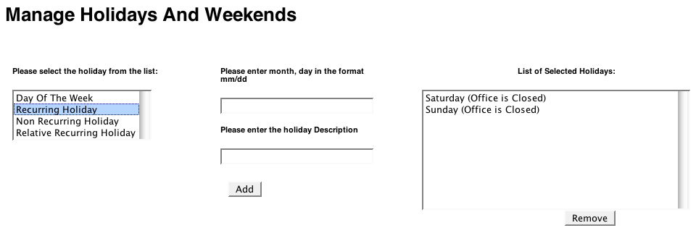
Non Recurring Holiday:
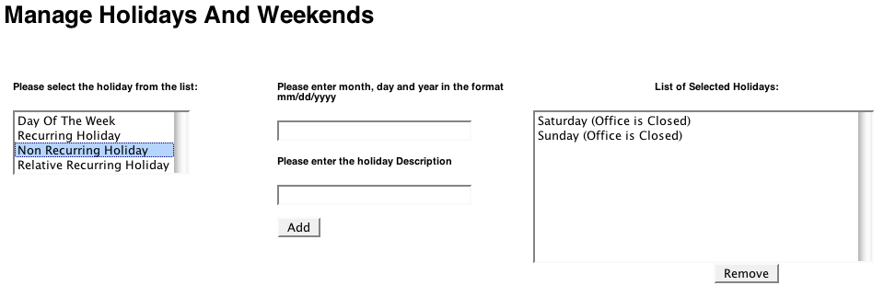

Relative Recurring Holiday:
