Technical Architecture Guide
V 1.1.2
CTMS Patient Study Calendar Module Phase II
Robert H. Lurie Comprehensive Cancer Center of Northwestern University

Document Change History
Version Number | Date | Contributor | Description
V 1.0 | 2007-07-1 | John Dzak | Added New Functionality
V 1.1 | 2007-8-16 | John Dzak | Updated Diagrams with new UML Diagrams
V 1.1.1 | 2007-9-13 | Sean Whitaker | Minor updates for Construction Release 1
V 1.1.2 | 2007-10-23 | Sean Whitaker | Address BAH feedback

Copyright and License page

LGPL or similar license TBD.

Patient Study Calendar Team
Development | Project Management
Rhett Sutphin¹ (lead) | Sean Whitaker¹
Ram Chilukuri²
Andrew Winter¹
Nataliya Shurupova¹
Anurag Kondapalli¹
John Dzak¹
- Northwestern University Robert H. Lurie Comprehensive Cancer Center
- SemanticBits
Table of Contents

1. Introduction to the Technical Architecture Guide 1
About Patient Study Calendar 1
Overview of the Guide 1
Organization of the Guide 1
Document Text Conventions 2
2. Overview of the Software 1
Software overview 1
System requirements 1
Required Software 1
Database Requirements 1
Design and architecture 2
3. Patient Study Calendar Requirements (Use Case View) 3
Trial protocols 5
Tracking participants 5
Usability 5
4. Patient Study Calendar Architecture 7
Overview 7
Architectural Layers (Logical View) 7
Domain 7
Business Logic 7
Data access 8
Presentation 9
Control 9
View 9
Dependency injection (Architectural Pattern) 9
Process View 11
11
Component View 12
Deployment View 12
5. Security 15
Roles 15
Authentication 15
Authorization 16
6. Patient Study Calendar APIs 17
7. Information Models 19
8. Customized Tools 21
Bering – Incremental database development 21
Technical Manuals/Articles 23

- Introduction to the Technical Architecture Guide

About Patient Study Calendar
The Patient Study Calendar of the Clinical Trials Management System is a system for modeling an approved clinical trial protocol and tracking trial participants’ progress through the protocol over a period of weeks, months, or years.
This chapter of the guide
Topics in this chapter include:
- Overview of the Guide
- Organization of the Guide

Overview of the Guide
This document covers the technical and design aspects of the implementation of the Patient Study Calendar application with an overview of the requirements for context. Not covered here, but available in other project documents are:
- Detailed requirements
- Use cases
- Domain UML model
- Installation
- Administration

Organization of the Guide

Chapter | Contents
Table 1. 1 Summary of the summary of the summary
Chapter 1 | Overview of this document
Chapter 2 | Technical overview of the Patient Study Calendar application
Chapter 3 | User-visible requirements overview; description of the domain
Chapter 4 | Technical design and architecture; libraries used and their purpose; code organization
Chapter 5 | Overview of security architecture
Chapter 6 | Explanation of why there are no programmatic APIs
Chapter 7 | UML and its role in Patient Study Calendar development
Chapter 8 | Bering (a custom tool for database-independent schema development)

Document Text Conventions
The following table shows various typefaces to differentiate between regular text and menu commands, keyboard keys, and text that you type. This illustrates how conventions are represented in this guide.
Convention | Description | Example
Bold & Capitalized Command  Capitalized command > Capitalized command | Indicates a Menu command  Indicates Sequential Menu commands | Admin > Refresh
text in small caps | Keyboard key that you press | Press enter
text in small caps + text in small caps | Keyboard keys that you press simultaneously | Press shift + ctrl and then release both.
Special typestyle | Used for filenames, directory names, commands, file listings, source code examples and anything that would appear in a Java program, such as methods, variables, and classes. | URL_definition ::= url_string
Boldface type | Options that you select in dialog boxes or drop-down menus. Buttons or icons that you click. | In the Open dialog box, select the file and click the Open button.
Italics | Used to reference other documents, sections, figures, and tables. | caCORE Software Development Kit 1.0 Programmer’s Guide
Italic boldface type | Text that you type | In the New Subset text box, enter Proprietary Proteins.
Note: | Highlights a concept of particular interest | Note: This concept is used throughout the installation manual.
Warning! | Highlights information of which you should be particularly aware. | Warning! Deleting an object will permanently delete it from the database.
{} | Curly brackets are used for replaceable items. | Replace {root directory} with its proper value such as c:\cabio
Table 1. 2 Document Conventions

2. Overview of the Software

Software overview
Patient Study Calendar is a Java web application based on the J2EE Servlets infrastructure. For details on the implementing libraries, see Chapter 4.

System requirements

Required Software
Software Name | Version | Description | URL
Java SE Development Kit | JDK 5.0 | The Java SE development kit with JRE, compilers and debuggers | http://java.sun.com/javase/downloads/index.jsp
Apache Tomcat | 5.5.17 or higher | Servlet container for JSP | http://tomcat.apache.org/download-55.cgi
Apache Ant | 1.6 or higher | Java-based build tool | http://ant.apache.org/bindownload.cgi
Table 1 Required software and technology

Database Requirements
The Patient Study Calendar requires access to a properly-configured database. The application is built with database-independence in mind and has been tested on the following:

Database Name | Version | Description | URL
PostgreSQL | 8 | PostgreSQL is a powerful, open source relational database system. | http://www.postgresql.org/download/
Oracle | 9i | Industry-leading, commercial database product. | http://www.oracle.com/technology/software/products/oracle9i/index.html

For more details, please see the Installation Guide.

Design and architecture
Patient Study Calendar follows the widely-accepted Model-View-Controller (MVC) structure for object-oriented software. It is built in layers, with most communication occurring between adjacent layers only, and communication consisting of passed domain instances or other model objects. For more detail, see Chapter 4.
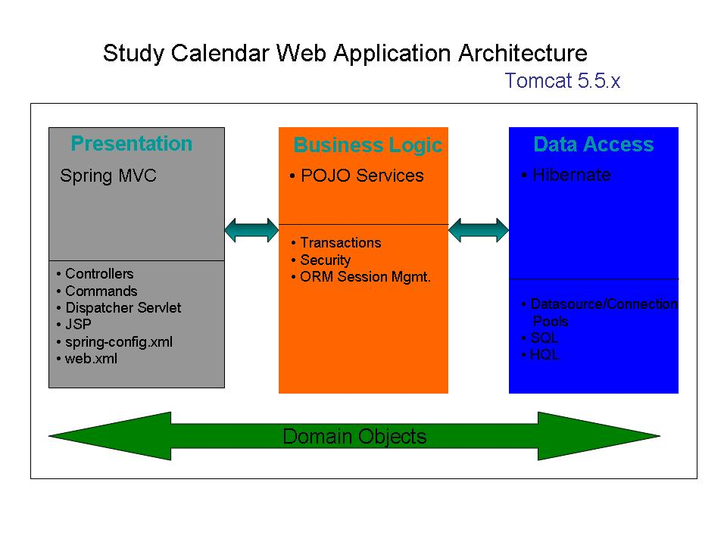

3. Patient Study Calendar Requirements (Use Case View)
This is a brief overview. For more information, please see the Software Requirement Specifications Document: http://gforge.nci.nih.gov/plugins/scmcvs/cvsweb.php/studycalendar/Final/PSC_SRS.doc?cvsroot=studycalendar

The diagram below illustrates the high-level use case model for the Patient Study Calendar Phases I and II:

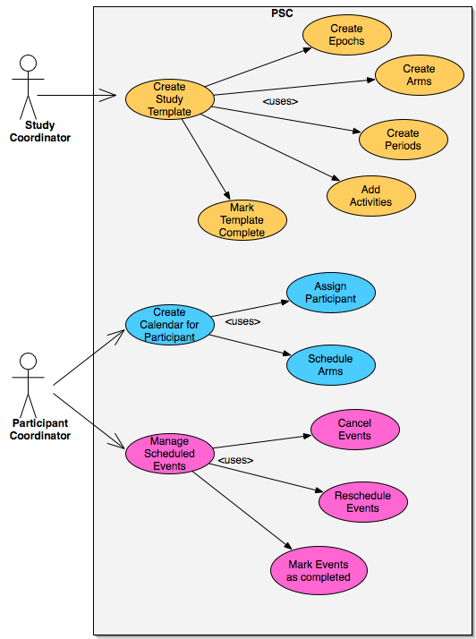

Trial Protocols
As modeled in the Patient Study Calendar, a clinical trial protocol is a schedule of procedures, treatments, and examinations (collectively called activities) that a participant is expected to undergo over the course of the trial. The schedule is broken down into large-scale segments (epochs).
An epoch may have more than one possible course of activities – these courses are called arms – of which a participant will usually only follow one.
Each arm contains one or more periods.
A period is a set of consecutive days, beginning at a certain day in the arm and possibly repeating.
Activities are assigned to days within the period, creating planned events. An activity may be scheduled to happen more than once on a given day in a period, but there is no requirement to schedule at a finer time scale than one day.

Tracking Participants
Once the full protocol is modeled in the application and finalized, participants may be assigned to it. Assigning a participant involves giving him a start date and selecting which arm he’ll be on for the first epoch. This allows the system to create the first set of scheduled events, which are planned events with a date and participant attached.
As the participant proceeds through the protocol, a participant coordinator or research associate will mark the scheduled events he’s completed and/or canceled. At the end of each epoch, the user will be prompted to select the arm for the participant for the next epoch. At any time, the user may manually shift the participant to a different epoch or a different arm within the same epoch.

Usability
The model for a schedule is very complex, with four levels of nested objects and the possibility of repeats and parallel paths. For this reason, it is important to display the protocol in a clear, comprehensible, and familiar manner, and to allow it to be edited simply and directly.

4. Patient Study Calendar Architecture

Overview
Patient Study Calendar is a standard, modern, non-EJB java web application with a well defined set of public API’s. The architecture of the Patient Study Calendar is described below using the 4 +1 view paradigm.

Architectural Layers (Logical View)
It has 4 fundamental layers – domain, data access, business logic, and presentation – and several ancillary packages, all glued together using dependency injection.

Domain
Patient Study Calendar’s domain objects are implemented as plain java beans. They are contained in the “edu.northwestern.bioinformatics.studycalendar.domain” java package. The domain model is documented in a UML class diagram, which can be accessed at:
The implementation model is based on a domain analysis model which has been harmonized with the BRIDG model.
They domain objects in the implementation model are mapped to tables in the database (commonly referred to as Object Relational Mapping) using Hibernate Annotations. For more information on Hibernate, please see: http://hibernate.org/5.html
The following graphic enumerates the domain objects of the Patient Study Calendar:
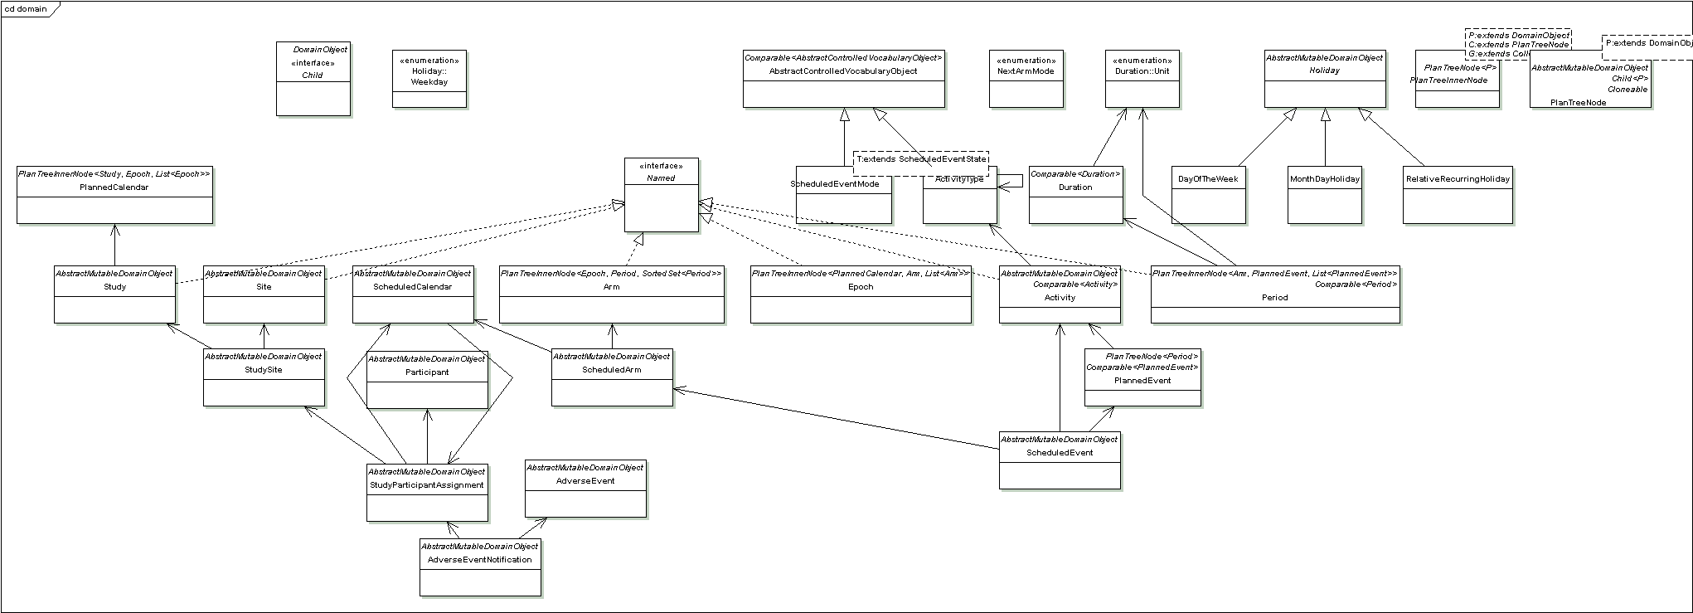

Business Logic
Business logic based on a single domain object (commonly referred to as domain logic) and its attributes is implemented within the domain object itself, following good object-oriented design principles. For example, an Epoch has no intrinsic length attribute, but it can calculate its own maximum length by examining its Arms.
Business logic involving multiple domain objects is implemented externally, generally in the business service tier. For example, adding a participant to a study involves reads, updates, and inserts spanning more than 10 different domain objects. It is therefore implemented in a service class (ParticipantService).
Following graphic enumerates all the classes in the business logic layer:
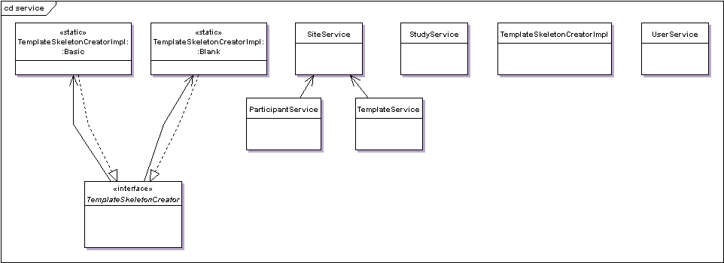

Data access
The data access layer in the Patient Study Calendar is implemented using the Data Access Object (DAO) J2EE design pattern. The domain objects are created, updated and queried exclusively via DAOs. A DAO essentially encapsulates the logic necessary to create, retrieve update, and delete a domain object from the database. Implementation of DAO pattern promotes database portability. The DAOs in the Patient Study Calendar are based on the Spring Framework’s Hibernate abstraction layer. Use of this abstraction layer greatly simplifies the data access by eliminating the need to write low level and repetitive plumbing code using the API provided by Hibernate framework.
The DAOs in the Patient Study Calendar are contained in the “edu.northwestern.bioinformatics.studycalendar.dao” java package. The graphic below enumerates all the DAO classes in the Patient Study Calendar.
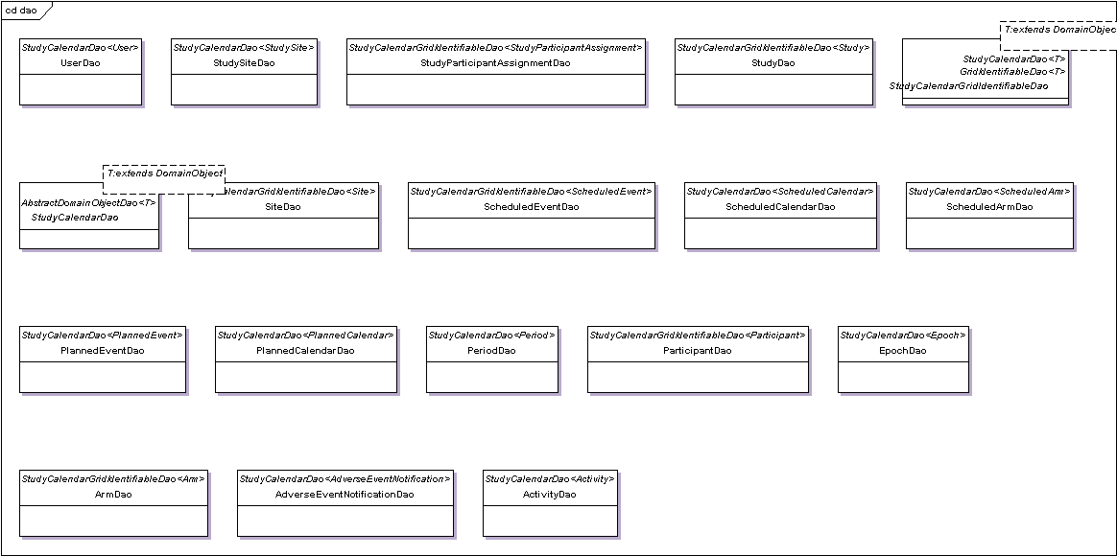

Presentation
The presentation layer can further be sub divided into control and view layers, which are described below.

Control
The control layer is made up of two closely-collaborating types of classes: commands and controllers. Commands encapsulate the data and behavior associated with a user operation, generally including one or more domain objects. Controllers handle mapping incoming requests onto command instances and providing the command output back to the view layer.
Patient Study Calendar uses Spring MVC (which is itself based on Servlets) to dispatch web requests to the appropriate controllers.

View
The view layer uses JSP 2.0 and takes full advantage of tag libraries, both provided by Spring and custom developed, to reduce boilerplate code.
Design templating is handled using SiteMesh, which takes the full HTML pages generated from the JSPs and decorates it with the common site elements.

Dependency injection (Architectural Pattern)
The objects in different layers are connected or wired together using an architectural pattern called dependency injection/inversion of control. This means that, instead of a DAO object acquiring a data source from JNDI, or a controller finding a DAO using some sort of service locator, each object declares the objects (commonly referred to as collaborators) it depends on based on its own requirements. All the collaborators are instantiated by an external configuration tool; all their dependencies are satisfied by that tool when they are created.
Inter-layer dependencies are oriented such that higher levels depend on lower levels, but never vice versa. For instance, a service may depend on a DAO, but a DAO will never depend on a service.
Patient Study Calendar uses the Spring Framework (version 2.0), specifically Spring IOC container for dependency injection, with the dependencies declared in a series of XML files included alongside the deployed classes. For more information about the Spring Framework, please see http://www.springframework.org/documentation.

The following diagram illustrates the wiring of various objects that belong to different layers in the Patient Study Calendar:

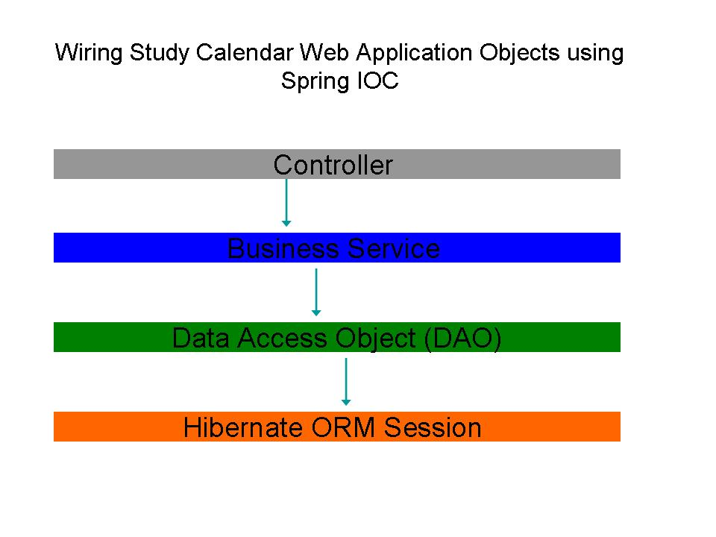

Process View
The figure below is a generic sequence diagram illustrating the interaction between the Patient Study Calendar classes and some of the key classes of the Spring MVC framework during the processing of a user request for a web page.
All HTTP requests in the Spring MVC go thru the DipatcherServlet, which serves as a front controller. It uses a HandlerMapping object to figure out the Controller class that should be used to handle the request. The mapping between the URL and the controller class is configured in the spring-servlet.xml file. The DispatcherServlet also retrieves all the interceptors that are configured for the controller before delegating the request to the controller class. In the case of the Patient Study Calendar, two interceptors are used; LoginCheckInterceptor to check if the user is logged in and has a valid active session and URLAccessCheckInterceptor to verify if the logged in user is authorized to access the page that he/she is requesting. If the login check fails, the user is redirected to the login page and if the user does not have privileges to access a page then the access denied page is displayed. The URLAccessCheckInterceptor uses the CSM API for establishing the access rights of the logged in user.
After the request passes the checks, the DispatcherServlet creates a command object that encapsulates the HTML form elements and delegates the processing of the request to a controller object by passing the command object to it. The controller object uses the command object, appropriate Patient Study Calendar service and DAO objects to process the request and returns a ModelAndView object, which contains the model and the view to be rendered. The Dispatcher uses the model information to render the view.

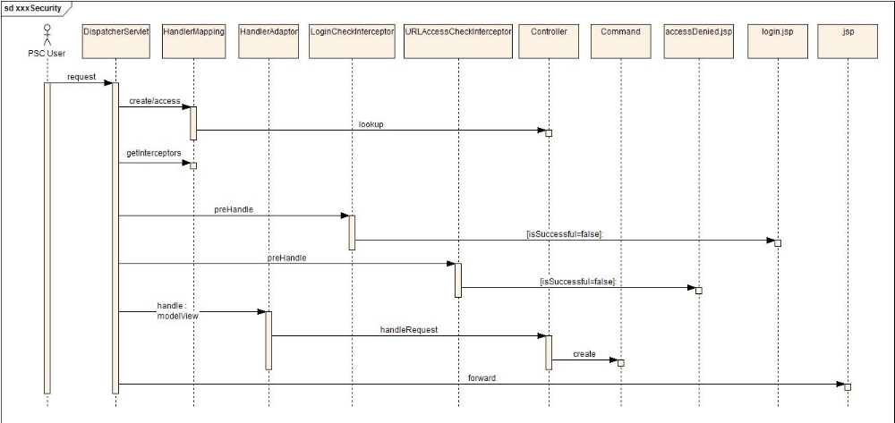

Component View
The following UML diagram illustrates the component view of the Patient Study Calendar system.

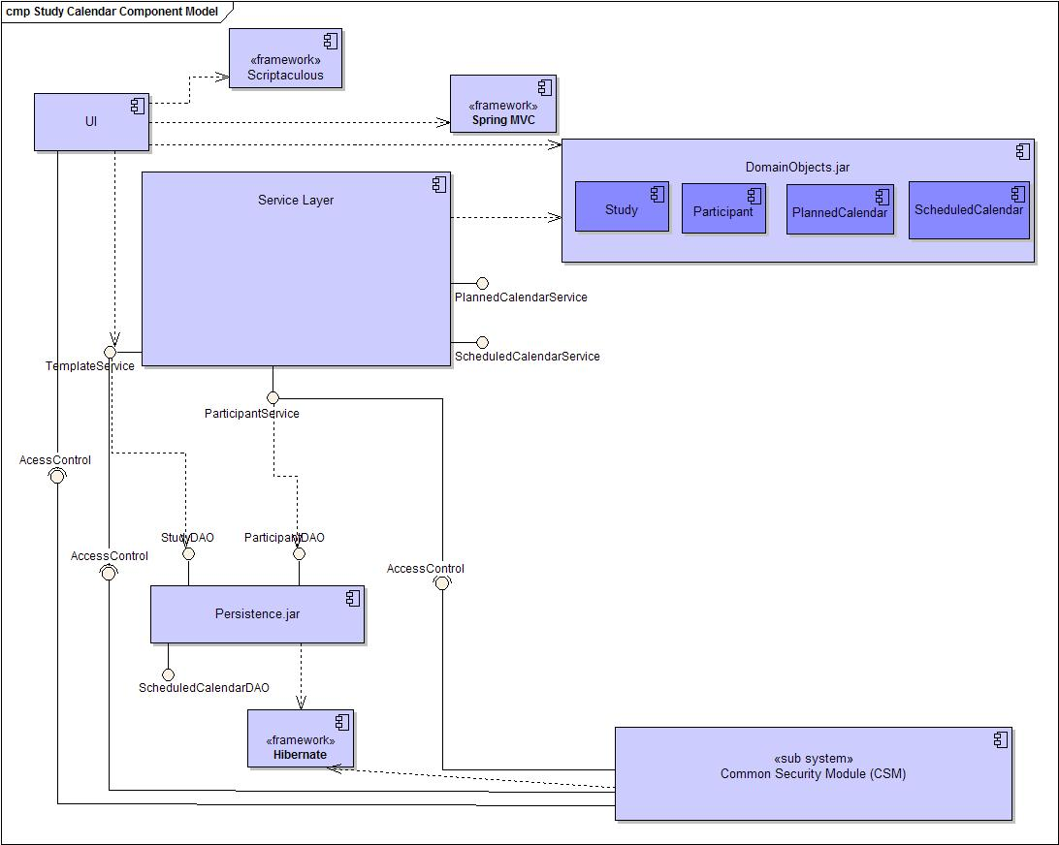

Deployment View
The following UML diagram illustrates the deployment view for the Patient Study Calendar system.

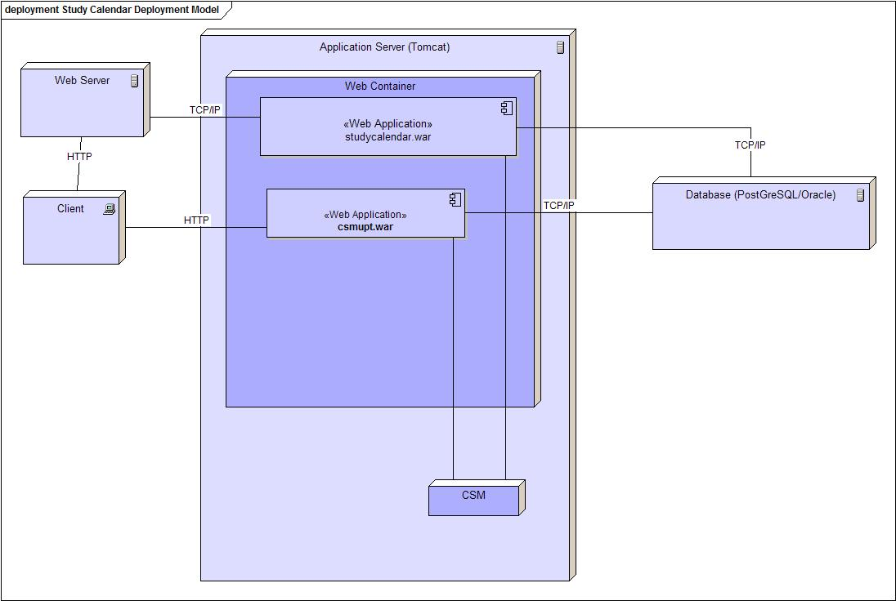

5. Security

Roles
Patient Study Calendar users are assigned one or more roles. These roles are based on the roles described in our Use Case documents.
Study Administrator | - Reviews completed Study Templates to determine if they are complete and correct  - Enters new sites into the system  - Determines which studies will be deployed at each site  - Determines which Site Coordinators will be able to manage Study Templates for each site  - Schedule patient re-consents  - Manages user access to the application  - Approves and manages user registration process  - Grants users to a role within the application  - Create holiday schedule
Study Coordinator | - Creates new Study Templates  - Marks Templates as being ready for review by Study Administrator
Site Coordinator | - Determines which Participant Coordinators belong to the site  - Determines which studies will be usable for each Participant Coordinator at the site  - Schedule patient re-consents
Participant Coordinator | - Assigns Participants to Studies for which approval has been granted  - Generates Calendars for each Participant
Research Associate | - Views Calendars and Reports

Authentication
The username and password are authenticated using CSM from credentials stored in the application database. For more information on CSM, please see: http://ncicb.nci.nih.gov/infrastructure/cacore_overview/csm.

Authorization
Patient Study Calendar uses role-based authorization of two types. First is access to URLs – roles are assigned access permissions to the pages they need to function. Second is attribute-based – some pages mutate based on the roles granted to the logged-in user. Certain links or forms will only appear if a user has a role that grants him or her access to the target page.
Patient Study Calendar also uses user-based authorization for specific resources. For example, it is possible to limit access of an individual template to specific users.

6. Patient Study Calendar APIs
Javadoc is provided for the domain classes as an informational alternative to the published UML models and to document the public dynamic API. Please see: http://gforge.nci.nih.gov/plugins/scmcvs/cvsweb.php/studycalendar/Final/PSC_API.tar.bz2?cvsroot=studycalendar

Public API:
Interface PlannedCalendarService
registerStudy
PlannedCalendar registerStudy(Study study)
Notify the PSC about the given study. The PSC will create a default template for it. The study must include all site associations.
If the study has previously been registered, the existing template will be returned. If a study is re-registered with different site associations, any new site associations will be added. Attempting to re-register with missing site associations is an error.
Parameters:
study –
Returns:
the newly created default template for the study.

getPlannedCalendar
PlannedCalendar getPlannedCalendar(Study study)
Retrieve the calendar template for the given study.
Parameters:
study - The study for which to return the calendar. For purposes of matching, implementations are only required to consider the study's grid ID.
Returns:
The full calendar template as it currently exists in the system.

Interface ScheduledCalendarService

assignParticipant
ScheduledCalendar assignParticipant(Study study,
Participant participant,
Site site,
Arm firstArm,
Date startDate)
Assign a participant to the given study from the given site.
Parameters:
study - The study to which the participant will be assigned. PSC must already know about it.
participant - If the participant is unknown, it will be automatically registered.
site - The site from which the participant is being assigned. The PSC must already know about it and its association with the study.
firstArm - The arm of the template to which the participant should be initially assigned
startDate -
Returns:
the newly created schedule

getScheduledCalendar
ScheduledCalendar getScheduledCalendar(Study study,
Participant participant,
Site site)

Retrieve the full schedule for a participant on a study at a site. Implementations may consider only the grid IDs for the parameters.
Parameters:
study -
participant -
site -
Returns:
The full schedule, with all scheduled arms and scheduled events, as it currently exists.

getScheduledEvents
Collection<ScheduledEvent> getScheduledEvents(Study study,
Participant participant,
Site site,
Date startDate,
Date endDate)
Return the events that exist for a schedule in the given date range. The date range is matched by the actual date for events in the scheduled and occurred states, and the ideal date for events in the canceled state.
Parameters:
study -
participant -
site -
startDate - The beginning of the range of dates to include. If null, there is no early limit.
endDate - The end of the range of dates to include. If null, there is no late limit.

changeEventState
ScheduledEvent changeEventState(ScheduledEvent event,
ScheduledEventState newState)
Change the state of the given event to the given new state. For matching, implementations may consider only the grid ID of the event.
Parameters:
event -
newState -
Returns:
The same event, updated into the new state

scheduleNextArm
void scheduleNextArm(Study study,
Participant participant,
Site site,
Arm nextArm,
NextArmMode mode,
Date startDate)
Indicate the next arm for the participant's schedule.
Parameters:
study -
participant -
site -
nextArm -
mode -
startDate -

7. Information Models
Patient Study Calendar follows a code-driven modeling approach, whereby UML is used for communication among developers, documentation for the domain, and a guide for future harmonization, but is not used directly to generate software.

For additional models, please see: http://gforge.nci.nih.gov/plugins/scmcvs/cvsweb.php/studycalendar/PhaseII/Elaboration/?cvsroot=studycalendar

8. Customized Tools

Bering – Incremental database development
In support of Patient Study Calendar development we have developed a tool called Bering. It enables database-independent incremental schema development in a manner similar to ActiveRecord migrations in Ruby on Rails.
The basic idea is this: say developer Alice needs to change the structure or content of the database (e.g., to add a column to a table or change the values in a lookup table). She writes a Bering migration script encapsulating that modification and commits it alongside whatever code makes use of the revised database. After developer Bob updates his local working copy and receives Alice’s new code, he can execute Bering as part of his rebuild process. Bering discovers that there is a new script which hasn’t been applied to Bob’s development database and updates it automatically.
Using database migration scripts is superior to a single project schema SQL file because it makes it easy for each developer to maintain his or her own development/test database(s) – and since each developer doesn’t have to spend time tracking down and manually applying schema changes after each update, there is more time to do useful work. And since the process is automatic, it can be used (in conjunction with a unit test suite) by a continuous integration server to verify that the schema changes don’t break existing functionality.
The migration scripts can also be used when the application is deployed in production and a new version becomes available. Since the scripts are incremental, they can update a database with existing data as easily as a development database (where you don’t care about the contents). And since Bering keeps track of which scripts have been applied to the database, no developer time has to be spent writing special upgrade scripts for end users.
Bering has been developed in parallel with Patient Study Calendar and should be suitable for use in other projects. Its source is available from https://svn.bioinformatics.northwestern.edu/bering/trunk and includes an Ant task and some examples of use.
- References

Technical Manuals/Articles
- National Cancer Institute. "caCORE 2.0 Technical Guide", ftp://ftp1.nci.nih.gov/pub/cacore/caCORE2.0_Tech_Guide.pdf
- Java Bean Specification: http://java.sun.com/products/javabeans/docs/spec.html
- Foundations of Object-Relational Mapping: http://www.chimu.com/publications/objectRelational/
- Object-Relational Mapping articles and products: http://www.service-architecture.com/object-relational-mapping/
- Hibernate Reference Documentation: http://www.hibernate.org/hib_docs/reference/en/html/
- Basic O/R Mapping: http://www.hibernate.org/hib_docs/reference/en/html/mapping.html
- Java Programming: http://java.sun.com/learning/new2java/index.html
- Javadoc tool: http://java.sun.com/j2se/javadoc/
- JUnit: http://junit.sourceforge.net/
- Extensible Markup Language: http://www.w3.org/TR/REC-xml/
- XML Metadata Interchange: http://www.omg.org/technology/documents/formal/xmi.htm

- Glossary
.
Term | Definition
API | Application Programming Interface
caBIG | cancer Biomedical Informatics Grid
CSM | Common Security Module
DAO | Data Access Objects
HTTP | Hypertext Transfer Protocol
JAR | Java Archive
Javadoc | Tool for generating API documentation in HTML format from doc comments in source code (http://java.sun.com/j2se/javadoc/)
JDBC | Java Database Connectivity
JSP | JavaServer Pages
JUnit | A simple framework to write repeatable tests (http://junit.sourceforge.net/)
MVC | Refers to the separation of Model, View, and Controller
POJO | Plain Old Java Object
ORM | Object Relational Mapping
RDBMS | Relational Database Management System
SDK | Software Development Kit
SQL | Structured Query Language
UML | Unified Modeling Language
UPT | User Provisioning Tool
URL | Uniform Resource Locators
WAR | Web Application Archive
XMI | XML Metadata Interchange (http://www.omg.org/technology/documents/formal/xmi.htm) - The main purpose of XMI is to enable easy interchange of metadata between modeling tools (based on the OMG-UML) and metadata repositories (OMG-MOF) in distributed heterogeneous environments
XML | Extensible Markup Language (http://www.w3.org/TR/REC-xml/) - XML is a subset of Standard Generalized Markup Language (SGML). Its goal is to enable generic SGML to be served, received, and processed on the Web in the way that is now possible with HTML. XML has been designed for ease of implementation and for interoperability with both SGML and HTML

