Administration Guide
V 2.0

CTMS Patient Study Calendar Module
Robert H. Lurie Comprehensive Cancer Center of Northwestern University

Document Change History
Version Number | Date | Contributor | Description
V1.0 | 2006-09-18 | Padmaja Vedula | Initial revision
V1.1 | 2006-11-02 | Cal Collins | Incorporate feedback and comments from training workspace
V1.2 | 2006-12-12 | Sean Whitaker | Formatting and slight revisions
V1.3 | 2007-09-11 | Nataliya Shurupova | Revised for Phase II (removal of UPT)
V1.3.1 | 2007-10-23 | Sean Whitaker | Address BAH comments
V 1.4 | 2007-10-26 | Nataliya Shurupova | Revised for Phase II
V 2.0 | 2008-7-2 | Sean Whitaker | Updated for Phase III, R 2.1

Table of Contents

1 Introduction to the Administration Guide 3
2 Overview of the Software 3
3 Patient Study Calendar Roles Overview 3
4 Initial Launch of PSC 4
4.1 System Administrator account 4
4.2 Default site 4
5 Administration Tab 4
5.1 Manage sites 5
5.2 Manage users 5
5.3 Configure PSC 6
5.4 Configure authentication 7
6 Application Security 7
7 System Operation 7
7.1 Startup 7
7.2 Termination 7
7.3 Backup and Restore Strategy 7
7.3.1 Backup 7
7.3.1.1.1 System Configuration Settings 7
7.3.1.1.2 Application Data 8
7.3.2 Restore 8
7.3.2.1.1 System Configuration Settings 8
7.3.2.1.2 Application Data 8
8 Appendix A. Abbreviations and Acronyms 9

Introduction to the Administration Guide
This administration guide outlines the Patient Study Calendar user management, application configuration and secure access configuration. It includes an overview of security implementation for the Patient Study Calendar.

Overview of the Software
The caBIG CTMS Patient Study Calendar Module is an open source, standards-compliant software application that can be used by organizations that manage patients on cancer clinical trials. The caBIG CTMS Study Calendar Module supports the application of a study template to study participants and enables the prospective forecasting of visit information and provide a framework for reviewing historical study calendar events. The caBIG CTMS Study Calendar supports studies that include therapeutic, observational, correlative, ancillary, and biobanking aspects. The standalone Study Calendar module integrates with the components necessary to create study calendar templates (protocol authoring), can instantiate a template for a study participant and represent study events for that participant. These study events are uniquely identified at a study participant and event level, enabling the stable linking to external systems such as patient scheduling systems, laboratory interfaces, adverse event reporting modules, case report forms, and other event-based data that are specified by a study.
The study calendar can serve as an event-centric hub for linking these data, but the study calendar module itself does not model or extend into these domains.
Functionally, the Study Calendar includes features to support patient screening and registration, adaptable schedule definitions and a comprehensive security model that is suitable for multi-site protocols,

Patient Study Calendar Roles Overview
The Patient Study Calendar interface for administering users and roles is handled within the application itself rather than using the NCICB’s Common Security Module (CSM) for user authentication and authorization User Provisioning Tool (UPT).

The security for Patient Study Calendar has been implemented using role-based access. Each role defines a set of tasks within PSC that a user of that role can perform.

The following roles are pre-defined in the PSC distribution:

System Administrator  (SysAd) | - Creates user accounts  - Grants users to role(s) and site(s) within the application  - Configures the application
Study Administrator  (SA) | - Reviews completed study templates and approves them  - Imports and exports study templates  - Makes studies available to each site
Study Coordinator  (SC) | - Creates new study templates  - Marks templates as being ready for review by Study Administrator
Site Coordinator  (SiC) | - Determines which study templates are accessible by each Subject Coordinator  - Reassigns subject calendars to appropriate Subject Coordinator
Subject Coordinator  (SubC) | - Assigns subjects to studies  - Generates and manages calendars for subjects
Figure 1 User roles

Initial Launch of PSC
After a successful installation, PSC will prompt you to create an initial System Administrator account and a default site.

System Administrator account

You will first be prompted to enter a username and password for the initial System Administrator account. Use this account to login to PSC to configure the system and create additional users.

Default site
You will next be prompted to create the first site within PSC. If no other sites are created, this site will serve as the default site through which all access to templates will be assigned (by a Study Administrator). If more than one site will be using PSC, add the appropriate sites after the initial launch of PSC.

Administration Tab

Login to PSC as a System Administrator and locate the tab labeled “Administration.” Click on this tab to view the list of available administrative options.

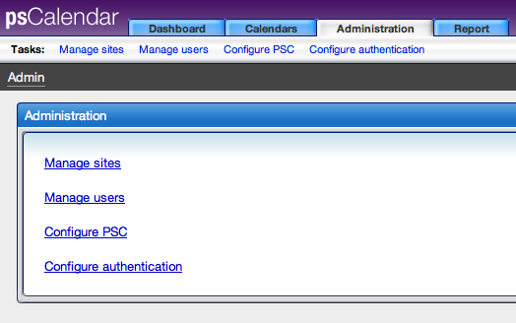
Figure 2 Administration tab

Manage sites

Click “Manage sites” in order to see a list of existing sites and to access the option to create a new site. To create a new site, click “Create new site,” enter a name for the site, and click “Create.”

Each site has its own list of days on which it does not provide services. If you wish to modify this list (it is initially empty), click the “Manage holidays and weekends” link next to the appropriate site.

Manage users

Click “Manage users” in order to see a list of existing users, make changes to existing user accounts, and add new user accounts.

Add new user account
After clicking “Manage users,” click “Create user.” Enter the appropriate information, including the role and site information. Note that Study Coordinators, Study Administrators, and System Administrators are not site specific, but Subject Coordinators and Site Coordinators are. This means that the Subject Coordinator and Site Coordinator roles must be check for each site in which the user will work. The example below shows an account that is a Study Coordinator and a Subject Coordinator at two sites:

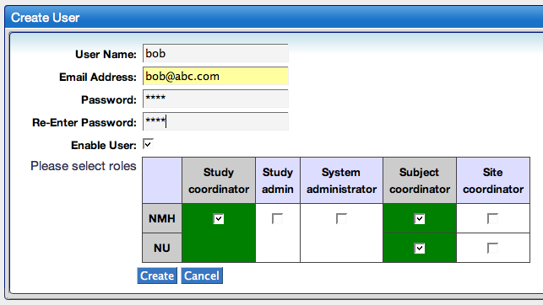
Figure 3 Creating a user

Modify existing user account
To modify a user account, click “Manage users” and then select the desired account from the list. Any of the user account attributes may be modified and saved.

Disable account
After selecting the account from the list, uncheck the “Enable User” box.

Configure PSC

Click the “Configure PSC” link on the “Administration” tab to set most application configuration options. These include debugging information, automatic email notifications of application errors, etc… All options are described on the configuration page.

Configure authentication
Click “Configure authentication” from the “Administration” tab in order to choose between four authentication options. The default is “local,” meaning that user accounts and passwords are stored locally. The other options are CAS, caGrid WebSSO (for use with CCTS), and custom.

Application Security
Patient Study Calendar should be run on a secure network infrastructure using 128-bit SSL encryption. Use of a firewall to limit outside access to the system in accordance with institutional policies is also highly recommended.

System Operation
Operation of the Patient Study Calendar system depends on two main layers of application infrastructure: A data persistence backend (a relational database - either PostgreSQL or Oracle) and an application server (Apache Tomcat). Please see the Patient Study Calendar Install and Technical Architecture Guides for more information on system requirements and components.

Startup
To start the Patient Study Calendar application, ensure the database server is running and start Tomcat. The Patient Study Calendar will then be started.

Termination
To stop the Patient Study Calendar application, stop Tomcat

Backup and Restore Strategy
System backups should be conducted on a regular basis in order to ensure continuity in the event of a crash or corruption of the system.
    - Backup

System Configuration Settings
The file studycalendar.properties in the db folder of the source code should be backed up to a secure location according to local IT administration policies.

Application Data
It is recommended that system data backups should be conducted on a regular basis according to local organization policies. There are multiple ways to conduct database backups on both Oracle and Postgres and the appropriate approach should be determined based on the size of the Patient Study Calendar database, system availability requirements, and local database and IT administration policies.
The database can be identified by looking at the database connection parameters in the studycalendar.properties in the db folder. The default name for the Patient Study Calendar database is ‘study_calendar’, but this may have been changed during installation. All data and tables in this database should be backed up.
Below basic backup methods for both Oracle and Postgres are provided as examples:

Oracle Database Backup and Recovery Operations
Please see ‘Oracle Backup & Recovery ’ at http://www.oracle.com/technology/deploy/availability/htdocs/BR_Overview.htm

Postgres Database Backup and Recovery Operations
Please see Postgres 8.1.5 Manual ‘Chapter 23. Backup and Restore’ at
http://www.postgresql.org/docs/8.1/static/backup.html
.
    - Restore

In the event of a crash or corruption of the system, recovery allows continuity by rebuilding the application to a recent ‘good’ state using system backups.

System Configuration Settings
To restore system configuration after a serious problem, copy the file studycalendar.properties from the backup location into the db folder of the source code and rebuild the application according to the instructions found in the Installation Guide:
http://gforge.nci.nih.gov/plugins/scmcvs/cvsweb.php/studycalendar/Final/PSC_Final_Install_Guide.doc?cvsroot=studycalendar

Application Data
The procedure for restoring the database from a backup is dependent on the chosen backup methodology. Please consult documentation for the chosen backup strategy

References:

Oracle Backup & Recovery
http://www.oracle.com/technology/deploy/availability/htdocs/BR_Overview.htm

Postgres 8.1.5 Manual ‘Chapter 23. Backup and Restore’ http://www.postgresql.org/docs/8.1/static/backup.html
http://www.postgresql.org/docs/8.1/static/backup.html#BACKUP-DUMP-RESTORE

Appendix A. Abbreviations and Acronyms

Term | Definition
CSM | Common Security Module
NCICB | The National Cancer Institute’s Center for Bioinformatics
UPT | User Provisioning Tool – Interface for user account and role management of the NCICB’s CSM tool

