Conditional Events
Technical Specification

Technical Specification

Version History
Version | Date Modified | Author
Elaboration Iteration -2 | 07/30/2007 | Nataliya Shurupova
Elaboration Iteration -2 | 09/11/2007 | Nataliya Shurupova
BAH revisions | 10/24/2007 | Sean Whitaker

Contacts and Support
Nataliya Shurupova | n-shurupova@northwestern.edu

LISTSERV Facilities Pertinent to software teams
LISTSERV | URL | Name
Table of Contents
1 Scope and Purpose 4
2 Overview 4
2.1 Features 4
2.2 Assumptions 8
3 Design Approach 8
3.1 Domain Objects 8
3.2 Persistence Layer 8
3.3 Service Layer 9
3.4 Controller Layer 9
3.5 View Layer 9
4 Implementation 9
4.1 Domain Model 9
4.2 Sequence Diagram 9
4.3 Activity Diagram 9
5 Testing 10
5.1 Domain Layer 10
5.2 Persistence Layer 10
5.3 Service Layer 10
5.4 Web Layer 10

List of Figures
Figure 1 4
Figure 2 5
Figure 3 5
Figure 4 6
Figure 5 7
Figure 6 7
Figure 7 8
Figure 8 9

Scope and Purpose

Allow creation of a conditional activity that will become a scheduled activity for a particular participant only if the specified condition is met.

Overview

Some events or activities have to be scheduled only if a certain condition(s) has been achieved. The Site Coordinator (SC) will be able to define these conditional events as part of the template so that a Participant Coordinator (PC) can later schedule them, if appropriate.

Features

PSC provides a mechanism for helping SC’s to manage conditional events. If some activity is to be defined as conditional within a template for a study, SC will have to check a checkbox and add the condition (conditional details) as free text to identify under what circumstances the associated event must be scheduled (Figure1).

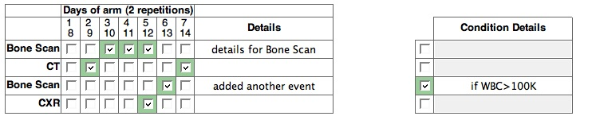
Figure 1. Event’s overview for scheduled and conditional state

If event is conditional and the associated conditions (details) are different for the Day3 Scan and the Day5 Scan, those two events will be represented as two different activities.
If the condition is complex (WBC >100K and Hb<10.5 and female and age>18), all these conditions will be captured in one “conditional details”.

Within a period conditional events will have an identifier with provided details. The period displays conditional events as following (Figure 2):

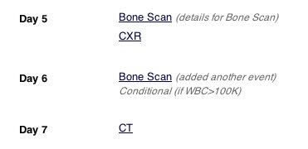

Figure 2. Identification of the conditional events on a period level.

The additional states are added for the conditional events: Conditional and NA. The state diagram is shown on Figure 3. If the state of a planned event was Conditional before it became scheduled, the available states that the event can be changed to will be NA, Conditional, Occurred, and Canceled. Once in one of these states, the state of the event can be changed to the state that is shown below. If the state of the planned event wasn’t Conditional, the only states the scheduled event can be changed to will be Occurred and Canceled (the old behavior).

Only for Conditional Events
Occurred
Canceled
Scheduled
NA
Conditional

Figure 3. The State Diagram describing the available states for the scheduled events.

If the conditional activity has to be a non-conditional, the conditional checkmark should be unchecked. The change will be automatically applied to all the events in this activity.
Once the template is finalized, we can assign the participant to the study and the scheduled events will be in the conditional state (Figure 4).

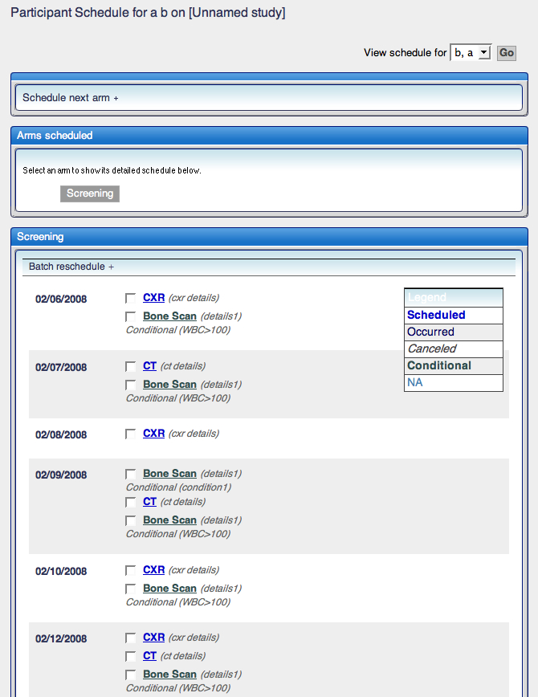

Figure 4. Assigning the participant to the study with conditional events. The Legend shows two additional new states that are added for the conditional events – Conditional and NA.

Figure 5 shows various scenarios for changing the scheduled (conditional) event. For the display purpose, the event is going to be changed to Scheduled state.

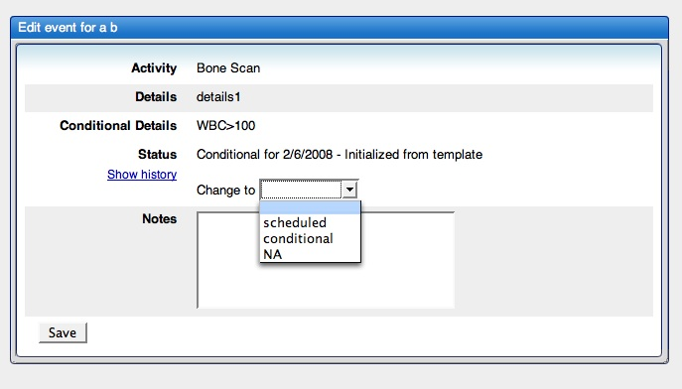

Figure 5. Available states for the scheduled event, which is conditional. Conditional

Details are specified and the Status indicates the current state the event is in.

Figure 6 below shows the change to the conditional event Bone Scan scheduled for 02/06/2008. According to the legend table, the font is changed, although the conditional details are still displayed:

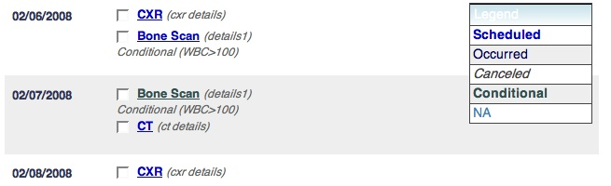

Figure 6. Changes made to the Bone Scan event’s state from conditional to scheduled.

If the same event selected again, the following states are available (Figure 7):

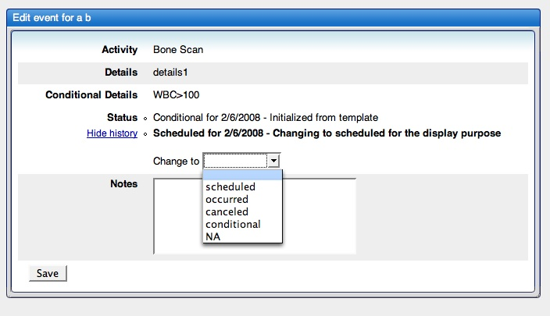

Figure 7. Displays the changes to the scheduled event that is conditional. The History captures the changes made to the initial state, and additional states are available for the event.

Assumptions

No assumptions present for this feature.

Design Approach

Domain Objects
Affected portion of the model for this particular implementation is PlannedEvents. The planned_event’s database table was changed to have new additional column for holding the condition. The existence of the condition distinguishes the event (if it’s conditional or not). Also, the condition is displayed on the period page.

Persistence Layer

No persistence layer is added/modified for this feature

Service Layer

No service layer was added/modified for this feature

Controller Layer

No controller layer was added/modified for this feature

View Layer

See Figures # 1, 2, 4, 5.

Implementation

Domain Model

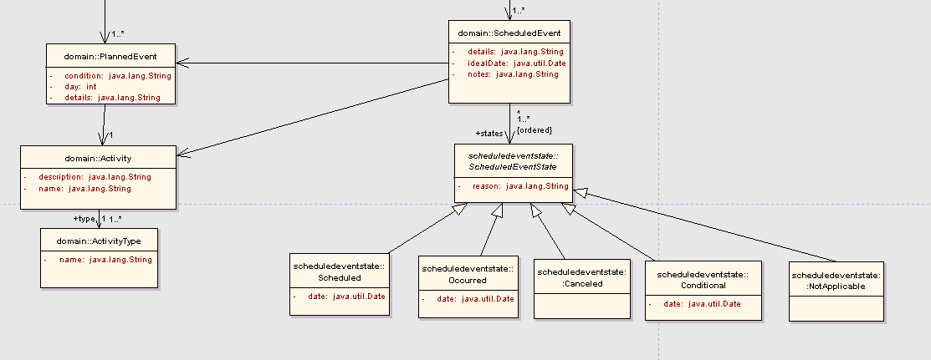

Figure 8. Domain model overview of the conditional feature. Additional attribute (condition) is added to the PlannedEvent, along with additional states for the conditional events that are scheduled (Conditional and NotApplicable)

Sequence Diagram

No sequence diagram present for this feature

Activity Diagram

No activity diagram needed for this feature.

Testing

Domain Layer

Test Class Name | Target
ManagePeriodEventsCommandTest | Adding and removing events.  Modifying the event details as well as  conditional details.  Adding conditional details without checking the dates.  Adding events with same conditional details but with  different dates.
ManagePeriodEventsControllerTest | Testing requests and responses coming from the page.

Persistence Layer

No persistence layer added for this feature.

Service Layer

No services added for this feature.

Web Layer

Web layer is not affected by this feature

