Patient Study Calendar End User Guide

Patient Study Calendar Phase III

Robert H. Lurie Comprehensive Cancer Center

Document Change History
Version Number | Date | Contributor | Description
V1.0 | 1/9/2008 | Sean Whitaker | First submission
V1.1 | 1/30/2008 | Sean Whitaker | Add login-logout, glossary
V1.2 | 2/01/2008 | Lara Fournier (D&T WS) | Convert to caBIG End User Guide template
V 1.3 | 2/8/2008 | Sean Whitaker | Address D&T comments, add diagrams and index
V 1.4 | 3/11/2008 | Sean Whitaker | Edits from John Speakman and Ann Setser
V 1.4.1 | 4/7/2008 | Sean Whitaker | Update TOC and fix format errors
V 1.5 | 10/10/2008 | Sean Whitaker | Update with 2.3.1 features
V 1.6 | 2/19/2009 | Sean Whitaker | Updated with 2.4.2 features


Updated February 19, 2009

Copyright and License
The caBIG software license may be found here:
https://cabig.nci.nih.gov/working_groups/DSIC_SLWG/FINAL-DSIC-WS-Documents/Model_caBIG_Software_License_Agreement_v1_04.20.06.doc

Patient Study Calendar
Development | Project Management
Rhett Sutphin¹ | Sean Whitaker¹
Saurabh Agrawal² | Warren Kibbe¹ (Principal Investigator)
John Dzak¹ | Ram Chilukuri²
Nataliya Shurupova¹
Key Contributors: Renee Webb¹, David Patton¹, Maggie Patton¹, Sharon Elcombe³, Jean Hanson³, Nicole Knutson³, Cindy Sleeper³, Jack London⁴, Bob Morrell⁵, Steve Cheng⁵, Paul Courtney⁶, Robert Dennis⁷, Christopher Denny⁷, Virginia Hetrick⁸, Cal Collin⁹s, Cathy Reniere¹⁰, Courtney Haverdink¹¹, Umit Topaloglu¹², Kristel Hackett¹³, Michael Schauer¹⁴, Patrick McConnell¹⁴, Lisamarie Schick¹⁵, Niket Parikh¹⁵, John Koish¹⁵, David Wu¹⁵
¹Northwestern University
²Semantic Bits
³Mayo Clinic
⁴Thomas Jefferson University
⁵Wake Forest University
⁶Dartmouth University
⁷UCLA
⁸Patient Advocate
⁹Akaza Research
¹⁰University of Virginia
¹¹Siouxland Hematology Oncology Associates
¹²University of Arkansas
¹³Vocabularies & Common Data Elements (VCDE) Mentor
¹⁴Duke Comprehensive Cancer Center
¹⁵Booz Allen Hamilton

Contacts and Support
Adopter support | studycalendar-adopters@gforge.nci.nih.gov

LISTSERV Facilities Pertinent to software teams
LISTSERV | Address
PSC_Developers | studycalendar-technical@gforge.nci.nih.gov
PSC_Users | studycalendar-adopters@gforge.nci.nih.gov

Table of Contents

Chapter 1 Introduction to the Guide 1
Overview of the Guide 1
Audience 1
Chapter Organization and Content 1
Relevant Documents 2
Document Text Conventions 3
Chapter 2 Overview of the Software 5
Software Overview 5
Features and Functions 5
Roles 6
Workflow 6
Application Requirements 7
Chapter 3 User Interface 9
Launching the Application 9
Authentication 9
Navigation 9
Common Controls 10
Chapter 4 Manage Templates 11
Create Template 11
Populations 13
Epochs 13
Study segments 14
Periods 15
Activities 17
Release Template 20
Release to pending state 21
Assign to sites 21
Amend Template 22
Mandatory amendments 22
Optional amendments 22
Import/Export Template 22
Copy Template 23
Activity Management 23
Sources 23
Activities tab 23
Chapter 5 Manage Site and Personnel 25
Site Coordinator Dashboard 25
Approve Templates and Amendments 25
Grant Access to Subject Coordinators 26
Change Ownership of Subject Calendars 26
Chapter 6 Manage Subjects 27
Create/Assign Subjects 27
Subject Calendar 27
AE notifications 28
Link to Lab Viewer 28
Schedule study segments 28
Delay or advance 29
Download calendar file 29
Off study 30
Manage activities 30
Subject Coordinator Dashboard 32
Chapter 7 Error Messages 34
Access Denied 34
Interface Errors 34
Internal Server Errors 34
Appendix A References 35
Technical Manuals/Articles 35
caBIG Material 35
Appendix B Glossary 35
Index 37

Introduction to the Guide
This chapter provides an overview of the Patient Study Calendar (PSC) End User Guide. Topics in this chapter include:
- Overview of the Guide
- Audience
- Chapter Organization and Content
- Relevant Documents
- Document Text Conventions

Overview of the Guide
The Patient Study Calendar (PSC) End User Guide covers the general use and operation of the PSC application. Included here are instructions for using PSC to create and manage patient study calendars. For detailed information about installing, configuring and administering PSC, refer to the PSC Installation Guide and PSC Administration Guide.

Audience
This PSC End User Guide is intended for use by clinical trials personnel who are involved with managing the schedules of subjects on clinical trials. This guide will explain how to use PSC to simplify and standardize the management of subject activities. This document assumes that PSC has already been installed and configured, and that appropriate user accounts have been created. This document also assumes that users of PSC are familiar with concepts essential to clinical trials management.

Chapter Organization and Content
This guide includes general PSC information, task-specific steps and troubleshooting information. The following table briefly describes each chapter
Chapter | Chapter Contents
Chapter 1 | Introduction to the Guide
Chapter 2 | Overview of the Software
Chapter 3 | User Interface
Chapter 4 | Manage Templates
Chapter 5 | Manage Site / Personnel
Chapter 6 | Manage Subjects
Chapter 7 | Error Messages/Indicators and Problem Resolutions
Appendix A | References
Appendix B | Glossary
Index | Complete Index of Manual
Table 1-1 Chapter Outline of the PSC End User Guide

Relevant Documents
Additional information about PSC can be found in the following documents.
Table 1-2 Additional PSC Documentation
Document | Location
PSC Installation Guide | http://gforge.nci.nih.gov/plugins/scmcvs/cvsweb.php/studycalendar/PhaseII/Construction/Iteration4/PSC_Install_Guide.doc?cvsroot=studycalendar
PSC Technical Architecture Guide | http://gforge.nci.nih.gov/plugins/scmcvs/cvsweb.php/studycalendar/PhaseII/Construction/Iteration4/PSC_Final_Tech_Arch_Guide.doc?cvsroot=studycalendar
PSC Administration Guide | http://gforge.nci.nih.gov/plugins/scmcvs/cvsweb.php/studycalendar/PhaseII/Construction/Iteration4/PSC_Admin_Guide.doc?cvsroot=studycalendar
Vision & Scope Document | http://gforge.nci.nih.gov/plugins/scmcvs/cvsweb.php/studycalendar/PhaseII/Inception/PSC2_VandS.doc?cvsroot=studycalendar
Use Case Document | http://gforge.nci.nih.gov/plugins/scmcvs/cvsweb.php/studycalendar/PhaseII/Construction/Iteration4/PSC_Use_Case.doc?cvsroot=studycalendar

Document Text Conventions
The following table shows various typefaces to differentiate between regular text and menu commands, keyboard keys, and text that you type. This illustrates how conventions are represented in this guide.
Convention | Description | Example
Bold & Capitalized Command  Capitalized command > Capitalized command | Indicates a Menu command  Indicates Sequential Menu commands | Admin > Refresh
text in small caps | Keyboard key that you press | Press enter.
text in small caps + text in small caps | Keyboard keys that you press simultaneously | Press shift + ctrl and then release both.
Boldface type | Options that you select in dialog boxes or drop-down menus. Buttons or icons that you click. | In the Open dialog box, select the file and click the Open button.
Italics | Used to reference other documents, sections, figures, and tables. | caCORE Software Development Kit 1.0 Programmer’s Guide
Italic boldface type | Text that you type | In the New Subset text box, enter Proprietary Proteins.
Courier typestyle | Used for filenames, directory names, commands, file listings, source code examples and anything that would appear in a Java program, such as methods, variables, and classes. | URL_definition ::= url_string
Note: | Highlights a concept of particular interest | Note: This concept is used throughout the installation manual.
Table 1-3 Document Text Conventions
Warning! | Highlights information of which you should be particularly aware. | Warning! Deleting an object will permanently delete it from the database.
{} | Curly brackets are used for replaceable items. | Replace {root directory} with its proper value such as c:\cabio

Overview of the Software
This chapter provides an overview of the PSC software application.
Topics in this chapter include:
- Software Overview
- Features and Functions
- Roles
- Workflow
- Application Requirements

Software Overview
The Patient Study Calendar (PSC) is an open source, standards-compliant, web-based application that assists with the management of the activities of subjects on clinical trials. PSC provides the ability to create and edit a standard template to represent the activities defined by a study protocol, use this template to generate and view prospective calendars of subject activities, track the state of activities as a subject progresses through the study, and manage subject calendars as they change during a study. PSC also provides interfaces for managing access to data across a multi-site environment and balancing the workload of Subject Coordinators.

Features and Functions
The core features of PSC are:
    - Create and amend templates that represent activities of a study and release templates to sites as per IRB approval.
    - Apply template to subject to generate calendar.
    - Schedule the collection of re-consent forms.
    - Manage activities for special subject populations.
    - Manage state and schedule of subject activities.
    - Provide access control to subject calendars within a multi-site environment.
    - Export patient calendar in ICS format.
    - Provide aggregate view of upcoming patient activities for coordinators.
    - Allow coordinators to view upcoming activities of their colleagues.
    - Allow managers to balance workload of coordinators.

Roles
Users are assigned to one or more roles when their accounts are created. Each role is associated with a certain set of functions within PSC. Depending upon the user’s role(s), PSC will present the appropriate set of functionality to the user. The End User Guide will describe the functions of each of the roles except for the System Administrator, whose functions are described in the System Administration Guide. The following Table 2-1 lists each of the roles to which a user of PSC can be assigned.
System Administrator  (SysAd) | - Creates user accounts  - Grants users to role(s) and site(s) within the application  - Configures the application
Study Administrator  (SA) | - Reviews completed study templates and approves them  - Imports and exports study templates  - Makes studies available to each site
Study Coordinator  (SC) | - Creates new study templates  - Marks templates as being ready for review by Study Administrator
Site Coordinator  (SiC) | - Determines which study templates are accessible by each Subject Coordinator  - Reassigns subject calendars to appropriate Subject Coordinator
Subject Coordinator  (SubC) | - Assigns subjects to studies  - Generates and manages calendars for subjects
Table 2-4 Roles of PSC Users

Workflow
As explained in more detail later, a study is represented in PSC by exactly one template. This template describes the activities of the study. The appropriate parts of a template are applied by a Subject Coordinator to a subject creating the subject’s calendar. The following Figure 2-1 illustrates the basic workflow of actions within PSC and the roles that perform those actions.
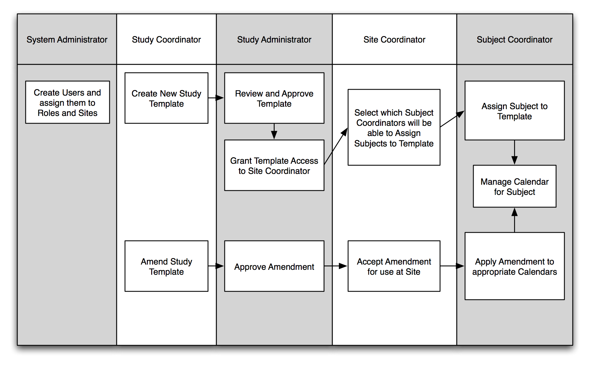
Figure 2-1 PSC Roles and Workflow activities

Application Requirements
PSC is a web-based application. To access and use PSC, your computer must meet the following minimum requirements:
- Internet connection: broadband strongly recommended
- Browser: Firefox 1.5 or 2.0, Internet Explorer 7
- Display: resolution of 1024 x 768 or better is recommended, 800 x 600 is supported

User Interface
This chapter provides an overview of the PSC user interface. Topics in this chapter include:
- Launching the Application
- Authentication
- Navigation
- Common Controls

Launching the Application
Before launching PSC, you will need to get a user login, password and assigned role(s) from your system administrator as well as the web address (url) for your local installation of PSC. To start, open up a web browser and enter the web address for PSC.

Authentication

Login
If you are not already logged in to PSC, you will be presented with the login page when you access the application. Type your {username} and {password} on this page. If you forget your password, please see your System Administrator to reset it.

Log out
The option to log out is available at all times within PSC. Simply click Log out in the upper right-hand corner.

Navigation
PSC presents three basic levels of navigation (Figure 3-1) to allow you to quickly access any page within the application. At the top level, the tabs divide PSC into a few large sections. The “Tasks” then provide links to pages within the tab. Finally, the “breadcrumbs” provide a trail of pages visited so that you can easily return to the page that linked to the page you are currently viewing.
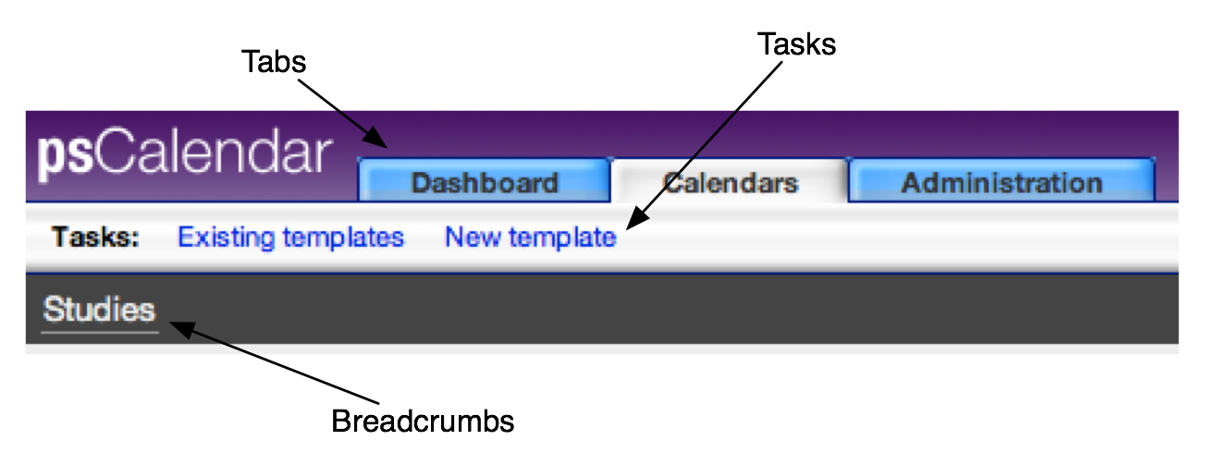
Figure 3-2 PSC Basic Navigation Please note that the features of the Administration tab are covered in the Administration Guide.

Common Controls
Throughout PSC, you will notice a common set of control options. These options were designed to perform common tasks while occupying as little space on the interface as possible. The most common of these are:
- Up, Down, Right, Left arrows – used for reordering items by moving the item associated with the arrow by one location in the direction of the arrow.
- Add – when selected, will add another of the indicated item.
- Delete – will remove the item and any items that may exist within it. A verification message will be presented to safeguard against accidental deletion.
- Edit – when selected, will allow editing of the item.
- Plus sign ‘+’ – indicates that data or additional options are hidden to conserve space on the screen. Click the plus sign to reveal the hidden items. The plus sign will then become a minus sign.
- Minus sign ‘-‘ – indicates that onscreen data or options may be hidden to conserve space on the screen. Click the minus sign to hide the items. The minus sign will then become a plus sign.
- Save – makes changes permanent.
- Submit – places the data into the database and shows the changes effected by the new data.

Manage Templates

This chapter provides an overview of managing templates in PSC. Before any calendars can be generated, you must first create a template. A template is a representation of all of the activities prescribed by the study protocol for subjects. Templates consist of epochs, study segments, periods, and activities.
The template creation process is flexible in order to accommodate each of the wide variety of study designs. The template shows the study divided into large sections called “epochs.” An epoch is a section of the trial during which activities for subjects have the same goal. Some commonly-used epochs are “Screening,” “Treatment,” and “Follow-up.”
Each epoch contains one or more study segments. A study segment is a portion of the trial that has a definable beginning and ending and within which activities can be defined. A study segment could be a set of cycles, a run-in to a transplant, or even a set of follow-up phone calls. Another way of describing study segments would be to say that they last from one decision point to the next. When the time comes to decide what set of activities should happen next for a subject, one study segment will end and the next will begin. The study segments can be listed in any order within an epoch. This order does not determine the sequence order for a given subject.
Time within a study segment is defined by periods. Periods have a duration (in days or weeks), a start day (relative to the beginning of the segment), and a number of repetitions. Activities are planned to occur on days within a period.
Topics in the chapter include:
- Create Template
- Release Template
- Amend Template
- Import/Export Template
- Copy Template
- Activity Management

Create Template
To create a template you must have the Study Coordinator role in PSC. Creating a template in PSC involves defining and entering information about the following primary areas:
- Populations
- Epochs
- Study segments
- Periods
- Activities

Once logged in to PSC as a user with the Study Coordinator role,
1. Within the Calendars tab, Click Create a new template (Figure 4-1)
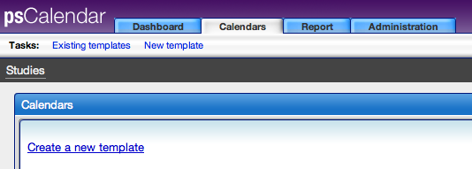
Figure 4-3Create new template

2. As per the instructions in the “Manipulate study” box (Figure 4-2), begin by entering the protocol identifier for the study. This identifier will be used to identify the study template throughout PSC. To enter the protocol identifier, click either the button provided in the “Manipulate study” box or the “Set protocol identifier” button in the “Study info” box to the left. The “Set protocol identifier” button will always be available in case the identifier needs to be changed.
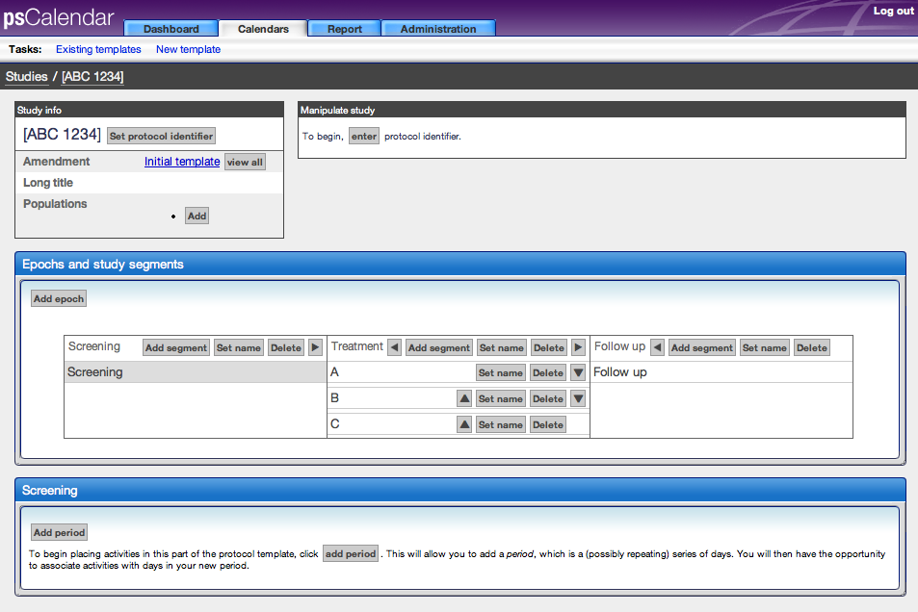
Figure 4-4 Create template view

Populations
If the study protocol specifies that additional activities are required for certain subject populations (i.e. cohorts such as older than 65, female, hepatitis positive, etc…), click the Add button in the Study info box. Follow the onscreen instructions to name the population and to create an abbreviation for them. You will see how to create activities for populations in the Activities section of this chapter.

Epochs
An epoch is a section of the trial during which activities for subjects have the same goal. By default, the initial template is created with three epochs: Screening, Treatment, and Follow-up. You may add, delete, rename, or reorder the epochs at any time during template creation.
Warning! Deleting an epoch will remove any study segments that have been created within it.

The following diagram shows the various controls for editing epochs:
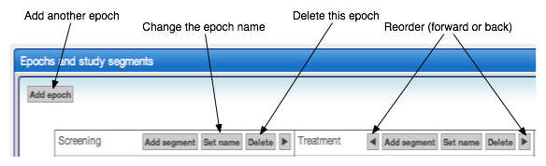
Figure 4-5 Epochs in the Create template view

Study segments
Epochs contain one or more study segments, portions of the trial that have a definable beginning and ending and within which activities can be defined. As with epochs, you may add, delete, rename, or reorder the study segments at any time during template creation (Figure 4-4). Deleting a segment will remove any periods and activities that you have created within it.
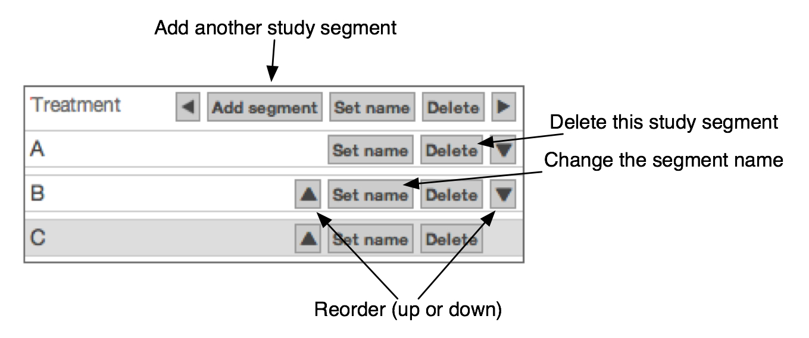
Figure 4-6 Segments section of the Create template view
By default, time within the study segment will be in consecutive days. However, if the template describes time in cycles, define the cycle length in the study segment details box. In Figure 4-5, study segment ‘C’ has been given a cycle length of 21 days.
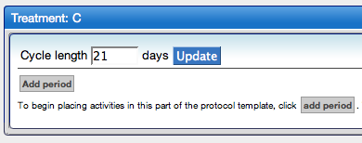
Figure 4-7 A study segment with a cycle length of 21 days.

Periods
Time within a study segment is defined by periods. Periods have a duration (in days or weeks), a start day (relative to the beginning of the segment), and a number of repetitions. When a study segment in the template is selected, the box below it will show the periods and activities that have been setup. To add a period to the study segment, click the “Add period” button (Figure 4-6). The following screen will appear:
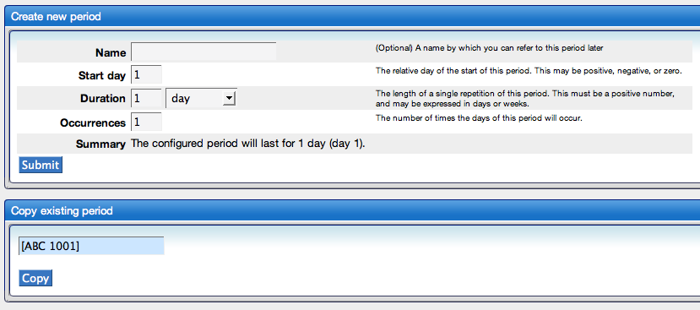
Figure 4-6 Add period section of the Create template view
You now have the choice of either adding a new period or adding a period that is a duplicate of an existing one.
Create new period
To create a new period, enter the information into the “Create new period” box as shown in Figure 4-7.
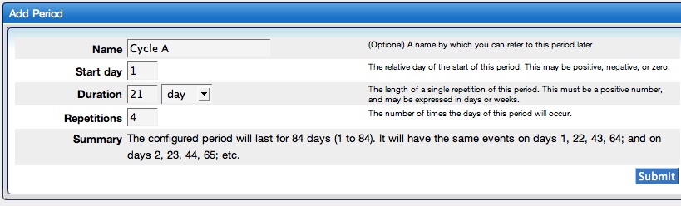
Figure 4-7 Create new period section of the Create template view

In the example above, the period is named “Cycle A,” begins on day one of the study segment, is twenty-one days long, and will occur four times. The “Summary” section helps to confirm that you have entered the information correctly. Press “Submit” to add the period.

Copy existing period
If the period that you want to add is identical or very similar to a period that you have already created in this or any other template, use the “Copy existing period” box. The existing periods from the template that you are currently modifying will be listed by default. If you wish to copy a period from a different template, use the search box to find that template. This will list all of the periods from that template, as shown in Figure 4-8.
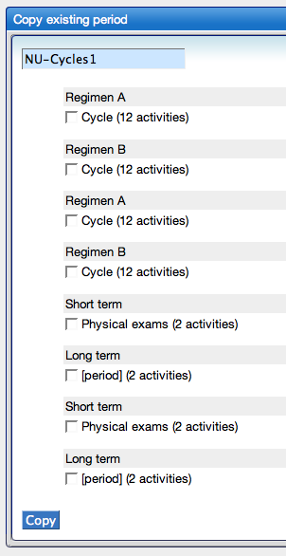
Figure 4-8 Copy existing period section of the Create template view
Select one of the periods and press “Copy.” You will be presented with the current parameters of the period (see Figure 4-7). Modify these to suit the current template. Note that reducing the duration of a period may result in deletion of activities from the period.

Once added to the study segment, the period information will appear in the study segment details box with some new controls (Figure 4-):
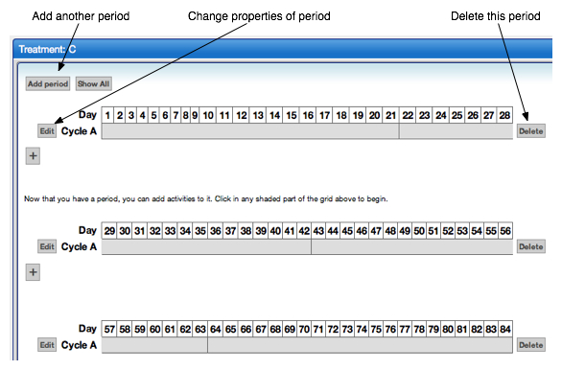
Figure 4-9 Study segment details area of Create template view

You may add as many periods as needed. When you are ready to add activities to the period, simply click in the gray area of the period.

Activities
Click inside the gray area of a period to access the page for managing activities of that period. This page allows you to add or remove activities for all patients or for certain populations (Figure 4-10).
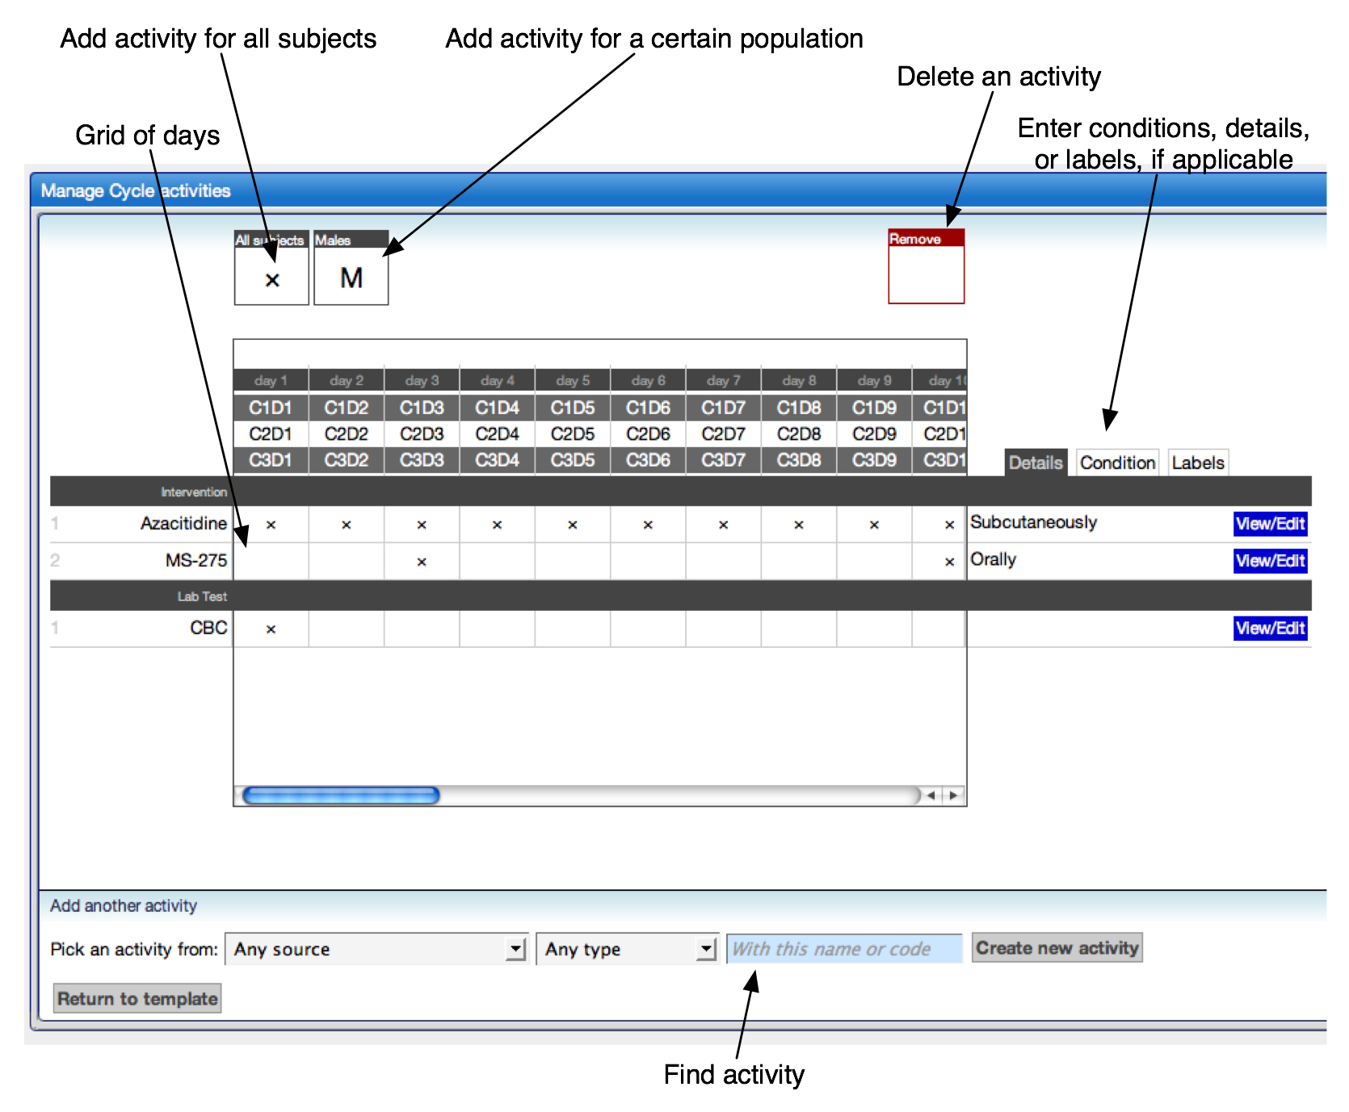
Figure 4-10 Add Activities screen of Create template view

Add/remove
To add an activity, locate the activity using the search box (bottom section, Figure 4-7). The dropdown menus to the left will allow you to limit the search by activity source and activity type. Once you have found the desired activity, click Add to period button to move the activity to appear under the grid of days. The page will now display a row of empty boxes each of which represents the set of days from the grid above. In the above example, the first box represents the first day of the period “Cycle A”: days 1, 22, 43, and 64. To add an activity to these days, simply use the mouse to drag the ‘X’ from the “Add” box to the open square. Repeat these steps for each of the desired set of days for the activity. Next, enter any details that you want to capture about the activity.

To remove an activity, simply drag the ‘X’ from the grid to the “Delete” box above the grid.
For a given activity to occur more than once per day, you will need to add it to the period multiple times. This technique will also allow you to enter differing details or conditions for the same activity occurring on different days.
Figure 4-11 is a simplified example of the latter:
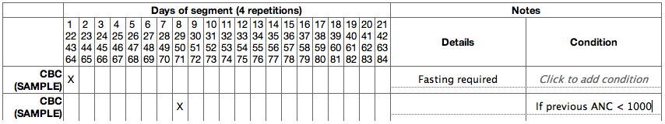
Figure 4-11 Example of same same activity with different conditions

Here one CBC will be performed for all subjects on the first day of the period, but will be performed on the eighth day only for subjects whose previous absolute neutrophil count met the condition. Note that PSC does not have the ability to determine if the condition has been met. The user must make this determination.

Once all activities have been added, click the Return to template button.

Conditional
If the activity should only occur under a certain condition (for example, only if white blood cell counts are below a certain level), enter that condition in the rightmost box.
For the most efficient use of PSC, only use conditional activities for conditions that should be evaluated for all subjects that will experience the study segment. If the activity will only be performed for certain types of subjects (e.g. males over 65, females of childbearing potential, smokers), use the Populations feature described in the next section. Generally, use a conditional activity if the decision to perform an activity is based upon something that happens to the subject. Use a population if the decision is based upon an enduring characteristic of the subject.

Populations
To add activities that will only occur for certain types of subjects, use the populations feature. The first step is to create the population as described previously in Create Template. On the page where activities are added, an “Add” box will appear for each available population. Rather than dragging an ‘X’ to the activities grid, drag the abbreviation from the appropriate populations box as shown here:
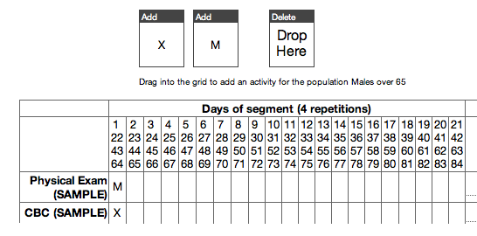
Figure 4-12 Example of different populations in Add activities view
In Figure 4-12, the ‘M’ represents the population “Males over 65.” In this example, while a CBC will be performed for all subjects, a physical exam need only be performed for subjects who are males over sixty-five years of age.

Details
To add additional information or instructions about an activity, click “View/Edit” and enter information into the “Details” section. This information will show on subject schedules for subject coordinators to see.

Labels
Any number of labels can be added to an activity. A label is a single word (or any consecutive letters) that can be used to generate special reports. Labels are separated from each other by spaces. Labels can be used to designate certain activities as being research billing, requiring special kit preparation, or any other use as determined by your organization.

Release Template

Once you have determined that the template is complete, the next step is to release the template for use. Before this option becomes available, though, all periods must have at least one activity, and each study segment must have at least one period. PSC will not allow incomplete templates to be released.

Release to pending state
A template that satisfies the completeness criteria described above will present a button labeled Release this template for use in the Manipulate study box of the view for editing the template. As Study Coordinator, pressing this button and confirming your choice will release the template to the pending section of the study list, which is accessed by clicking the Calendars tab. The template may no longer be modified unless it is amended as described in the Amend Template section below.

Assign to sites
While logged in as a Study Administrator, access the study list by clicking the Calendars tab. The template will be in the Pending section of this page. Click on the {template} to view the template. Instead of being able to edit the template, however, you will have an option to Assign sites. Click the Assign sites button to view the following page (Figure 4-13):
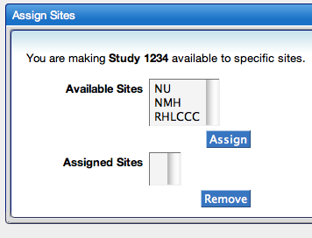
Figure 4-13 Assign sites section of template view

The System Administrator created the sites that appear on this page. Instructions for doing this are found in the Administration Guide. As Study Administrator, highlight the sites that should have access to this template and click Assign. You may return to this page in the future to either assign additional sites or remove them. Notification of this assignment will be sent to the Site Coordinator(s) of each site. Instructions for accepting the template at the site and assigning the template to Subject Coordinators can be found in Chapter 5 of this guide.

Amend Template
As a Study Coordinator, you may amend a template that has already been released.
The amendment process is much like template creation. All of the features for creation are available. PSC will track the changes that are made and keep a history of all amendments and their corresponding changes. When you have finished with your changes, release the amendment for use. The amendment will be sent to each Site Coordinator at each site that has been assigned to the template. The Site Coordinator will then approve the amendment as described in Chapter 5 of this document.
- From the Calendars tab, click {your template} form the released list
- Enter {Date: mm/dd/yyyy} that amendment goes into effect
- Type {name} or {identifier} for the amendment
- Select {Optional or Mandatory}, defined below.
- Modify template as needed (described in Create Template section)
- When finished, click Release amendment for use button

Mandatory amendments
These changes to the template must be applied to all previously existing subject calendars using that template. With a mandatory amendment, the changes to the template will be pushed automatically to every subject calendar as soon as the Site Coordinator accepts the amendment at the site.

Optional amendments
Optional amendments do not have to be applied to all subject calendars. After approval at a site, the changes to subject calendars are effected on a per-subject basis by Subject Coordinators. Please note that at this time it is not possible to skip amendments. For an amendment to be applied to a subject’s calendar, all prior amendments must be accepted.

Import/Export Template
As a Study Coordinator, you can import and export templates in XML format. The link to import templates can be found at the top of the study list. The link to export the templates can be found within the template view. Using this feature, a coordinating center could create a template for a study, and then send it to each institution that is participating in the study. This would help to ensure consistency of study conduct across multiple institutions.

Copy Template
If you wish to create a template that is similar to an existing template, use the “Copy” feature. Click the “Copy” button that appears to the right of the original template displayed on the “Calendars” tab. This will create a duplicate template that will be named by default “Original name copy”. Replace this with the correct name and edit the template using the same controls as if the template were newly created.
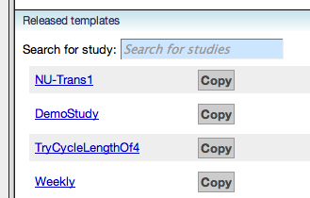
Figure 4-14 Copy template

Activity Management
PSC provides three choices for managing activities. They can be created individually during template creation (as describe above), imported from an XML document, or the “Activities” tab can be used to add, edit, or delete activities and their sources.

Sources
PSC allows users to manage activities from multiple sources. Each activity is tracked by the source from which it came.

Activities tab
The Activities tab (Figure 4-14) is visible to Study Coordinators.
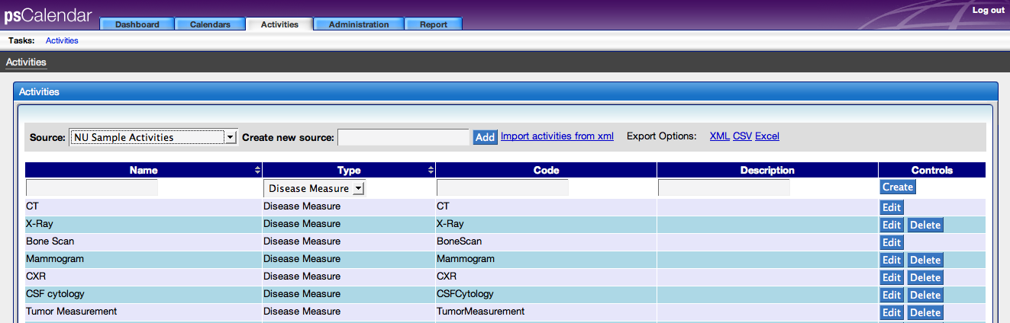
Figure 4-15 Activities tab
Add new activity sources, create new activities within sources, import XML documents of activities, edit existing activities, delete unused activities, and export activities in XML, CSV, or Excel formats from this tab.

Manage Site and Personnel
This chapter provides an overview of site and personnel management functions in PSC. A Site Coordinator is responsible for approving templates and amendments to templates assigned for use at their site(s). The Site Coordinator is also responsible for granting access to templates to Subject Coordinators and reassigning subjects from one Subject Coordinator to another.
Topics in the chapter include:
- Site Coordinator Dashboard
- Approve Templates and Amendments
- Grant Access to Subject Coordinators
- Change Ownership of Subject Calendars

Site Coordinator Dashboard
This dashboard provides a convenient interface for performing the functions of a Site Coordinator. As a Site Coordinator, you will see this dashboard by default when you login. If another dashboard is presented because you are also a Subject Coordinator or you have navigated away from this page, simply select the Dashboard tab and follow the Site Coordinator link (Figure 5-1).
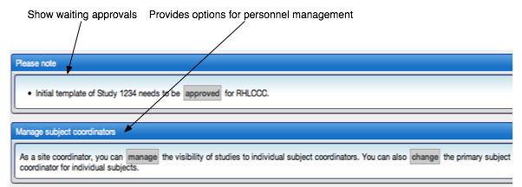
Figure 5-8Site Coordinator Dashboard

Approve Templates and Amendments
The Please note section at the top of the dashboard will notify you of any waiting approvals. Simply follow the approved link, check the Approve box, verify the approval date, and then finalize the approval.

Grant Access to Subject Coordinators
To grant access to a template to a Subject Coordinator, simply press the manage button from the Manage Subject Coordinators box. Select the study that the template represents from the dropdown list, and then check the appropriate boxes in the grid of sites and Subject Coordinators. A check means that the Subject Coordinator in that row is authorized to assign subjects to the selected study at the site in the column.

Change Ownership of Subject Calendars
Also from the Manage Subject Coordinators box, press the Change button in order to change the ownership of subject calendars. Although Subject Coordinators are able to lookup the calendars of any subject that is assigned to a study and site for which the Subject Coordinator has access, subject calendars are “owned” by only one Subject Coordinator. This ownership means that the subject’s calendar will appear within the Subject Coordinator’s dashboard, which is discussed in Chapter 6, Create and Assign Subjects.

To change the ownership, select the {Subject Coordinator} that currently owns the subject’s calendar. A list of all of subjects will appear in a list that is also delineated by site and study. Next to each study will appear a list of all available Subject Coordinators. Check the box next to the subject(s), choose the {new owner} from the dropdown box, and click the assign button. The change has now been made.

Manage Subjects
The chapter provides and overview of the Manage Subject functions in PSC. A template for the study has been created and assigned to a site. The site has approved the template for use and assigned Subject Coordinators to use the template. Finally, it is time to generate subject schedules and begin using PSC for its true purpose.
Topics in the chapter include:
- Create/Assign Subjects
- Subject Calendar
- Subject Coordinator Dashboard

Create/Assign Subjects
Log on as a Subject Coordinator. You will be presented with the Subject Coordinator dashboard, which will be described in greater detail later in this chapter. From the Available studies box on this page, or the list of studies on the Calendars tab, select the appropriate {study}. You will be taken to a view of the template for this study. Press the Assign Subject button to begin.

The assign subject page will require information about the subject, a unique identifier for the subject on the study, the start date of the first study segment, the name of the first study segment, and any populations to which the subject should be assigned. Submitting this information generates the subject’s calendar.

Subject Calendar
You will automatically be taken to the subject’s calendar when the subject is assigned to the study. You can also access it through the Subject Coordinator dashboard or from the template view of the study. The calendar will be titled “Schedule for {subject name}.”

In addition to the schedule of activities for the subject, this page includes details about the patient, links to other Clinical Trials Management Systems, and features for exporting the calendar, taking the subject off study, modifying the schedule, scheduling additional study segments, and changing the state of individual activities. These will be described in the following sections.

AE notifications
If PSC is configured to receive adverse event (AE) notifications from an AE management/reporting system such as caAERS, these will be displayed near the top of the subject calendar. You will be able to see details of the AE, view a history of AEs that have been sent to PSC for the subject, link to caAERS to access additional information, and dismiss the notification from appearing in this view.

Link to Lab Viewer
If PSC has been configured to access laboratory data in Lab Viewer, a link to this application will be provided near the top of the subject calendar. Following this link will bring you to a view of the subject’s lab results as stored in Lab Viewer.

Schedule study segments
In order to schedule the next study segment for a subject, click the “Schedule next study segment” text in the “Modify entire schedule”. This will reveal a view of the template showing the available epochs and study segments. Select the desired study segment, and it will populate the scheduling box.

In the following example (Figure 6-1), a user has selected the High Dose study segment of the Induction epoch to be added to this subject’s schedule:
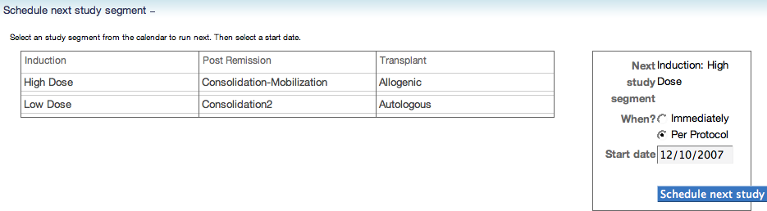
Figure 6-9 Schedule next study segment for subject area
You must then enter whether this next segment should occur “immediately” or “per protocol.” These are described in the following two sections. In either case, adjust the start date for the new study segment if necessary and press the “Schedule…” button. Your action will add a study segment to the “Study segments scheduled” box and will add the corresponding activities to the subject’s calendar.

As per protocol
Scheduling the next study segment as per protocol simply means that the subject is expected to finish all of the activities of the previous study segment before moving to this one. The start date will be automatically populated with a suggested start date, but you should verify this date and adjust it as needed.

Immediate
Scheduling the next study segment immediately means that the subject will not complete the previous study segment. All activities that have not been completed as of the current date will be canceled. The start date will be automatically set to today’s date, but once again you should verify this date and adjust it accordingly.

Delay or advance
The other option within the “Modify entire schedule” box is the “Delay or advance” feature (Figure 6-2). Click this text to reveal the following fields:
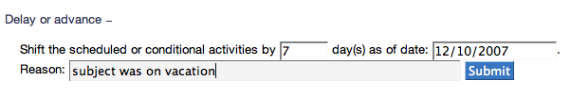
Figure 6-10Delay or advance feature of modify entire schedule area

You may now adjust the subject’s entire schedule by a specified number of days as of a certain date. In the above example, all activities that are scheduled (or in the “conditional” state) to occur on or after 12/10/2007 will be rescheduled to occur seven days later. The reason will be saved to the history of changes for each activity for which the date was modified.

Note: If you want to shift the schedule to happen earlier, use negative numbers in the first field.

Download calendar file
The “Export ICS” button near the top of this page will download a file in ICS (iCalendar) format of the subject’s calendar. This format will allow the calendar to be imported into Outlook, iCal, Meeting Maker, Google Calendar, and nearly every other calendar application. The file will show only the activities that are scheduled to occur and will keep subject and study information in the details of the activity. This will allow you to upload more than one calendar file and be able to differentiate one set of activities from another. This feature will also allow you to provide patients with an electronic copy of their own calendar, assuming this is in accord with the policies of your institution.

Please note that modifying the schedules from an external application such as Outlook will not change data within PSC. A better course of action is to modify the schedule within PSC, then export the file again and replace the previous one.

Off study
If a subject is taken off study, use this function to cancel the remaining activities for the subject. You will need to know the date that the subject was removed from the study.

Manage activities
Click a study segment from the “Study segments scheduled” box to populate the most important and final box on this page: the scheduled activities for the subject. By default, this box will be populated with the earliest study segment that still contains activities that are scheduled to occur.
Click on an activity to bring up the details page (Figure 6-3) for that activity. From this page, view or make schedule and state changes (more about state later in this chapter) to the activity as well as record notes about the activity. Here is a sample of this page:
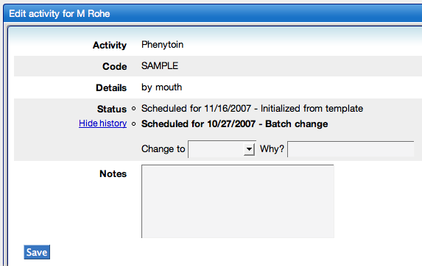
Figure 6-11Activities detail page for a subject

When you are finished editing this page, click “Save” to return to the subject’s calendar.

Reschedule
Back to the schedule section of the subject’s calendar, activities may be rescheduled individually or in batches (Figure 6-4). Use the “Select activities” links at the top of this box to select all of the activities, deselect all activities (by clicking “None”), select the conditional activities, or select the past due activities. You may also use the check boxes next to each activity to select any number or combination of activities to manage. The following screen shot shows these options:
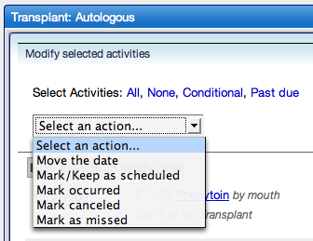
Figure 6-12 Modify selected activities screen

The above screen shot shows that not only can the dates be modified, but the states as well. See the next section for a description of each activity state.

Activity states
PSC tracks the state of activities to assist you in tracking the subject’s progress through the study and in knowing what should happen next for a subject. Each activity within PSC has one state at any given time. Each time the activity changes to a state that is other than “occurred,” you should enter a reason for the change.
Figure 6-5 is the list of states from the Legend on the subject calendar with the corresponding icons:
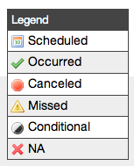
Figure 6-13 Activity state icons list
The icons will show the current state of the activities.

Scheduled
These activities are expected to occur on the given date. All activities that are not conditional are created as scheduled activities. If a scheduled activity has a date that is before the present date, it is also considered past due.

Occurred
When a scheduled activity occurs, mark it as “Occurred.” This will help you to track the subject’s progress through the study.

Canceled
If you know that an activity will not or should not occur, mark it as “Canceled.”

Missed
If an activity was supposed to happen but failed to complete, mark it as “Missed.”

Conditional
If a condition was supplied for this activity during template creation, it will be in the conditional state. The condition will be displayed beside the activity on the subject’s schedule. If the condition is true, the activity should be performed for the subject, change the activity to “Scheduled.”

Not Applicable
If the condition of a conditional activity is not true, change the activity to “Not Applicable” or “NA.”

Subject Coordinator Dashboard
When you login as a Subject Coordinator, you will automatically be taken to your dashboard (Figure 6-6). This dashboard displays the past due activities and upcoming activities of any subjects assigned to you. It also provides access to all studies that you are authorized to use. You may view subject calendars or assign new subjects through these studies. Finally, it provides access to the upcoming activities of other Subject Coordinators at your site(s). If one of your Subject Coordinator colleagues takes a vacation, you can simply follow a link to see the upcoming activities.

The following screen shot is an example of a Subject Coordinator dashboard:

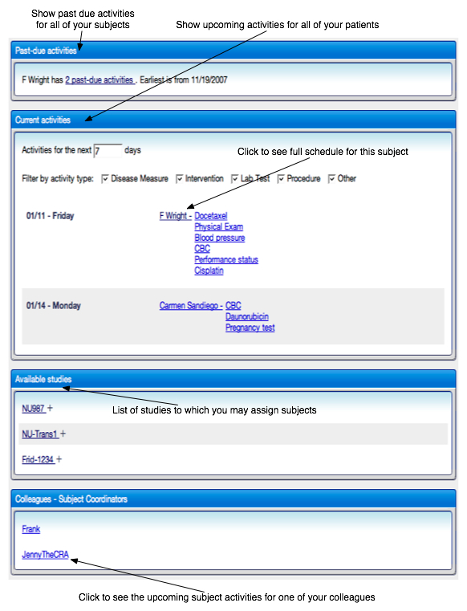
Figure 6-14 Study coordinator dashboard

Error Messages

Access Denied
Access Denied errors occur when a user tries to access a resource for which he or she does not have the appropriate permissions. This usually means that the user has not been assigned to the proper role to use the desired feature. Should you experience this error, please contact your System Administrator to ensure that you have been assigned to the correct roles.

Interface Errors
If items onscreen do not appear properly, please make sure that you are using either Firefox versions 1.5 – 2 or Internet Explorer 7. Some pages may not display properly with Internet Explorer 6.
Also, PSC looks best with a screen resolution of 1024 X 768 or higher. Some pages contain many different items and will be easiest to use if the window is expanded to full screen.

Internal Server Errors
If you encounter an internal server error, we encourage you to report it to us. Please send an email to studycalendar-adopters@gforge.nci.nih.gov with a description of the actions leading to this error, a screen shot, and a copy of the log from $CATALINA_HOME/logs/studycalendar-debug.log, if possible.

- References

Technical Manuals/Articles
- ICS: http://en.wikipedia.org/wiki/ICalendar
- XML Metadata Interchange: http://www.omg.org/technology/documents/formal/xmi.htm

caBIG Material
- caBIG: http://cabig.nci.nih.gov/
- caBIG CTMS Workspace: https://cabig.nci.nih.gov/workspaces/CTMS
- Glossary

Term | Definition
Amendment | A revision or change to a study.
C3PR | Cancer Center Clinical Participant Registry
caAERS | caBIG Adverse Event Reporting System
Calendar | The activities that are expected to occur for a subject on study. The calendar includes detailed information about the activity including its date and state information.
Conditional activity | An activity that will take place only under a specified circumstance. For example, administer growth factor only if blood levels have not adequately recovered.
Epoch | A section of the study during which similar activities take place for all participants. Subjects move through epochs in serial, and no subject can take part in more than one epoch at any point in time. Examples of epochs commonly used in studies are screening, treatment, and followup.
ICS | Also known as iCalendar, ICS is a standard format for exchanging calendar data. Nearly all schedule-based software, both open source and commercial, uses this format. Some examples of applications which use ICS are Outlook, iCal, Google Calendar, and Meeting Maker.
NCI | National Cancer Institute
NCICB | National Cancer Institute Center for Bioinformatics
Period | A possibly-repeating collection of consecutive days that define the length of a Study Segment and determine when an activity is planned to occur.
Population | A group of subjects that share one or more characteristics that will impact the way they are treated during the study.
Study segment | One of possibly many pre-defined sequences of activities that exist within an epoch.
Template | A representation of the planned activities for a study. The template used by PSC starts by assigning activities to chunks of time known as “periods.” Periods are collected into logical sections of the study known as “study segments.” For clarity, the study segments are listed according to the epoch during which they would be expected to occur.

Index

A
Activities 16
Add/remove 17
Canceled 30
Conditional 18, 30
Manage 28
Missed 30
Not Applicable 30
Occurred 30
Populations 18
Scheduled 30
AE notifications 26
Amendments
Approve 23
Mandatory 21
Optional 21
Application Requirements 7
Authentication 9
C
Calendar 25
Delay or advance 27
Download 27
Schedule study segments 26
Calendars
Change ownership 24
Controls 10
D
Dashboard
Site Coordinator 23
Subject Coordinator 30
E
Epochs 13
Error Messages 33
I
iCalendar 27
ICS 27
L
Lab Viewer 26
Launching the Application 9
Log out 9
Login 9
N
Navigation 9
O
Off study 28
Outlook 27
P
Periods 14
Populations 13
R
Roles, table of 6
S
Site Coordinator 23
Study segments 14
Subject Coordinator 30
Subjects
Calendar 25
Create/Assign 25
T
Templates
Access to Subject Coordinators 24
Amend 20
Approve 23
Assign to sites 19
create 11
Import/Export 21
overview 11
Release 19
Text conventions, Supplement 3
W
Workflow, diagram 6

