caBIG™ Standard Templates

CDE Usage Report Example

Please Note: This is an example document, not a template document. There is not standard “template”; however, this document walks the user through the creation of and format of an CDE Usage Report in the caBIG™ program.

CDE Overview

In caBIG™, UML models annotated with controlled vocabularies (in the form of an XMI file) are used as the substrate for the UML loader tool to generate Iso11179 compliant common data elements stored in the caDSR. For a more detailed description of CDE creation from UML models please visit http://ncicb.nci.nih.gov/core/caDSR/Training.

Common Data Elements (CDEs) are a core component of the caBIG™ infrastructure. Common elements serve as the basis for interoperability between systems by providing touch points to match disparate systems together. For a complete VCDE review a CDE usage report is needed to determine what CDEs are used in a given system.

How to Generate CDE Use Report

To create a CDE Usage Report for review go the caDSR CDE Browser, select the CDEs you would like to view, select “Download to Excel” or Download to XML”. The below screen shot shows the caBIO CDEs in the caDSR and the options to download to Excel or XML. Also, please find below and example of a CDE Use Report for NCICB’s caBIO.
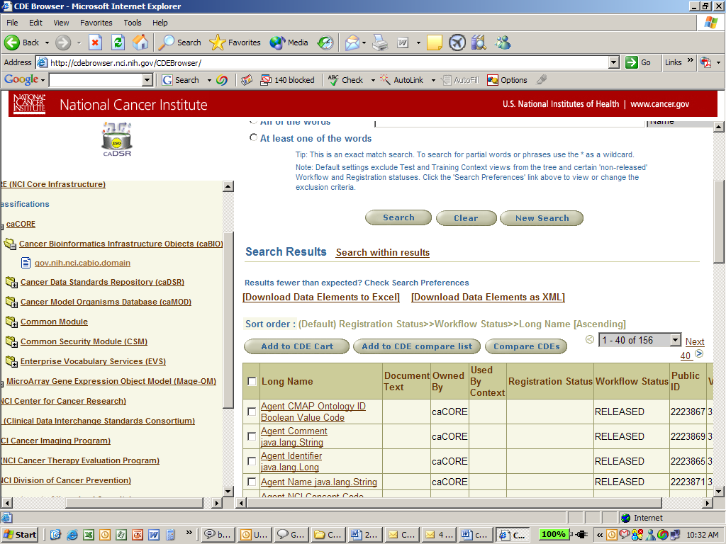

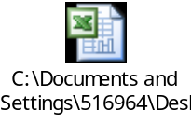

What the CDE Use Report is USED for

The CDE Use report is one of several deliverables submitted by devleopers to the Crosscutting WS as part of the compatibility submission package. The CDE Use report is used to validate that the CDEs created by the UML Loader map exactly back to the fully annotated UML model. For more details on compatibility reviews please see

https://cabig.nci.nih.gov/workspaces/VCDE/VCDE_Compatibility_Review/Compatibility_Review

http://gforge.nci.nih.gov/projects/compat-rev/

