Thank you for testing the Patient Study Calendar Module. The PSC team is developing this software over a six-month period which has been divided into four releases--one every six weeks. The software you are about to test is the result of Release 2. Your feedback will help guide our development efforts.

We are debuting a few new features as well as the ability to use the application from the perspective of various roles within a clinical research organization. You will find a few guiding instructions below.

A few considerations before you begin:
- This is a public instance. You may encounter sample study calendars created by other users. Other users may be able to see data that you enter. Please do not enter any confidential information.
- The big, beautiful green box at the bottom of each screen contains debugging information and will not be visible in the final release of the Study Calendar Module.
- We have focused on functionality rather than visual design in our development efforts thus far. However, please feel free to make design recommendations if you so desire.

Let the testing begin: https://vera.bioinformatics.northwestern.edu/studycalendar

To test all of the features of the Study Calendar Module from a single logon:

- Logon as: superuser with the password: superuser
- Click “New study” to begin the process of creating a new study.
- You can name the study, create epochs (screening, treatment, follow-up, etc…), and add arms to the study from this page.
- The next page is the “Template page.” You’ll come back to this now and then. You’ll want to add some periods to the arms of your study in order to make this more interesting.
- When you’ve finished creating your periods, go ahead and select one from the template in order to add activities to it. Add some activities by selecting it from the drop box, clicking the Add button, and specifying how times you would like that activity to occur on any day within the period. If you don’t see the activity that you want, feel free to create a new one.
- The “Mark this template as complete” link is a way to make a note that the template has been reviewed and is both correct and complete.
- Please also try adding some participants to the study. You can create new participants, too.
- Please send your feedback to s-whitaker@northwestern.edu

To test our implementation of roles within the Study Calendar Module:

Here are the roles that we are able to capture with the current Study Calendar Module:

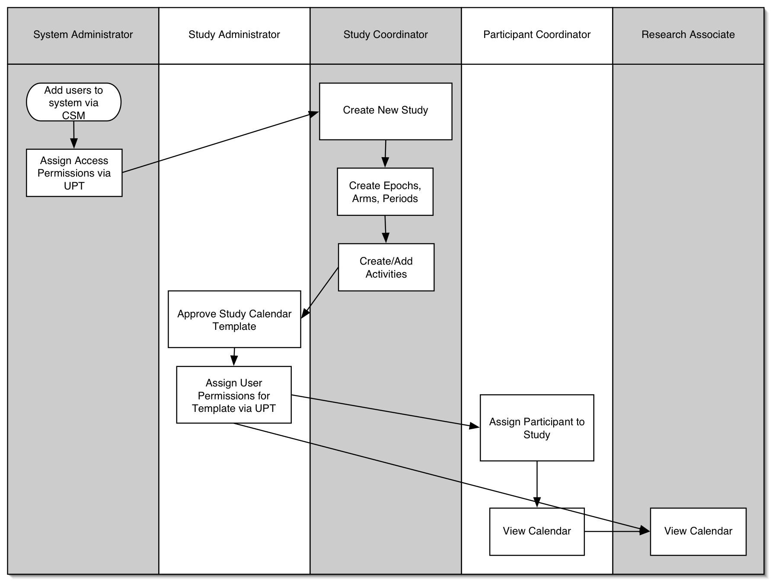

To login as a Study Coordinator use login and password of “studycd_1”

To login as a Study Administrator use login and password of “study_admin1”

To login as a Participant Coordinator use login and password of “participantcd_1”

To login as a Research Associate use login and password of “ra_1”

You should find the features of the module limited to those that are assigned to that particular user.

Thank you for your participation. Please send feedback to s-whitaker@northwestern.edu

