Software Requirements Specification

Login Authentication
Center name

DOCUMENT REVISION HISTORY
Version Number | Date | Description
1.0 | July 2006 | - Draft

Background/Summary
This document presents the use cases for the Login Authentication of the Patient Study Calendar system. Principal feature is to authenticate the user using the CSM (Common Security Module) login authentication service. Other features include:
- User logout
- User authentication and access management using CSM UPT (User Provisioning Tool)
Table of Content
1 Introduction 4
1.1 Overview 4
1.2 Related Documents 4
2 Actors and Goals 4
3 Use Cases 4
3.1 Login 4
3.1.1 Use Case Model 4
3.1.2 Brief Description 5
3.1.3 Primary Actor 5
3.1.4 Secondary Actors 5
3.1.5 Preconditions 5
3.1.6 Basic Flow of Events 5
3.1.7 Postconditions 5
3.1.8 Alternative Flows 5
3.1.8.1 Invalid Credentials 5
3.1.9 Postconditions 6
3.1.10 Special Requirements 6
3.2 Logout 6
3.2.1 Use Case Model 6
3.2.2 Brief Description 6
3.2.3 Primary Actor 6
3.2.4 Secondary Actors 6
3.2.5 Preconditions 6
3.2.6 Basic Flow of Events 6
3.2.7 Postconditions 6
3.2.8 Alternative Flows 6
3.2.9 Postconditions 7
3.2.10 Special Requirements 7
3.3 Manage authentication and access data using UPT 7
3.3.1 Use Case Model 7
3.3.2 Brief Description 7
3.3.3 Primary Actor 7
3.3.4 Secondary Actors 7
3.3.5 Preconditions 7
3.3.6 Basic Flow of Events 7
3.3.7 Postconditions 8
3.3.8 Alternative Flows 8
3.3.9 Postconditions 8
3.3.10 Special Requirements 8
4 Overall Requirements 8
4.1 Requirements Prioritization 8
5 Data Definitions 8
6 Sign Off 10
6.1 Approval 10

Introduction

Overview
Login authentication uses CSM which works with JAAS to authenticate and authorize users. The UPT is used to create and manage user data and access rights

Related Documents
None

Actors and Goals
Registered User – Patient Study Calendar is accessible to only these individuals.
System Administrator – The Patient Study Calendar system administrator is a registered user of the system with rights to create and manage user access data using the UPT.

Use Cases

Login

Use Case Model
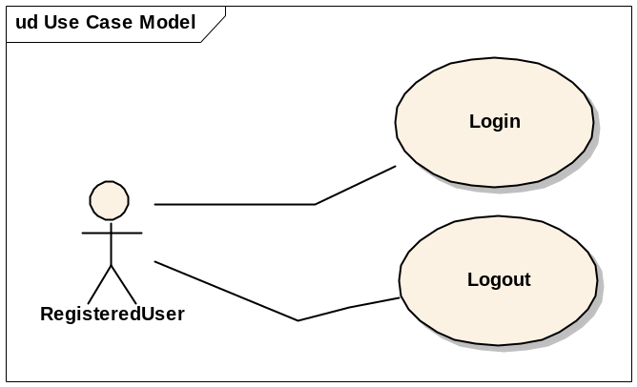

Brief Description
In this use case a user logs into the system. Each individual user has a role and a group and access permissions can be defined for the user.

Primary Actor
Registered User

Secondary Actors
None

Preconditions
The application is pre-loaded with the correct URL. The user authentication data is already present in the database.

Basic Flow of Events
- The Patient Study Calendar system presents a login screen that includes fields for username and password.
- The user provides his username, password and clicks submit.
- The system successfully authenticates the user with the provided credentials using CSM.
- A Listing of studies is displayed to the user.

Postconditions
None

Alternative Flows

Invalid Credentials
- This use case flow of events starts at Step 2 of the Basic Flow if the system indicates that the login or password provided is invalid.
- The Patient Study Calendar system presents the login screen again and displays an error message that the login credentials were invalid.

Postconditions
None

Special Requirements
None

Logout

Use Case Model
Same as Model 1

Brief Description
In this use cases a user logs out of the system.

Primary Actor
Registered User

Secondary Actors
None

Preconditions
The user is logged in.

Basic Flow of Events
- The user clicks on the Logout link or button.
- The system successfully logs out the user.
- The system redirects the user to the login page.

Postconditions
None

Alternative Flows
None

Postconditions
None

Special Requirements
None

Manage authentication and access data using UPT

Use Case Model
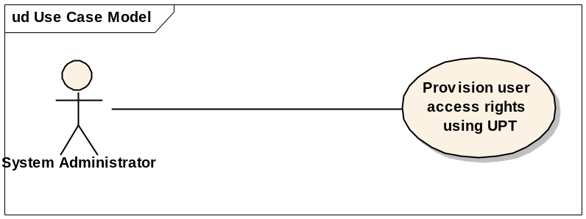

Brief Description
The System Administrator uses the UPT to manage user authentication and access data.

Primary Actor
Registered User

Secondary Actors
None

Preconditions
UPT application is already set up.
The user authentication data is present in the database and he has access rights to the UPT.

Basic Flow of Events
- The UPT application login page is displayed
- The system administrator provides username, password and the application (context) name for login
- The system successfully redirects the user to the UPT tool.
- The user uses the UPT tool to create and manage user access rights.

Postconditions
None

Alternative Flows
None

Postconditions
None

Special Requirements
None

Overall Requirements

Requirements Prioritization

Priority | Use Case Name | Supp Requirement Ref #
1 | Login
2 | Manage authentication and access data using UPT
3 | Logout
UPT is a tool provided by NCICB CSM and needs to be setup for the Patient Study Calendar system

Data Definitions
Examples:
CSM – NCICB’s Common Security Module API
UPT – User Provisioning Tool
Invalid Credentials – user name and password provided by the user for login do not exists in the system or cannot be authenticated by the system
.

Sign Off

Approval

Workspace General Contractor Rep Print Name Date
Architecture Workspace Rep Print Name Date
VCDE Workspace Rep Print Name Date
Workspace Working Group Rep Print Name Date
NCICB Rep Print Name Date

