Patient Study Calendar Phase II
Design Document
Feature | Date
Conditional Events | July, 2007

1. Overview – Conditional Events
It’s often can be the case, when some events have to be scheduled only if specific conditions have been achieved. This means that Site Coordinator have to schedule them in the appropriate fashion
PSC will provide a mechanism for helping Site Coordinators to manage conditional events. If some activity has to be marked as conditional, Site Coordinator will have to check a checkbox and add the condition (conditional details) under what the events within this activity have to occur.

2. Details
Within PSC, we have PlannedEvents that are associated with an activity. When the activity is Conditional then all the events within this activity have to be marked Conditional as well. To achieve that Site Coordinator has to check a conditional checkbox and should provide the details. The order in which the activity is marked as Conditional does not matter. It can be done at any point and the changes will be automatically applied to the events.

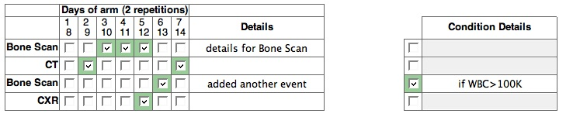

Within a period the conditional events will have an identifier with provided details. The period displays conditional events as following:

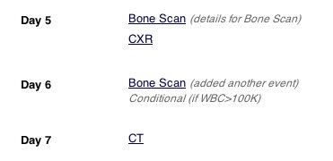

If the conditional activity has to be a non-conditional, the conditional checkmark should be unchecked. The change will be automatically applied to all the events in this activity.

(TODO – need to apply conditional changes for the scheduled page.)

