name of software
Title of Publication

Installation Guide

caBIG™ is an initiative of the National Cancer Institute, NIH, DHHS
Table of Contents

Introduction 1
Overview of {product} 1
{Product} Minimal System Requirements 1
Minimal System Requirements 2
{product} Software and Technology Requirements 2
Software Requirements 2
Required Software—Not Included in the {product} 2
Optional Software 3
Documentation and Source Code Styling Tools 4
Useful tools included in the {product} 4
Upgrading to {product} from Previous {product} Versions* 5
Installing the {product} 6
Preliminary Considerations 6
{product} Object Model 6
Downloading the {product} 7
Running the Example 9
Modifying the deploy.properties File in Windows 10
Modifying the deploy.properties File in UNIX or Linux 11
MySQL Database Issues 12
User MySQL Download 13
Building a Demonstration System 14
Executing Tests 16
Testing the Proxy 16
Testing the Database 16
Testing the System 17
Running the Demonstration Program 18
Appendix I {product} Components 21
Contacting Technical Support 21
{product} Application Support 21

After completing your installation guide, to update the Table of Contents, select it and press F9.

Introduction
Your final installation guide should be in black text (and some sample text that you might want to use in your guide has been left black in this template). The red text is used in this template to draw attention to suggestions and comments.
This installation guide outlines the supported configurations and installing, setting up and configuring the application and/or databases. It can also include information about importing and exporting data for or from databases. If testing instructions are also included, you might include a sentence similar to this: Directions for testing the {product} are also included here.
All of the examples and screenshots included in this chapter are Windows specific. If you are using a different platform, then modify the information as appropriate for your system.
Many sections that you might want to adapt to your guide have been left in this template. If you choose not to use them, just delete them.
This template uses the formatting style called Information Mapping. It creates a clean and easily usable final document. This type of formatting uses numerous tables with hidden borders (gray in this template) and other tables with gridlines showing. Note also the “Block lines” between blocks of text and tables. To insert a Block Line, click the Block Line Style. You will note some other formatting styles which help create a professional looking final document. We have left many features in this template file to make it easy to copy and paste items which you then can adapt to your own installation guide needs.

Overview of {product} | Include an overview of the product in this space. You could describe target audience, expected prerequisities, purpose of the product, etc. If appropriate, include a URL where programmers/users can obtain more information (for instance, a link to a programmers or end users guide).

NOTE: | Enter notes to which you want to draw attention.

{Product} Minimal System Requirements

Minimal System Requirements | - Internet connection  - Tested Platforms
The {product} has been tested on the platforms shown in Table 1 (examples shown).

 | Linux Server | Solaris | Windows
Model | HP Proliant ML 330 | Sunfire 480R | Dell GX 270
CPU | 1 x Intel® Xeon™ Processor 2.80GHz | 2 x 1050MHz | 1 x Intel® Pentium™ Processor 2.80GHz
Memory | 4 GB | 4 GB | 1 GB
Local Disk | System 2 x 36GB  (RAID 1)  Data = 2 x 146 (RAID 1) | System 2 x 72GB | System 1 x 36GB
OS | Red Hat Linux ES 3 (RPM 2.4.21-20.0.1) | Solaris 8 | Windows XP/2000 Professional
Table 1 Platform Testing Environment

{product} Software and Technology Requirements

Software Requirements
Required Software—Not Included in the {product} | You must download and install the required software that is not included with the {product} (listed in Table 2 .) The software name, version, description, and URL hyperlinks (for download) are indicated in the table.

(Required software that is included with the {product} is listed in Appendix I on page Error: Reference source not found.)
Software Name | Version | Description | URL
Java Software Development Kit (SDK):Java 2 Standard Edition (J2SE) | j2sdk1.4.2_06 or higher | The J2SE Software Development Kit (SDK) supports creating J2SE applications | http://java.sun.com/j2se/1.4.2/ download.html
UML 1.3 Modeling Tool that produces XMI 1.1 output format | EA 4.50.744 | We recommend using Enterprise Architect (EA) | http://www.sparxsystems.com.au/ ea.htm
Table 2 Required software and technology for the {product}

Optional Software | Optional software to use with the {product} is listed in Table 3. (Examples shown.) The included (Incl.) column indicates (with a Yes) if the software is packaged with the SDK. No indicates that you must supply the software. A hyperlink is included for your reference to appropriate sources.

Software Name | Version | Description | URL | Incl.
Eclipse IDE | 3.0 | An open platform for tool integration which provides tool developers with flexibility and control over their software technology. | http://www.eclipse.org/downloads/ index.php | No
jeteditor-eclipse plugin | 0.0.1-alpha-2004-07-22 | JET-Editor is an Eclipse-based Editor for JET-templates (templates used by EMF). It is intended to support the development of JET-templates in a quality that is adequate to other eclipse language support. | http://sourceforge.net/projects/jet-editor | Yes
Oracle 9i Database | 9i | Oracle is a commercially-available, alternative relational database management system (RDBMS) that can be used in place of MySQL. Release 9i is currently the only release supported by the SDK | http://www.oracle.com/technology/products/oracle9i/index.html | No
IBM DB2 | 8.2 | Like Oracle, DB2 is another commercially-available alternative to MySQL. | http://www-306.ibm.com/software/data/db2/ | No
Table 3 Optional software and technology for the {product}

NOTE: | Be sure and include everything in this installation guide that installers will need to get your system up and running. You needn’t include information about installing and starting other applications needed for your system; you do need to include appropriate directions, though, for integrating those applications with your system. As an example, the following information is relevant for getting the product described in this Installation Guide up and running.  Drivers for MySQL, Oracle 9i and DB2 are included with the {product}. If you are using a different version of Oracle or DB2, you must obtain the appropriate drivers. JDBC drivers can be downloaded from the Sun Developer Network at http://developers.sun.com/product/jdbc/drivers/index.html, or from the individual vendors’ sites (for example, the Oracle 8i driver classes12.zip can be downloaded from http://www.oracle.com/technology/software/tech/java/sqlj_jdbc/htdocs/ jdbc817.html). These drivers should be placed in the {project_home}/lib directory and the {tomcat_home}/common/lib directory to enable connection to the appropriate database. In addition, some manual modification of the Hibernate configuration files may be necessary.
The block lines between topics and sections are the Block Lines listed in the this Word templates Style directory.

Documentation and Source Code Styling Tools
The following tools, useful for documentation and source code styling, are part of the {product} framework.
Useful tools included in the {product} | - Javadoc – Execute the Ant task doc to generate Javadocs for your beans. Your javadocs will be generated to the {home_directory}\output\javadoc directory. For more information on Javadoc see http://java.sun.com/j2se/javadoc/.  - Jalopy – Execute the Ant task format to make your code well formatted. The default indentation format is used in the {product} This task is configurable to enforce coding standards that you wish to adhere to for your project. See http:// jalopy.sourceforge.net/manual.html for information on how to customize this task.

NOTE: | {product} Components are listed in Appendix II on page 19.

Upgrading to {product} from Previous {product} Versions*
This section includes information on upgrading your product from previous version.
{product} Users Upgrading to {product} | *Include any information that should be a Warning or Caution to users or installers.

Note the following points in downloading and installing the {product} upgrade:
In this template, all numbered instructions are inserted in these “step-action” tables. This first one is left somewhat intact so you can see how the table is used.

Step | Action
1 | Follow the directions for downloading the {product} on page 7. If you have previously installed {product}, to upgrade to {product v.#, unzip the {product} to a new directory.
2 | If you are using a previously {product} -installed MySQL database, make sure to set the parameters in the deploy.properties file as described in Table 4 so you do not force a reinstall of MySQL and reloading of the example database. Make sure all other MySQL database settings remain the same.  Note: The default project_name for the {product} is project.name. If you choose to replace that name with one used in previous {product} versions, ensure that the project_name is consistent for all parameters described in this installation and test guide.
3 | Follow installation and testing instructions for the new {product} beginning on page 6.
4 | Note: The output directory in {product} is not created until after you run build-system or semantic-connector, so do not delete {product} files until you know the {product} has a successful build.  - If you have created your own models in the previous {product}, copy all of your models within your {OLD_{product} _HOME}/models directory to your {NEW_{product} _HOME}/models directory.  - Copy any EVS reports or annotated XMI files you want to save that are in the old version. Copy them in the \output\{project_name}\semantic directory and paste them into the corresponding directory in the {product}.  After you have successfully installed {product}, you can delete the {product} directory from your computer.

Installing the {product}

Preliminary Considerations
 | BEFORE YOU BEGIN | The {product} has been tested with the operating systems and hardware specified on pages 1 through 3 of this guide. We cannot guarantee the {product} will work If you are using variations of these operating systems and/or hardware.

{product} Object Model
To demonstrate the {product}, a small {product} sample object model is included with the {product}. The sample model, as shown in Figure 1, contains seven of the core objects from the gov.{appropriate name}.domain package.
NOTE: | Figure 1 is a UML class diagram. For more information about UML , see Appendix A in the {product} Programmer’s Guide, available from insert URL. Where appropriate, include cross references to technical and end-user documentation.

Insert figures where appropriate
Figure 1 {appropriate text} class diagram

After successfully installing the {product} and executing the example demonstration, as described in this guide, you should be ready to start customizing the {product} to produce output tailored for your specific needs with your specific database connections. If you have the required software installed on your system (see the previous section), then installing and running this example should not take more than 10 minutes.

Downloading the {product}
 | SUGGESTION | To best understand the installation and testing procedures for the {product}, it is recommended that you follow the procedures described in this section with minimal deviation.
Complete the following steps to download the {product}:

Step | Action
1 | Go to the {appropriate term} download web site (add URL).
2 | Provide your email, name, and institution. Click Enter the Download Center.
3 | Select {product} and agree to the {product} software license by selecting Checking this box indicates that you agree to the above terms.
4 | Under Source Distribution, select the appropriate {product} file for your platform (Windows or Unix/Linux) and save it to a temporary directory on your computer (for example, C:\temp in Windows). This may take several minutes.
5 | Extract the contents of the{product} distribution zip file to your root directory. For example, if your root directory in Windows is C:\, then your {name} home directory is C:\{name}.  Note: This directory name cannot contain any spaces or this will cause errors in Windows. For instance, do not place the {product} directory in the Program Files directory.  Include appropriate information and screen shots.  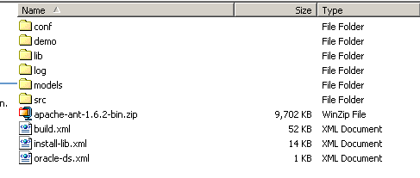
6 | Extract the contents of the Ant zip file, apache-ant-1.6.2-bin.zip and save it to your computer. For example, if your root directory in Windows is C:\, then extract your Ant home directory to C:\apache-ant-1.6.2.
7 | Verify that the environment variables ANT_HOME and JAVA_HOME are set and that your PATH statement includes the locations of the Ant and Java binaries. For example., PATH should include C:\apache-ant-1.6.2\bin; C:\j2sdk1.4.2_06\bin.  To do this in Windows:  - Select My Computer > Properties (from the shortcut menu) > Advanced tab.  - Click the Environment_Variables... button.  - ANT_HOME and JAVA_HOME must each be listed in one or the other of the panels of the dialog box. To add either, below one of the panels, click the New button.  - In the New User Variable dialog box, add the Variable and Variable Value.  Examples:  Variable = ANT_HOME; Variable Value = C:\apache-ant-1.6.2  Variable = JAVA_HOME; Variable Value = C:\j2sdk1.4.2_06  - Verify that the PATH statement listed in the Environment Variables dialog box includes both the ANT_HOME and JAVA_HOME binaries and that they read as follows: C:\j2sdk1.4.2_06\bin;C:\apache-ant-1.6.2\bin. (To easily review these, copy them to a text editor.) If necessary, click the Edit button and enter the correct information.

Running the Example
The {product} example is configured to work with MySQL 4.1.11, however, you must assign the appropriate values for the database properties in the deploy.properties file.

NOTE: | When entering information for use by the {product}, no spaces are allowed in filenames or directory names.

Modifying the deploy.properties File in Windows | - The file {home_directory}/conf/deploy.properties contains properties values that must be updated for your system environment. These values are used during the installation step to indicate the location and version of software.  - For the purpose of running the example, we recommend that you only modify the properties listed in both Table 4 and Table 5, as described. Otherwise, leave the deploy.properties unaltered.  - Note: Do not modify the forward slashes (/) in the deploy.properties file, even when installing on Windows.

Property Name | Description
ant_home | Provide the home directory for Ant (For example, in Windows, C:\apache-ant-1.6.2).
install_tomcat | Specify yes to install Tomcat 4.1.31 (http://jakarta.apache.org/tomcat/) or specify no if Tomcat or another web container is already installed.  Note: If you specify yes, any previous versions of Tomcat may be overwritten which could adversely affect programs running on your computer.
tomcat_home | Provide the home directory for Tomcat (for example, in Windows, C:\ tomcat). If you instruct the {product} to install Tomcat, this property defines the directory in which it will be installed.  Note: This directory name cannot contain any spaces or this will cause errors.
mysql_home | Provide the home directory for MySQL (for example, in Windows, C:\mysql). If you instruct the {product} to install MySQL, this property defines the directory in which it will be installed.  Note: This directory cannot contain any spaces or this will cause errors.  See Table 5 and User MySQL Download on page 11 for configuring other MySQL properties.
project_name | The default project_name for the {product} is {name}. If you choose to replace the name, be sure and use your user-defined name for all project_name parameters described in this installation and test guide.
Table 4 Required deploy.properties values

NOTE: | When entering information for use by the {product}, no spaces are allowed in filenames or directory names.

Modifying the deploy.properties File in UNIX or Linux | - The file {home_directory}/conf/deploy.properties contains property values that must be updated for your UNIX or Linux system environment. These values are used during the installation step to indicate the location and version of software. For example, make sure to update the pathnames to point to the location of MySQL, etc., on your computer.
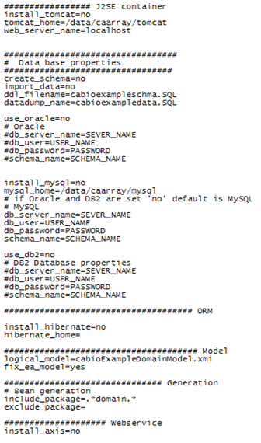
Figure 2 Example deploy.properties file for UNIX/Linux

MySQL Database Issues | Select from the four scenarios described below Error: Reference source not foundregarding MySQL, and modify the deploy.properties file appropriately. (We recommend you use scenario 1a, allowing the {product} to download and install MySQL.)

Scenario | 1  a. You have not downloaded MySQL,  or  b. You have an installed MySQL and want the {product} to reinstall it. |  | 2  You do have an installed MySQL but want to create a new user |  | 3  You do have an installed MySQL and want to use an existing user.
install _  mysql | Yes |  | No |  | No
db_user | User name to create for your MySQL database |  | User name to create for your MySQL database |  | Existing user name
db_pass  word | Password to create for your MySQL database |  | Password to create for your MySQL database |  | Existing password
schema_ name | Name of schema to create |  | Name of schema to create |  | Name of existing schema
db_  server_ name | Fully qualified server name of the machine where mySQL will be installed.  Example: localhost |  | Fully qualified server name of the machine where mySQL is installed.  Example: localhost |  | Fully qualified server name of the machine where mySQL is installed.  Example: localhost
create_mysql_  user | Yes |  | Yes |  | No
create_schema |  | Yes |  | Yes |  | No
install_data |  | Yes |  | Yes |  | No
Table 5 MySQL properties in the deploy.properties file

User MySQL Download | If you would like to download and install MySQL yourself and are using Microsoft Windows, observe the following guidelines to ensure that your installation is compatible with the {product}.

Perform the following steps to download and install MySQL:

Step | Action
1 | When using the MySQL installation wizard, select the Custom setup type (do NOT choose Typical).
2 | In the Custom Setup screen of the wizard, change the installation path to a location that does not include any spaces, for example C:\mysql.
3 | After the wizard has finished installing MySQL, you will be prompted to sign up for a MySQL.com account. This step is optional (most users will want to choose Skip Sign-Up).
- 4  4 | The final screen of the setup wizard gives you the option to configure the MySQL server. Make sure this box is checked before pressing Finish.
- 5  5 | If you are not sure about how to configure your instance of MySQL, step through the configuration wizard and use the default values already selected. However, on the screen allowing you to choose the Windows options, UNCHECK the option to Install as Windows Service.

Building a Demonstration System | Perform the following steps to build your system.

Step | Action
1 | In a Command Prompt window, enter cd {home_directory} to go to your home directory (for example, in Windows C:\cacoretoolkit).
2 | Enter ant build-system.
3 | After your web application server has completely finished starting, run the following command to deploy the system web services: ant deployWS.

NOTE: | These commands should only be run once with the deploy.properties file as you have configured it. After you have run build-system the first time, you must update the deploy.properties file so that software is not reinstalled on subsequent executions of build-system.

Ant messages display as each task is processing. The build-system task builds the entire system and deploys the software to the webapp directory of the web application server installation specified in the deploy.properties file.

Figure 3 displays the last few tasks of a successful build.
Figure 3 Successful build-system task

NOTE TO WINDOWS USERS : | Command screens that pop up during the build indicate that MySQL and Tomcat are running. If you plan to continue working with the {product}, or proceed through the testing procedures in this chapter, be sure and leave those windows open. Closing them kills the associated applications.

Figure 4 illustrates the directory structure resulting from running the build-system task. This task accomplishes many tasks including generating and compiling the domain source files, compiling the system source files, generating the Object Relational Mapping (ORM) configuration files and building the client.jar and server.war files. Most of these files are found in the output directory and subdirectories shown in Figure 4.
Include screen shot of directory structure
Figure 4 Generated Directory Structure

Executing Tests
This section is optional.
Tests must be performed to make sure your system is functioning properly. Perform the following system tests to verify a successful installation.
WARNING TO WINDOWS USERS: | Command screens that pop up during the build indicate that MySQL and Tomcat are running. You must leave those windows open as you execute the {product} system tests. Closing them kills the associated applications.

Testing the Proxy
Perform the following steps to test the proxy configuration:

Step | Action
1 | Enter the following URL in your browser:  http://{web server name}:8080/{project_name}/server/HTTPServer  Note: project_name is defined in the deploy.properties file. Example: {name}
2 | For the initial example, enter: http://localhost:8080/cacore30/server/HTTPServer

If you see the following message, you have successful deployed the system:
Welcome to the HTTP Proxy. The Server has been deployed. call doPost to send request!

Testing the Database
Perform the following steps to the database schema and verify data was loaded.
Step | Action
1 | In a Command Prompt window, enter cd {mysql_home} to go to your MySQL home directory.  Note: mysql_home is defined in the deploy.properties file.  Example: cd C:\mysql
2 | Enter cd bin to go to the bin directory.
3 | Enter mysql to execute the MySQL monitor.
4 | Enter select * from {schema_name}.clone;.  Notes:  - schema_name is defined in the deploy.properties file.  Example: {name}  - The semi-colon is an important part of the command--it prompts its execution.

If you see data, then your database load was successful

Testing the System
Perform the following steps to test the system:
Step | Action
1 | Enter the following URL in your browser to verify all your required system resources are available: http://{web_server_name}:8080/{project_name}/happy.jsp.  Note: project_name and web_server_name are defined in the deploy.properties file.  Example: project_name = {name}; web_server_name = localhost
2 | For the getting started example, enter: http://localhost:8080/cacore30/Happy.jsp

Figure 5 displays the browser window that opens with a successful system test.

Figure 5 Browser display with successful system test

Running the Demonstration Program
Perform one of the two following methods to run the demonstration program.
Step | Action
Method 1 | - Unzip the {home directory}\output\package\{web_server_name}\client.zip file to a temporary directory such as C:\SDKClient.  - In a Command Prompt window, enter cd C:\{temporary directory} for example cd c:\SDKClient.  - Enter ant.
Method 2 | - In a Command Prompt window, enter cd {home_directory}\output\package\{web_server_name}\client (for example, in Windows cd C:\cacoretoolkit\output\package\ localhost\client).  - Enter ant.

WARNING | If, in the deploy.properties file, you replaced the default project_name with a name of your choice, or if you defined a web_server_name other than localhost, you must edit the TestClient.java and TestEVS.java files accordingly for the demonstration to run successfully.

Figure 6 displays an example output (Method 2) of running the demonstration.

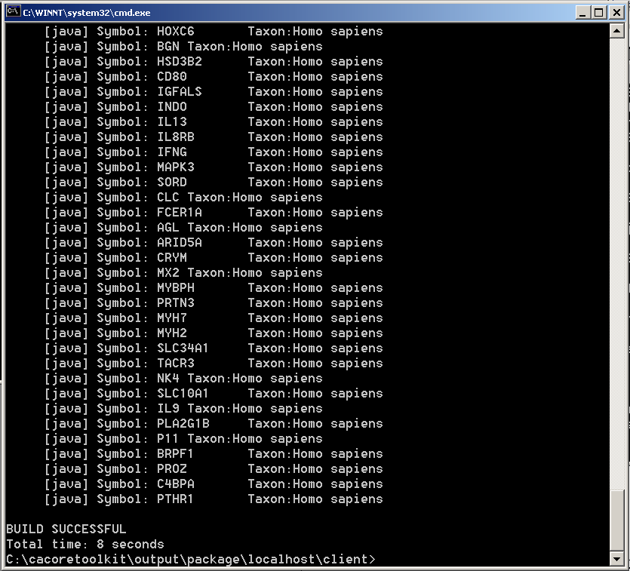
Figure 6 Example Output of Demo
NOTES: | - The TestClient.java file executes the default query which searches for genes whose symbol begins with the letter ‘N’. The TestClient.java file contains other queries which have been commented out, but can be run to see other examples of querying.  - These successful tests indicate the jar file was inserted to the class path for the test run; the class path is in place; the {product} can use the objects in the code generator; it can communicate with the database and servlet environments and “data in objects”.

Congratulations! If your installation passed these tests, you have successfully installed the infrastructure needed for a {product} -like system and built a demonstration application. Refer to the {product} technical documentation cross reference for the detailed procedures necessary to add your own appropriate text here.

Appendix I {product} Components
The {product} includes the following components:
  - Sample UML object/data model to use with the development kit
- cabioExampleModel.eap
  - XML Metadata Interchange (XMI) Version of the sample model
- cabioExampleModel.xmi
  - Framework packages
- gov.nih.nci.system
- gov.nih.nci.common
- org.hibernate
  - Configuration files to enable you to customize your installation to meet your specific database, server, and other network needs
- deploy.properties
- download.properties
  - Ant buildfile
  - Semantic connector package
- gov.nih.nci.semantic
  - EVS package
- gov.nih.nci.evs.domain
- gov.nih.nci.evs.query
  - Code generator package
- gov.nih.nci.codegen.core
- gov.nih.nci.codegen.framework
- Java JET templates for generating caCORE like APIs
  - MySQL database
  - Demo package with examples of how to leverage the code generation framework (for advanced users)

Contacting Technical Support
{product} Application Support | Include appropriate application support information, include information app support needs to troubleshoot your request.

