caBIG Software Requirements and Specification Template

DOCUMENT CHANGE HISTORY
Version Number | Date | Description
1.0 | November 2004 | Draft
1.1 | March 2005 | Added Sign-Off Page
[The first objective of the Software Requirements and Specification Document (SRSD) is to capture the complete software requirements for the system, or a portion of the system. The SRSD should fully describe the external behavior of the application or subsystem identified. It also should describe nonfunctional requirements, design constraints and other factors necessary to provide a complete and comprehensive description of the requirements for the software.
[The second objective of the SRSD is to describe the design of the requirements. It describes the design decisions, architectural design, and the detailed design needed to implement the software. The SRSD is used as the basis for implementing the software. It provides the acquirer visibility into the design and provides information needed for software support.
Template Instructions:
Throughout this template there are many italicized text areas surrounded in brackets '[]', similar to these instructions. These areas either prompt for user entry or provide instructions for completing the section. Delete each bracketed text area after completing the document. If a section title is italicized and surrounded in brackets ‘[]’, i.e. [Notes], this indicates that the entire section is optional.
Areas in regular text are standard wording that may not require modification.

Q5 Disease Classification by Mass Spectrometry Pattern Recognition Developer Project / 79761CBS10]
Q5 R Plug-in Release 1.0
Software Requirements and Specification Document
Version 1.1

[Insert approval date of document]

Document Change Record
Version Number | Date | Description
1.0 | [Insert approval date of document] | Initial draft document
1.1 |  | Added Technical Details to document

TABLE OF CONTENTS
1. caBIG Software Requirements and Specification Template i
2. Introduction 1
2.1 Related Documents 3
2.2 Scope 3
2.2.1 Identification 3
2.2.2 System Overview 4
2.2.3 Document Overview 6
2.3 Reference Documents 6
3. Project Description 7
3.1 Project Perspective 7
3.2 Project Functions 7
3.3 User Characteristics 8
3.4 Constraints 8
3.5 Qualification Provisions 10
3.6 Assumptions and Dependencies 10
4. Requirements 11
4.1 Datafile Handling 11
4.2 Analysis Routines 12
4.3 Analysis Output 13
5. System Architecture 14
6. Components 15
6.1 q5 15
6.2 mzXML 17
6.3 normalize 18
6.4 pcaProject 19
6.5 pca 20
7. [NOTES] 21
8. Sign off 22
8.1 Approval 22
9. Appendix A – Acronym List 23
10. [Appendix B – Other Appendices] 24

Introduction
This SRSD captures the complete software requirements for the Q5 software and describes the design decisions, architectural design and the detailed design needed to implement the software. It provides the acquirer visibility in to the design and provides information needed for software support.
The Q5 application is a probabilistic classification algorithm that employs principal components dimension-reduction and linear discriminant analysis.
Q5 has shown utility in disease classification of expression-dependent proteomic data from mass spectrometry of human serum. Q5’s ability to classify complex fragment mixtures was evaluated by testing its ability to discriminate the mass spectra of healthy vs. disease human serum samples. The two disease states examined in testing were ovarian and prostate cancer. Existing screening methods for both cancers carry a low positive predictive value (PPV). When detected early, the 5-year survival rate increases for both cancers.
Q5 outputs a classifier (discriminant) capable of classifying new mass spectra into one of the classes. The new spectra (called test spectra) that have not been seen by the algorithm and their classifications are unknown to the algorithm; the goal of the Mass Spectra Classification Algorithm (MSCA) is to determine the correct classification based on the classifier constructed from the training set. Classification verification is the testing process by which the discriminant is evaluated for its ability to correctly diagnose test samples. MSCAs can be characterized by the type of MS data processed, type of algorithm employed, and method of classification verification used.
Completeness of mass spectrum. Analysis may be performed on either complete or partial mass spectra. Complete mass spectra consist of the relative intensities of all m/z values acquired during MS data collection. This includes the relative intensities observed for all m/z values from 0 up to the upper limit of detection. An MSCA that processes complete mass spectra works with the entire recorded spectra: no values are “manually” excluded through preprocessing. When portions of a spectrum are excluded from consideration, we say a partial spectrum is generated.

Heuristic vs. Exact Classification Algorithms. Heuristic classification algorithms include approaches such as genetic algorithms, neural networks, and simulated annealing. These algorithms generally require multiple iterations to converge to a classifier; furthermore, the solution found by heuristic algorithms is not guaranteed to be optimal. In addition, many heuristic approaches are non-deterministic. Even when run on the same training set, the same non-deterministic algorithm often converges to a different discriminant. In contrast, MSCAs that utilize closed-form exact solutions (CFES) compute an exact solution using closed-form equations. CFES algorithms are computationally efficient; they are non-iterative and deterministic (i.e., always compute the same solution). Linear Discriminant Analysis (LDA), and thus Q5, are CFES algorithms.

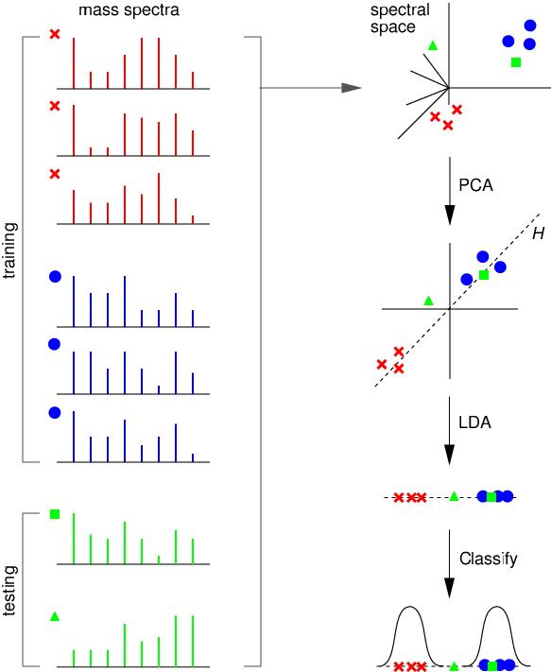

Related Documents
The current Q5 distribution contains a set of Matlab (Mathworks Inc, Natick, MA) functions. Q5 is presently written entirely in Matlab.
Reference: Ryan H. Lilien, Hany Farid, and Bruce R. Donald. "Probabilistic Disease Classification of Expression-Dependent Proteomic Data from Mass Spectrometry of Human Serum." Journal of Computational Biology, 10(6) 2003, pp. 925-946.
Q5 Use Case Scenarios (2005)

Scope
The overall scope of the Q5 Disease Classification by Mass Spectrometry Pattern Recognition Developer Project / 79761CBS10 is to reproduce the Q5 algorithm currently implemented in the Matlab software, a proprietary software package, into the open source software environment of R (a GNU Project implementation of the proprietary S software package developed originally at Bell Laboratories).
Initially the software will be implemented under the category of a tool, however the intent of the overall process is to make the Q5 software a service. This category redefinition will occur when the Fox Chase LIMS piece is implemented. This will require update to this document and utilization of not only a base UML document of the programmatic flow and interfaces but usage of the CDE and formal review by the VCDE upon implementation of this functionality. We hare hoping to work directly with the Fox Chase group to ensure that the data elements are in sync to the caBIG vocabulary but in line with the caBIG grid as a whole.
For more information about the R software package please refer to the url: http://www.r-project.org/

Identification
Abbreviations:
- Q5 Software Project - Abbreviated reference to the "Q5 Disease Classification by Mass Spectrometry Pattern Recognition Developer Project / 79761CBS10"
- OHSU - Oregon Health and Science University

System Overview
The Q5 software outputs a classifier (discriminant) capable of classifying new mass spectra into one of the classes( such as healthy vs. disease). The new spectra (called test spectra) that have not been seen by the algorithm and their classifications are unknown to the algorithm; the goal of the Mass Spectra Classification Algorithm (MSCA) is to determine the correct classification based on the classifier constructed from the training set. This method was originally outlined in the paper by Ryan H. Lilien, Hany Farid, and Bruce R. Donald. "Probabilistic Disease Classification of Expression-Dependent Proteomic Data from Mass Spectrometry of Human Serum." Journal of Computational Biology, 10(6) 2003, pp. 925-946.
The current adopter site for the software is targeted as Oregon Health and Science University and they will be performing the user acceptance and initial usage functions. The development group is composed of various members of the Computational Genetics Laboratory and other members of the Dartmouth Medical School.
The development site for the software will be located at the Norris Cancer Cotton Center located in Lebanon, N.H. and Dartmouth College with initial user testing and deployment at the OHSU site.
This development effort will utilize a "modified waterfall method" of software development with the SDLC phases being:
- Risk Analysis Assessment
- Base Analysis (Both system level and interfaces)
- Requirements gathering
- Development of use case scenarios
- Base prototype conversion of the current Q5 algorithm functionality
- Requirements release for final software development
- Development of test cases
- Implementation of the software for testing
- Execution of system test cases locally for validation
- Execution of use cases externally for validation
- Software release documentation and training

Software Development Life cycle Flow:

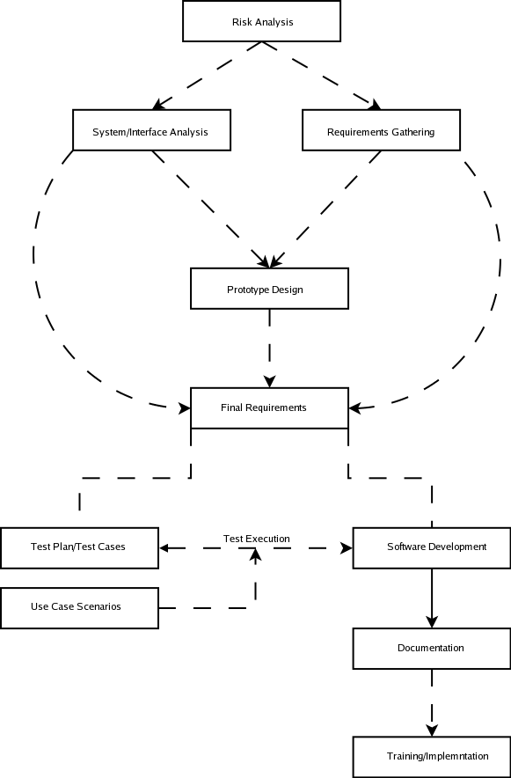
The Major Components of the R version of Q5 will consist of the following:
- Base Q5 algorithm developed as an R software plug-in
- Reading of a standardized datafile of mass spectrometry data (to be defined)
- Output of a project determined standardized format for analysis results
- Connectivity to the Fox Chase LIMS server located at Dartmouth Research Computing Resource as a mechanism for input/output source for the mass spectrometry data.

Document Overview
This SRSD captures the complete software requirements for the Q5 software release 1.0 as part of the Q5 Software Project.
This document should be considered as a mechanism to outline the requirements for design of the Q5 software. For detail regarding the algorithm itself, please refer to the original paper outlining the algorithm as referenced in section 2.1.
The remaining SRSD sections are organized as follows:
- Section 2. Project Description: Describes the general factors that affect the Q5 Software Project.
- Section 3. Requirements: Describes all the software requirements to a level of detail sufficient to enable designers to design a system to satisfy those requirements, and testers to test that the system satisfies those requirements.
- Section 4. Notes: Contains general information that aids in the understanding of this document.
- Appendix A. Acronym List: Defines the abbreviations used on the project.

Reference Documents
For additional project, and requirement specific information, refer to the following documents:
- Ryan H. Lilien, Hany Farid, and Bruce R. Donald. "Probabilistic Disease Classification of Expression-Dependent Proteomic Data from Mass Spectrometry of Human Serum." Journal of Computational Biology, 10(6) 2003, pp. 925-946.
- Q5 Project Use Case Scenarios

Project Description

Project Perspective
[Describe the relationship of the software products or projects. Describe the hardware and peripheral equipment with which the project operates.]
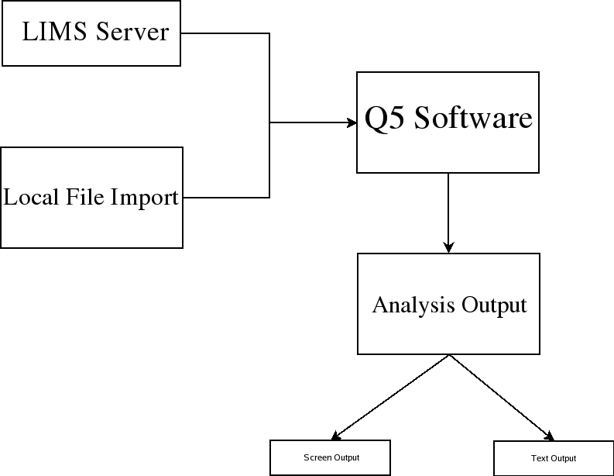
The structural architecture is outlined in the graphic depicted above. The Q5 software will run within the R Software framework as a module. This software package supports installations to Unix (and variants), Mac and Windows operating systems as to make it cross platform usable.

Project Functions
NCCC and Dartmouth have performed research on disease classification by spectrometry pattern recognition. The tie of clinical proteomics programs to patient diagnosis and the monitoring of treatments is in early stages of technology development and substantiation. Valid early detection protocols in identifying the presence or absence of cancerous cells will increase patient survival rates and extend their life expectancies by hastening appropriate management of treatable malignancies. Proteomic profiling of cancer cells exposed to experimental therapies will provide critical information in designing treatment regiments and discovering therapeutic targets. To address this challenge, researchers at Dartmouth have developed Q5, a Mass Spectrometry Classification Algorithm (MSCA) that is a combinatorially precise algorithm cast in closed-form equations and therefore provides a means to compute an optimized solution for disease classification. Q5 is designed to distinguish between plasma profiles of normal and disease-bearing individuals. Currently, Q5 is available as a MatLab application.

NCCC will apply an internally developed mass spectrometry pattern recognition tool, Q5, designed to distinguish between plasma profiles of normal and disease-bearing individuals. Ultimately, NCCC aims to deliver rapid disease classification method for dozens of neoplastic and other diseases through further development of Q5. Support for Q5 development with caBIG technologies and standards will facilitate the participation of institutions in data analysis.

To date, the Q5 algorithm method has been developed, evaluated and applied by one research group at Dartmouth. The current implementation uses MatLab for statistical calculations. For this project, Q5 will (1) Be translated to open source; (2) Be deployed to the Adopter site(s) for analysis; (3) Be adapted to the caBIG architecture.

User Characteristics
The primary target user audience identified by the caBIG adopter (OHSU) site has been the role of a bio-statistician with assistance for software installation via a bio-informatics specialist.
Bio-statisicians and bio-informatics personnel (both biostatisticians and bioinformatics don’t need to be hyphenated) at OHSU will be evaluating the output of the analysis routines for accuracy.
Developers located at the Dartmouth site will be performing unit testing on code produced for the Q5 project.

Constraints
- External Software Dependencies
The R software Project page supports operating system releases for Max [Mac] OS (System 8.6 to 10.2.x and above) as well as Linux and Microsoft Windows(95 and later). The source code for the R software is available for the software for compilation on additional platforms as well.
The R software was selected as a natural candidate due to the great number of inherent statistical functions already readily available to the language allowing possible additional statistical analysis of the results set via the use of the internal graphing functions. Finally, the compatibility of R to other toolsets and development languages might be used in structuring an "end to end" workflow for analysis of the data by the given site using the product.
Presently the only dependencies are the inclusion of the PROcess, caMassClass and MASS modules to be loaded [should make note that these packages have their own dependencies as well and list these]. These packages can be retrieved at the CRAN (Comprehensive R Archive Network) or the BioConductor R repository.

When loading the packages for Q5, the order of precedence should be PROcess, caMassClass and then Q5 (which will call MASS if already installed)

The Q5 Project has identified the R software version 2.1.1 [we have been working with R 2.2.0 on our Linux machine and have not run into any problems] to be the target environment for development of the Q5 R script.

Data Standards:
- Q5 Data Input Format
The specifics of the input format for the Q5 software has not been defined at this point outside of the development decision to utilize the mxXML format. Use of this format appears to be a somewhat standardized format in the mass spectrometry field and should allows integration into workflow with other caBIG sponsored products such as the R-Proteomics project.
The goal is to make this flexible but adhere to a standard that allows for flexibility and maintainability within the changing caBig infrastructure. Consideration of the widely used format of mzXML for the use by the Fox Chase LIMS server as well as the availability of XML parsers for various platforms is the current consideration for the output format. At present the Q5 software will output a classifications such as “diseased” and “non diseased”. [Note that current output is binary from predict.lda step and should note how diseased and nondiseased states are coded] Although there are more complex terminologies used in the accurate description of disease states, this is seen outside the initial scope of the Q5 project and therefore not extended to meet more specific classification output types.
At present, the adopters of the Q5 project do not intend to implement the LIMS system, so the software will be able to accept pre-formatted mzXML datafile from the local workstation as well. Addition of the LIMS connectivity will modify the category of this software from tool to service, therefore, requiring additional modeling of the system, it’s interaction with the server and to ensure that the data elements are in line with the caBIG vocabulary.
- Q5 Data Output Format
The output format will be in the form of two files created during the Q5 analysis. These two files are supplied to the algorithm in R and are written to provided path and filename. The raw output results will be written to one file in the format of:
Label:<tab>value [This is not in current version of Q5 software and should be either taken out of this document or a new version with this output format should be released]
The second file will contain the graph of the eigenvalues [also not in current version of document, should be removed or code re-released] generated by the Q5 analysis. The graphic will be rendered as a portable network graphic formatted image (PNG). This format is compatible with most all word processors on many platforms.
The selection of the R language for development was made based upon the inherent statistical functions within the language itself that are accessible to the end user and the fact that this software is open source and freely available to many platforms and in source format. This allows the potential for additional analysis and exploration of the end results by the user proficient in the R software. The only database interaction intended for the Q5 software is importing of spectra via the Fox Chase LIMS server.

Qualification Provisions
a. Demonstration: The operation of the system or component that relies on observable functional operation not requiring the use of instrumentation, special test equipment, or subsequent analysis.
b. Test: The operation of the system or component using instrumentation or other special test equipment to collect data for later analysis.
c. Analysis: The processing of accumulated data obtained from other qualification methods. Examples are reduction, interpretation, or extrapolation of test results.
d. Inspection: The visual examination of code, documentation, etc.
e. Special qualification methods: Any special qualification methods for the system, such as special tools, techniques, procedures, facilities, and acceptance limits.

Assumptions and Dependencies
Prior installation of the R software environment on the local workstation including the R MASS library (see section 3.4(1) for a statement of dependencies as well).
The current version of R will configure and build under a number of common Unix platforms including cpu linux-gnu for the i386, alpha, arm, hppa, ia64, m68k, mips/mipsel, powerpc, s390, sparc , and x86_64CPUs,powerpc-apple-darwin, mips-sgi-irix, rs6000-ibm-aix, and sparc-sun-solaris.
All Maldi-Tof data sets used by the adopter will be pre-processed (via R-Proteomics or similar software) to reduce dimensionality prior to execution of the Q5 software and make the analysis more time efficient. Although this is not a requirement of the software it is a workflow used by the adopter site. Q5 should be able to run on raw full spectra (properly formatted in mzXML) without pre-processing although the length of processing time may increase greatly.

Requirements
The Requirements categories outlined correspond to each functional area of the Q5 software and the software flow diagram.

Datafile Handling

Table 3.1-1: Data Handling Requirements
Req ID | Requirement Type | Requirement Description
1.1 | System | The system will allow the end user to import spectra from a local datafile located on the client workstation or network.
1.2 | System | The system will allow the end user to import spectra from a Fox Chase LIMS server into the Q5-R software via an mzXML transport mechanism.
1.3 | Interface | The system will display an error to the user if the datafile attempting to be imported is improperly formatted for usage.
1.4 | System | The input datafile format will be in mzXML format. Technical tag details will be outlined in the architecture section.[change this to “refer to architecture section of this document]
1.5 | System | The Q5 system will accept both properly formatted Seldi-TOF and Maldi-TOF data as inputs to the software.
1.6 | System | The Q5 system will allow for sample attribute acquisition by common ID value (a SUID, or single unique ID) from the Fox Chase LIMS. This indicates that the metadata drawn for a given record will be accessed by its SUID not the record itself in case of metadata extension.

Analysis Routines

Table 3.1-1: Analysis Routines Requirements
Req ID | Requirement Type | Requirement Description
2.1 | System | The Q5 system will allow the user to indicate whether or not the imported dataset is to be used for testing/training or to be split for use as both.
2.2 | System | The Q5 system will reduce the dimensional space for the data using PCA (Principal Components Analysis) within the software. This mechanism will be made visible to the user so that they can call this portion of the functionality from the R environment.
2.3 | System | Following PCA, the Q5 system will implement a linear discriminant analysis method against the data. This mechanism will be made visible to the user so that they can call this portion of the functionality from the R environment.
2.4 | System | The output of the LDA step of the Q5 system will be a linear discriminant used to classify the remainder of the data. This mechanism will be made visible to the user so that they can call this portion of the functionality from the R environment.

Analysis Output

Table 3.1-1: Analysis Output Requirements
Req ID | Requirement Type | Requirement Description
3.1 | System | The Q5 system will output the disease classification from the analysis in a numerical value as well as the associated statistics (Classification Sensitivity, Classification Specificity, Percentage of Samples Classified, Percentage of Samples Correctly Classified, and Positive Predictive Value.) These terms will be reviewed in the caDSR and made more solid to caBIG specifications.
3.2 | System | The output datafile format will consist of two possible files.  - datafile consisting of the output values (outlined in the analysis output section)  - graphics file containing the graph of eigenvalues in a portable network graphics format. [Again, not implemented in current version; take requirement out or re-release software]  These filenames and paths will be supplied by the user to the Q5 script. If the user does  not provide these parameters to the script, the Q5 script will write the output values to  standard out and produce an R graph of the eigenvalues.  Details of the output format are contained in the data standards section (#3) of this  document.
3.3 | System | The PCA function within the Q5 script will allow the user to output the values for a plot() function from R to produce a graph of sorted Eigenvalues. [not implemented in current version; take requirement out or re-release software]

System Architecture
Architectural Design – This diagram outlines the basic process flow of the Q5 software. The flow uses the major functional components:
- Q5 (main calling script) – This is the primary script that is the controlling interface for the overall Q5 process.
- LIMS – Server used for raw spectra retrieval. Not used in the initial Q5 software release(to be implemented when the Fox Chase Proteomic LIMS server is available)
- Database Filesystem – General representation of the datafile (this will be deployed in the initial release as mxXML)
- PCA – Principal Components Analysis portion of the script. This is an exposed interface that will allow the user to implement the standard PCA as outlined by the Q5 algorithm or utilize their own by calling a different method such as a windows PCA library for instance.
- LDA – Linear Discriminant Algebra portion of the Q5 script. This was broken out in case the user might want to utilize another method during this piece.
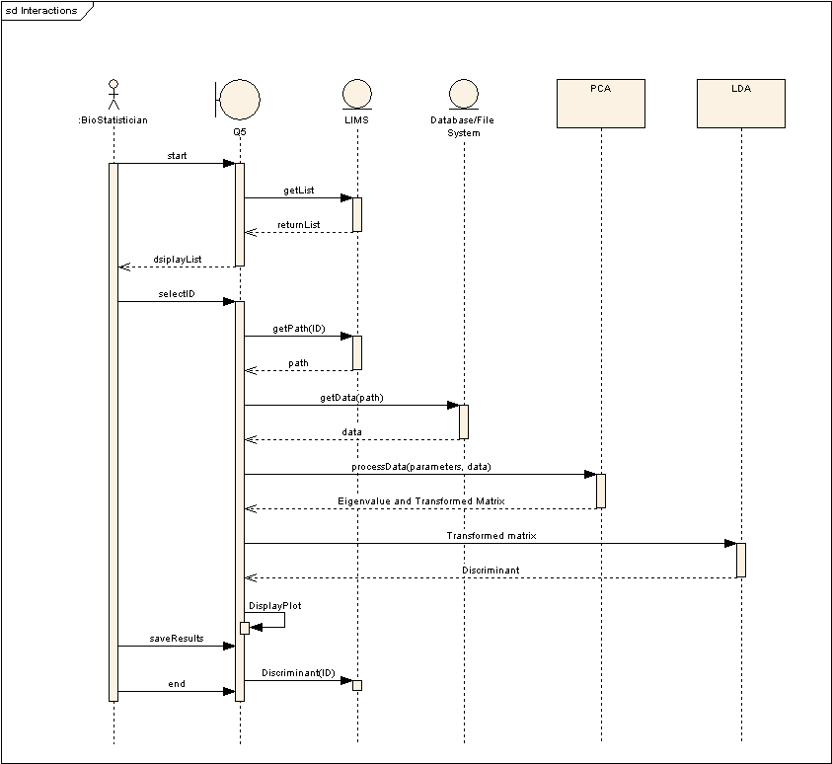

Components

q5
Purpose – Provides the main function for the script. Trains a disciminant on given training data and then assesses its predictive capacity with testing data. This is the function of the Q5 algorithm. Each of the functions it performs are accomplished by calling functions that are passed as parameters, this allows users to substitute their own functions for any of the steps in Q5 (with the exception of the statistical parameters generated).
- Type - This is the main function that implements the Q5 algorithm.
- Functional Description – Performs the Q5 algorithm in a flexible fashion that allows the user to alter its sub-functionality.
- Subordinate – Four functions passed by the user. Provides default values that depend on pca, lda, pcaProject, and MASS:::predict.lda.
- Dependencies - Requires the MASS package.
- Preconditions – Requires two matrices of data, one for training, one for testing, requires two vectors that describe the classes of the data. Optionally takes four functions for dimensional reduction, discriminant construction, data projection, and class prediction.
- Interfaces - q5(trainData, trainClasses, testData, testClasses, reductionFunction=pca, discriminantFunction=lda, projectionFunction=pcaProject, predictionFunction=MASS:::predict.lda)
- Takes two matrices of real numbers, one of training data, one of testing data. Takes two vectors of integers the label the class of each row in the two matrices, 1 indicates diseased state. Returns the generated discriminant, the estimated positive predictive value of the discriminant, the percentage of cases in the testing data that were correctly classified, the estimated sensitivity and specificity.
- Graphics - This is a non-graphical routine.
- Resources - None
- Error Conditions – The function will fail with an error message if any of the passed objects are not of the correct type.
Example Implementation –

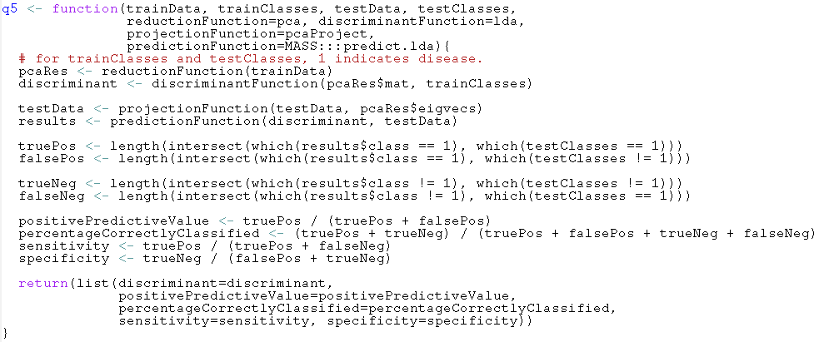

mzXML
Purpose - The mzXML function loads a datafile from a user supplied string containing the path to an mxXML file. It returns a list of two values; "mass", the mass to charge ratio of each peak in th escan and "peaks" which are the intensities for each peak in the scan.
- Type - This is a conveneince function within the Q5 script for the user's use.
- Functional Description - Reads each scan in the file and appends its peaks and mass to charge ratios to separate items in a list.
- Subordinate - This function makes external calls to function read.mzXML in the caMassClass.
- Dependencies - Requires the caMassClass package.
- Preconditions - Requires a string describing the location of a local file in mzXML format. This function is called prior to executing q5.
- Interfaces - mzXML(filename)
- Graphics - This is a non-graphical routine.
- Resources - None
- Error Conditions - The function will fail with an error message on malformed mzXML. The function will also provide an error message if the user supplied string does not contain the path to a local mzXML file.
- Example Implementation –

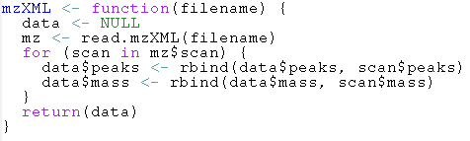

normalize
Purpose – Normalizes the peak intensity matrix. This is not part of the main script but it provides a simple normalization for the convenience of users.
- Type - This is a function that can be called before q5 to normalize the data.
- Functional Description - The normalize function normalizes the peak intensities of a scan to the range [0, 1] using a standard linear transformation.
- Subordinate - This function makes no function calls to dependency packages.
- Dependencies – None.
- Preconditions - Requires a two dimensional matrix of real values
- Interfaces – normalize(mat)
- Graphics - None.
- Resources – None.
- Error Conditions – This function will fail with an error message if it doesn't receive a matrix of rank 2.
- Example Implementation -
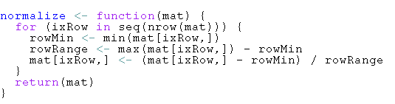

pcaProject
Purpose – Projects data into the pca space on which the discriminant was defined.
- Type - This is a function that can be passed to q5 as the projectionFunction parameter.
- Functional Description – Multiplies the user supplied matrix by the user supplied eigenvectors.
- Subordinate – This function makes no function calls to dependency packages.
- Dependencies – None.
- Preconditions - Requires two two dimensional matrices of real values
- Interfaces – pcaProject(mat, eigvecs)
- Graphics - None.
- Resources – None.
- Error Conditions – This function will fail with an error message if it receives the wrong type of input. The size of the second dimension of the matrix (mat) must be equal to the size of the first dimension of the second matrix (eigvecs).
- Example Implementation –

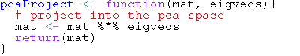

pca
The pca function performs principle components analysis on the given matrix.
- Type - This is a function within the Q5 script with an exposed development interface.
- Purpose – Dimensional reduction of the data.
- Function – Performs principle components analysis by singular value decomposition, taking the diagonal of the resultant matrix and multiplies this by the input matrix.
- Subordinate – None.
- Dependencies – Takes a two dimensional matrix of real values.
- Preconditions - Requires a two dimensional matrix of real values
- Interfaces – Performs principle components analysis by singular value decomposition, taking the diagonal of the resultant matrix and multiplies this by the input matrix.Returns the resultant matrix and the eigenvectors and eigenvalues of the matrix..
- Graphics - None.
- Resources – None.
- Error Conditions – This function will fail if it receives the wrong type of input with an error message.
- Example Implementation –

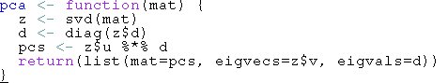

[NOTES]
[Insert any general information that aids in understanding this document (e.g., background information, glossary, and rationale). This section shall include a list of any terms and definitions needed to understand this document.]

Sign off

Approval

Architecture Workspace Rep Print Name Date
VCDE Workspace Rep Print Name Date
Adopter Rep Print Name Date

Appendix A – Acronym List
[Insert an alphabetical listing of all acronyms and abbreviations, and their meanings as used in this document.]
Term/  Abbreviation | Description
[????] | [Insert Project Name acronym]
[????] | [Insert Project all other project Test Plan specific acronyms and resort the table]
DBA | Database Administrator
PM | Project Manager
RM | Requirements Manager
RTM | Requirements Traceability Matrix
SCM | Software Configuration Management
SDLC | Software Development Lifecycle
SDP | Software Development Plan
SE | Software Engineering
SEPG | Software Engineering Process Group
SM | Software Manager
SOP | Standard Operating Procedure
SPI | Software Process Improvement
SQA | Software Quality Assurance
SW | Software
TBD | To Be Determined
TM | Test Manager

[Appendix B – Other Appendices]
[Use appendices to provide information published separately for convenience in document maintenance (e.g., charts, classified data). As applicable, the main text of the document should reference each appendix where the data would logically fit within the document. Appendices may be bound as separate documents for ease in handling. Appendices shall be lettered alphabetically (A, B, etc.).]

