Q5 Disease Classification by Mass Spectrometry Pattern Recognition Developer Project / 79761CBS10]

Adopter Data Analysis/ Review
Dartmouth Medical School

01/27/2005 - DRAFT

Table of Contents
I. Purpose 3
II. Environment Used 3
III Tests Performed 3
IV Conclusions 4
Appendix A 6
Appendix B 11

Purpose

The overall scope of this document is to provide an assessment of the synthetically created data files provided by the Q5 project adopter site, Oregon Health and Sciences University. The scope of this is merely to check for the proper formatting of the data, run an analysis with the Q5 algorithm and raise any issues that might be seen as an issue for the software based upon the data itself or the result set produced.

Environment Used

The environment used for execution of the data was the same as the environmental setup as outlined in the environmental section (Section 4 – Hardware) of the Q5 Test Approach Document.

III Tests Performed

Information provided by the adopter site personnel indicate that design of the synthetic data was structured for two types of comparisons in which we also used as a basis for our assessment:

Effect size: group3 (control) vs group4 (case)

Presence/Absence of peptide markers:

group1 (control) vs group3 (case)
group1 (control) vs group4 (case)
group2 (control) vs group 3 (case)
group 2 (control) vs group 4 (case)
For each group there were two replicates with two plates each.
Their was initial concern that the data itself was asymmetrical (not a square matrix.) OHSU responded to our question regarding this and indicated that scans from the mass spectrometer may encompass different scan lengths.

The data was preprocessed during the data analysis by removing peaks which did not appear in both datasets for each experiment. A pairwise reduction was used for each experiment as opposed to an intersection between all of the experiments, which we found to be the most valid method for reduction. For the pairing of each case/control, the intersection of the mass to charge ratio was found. Only the peaks having this m/z values were kept. So, if A has {1, 3, 6}, B has {1, 2, 3} and C has {3, 6, 7}:

When A is the case and B is the control we only use the peaks with m/z {1, 3}
When A is the case and C is the control we only use the peaks with m/z {3, 6}

We utilized 50% of the data for the training set for each experiment and the division among the attributes was as even as possible(same ratio of cases to controls; endpoints not attributes). Parallelization of the analysis process itself was utilized for expediency of effort; however, it was performed in a manner that would be the equivalent of a serial process of the data.

See Appendix A for the scripts used in the data analysis.

IV Conclusions

Based upon our assessment, we are of the opinion that although the data seems sound in terms of format and basic content, however, we suspect/conclude that the signal represented in the dataset may be too weak for Q5 to pickup.

We did notice that several of the statistics were reported as “NaN” (not a number). This was due to their denominators being zero. Positive prediction value is true positives/(true positives + false positives). In some cases all of the testing instances were classified as negatives, so there were neither true nor false positives. Our speculation is that the poor performance of Q5 on the OHSU dataset is most likely a relection that no normalization or peak alignment registration has been performed with the data prior to being seen by Q5.

See appendix B for raw output results and associated graphs.

Several Questions/Considerations have been submitted by the Booze|Allen|Hamilton staff for us to consider while performing this evaluation:

Q: How exactly does the data perform with the algorithm?

A: In our opinion, the algorithm did not perform well. Possibly no better than Bernoulli trials or random search (although these comparisons were out of scope of task)

Q: Could having a spiked set of data and not real patient samples possibly provide skewed and irrelevant scientific results?

A: Possibly. One method of proving the validity of how a method works is to characterize difficult features of the problem domain and perform the analysis and see how the algorithm performs upon that given problem set.

Q: How will you know the training set used on the sets are valid?

A: We used the standard practice of splitting the data by 50% of the total data size and distributing the attributes as evenly as possible (given that the data is not perfectly symmetric). We have no method of tuning inherent to the software and we did not seek to discard eigenvalues given our observation of the results.

Q: Does data sample size matter?

A: Presumably it is a factor as performance may not have outperformed a standard random selection with all instances, however, we were unable to perform this test. The dimensionality of data has been an issue discussed throughout the process and OHSU indicated that they intend to utilize R-Proteomics as a preprocess reduction step.

Q: What artifacts are created if using this data?

A: This is more a data collection oriented question and we felt we did not have the domain expertise to properly address this issue with the data alone.

Q: How valid are the scientific conclusions you are making?

A: This is typically based upon the quality of the data as a whole and for the given dataset the conclusions are strongly supported.

Appendix A
This appendix contains the scripts and procedural process used during the data evaluation.

The procedural process, in terms of how the attached scripts in this appendix were called is as follows:

R --no-save < readmzXML.r
python runPBS.py

# make sure all the jobs complete before you continue
R --no-save < collect.r
R --no-save < analysis.r

The actual scripts used:
readmzXML:

source('Q5/R/q5.R')
source('utils.r')

root <- getwd()
for (ixRep in seq(2)) {
if (ixRep == 1) {
plateSeq = c(1, 2)
} else {
plateSeq = c(3, 4)
}
for (ixPlate in plateSeq) {
for (ixCombo in seq(5)) {
if (ixCombo == 1) {
ixControl = 3
ixCase = 4
}
if (ixCombo == 2) {
ixControl = 1
ixCase = 3
}
if (ixCombo == 3) {
ixControl = 1
ixCase = 4
}
if (ixCombo == 4) {
ixControl = 2
ixCase = 3
}
if (ixCombo == 5) {
ixControl = 2
ixCase = 4
}

setwd(paste('q5 synthetic data/replicate ', ixRep, sep=''))

setwd(paste('group ', ixControl, sep=''))
files <- list.files()[grep(paste('plate', ixPlate, sep=''), list.files())]
control <- getData(files)

setwd('..')

setwd(paste('group ', ixCase, sep=''))
files <- list.files()[grep(paste('plate', ixPlate, sep=''), list.files())]
case <- getData(files)
setwd('..')

masses <- control[[1]]$mass
masses <- getCommonMasses(control, masses)
masses <- getCommonMasses(case, masses)

setwd(root)
save(masses, control, case, file=paste(ixRep, '_', ixPlate, '_', ixControl, 'vs', ixCase, sep=''))

for (ixRow in seq(max(len(control), len(case)))) {
sink(paste(ixRep, '_', ixPlate, '_', ixControl, '_', ixRow, '_', ixControl, 'vs', ixCase, '_PBS_.r', sep=''))
cat("source('Q5/R/q5.R')\n")
cat("source('utils.r')\n")
cat(paste('load("', ixRep, '_', ixPlate, '_', ixControl, 'vs', ixCase, '")\n', sep=''))

cat(paste('if (len(control) >= ', ixRow, ') {\n', sep=''))
cat('group <- NULL\n')
cat(paste('group[[1]] <- control[[', ixRow, ']]\n', sep=''))
cat("peaks <- filterOnMasses(group, masses)\n")
cat(paste("save(peaks, file='", ixRep, '_', ixPlate, '_ixControl', ixRow, '_', ixControl, 'vs', ixCase, "')", '\n', sep=''))
cat('}\n')

cat(paste('if (len(case) >= ', ixRow, ') {\n', sep=''))
cat('group <- NULL\n')
cat(paste('group[[1]] <- case[[', ixRow, ']]\n', sep=''))
cat("peaks <- filterOnMasses(group, masses)\n")
cat(paste("save(peaks, file='", ixRep, '_', ixPlate, '_ixCase', ixRow, '_', ixControl, 'vs', ixCase, "')", sep=''))
cat('}\n')

sink(NULL)
}
}
}
}

runPBS.py:

import os, time

root = os.getcwd()
files = os.listdir('.')
files = [x for x in files if '_PBS_' in x]
for file in files:
script = open('run.sh', 'w')
script.write('''#!/bin/bash
#PBS -l nodes=1:ppn=1
#PBS -m n
#PBS -l cput=24:00:00
#PBS -N running1vs3
export R_LIBS=/home/jgilbert/lib/R
''')
script.write('cd ' + root + '\n')
script.write('R --no-save < ' + file + ' \n')
script.close()
os.popen('qsub run.sh').read()

time.sleep(1)

collect.r :

source('utils.r')

for (ixRep in seq(2)) {
if (ixRep == 1) {
plateSeq = c(1, 2)
} else {
plateSeq = c(3, 4)
}
for (ixPlate in plateSeq) {
for (ixCombo in seq(5)) {
if (ixCombo == 1) {
ixControl = 3
ixCase = 4
}
if (ixCombo == 2) {
ixControl = 1
ixCase = 3
}
if (ixCombo == 3) {
ixControl = 1
ixCase = 4
}
if (ixCombo == 4) {
ixControl = 2
ixCase = 3
}
if (ixCombo == 5) {
ixControl = 2
ixCase = 4
}

load(paste(ixRep, '_', ixPlate, '_', ixControl, 'vs', ixCase, sep=''))
cRows <- len(control)
cCols <- len(masses)

control <- rep(-100, cRows * cCols)
dim(control) <- c(cRows, cCols)

for (ixRow in seq(cRows)) {
load(paste(ixRep, '_', ixPlate, '_ixControl', ixRow, '_', ixControl, 'vs', ixCase, sep=''))
control[ixRow,] <- peaks
}

cRows <- len(case)
case <- rep(-100, cRows * cCols)
dim(case) <- c(cRows, cCols)

for (ixRow in seq(cRows)) {
load(paste(ixRep, '_', ixPlate, '_ixCase', ixRow, '_', ixControl, 'vs', ixCase, sep=''))
case[ixRow,] <- peaks
}

save(control, case, masses, file=paste('all_', ixRep, '_', ixPlate, '_', ixControl, 'vs', ixCase, sep=''))
}
}
}

analysis.r :

source('Q5/R/q5.R')
source('utils.r')

files <- list.files()[grep('all', list.files())]
percentForTraining <- .5

for (file in files) {
load(file)

indices <- 1:nrow(control)
# ixTraCon means training indices of control matrix.
ixTraCon <- sample(indices, floor(percentForTraining * length(indices)))
# ixTesCon means testing indices of control matrix.
ixTesCon <- indices[-1 * ixTraCon]

indices <- 1:nrow(case)
# ixTraCase means training indices of case matrix.
ixTraCase <- sample(indices, floor(percentForTraining * length(indices)))
# ixTesCase means testing indices of case matrix.
ixTesCase <- indices[-1 * ixTraCase]

trainData <- rbind(control[ixTraCon,], case[ixTraCase,])
trainData <- normalize(trainData)
trainClasses <- c(rep(0, length(ixTraCon)), rep(1, length(ixTraCase)))

testData <- rbind(control[ixTesCon,], case[ixTesCase,])
testData <- normalize(testData)
testClasses <- c(rep(0, length(ixTesCon)), rep(1, length(ixTesCase)))

statfile <- paste('stats_', file, '.txt', sep='')
plotfile <- paste('plot_', file, '.png', sep='')
q5Res <- q5(trainData, trainClasses, testData, testClasses, statfile=statfile, plotfile=plotfile)

Appendix B
This appendix section contains all Q5 output results and associated graphs from the analysis run.

stats_all_1_1_1 vs 3:

positivePredictiveValue: 0.4545455
percentageCorrectlyClassified: 0.48
sensitivity: 0.9090909
specificity: 0.1428571

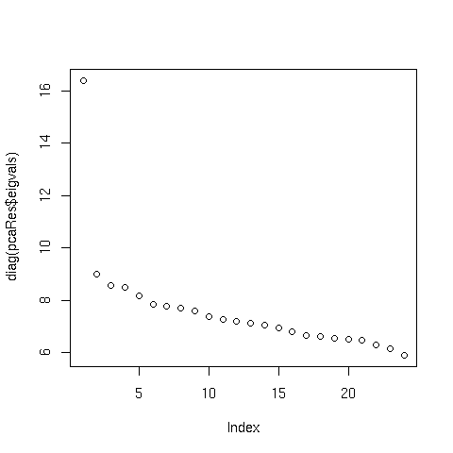
stats_all_1_1_1 vs 4:

positivePredictiveValue: 0.4615385
percentageCorrectlyClassified: 0.4615385
sensitivity: 1
specificity: 0

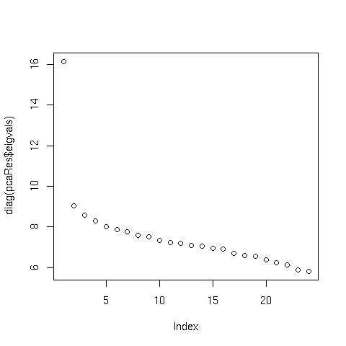
stats_all_1_1_2 vs 4:

positivePredictiveValue: 1
percentageCorrectlyClassified: 0.5769231
sensitivity: 0.08333333
specificity: 1

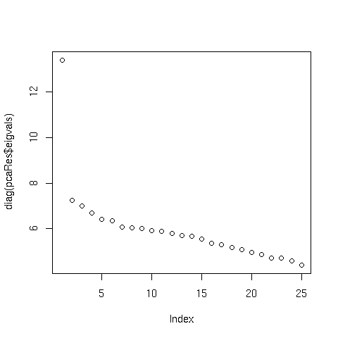
stats_all_1_1_3 vs 4:

positivePredictiveValue: 0.25
percentageCorrectlyClassified: 0.3913043
sensitivity: 0.08333333
specificity: 0.727272

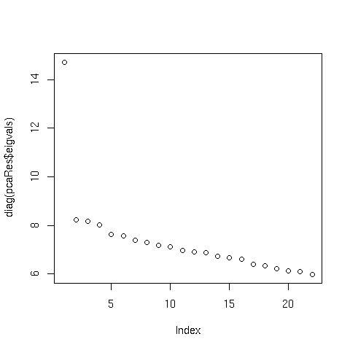
stats_all_1_2_1 vs 3:

positivePredictiveValue: 0.56
percentageCorrectlyClassified: 0.56
sensitivity: 1
specificity: 0

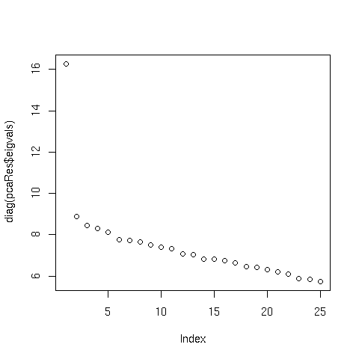
stats_all_1_2_1 vs 4:

positivePredictiveValue: 0.56
percentageCorrectlyClassified: 0.56
sensitivity: 1
specificity: 0

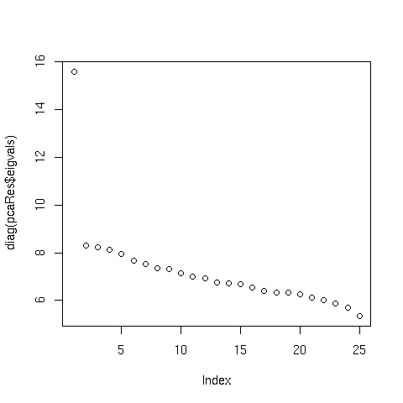
stats_all_1_2_2 vs 4:

positivePredictiveValue: 0.56
percentageCorrectlyClassified: 0.56
sensitivity: 1
specificity: 0

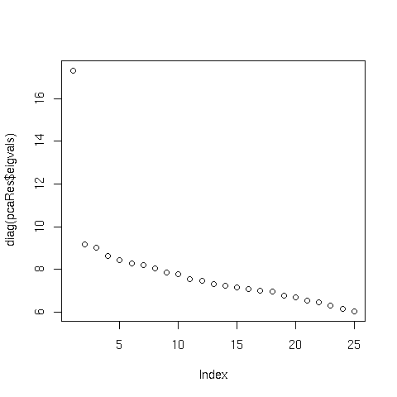
stats_all_1_2_3 vs 4:
positivePredictiveValue: 0.5
percentageCorrectlyClassified: 0.5
sensitivity: 1
specificity: 0

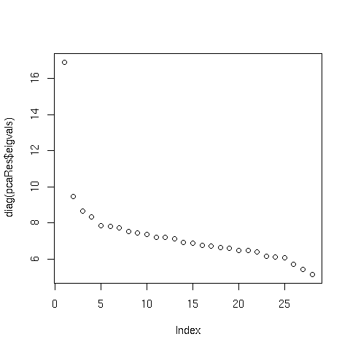

stats_all_2_3_1 vs 3:

positivePredictiveValue: NaN
percentageCorrectlyClassified: 0.56
sensitivity: 0
specificity: 1

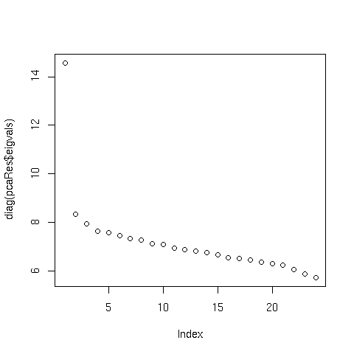
stats_all_2_3_1 vs 4:

positivePredictiveValue: NaN
percentageCorrectlyClassified: 0.5384615
sensitivity: 0
specificity: 1

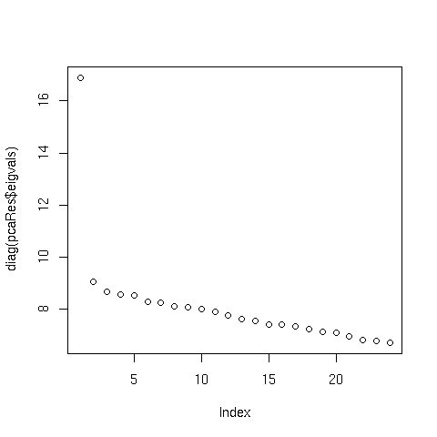
stats_all_2_3_2 vs 4:

positivePredictiveValue: NaN
percentageCorrectlyClassified: 0.5384615
sensitivity: 0
specificity: 1

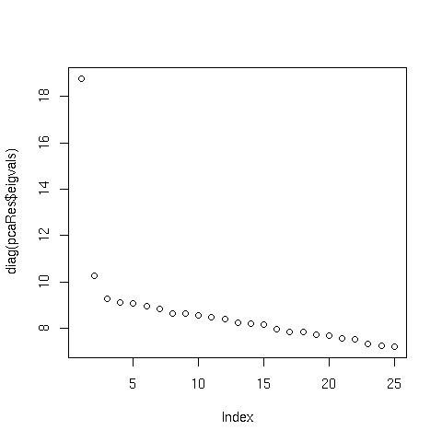
stats_all_2_3_3 vs 4:

positivePredictiveValue: NaN
percentageCorrectlyClassified: 0.4782609
sensitivity: 0
specificity: 1

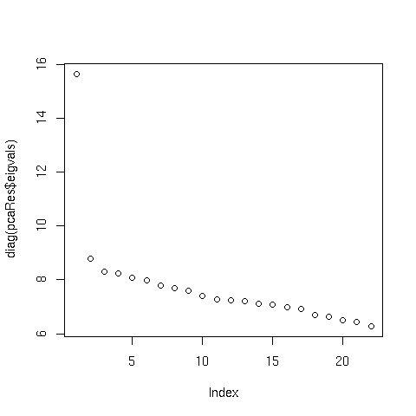
stats_all_2_4_1 vs 3:

positivePredictiveValue: 0.56
percentageCorrectlyClassified: 0.56
sensitivity: 1
specificity: 0

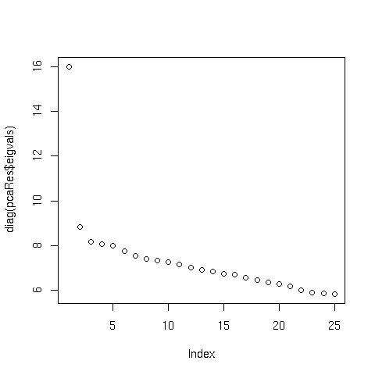
stats_all_2_4_1 vs 4:

positivePredictiveValue: 1
percentageCorrectlyClassified: 0.48
sensitivity: 0.07142857
specificity: 1

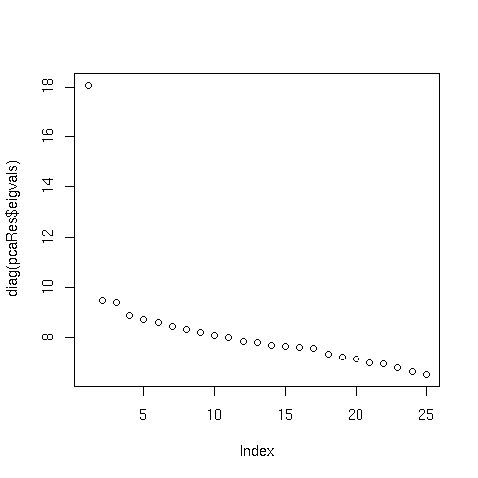
stats_2_4_2 vs 4:

positivePredictiveValue: NaN
percentageCorrectlyClassified: 0.44
sensitivity: 0
specificity: 1

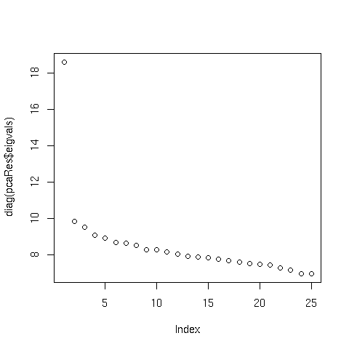
stats_all_2_4_3 vs 4:

positivePredictiveValue: NaN
percentageCorrectlyClassified: 0.5
sensitivity: 0
specificity: 1

