caBIG Software Requirements and Specification Template

DOCUMENT CHANGE HISTORY
Version Number | Date | Description
1.0 | November 2004 | Draft
1.1 | March 2005 | Added Sign-Off Page
1.2 | April 2005 | Minor Corrections
1.3 | January 2006 | Final Draft
1.4 | May 2006 | Added clarification for hardware dependency
[The first objective of the Software Requirements and Specification Document (SRSD) is to capture the complete software requirements for the system, or a portion of the system. The SRSD should fully describe the external behavior of the application or subsystem identified. It also should describe nonfunctional requirements, design constraints and other factors necessary to provide a complete and comprehensive description of the requirements for the software.
[The second objective of the SRSD is to describe the design of the requirements. It describes the design decisions, architectural design, and the detailed design needed to implement the software. The SRSD is used as the basis for implementing the software. It provides the acquirer visibility into the design and provides information needed for software support.
Template Instructions:
Throughout this template there are many italicized text areas surrounded in brackets '[]', similar to these instructions. These areas either prompt for user entry or provide instructions for completing the section. Delete each bracketed text area after completing the document. If a section title is italicized and surrounded in brackets ‘[]’, i.e. [Notes], this indicates that the entire section is optional.
Areas in regular text are standard wording that may not require modification.

Q5 Disease Classification by Mass Spectrometry Pattern Recognition Developer Project / 79761CBS10]
Q5 R Plug-in Release 1.0
Software Requirements and Specification Document
Version 1.4

[Insert approval date of document]

Document Change Record
Version Number | Date | Description
1.0 | [Insert approval date of document] | Initial draft document
1.1 |  | Added Technical Details to document
1.2 |  | Added corrections suggested by OHSU adopter site and VCDE.
1.3 |  | References to LIMS server removes, technical specification reference added and removed directly from this document. Removed basic flow diagram for Q5 to separate document file.
1.4 |  | Added line indicating hardware dependency of 32 bit hardware

TABLE OF CONTENTS

1. caBIG Software Requirements and Specification Template i
2. Introduction 1
2.1 Related Documents 3
2.2 Scope 3
2.2.1 Identification 3
2.2.2 System Overview 3
2.2.3 Document Overview 5
2.3 Reference Documents 6
3. Project Description 7
3.1 Project Perspective 7
3.2 Project Functions 8
3.3 User Characteristics 8
3.4 Constraints 9
3.5 Qualification Provisions 10
3.6 Assumptions and Dependencies 11
4. Requirements 12
4.1 Datafile Handling 12
4.2 Analysis Routines 13
4.3 Analysis Output 14
5. System Architecture 15
6. Components 16
7. [NOTES] 17
8. Sign off 18
8.1 Approval 18
9. Appendix A – Acronym List 19
10. [Appendix B – Other Appendices] 20

Introduction
This SRSD captures the complete software requirements for the Q5 software and describes the design decisions, architectural design and the detailed design needed to implement the software. It provides the acquirer visibility in to the design and provides information needed for software support.
The Q5 application is a probabilistic classification algorithm that employs principal components dimension-reduction and linear discriminant analysis.
Q5 has shown utility in disease classification of expression-dependent proteomic data from mass spectrometry of human serum. Q5’s ability to classify complex fragment mixtures was evaluated by testing its ability to discriminate the mass spectra of healthy vs. disease human serum samples. The two disease states examined in testing were ovarian and prostate cancer. Existing screening methods for both cancers carry a low positive predictive value (PPV). When detected early, the 5-year survival rate increases for both cancers.
Q5 outputs a classifier (discriminant) capable of classifying new mass spectra into one of the classes. The new spectra (called test spectra) that have not been seen by the algorithm and their classifications are unknown to the algorithm; the goal of the Mass Spectra Classification Algorithm (MSCA) is to determine the correct classification based on the classifier constructed from the training set. Classification verification is the testing process by which the discriminant is evaluated for its ability to correctly diagnose test samples. MSCAs can be characterized by the type of MS data processed, type of algorithm employed, and method of classification verification used.
Completeness of mass spectrum. Analysis may be performed on either complete or partial mass spectra. Complete mass spectra consist of the relative intensities of all m/z values acquired during MS data collection. This includes the relative intensities observed for all m/z values from 0 up to the upper limit of detection. An MSCA that processes complete mass spectra works with the entire recorded spectra: no values are “manually” excluded through preprocessing. When portions of a spectrum are excluded from consideration, we say a partial spectrum is generated.

Heuristic vs. Exact Classification Algorithms. Heuristic classification algorithms include approaches such as genetic algorithms, neural networks, and simulated annealing. These algorithms generally require multiple iterations to converge to a classifier; furthermore, the solution found by heuristic algorithms is not guaranteed to be optimal. In addition, many heuristic approaches are non-deterministic. Even when run on the same training set, the same non-deterministic algorithm often converges to a different discriminant. In contrast, MSCAs that utilize closed-form exact solutions (CFES) compute an exact solution using closed-form equations. CFES algorithms are computationally efficient; they are non-iterative and deterministic (i.e., always compute the same solution). Linear Discriminant Analysis (LDA), and thus Q5, are CFES algorithms.

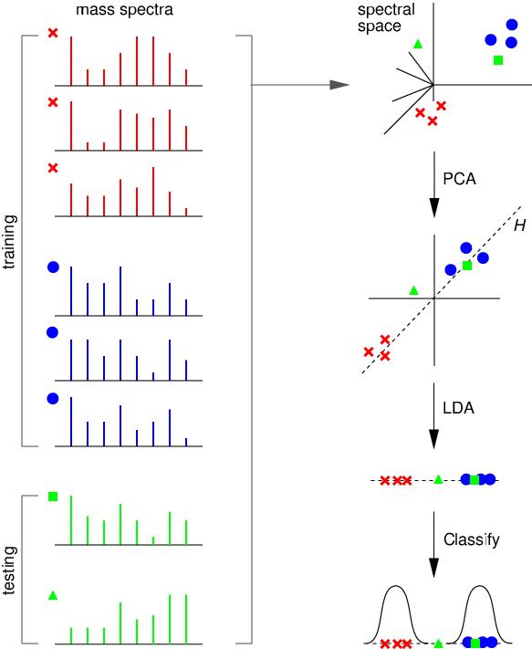

Related Documents
The current Q5 distribution contains a set of Matlab (Mathworks Inc, Natick, MA) functions. Q5 is presently written entirely in Matlab.
Reference: Ryan H. Lilien, Hany Farid, and Bruce R. Donald. "Probabilistic Disease Classification of Expression-Dependent Proteomic Data from Mass Spectrometry of Human Serum." Journal of Computational Biology, 10(6) 2003, pp. 925-946.
Q5 Use Case Scenarios (2005)

Scope
The overall scope of the Q5 Disease Classification by Mass Spectrometry Pattern Recognition Developer Project / 79761CBS10 is to reproduce the Q5 algorithm currently implemented in the Matlab software, a proprietary software package, into the open source software environment of R (a GNU Project implementation of the proprietary S software package developed originally at Bell Laboratories).
For more information about the R software package please refer to the url: http://www.r-project.org/

Identification
Abbreviations:
- Q5 Software Project - Abbreviated reference to the "Q5 Disease Classification by Mass Spectrometry Pattern Recognition Developer Project / 79761CBS10"
- OHSU - Oregon Health and Science University

System Overview
The Q5 software outputs a classifier (discriminant) capable of classifying new mass spectra into one of the classes( such as healthy vs. disease). The new spectra (called test spectra) that have not been seen by the algorithm and their classifications are unknown to the algorithm; the goal of the Mass Spectra Classification Algorithm (MSCA) is to determine the correct classification based on the classifier constructed from the training set. This method was originally outlined in the paper by Ryan H. Lilien, Hany Farid, and Bruce R. Donald. "Probabilistic Disease Classification of Expression-Dependent Proteomic Data from Mass Spectrometry of Human Serum." Journal of Computational Biology, 10(6) 2003, pp. 925-946.
The current adopter site for the software is targeted as Oregon Health and Science University and they will be performing the user acceptance and initial usage functions. The development group is composed of various members of the Computational Genetics Laboratory and other members of the Dartmouth Medical School.
The development site for the software will be located at the Norris Cancer Cotton Center located in Lebanon, N.H. and Dartmouth College with initial user testing and deployment at the OHSU site.
This development effort will utilize a "modified waterfall method" of software development with the SDLC phases being:
- Risk Analysis Assessment
- Base Analysis (Both system level and interfaces)
- Requirements gathering
- Development of use case scenarios
- Base prototype conversion of the current Q5 algorithm functionality
- Requirements release for final software development
- Development of test cases
- Implementation of the software for testing
- Execution of system test cases locally for validation
- Execution of use cases externally for validation
- Software release documentation and training

Software Development Life cycle Flow:

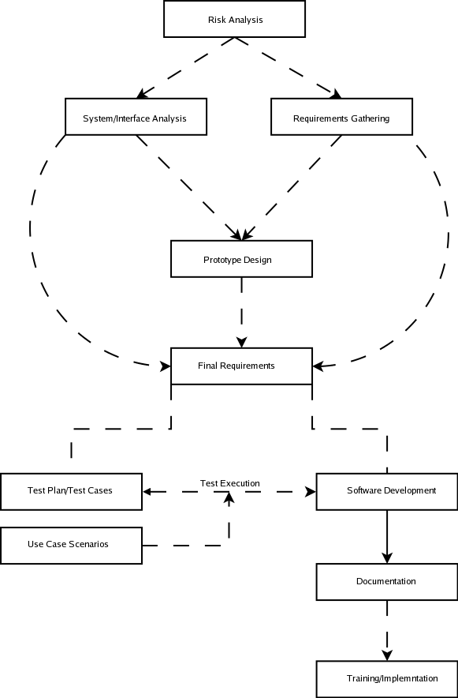
The Major Components of the R version of Q5 will consist of the following:
- Base Q5 algorithm developed as an R software plug-in
- Reading of a standardized datafile of mass spectrometry data (to be defined)
- Output of a project determined standardized format for analysis results

Document Overview
This SRSD captures the complete software requirements for the Q5 software release 1.0 as part of the Q5 Software Project.
This document should be considered as a mechanism to outline the requirements for design of the Q5 software. For detail regarding the algorithm itself, please refer to the original paper outlining the algorithm as referenced in section 2.1.
The remaining SRSD sections are organized as follows:
- Section 2. Project Description: Describes the general factors that affect the Q5 Software Project.
- Section 3. Requirements: Describes all the software requirements to a level of detail sufficient to enable designers to design a system to satisfy those requirements, and testers to test that the system satisfies those requirements.
- Section 4. Notes: Contains general information that aids in the understanding of this document.
- Appendix A. Acronym List: Defines the abbreviations used on the project.

Reference Documents
For additional project, and requirement specific information, refer to the following documents:
- Ryan H. Lilien, Hany Farid, and Bruce R. Donald. "Probabilistic Disease Classification of Expression-Dependent Proteomic Data from Mass Spectrometry of Human Serum." Journal of Computational Biology, 10(6) 2003, pp. 925-946.
- Q5 Project Use Case Scenarios

Project Description

Project Perspective
[Describe the relationship of the software products or projects. Describe the hardware and peripheral equipment with which the project operates.]
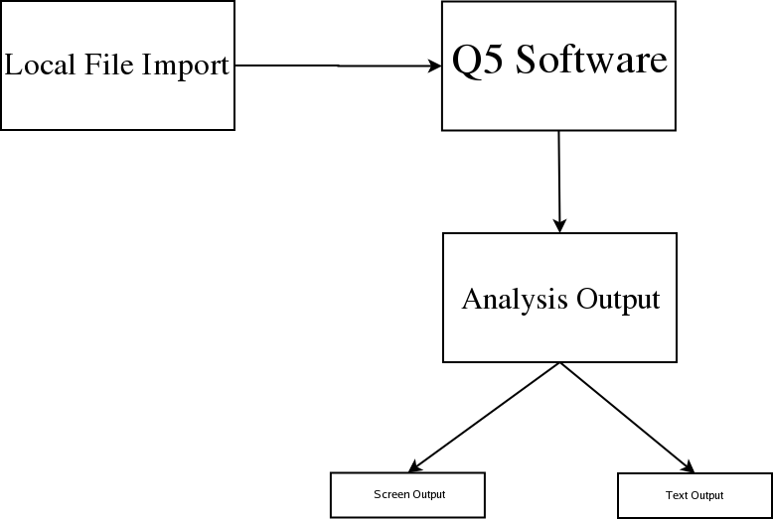
The structural architecture is outlined in the graphic depicted above. The Q5 software will run within the R Software framework as a module. This software package supports installations to Unix (and variants), Mac and Windows operating systems as to make it cross platform usable.

Project Functions
NCCC and Dartmouth have performed research on disease classification by spectrometry pattern recognition. The tie of clinical proteomics programs to patient diagnosis and the monitoring of treatments is in early stages of technology development and substantiation. Valid early detection protocols in identifying the presence or absence of cancerous cells will increase patient survival rates and extend their life expectancies by hastening appropriate management of treatable malignancies. Proteomic profiling of cancer cells exposed to experimental therapies will provide critical information in designing treatment regiments and discovering therapeutic targets. To address this challenge, researchers at Dartmouth have developed Q5, a Mass Spectrometry Classification Algorithm (MSCA) that is a combinatorially precise algorithm cast in closed-form equations and therefore provides a means to compute an optimized solution for disease classification. Q5 is designed to distinguish between plasma profiles of normal and disease-bearing individuals. Currently, Q5 is available as a MatLab application.

NCCC will apply an internally developed mass spectrometry pattern recognition tool, Q5, designed to distinguish between plasma profiles of normal and disease-bearing individuals. Ultimately, NCCC aims to deliver rapid disease classification method for dozens of neoplastic and other diseases through further development of Q5. Support for Q5 development with caBIG technologies and standards will facilitate the participation of institutions in data analysis.

To date, the Q5 algorithm method has been developed, evaluated and applied by one research group at Dartmouth. The current implementation uses MatLab for statistical calculations. For this project, Q5 will (1) Be translated to open source; (2) Be deployed to the Adopter site(s) for analysis; (3) Be adapted to the caBIG architecture.

User Characteristics
The primary target user audience identified by the caBIG adopter (OHSU) site has been the role of a bio-statistician with assistance for software installation via a bio-informatics specialist.
Bio-statisicians and bio-informatics personnel at OHSU will be evaluating the output of the analysis routines for accuracy.
Developers located at the Dartmouth site will be performing unit testing on code produced for the Q5 project.

Constraints
- External Software Dependencies
The R software Project page supports operating system releases for Max OS (System 8.6 to 10.2.x and above) as well as Linux and Microsoft Windows(95 and later). The source code for the R software is available for the software for compilation on additional platforms as well.
The R software was selected as a natural candidate due to the great number of inherent statistical functions already readily available to the language allowing possible additional statistical analysis of the results set via the use of the internal graphing functions. Finally, the compatibility of R to other toolsets and development languages might be used in structuring an "end to end" workflow for analysis of the data by the given site using the product.
Presently the only dependencies are the inclusion of the PROcess, caMassClass and MASS modules to be loaded. These packages can be retrieved at the CRAN (Comprehensive R Archive Network) or the BioConductor R repository.

When loading the packages for Q5, the order of precedence should be PROcess, caMassClass and then Q5 (which will call MASS if already installed). Each dependency module will have their own sets of dependencies that should be collected if securing the module via CRAN or BioConductor. Since these were outside the scope of the direct development, these dependencies have been omitted.

The Q5 Project has identified the R software version 2.1.1 to be the target environment for development of the Q5 R script. Usage with versions beyond 2.1.1 are not guaranteed to work properly as they have not been tested as this version was not an official release at the time of development work.
Data Standards:
- Q5 Data Input Format
The Q5 software will utilize the mxXML format as its input format type. Use of this format appears to be a somewhat standardized format in the mass spectrometry field and should allows integration into workflow with other caBIG sponsored products such as the R-Proteomics project.
The goal is to make this flexible but adhere to a standard that allows for flexibility and maintainability within the changing caBig infrastructure. The availability of XML parsers for various platforms is also in support for the decided output format. At present the Q5 software will output a statement indicating if the classification of the testing spectra comes from the diseased or normal data and a classification numerical value. Although there are more complex terminologies used in the accurate description of disease states, this is seen outside the initial scope of the Q5 project and therefore not extended to meet more specific classification output types.
At present, the software will only be able to accept pre-formatted mzXML datafile from the local workstation or network.
- Q5 Data Output Format
The output format will be in the form of two files (one standard text file and a PNG graphics file) created during the Q5 analysis. These two filenames are supplied to the algorithm in R and are written to provided path and filename. The raw output results will be written to the standard textfile in the format of:
Label:<tab>value
The second file will contain the graph of the eigenvalues generated by the Q5 analysis. The graphic will be rendered as a portable network graphic formatted image (PNG). This format is compatible with most all word processors on many platforms.
The selection of the R language for development was made based upon the inherent statistical functions within the language itself that are accessible to the end user and the fact that this software is open source and freely available to many platforms and in source format. This allows the potential for additional analysis and exploration of the end results by the user proficient in the R software. There will be no database interactivity for the tool at this point.

Qualification Provisions
a. Demonstration: The operation of the system or component that relies on observable functional operation not requiring the use of instrumentation, special test equipment, or subsequent analysis.
b. Test: The operation of the system or component using instrumentation or other special test equipment to collect data for later analysis.
c. Analysis: The processing of accumulated data obtained from other qualification methods. Examples are reduction, interpretation, or extrapolation of test results.
d. Inspection: The visual examination of code, documentation, etc.
e. Special qualification methods: Any special qualification methods for the system, such as special tools, techniques, procedures, facilities, and acceptance limits.

Assumptions and Dependencies
Prior installation of the R software environment on the local workstation including the R MASS library (see section Architecture Section 3.4(1) for a statement of dependencies as well).
The current version of R will configure and build under a number of common Unix platforms including cpu linux-gnu for the i386, alpha, arm, hppa, ia64, m68k, mips/mipsel, powerpc, s390, sparc , and x86_64CPUs,powerpc-apple-darwin, mips-sgi-irix, rs6000-ibm-aix, and sparc-sun-solaris.
All Maldi-Tof data sets used by the adopter will be pre-processed (via R-Proteomics or similar software) to reduce dimensionality prior to execution of the Q5 software and make the analysis more time efficient. Although this is not a requirement of the software it is a workflow used by the adopter site. Q5 should be able to run on raw full spectra (properly formatted in mzXML) without pre-processing although the length of processing time may increase greatly.
The Q5 software was developed to run specifically on a 32-bit hardware platform and no commitments to function are assumed on other hardware platforms.

Requirements
The Requirements categories outlined correspond to each functional area of the Q5 software and the software flow diagram.

Datafile Handling

Table 3.1-1: Data Handling Requirements
Req ID | Requirement Type | Requirement Description
1.1 | System | The system will allow the end user to import spectra from a local datafile located on the client workstation or network properly formatted in mzXML.
1.2 | Interface | The system will display an error to the user if the datafile attempting to be imported is improperly formatted for usage.
1.3 | System | The input datafile format will be in mzXML format. Please refer to the architecture section for technical tag details.
1.4 | System | The Q5 system will accept both properly formatted Seldi-TOF and Maldi-TOF data as inputs to the software.

Analysis Routines

Table 3.1-1: Analysis Routines Requirements
Req ID | Requirement Type | Requirement Description
2.1 | System | The Q5 system will allow the user to indicate whether or not the imported dataset is to be used for testing/training or to be split for use as both.
2.2 | System | The Q5 system will reduce the dimensional space for the data using PCA (Principal Components Analysis) within the software. This mechanism will be made visible to the user so that they can call this portion of the functionality from the R environment.
2.3 | System | Following PCA, the Q5 system will implement a linear discriminant analysis method against the data. This mechanism will be made visible to the user so that they can call this portion of the functionality from the R environment.
2.4 | System | The output of the LDA step of the Q5 system will be a linear discriminant used to classify the remainder of the data. This mechanism will be made visible to the user so that they can call this portion of the functionality from the R environment.

Analysis Output

Table 3.1-1: Analysis Output Requirements
Req ID | Requirement Type | Requirement Description
3.1 | System | The Q5 system will output the disease classification from the analysis in a numerical value as well as the associated statistics (Classification Sensitivity, Classification Specificity, Percentage of Samples Classified, Percentage of Samples Correctly Classified, and Positive Predictive Value.) These terms will be reviewed in the caDSR and made more solid to caBIG specifications.
3.2 | System | The output datafile format will consist of two possible files.  - datafile consisting of the output values (outlined in the analysis output section)  - graphics file containing the graph of eigenvalues in a portable network graphics format.  These filenames and paths will be supplied by the user to the Q5 script. If the user does not provide these parameters to the script, the Q5 script will write the output values to standard out and produce an R graph of the eigenvalues.  Details of the output format are contained in the data standards section (#3) of this  document.
3.3 | System | The PCA function within the Q5 script will allow the user to output the values for a plot() function from R to produce a graph of sorted Eigenvalues.

System Architecture
Architectural Design – Q5 uses the following major functional components:
- Q5 (main calling script) – This is the primary script that is the controlling interface for the overall Q5 process.
- Database/Filesystem – General representation of the datafile (this will be deployed in the initial release as mxXML)
- PCA – Principal Components Analysis portion of the script. This is an exposed interface that will allow the user to implement the standard PCA as outlined by the Q5 algorithm or utilize their own by calling a different method such as a windows PCA library for instance.
- LDA – Linear Discriminant Algebra portion of the Q5 script. This was broken out in case the user might want to utilize another method during this piece.

Components

Please reference the Q5 API documentation for a technical description of the functionality as well as functional prototypes, etc.

[NOTES]
[Insert any general information that aids in understanding this document (e.g., background information, glossary, and rationale). This section shall include a list of any terms and definitions needed to understand this document.]

Sign off

Approval

Architecture Workspace Rep Print Name Date
VCDE Workspace Rep Print Name Date
Adopter Rep Print Name Date

Appendix A – Acronym List
[Insert an alphabetical listing of all acronyms and abbreviations, and their meanings as used in this document.]
Term/  Abbreviation | Description
[????] | [Insert Project Name acronym]
[????] | [Insert Project all other project Test Plan specific acronyms and resort the table]
DBA | Database Administrator
PM | Project Manager
RM | Requirements Manager
RTM | Requirements Traceability Matrix
SCM | Software Configuration Management
SDLC | Software Development Lifecycle
SDP | Software Development Plan
SE | Software Engineering
SEPG | Software Engineering Process Group
SM | Software Manager
SOP | Standard Operating Procedure
SPI | Software Process Improvement
SQA | Software Quality Assurance
SW | Software
TBD | To Be Determined
TM | Test Manager

[Appendix B – Other Appendices]
[Use appendices to provide information published separately for convenience in document maintenance (e.g., charts, classified data). As applicable, the main text of the document should reference each appendix where the data would logically fit within the document. Appendices may be bound as separate documents for ease in handling. Appendices shall be lettered alphabetically (A, B, etc.).]

