caBIG Software Requirements and Specification Template

DOCUMENT CHANGE HISTORY
Version Number | Date | Description
1.0 | November 2004 | Draft
1.1 | March 2005 | Added Sign-Off Page
[The first objective of the Software Requirements and Specification Document (SRSD) is to capture the complete software requirements for the system, or a portion of the system. The SRSD should fully describe the external behavior of the application or subsystem identified. It also should describe nonfunctional requirements, design constraints and other factors necessary to provide a complete and comprehensive description of the requirements for the software.
[The second objective of the SRSD is to describe the design of the requirements. It describes the design decisions, architectural design, and the detailed design needed to implement the software. The SRSD is used as the basis for implementing the software. It provides the acquirer visibility into the design and provides information needed for software support.
Template Instructions:
Throughout this template there are many italicized text areas surrounded in brackets '[]', similar to these instructions. These areas either prompt for user entry or provide instructions for completing the section. Delete each bracketed text area after completing the document. If a section title is italicized and surrounded in brackets ‘[]’, i.e. [Notes], this indicates that the entire section is optional.
Areas in regular text are standard wording that may not require modification.

Q5 Disease Classification by Mass Spectrometry Pattern Recognition Developer Project / 79761CBS10]
Q5 R Plug-in Release 1.0
Software Requirements and Specification Document
Version 1.0

[Insert approval date of document]

Document Change Record
Version Number | Date | Description
1.0 | [Insert approval date of document] | Initial draft document

TABLE OF CONTENTS
1. caBIG Software Requirements and Specification Template i
2. Introduction 1
2.1 Related Documents 3
2.2 Scope 3
2.2.1 Identification 3
2.2.2 System Overview 4
2.2.3 Document Overview 5
2.3 Reference Documents 6
3. Project Description 7
3.1 Project Perspective 7
3.2 Project Functions 8
3.3 User Characteristics 8
3.4 Constraints 9
3.5 Qualification Provisions 10
3.6 Assumptions and Dependencies 10
4. Requirements 11
4.1 Datafile Handling 11
4.2 Analysis Routines 12
4.3 Analysis Output 13
4.3.1 [Further Category Designation] 13
5. System Architecture 15
6. Components 18
6.1 [Name of application component] 18
7. [NOTES] 20
8. Sign off 21
8.1 Approval 21
9. Appendix A – Acronym List 22
10. [Appendix B – Other Appendices] 23

Introduction
This SRSD captures the complete software requirements for the Q5 software and describes the design decisions, architectural design and the detailed design needed to implement the software. It provides the acquirer visibility in to the design and provides information needed for software support.
The Q5 application is a probabilistic classification algorithm that employs principal components dimension-reduction and linear discriminant analysis.
Q5 has shown utility in disease classification of expression-dependent proteomic data from mass spectrometry of human serum. Q5’s ability to classify complex fragment mixtures was evaluated by testing its ability to discriminate the mass spectra of healthy vs. disease human serum samples. The two disease states examined in testing were ovarian and prostate cancer. Existing screening methods for both cancers carry a low positive predictive value (PPV). When detected early, the 5-year survival rate increases for both cancers.
Q5 outputs a classifier (discriminant) capable of classifying new mass spectra into one of the classes. The new spectra (called test spectra) that have not been seen by the algorithm and their classifications are unknown to the algorithm; the goal of the Mass Spectra Classification Algorithm (MSCA) is to determine the correct classification based on the classifier constructed from the training set. Classification verification is the testing process by which the discriminant is evaluated for its ability to correctly diagnose test samples. MSCAs can be characterized by the type of MS data processed, type of algorithm employed, and method of classification verification used.
Completeness of mass spectrum. Analysis may be performed on either complete or partial mass spectra. Complete mass spectra consist of the relative intensities of all m/z values acquired during MS data collection. This includes the relative intensities observed for all m/z values from 0 up to the upper limit of detection. An MSCA that processes complete mass spectra works with the entire recorded spectra: no values are “manually” excluded through preprocessing. When portions of a spectrum are excluded from consideration, we say a partial spectrum is generated.

Heuristic vs. Exact Classification Algorithms. Heuristic classification algorithms include approaches such as genetic algorithms, neural networks, and simulated annealing. These algorithms generally require multiple iterations to converge to a classifier; furthermore, the solution found by heuristic algorithms is not guaranteed to be optimal. In addition, many heuristic approaches are non-deterministic. Even when run on the same training set, the same non-deterministic algorithm often converges to a different discriminant. In contrast, MSCAs that utilize closed-form exact solutions (CFES) compute an exact solution using closed-form equations. CFES algorithms are computationally efficient; they are non-iterative and deterministic (i.e., always compute the same solution). Linear Discriminant Analysis (LDA), and thus Q5, are CFES algorithms.

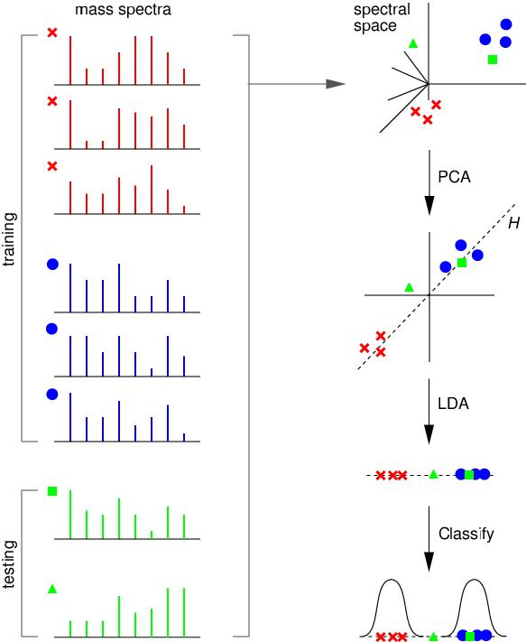

Related Documents
The current Q5 distribution contains a set of Matlab (Mathworks Inc, Natick, MA) functions. Q5 is presently written entirely in Matlab.
Reference: Ryan H. Lilien, Hany Farid, and Bruce R. Donald. "Probabilistic Disease Classification of Expression-Dependent Proteomic Data from Mass Spectrometry of Human Serum." Journal of Computational Biology, 10(6) 2003, pp. 925-946.
Q5 Use Case Scenarios (2005)

Scope
The overall scope of the Q5 Disease Classification by Mass Spectrometry Pattern Recognition Developer Project / 79761CBS10 is to reproduce the Q5 algorithm currently implemented in the Matlab software, a proprietary software package, into the open source software environment of R (a GNU Project implementation of the proprietary S software package developed originally at Bell Laboratories).
For more information about the R software package please refer to the url: http://www.r-project.org/

Identification
Abbreviations:
- Q5 Software Project - Abbreviated reference to the "Q5 Disease Classification by Mass Spectrometry Pattern Recognition Developer Project / 79761CBS10"
- OHSU - Oregon Health and Science University

System Overview
Q5 outputs a classifier (discriminant) capable of classifying new mass spectra into one of the classes( such as healthy vs. disease). The new spectra (called test spectra) that have not been seen by the algorithm and their classifications are unknown to the algorithm; the goal of the Mass Spectra Classification Algorithm (MSCA) is to determine the correct classification based on the classifier constructed from the training set. This method was originally outlined in the paper by Ryan H. Lilien, Hany Farid, and Bruce R. Donald. "Probabilistic Disease Classification of Expression-Dependent Proteomic Data from Mass Spectrometry of Human Serum." Journal of Computational Biology, 10(6) 2003, pp. 925-946.
The current adopter site for the software is targeted as Oregon Health and Science University and they will be performing the user acceptance and initial usage functions. The development group is composed of various members of the Computational Genetics Laboratory and other members of the Dartmouth Medical School.
The development site for the software will be located at the Norris Cancer Cotton Center located in Lebanon, N.H. and Dartmouth College with initial user testing and deployment at the OHSU site.
This development effort will utilize a "modified waterfall method" of software development with the SDLC phases being:
- Risk Analysis Assessment
- Base Analysis (Both system level and interfaces)
- Requirements gathering
- Development of use case scenarios
- Base prototype conversion of the current Q5 algorithm functionality
- Requirements release for final software development
- Development of test cases
- Implementation of the software for testing
- Execution of system test cases locally for validation
- Execution of use cases externally for validation
- Software release documentation and training

Software Development Life cycle Flow:

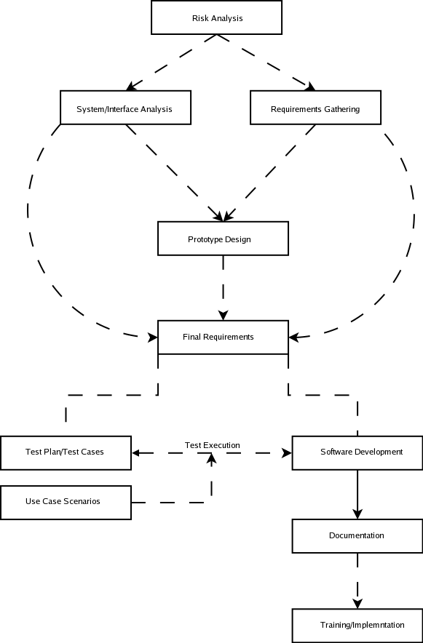
The Major Components of the R version of Q5 will consist of the following:
- Base Q5 algorithm developed as an R software plug-in
- Reading of a standardized datafile of mass spectrometry data formatted in mzXML.
- Output of a standardized format for analysis results determined by the project team and adopter site.
- Connectivity to the Fox Chase LIMS server located at Dartmouth Research Computing Resource as a mechanism for input source for the mass spectrometry data or a properly mzXML formatted local datafile.

Document Overview
This SRSD captures the complete software requirements for the Q5 software release 1.0 as part of the Q5 Software Project.
This document should be considered as a mechanism to outline the requirements for design of the Q5 software. For detail regarding the algorithm itself, please refer to the original paper outlining the algorithm as referenced in section 2.1.
The remaining SRSD sections are organized as follows:
- Section 2. Project Description: Describes the general factors that affect the Q5 Software Project.
- Section 3. Requirements: Describes all the software requirements to a level of detail sufficient to enable designers to design a system to satisfy those requirements, and testers to test that the system satisfies those requirements.
- Section 4. Notes: Contains general information that aids in the understanding of this document.
- Appendix A. Acronym List: Defines the abbreviations used on the project.

Reference Documents
For additional project, and requirement specific information, refer to the following documents:
- Ryan H. Lilien, Hany Farid, and Bruce R. Donald. "Probabilistic Disease Classification of Expression-Dependent Proteomic Data from Mass Spectrometry of Human Serum." Journal of Computational Biology, 10(6) 2003, pp. 925-946.
- Q5 Project Use Case Scenarios

Project Description

Project Perspective
[Describe the relationship of the software products or projects. Describe the hardware and peripheral equipment with which the project operates.]
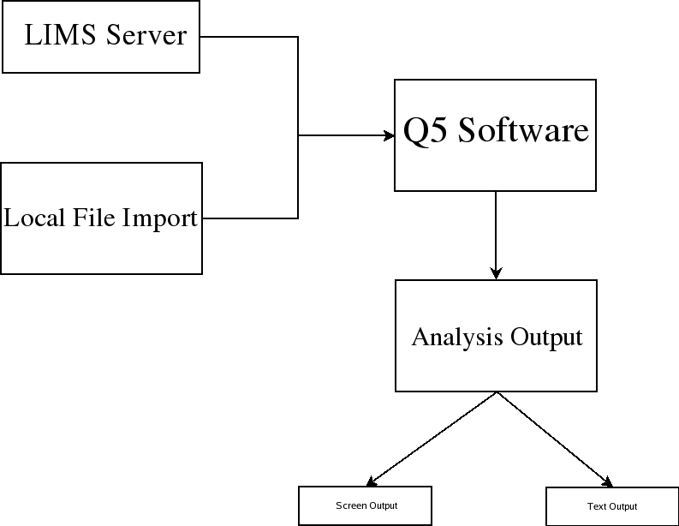
The structural architecture is outlined in the graphic depicted above. The Q5 software will run within the R Software framework as a module. This software package supports installations to Unix (and variants), Mac and Windows operating systems as to make it cross platform usable.

Project Functions
NCCC and Dartmouth have performed research on disease classification by spectrometry pattern recognition. The tie of clinical proteomics programs to patient diagnosis and the monitoring of treatments is in early stages of technology development and substantiation. Valid early detection protocols in identifying the presence or absence of cancerous cells will increase patient survival rates and extend their life expectancies by hastening appropriate management of treatable malignancies. Proteomic profiling of cancer cells exposed to experimental therapies will provide critical information in designing treatment regiments and discovering therapeutic targets. To address this challenge, researchers at Dartmouth have developed Q5, a Mass Spectrometry Classification Algorithm (MSCA) that is a combinatorially precise algorithm cast in closed-form equations and therefore provides a means to compute an optimized solution for disease classification. Q5 is designed to distinguish between plasma profiles of normal and disease-bearing individuals. Currently, Q5 is available as a MatLab application.

NCCC will apply an internally developed mass spectrometry pattern recognition tool, Q5, designed to distinguish between plasma profiles of normal and disease-bearing individuals. Ultimately, NCCC aims to deliver rapid disease classification method for dozens of neoplastic and other diseases through further development of Q5. Support for Q5 development with caBIG technologies and standards will facilitate the participation of institutions in data analysis. Q5 is a potentially important tool in following the pharmacokinetic status of cancer patients in chemotherapeutic treatment.

To date, the Q5 algorithm method has been developed, evaluated and applied by one research group at Dartmouth. The current implementation uses MatLab for statistical calculations. For this project, Q5 will (1) Be translated to open source; (2) Be deployed to the Adopter site(s) for analysis; (3) Be adapted to the caBIG architecture.

User Characteristics
The primary target user audience identified by the caBIG adopter (OHSU) site has been the role of a bio-statistician with assistance for software installation via a bio-informatics specialist.
Bio-statisicians and bio-informatics personnel at OHSU will be evaluating the output of the analysis routines for accuracy.
Developers located at the Dartmouth site will be performing unit testing on code produced for the Q5 project.

Constraints
- External Software Dependencies
The R software Project page supports operating system releases for Max OS (System 8.6 to 10.2.x and above) as well as Linux and Microsoft Windows(95 and later). The source code for the R software is available for the software for compilation on additional platforms as well.
The R software was selected as a natural candidate due to the great number of inherent statistical functions already readily available to the language allowing possible additional statistical analysis of the results set via the use of the internal graphing functions. Finally, the compatibility of R to other toolsets and development languages might be used in structuring an "end to end" workflow for analysis of the data by the given site using the product.
Presently the only dependencies are the following two R modules:
caMassClass: http://cran.fhcrc.org/src/contrib/caMassClass_1.1.tar.gz
- This module may be obtained from the R repository (CRAN)
- To install the module, change to the directory the module is located in and execute (given R is in the system path): R INSTALL MASS

grDevices: (Included in R distribution)
(http://cran.r-project.org/doc/FAQ/R-FAQ.html#Add_002don-packages-in-R)

The Q5 Project has identified the R software version 2.1.1 to be the target environment for development of the Q5 R script.
Data Standards:
- Q5 Data Input Format
The specifics of the input format for the Q5 software has not been defined at this point outside of the development decision to utilize the mxXML format. Use of this format appears to be a somewhat standardized format in the mass spectrometry field and should allows integration into workflow with other caBIG sponsored products such as the R-Proteomics project.
The goal is to make this flexible but adhere to a standard that allows for flexibility and maintainability within the changing caBig infrastructure. Consideration of the widely used format of mzXML for the use by the Fox Chase LIMS server as well as the availability of XML parsers for various platforms is the current consideration for the output format.
- Q5 Data Output Format
The output format will be in the form of two files created during the Q5 analysis. These two files are supplied to the algorithm in R and are written to provided path and filename. The raw output results will be written to one file in the format of:
Label:<tab>value
The second file will contain the graph of the eigenvalues generated by the Q5 analysis. The graphic will be rendered as a portable network graphic formatted image (PNG). This format is compatible with most all word processors on many platforms.
- The selection of the R language for development was made based upon the inherent statistical functions within the language itself that are accessible to the end user and the fact that this software is open source and freely available to many platforms and in source format. This allows the potential for additional analysis and exploration of the end results by the user proficient in the R software. The only database interaction intended for the Q5 software is importing of spectra via the Fox Chase LIMS server.

Qualification Provisions
a. Demonstration: The operation of the system or component that relies on observable functional operation not requiring the use of instrumentation, special test equipment, or subsequent analysis.
b. Test: The operation of the system or component using instrumentation or other special test equipment to collect data for later analysis.
c. Analysis: The processing of accumulated data obtained from other qualification methods. Examples are reduction, interpretation, or extrapolation of test results.
d. Inspection: The visual examination of code, documentation, etc.
e. Special qualification methods: Any special qualification methods for the system, such as special tools, techniques, procedures, facilities, and acceptance limits.

Assumptions and Dependencies
Prior installation of the R software environment on the local workstation including the R caMASSClass and grDevices libraries (see section 3.4(1) for a statement of dependencies as well).
The current version of R will configure and build under a number of common Unix platforms including cpu linux-gnu for the i386, alpha, arm, hppa, ia64, m68k, mips/mipsel, powerpc, s390, sparc , and x86_64CPUs,powerpc-apple-darwin, mips-sgi-irix, rs6000-ibm-aix, and sparc-sun-solaris.
All Maldi-Tof data sets will be pre-processed (via R-Proteomics or similar software) to reduce dimensionality issue prior to execution of the Q5 software.

Requirements
The Requirements categories outlined correspond to each functional area of the Q5 software and the software flow diagram.

Datafile Handling

Table 3.1-1: Data Handling Requirements
Req ID | Requirement Type | Requirement Description
1.1 | System | The system will allow the end user to import spectra from a local datafile located on the client workstation or network.
1.2 | System | The system will allow the end user to import spectra from a Fox Chase LIMS server into the Q5-R software via an mzXML transport mechanism.
1.3 | Interface | The system will display an error to the user if the datafile attempting to be imported is improperly formatted for usage.
1.4 | System | The input datafile format will be in mzXML format. Technical meta tag details will be outlined in the architecture section.
1.5 | System | The Q5 system will accept both properly formatted Seldi-TOF and Maldi-TOF data as inputs to the software.
1.6 | System | The Q5 system will allow for database attribute acquisition by common ID value with the Fox Chase LIMS version.

Analysis Routines

Table 3.1-1: Analysis Routines Requirements
Req ID | Requirement Type | Requirement Description
2.1 | System | The Q5 system will allow the user to indicate whether or not the imported dataset is to be used for testing/training or to be split for use as both.
2.2 | System | The Q5 system will reduce the dimensional space for the data using PCA (Prinicpal Components Analysis) within the software. This mechanism will be made visible to the user so that they can call this portion of the functionality from the R environment.
2.3 | System | Following PCA, the Q5 system will implement a linear discriminant analysis method against the data. This mechanism will be made visible to the user so that they can call this portion of the functionality from the R environment.
2.4 | System | The output of the LDA step of the Q5 system will be a linear discriminant used to classify the remainder of the data. This mechanism will be made visible to the user so that they can call this portion of the functionality from the R environment.

Analysis Output

Table 3.1-1: Analysis Output Requirements
Req ID | Requirement Type | Requirement Description
3.1 | System | The Q5 system will output the disease classification from the analysis in a numerical value as well as the associated statistics (Classification Sensitivity, Classification Specificity, Percentage of Samples Classified, Percentage of Samples Correctly Classified , Positive Predictive Value.) These terms will be reviewed in the caDSR and made more solid to caBIG specifications.
3.2 | System | The output datafile format will consist of two possible files.  - datafile consisting of the output values (outlined in the analysis output section)  - graphics file containing the graph of eigenvalues in a portable network graphics format.  These filenames and paths will be supplied by the user to the Q5 script. If the user does  not provide these parameters to the script, the Q5 script will write the output values to  standard out and produce an R graph of the eigenvalues.  Details of the output format are contained in the data standards section (#3) of this document.
3.3 | System | The PCA function within the Q5 script will allow the user to output the values for a plot() function from R to produce a graph of sorted Eigenvalues.

[Further Category Designation]
[This section should describe a more specific category designation, such as a specific group of requirements that may logically become a module, system, or interface.
Include either or both of the following:
- A conceptual, use-case, or process diagram, that describes the requirements according to the chosen methodology (e.g., UML)
- A table listing all of the requirements that apply.]

Table 3.1.1-1: [Further Category Designation] Requirements
Req ID | Requirement Type | Requirement Description | CCR # (Optional) | Trace from User Requirement/  Trace to System Requirement (Optional)

System Architecture
[This section shall be divided into paragraphs as needed to present unit-wide design decisions.]
[System Architecture Overview - Explain the high-level concept of the system. Summarize the system context and system design, with diagrams if available. This section shall present unit-wide design decisions, that is, decisions about the requirement's behavioral design (how it will behave, from a user's point of view, in meeting its requirements, ignoring internal implementation) and other decisions affecting the selection and design of the software units that make up the requirement. If all such decisions are explicit in the Requirements or are deferred to the design of the requirement's software units, this section shall so state. Design decisions that respond to requirements designated critical, such as those for safety, security, or privacy, shall be placed in separate subparagraphs. If a design decision depends upon system states or modes, this dependency shall be indicated. Design conventions needed to understand the design should be presented or referenced. Examples of requirement-wide design decisions are the following:
- Design decisions on requirement behavior in response to each input or condition, including actions the requirement will perform, response times and other performance characteristics, description of physical systems modeled, selected equations/algorithms/rules, and handling of unallowed inputs or conditions.
- Other requirement-wide design decisions made in response to requirements, such as selected approach to providing required flexibility, availability, and maintainability.]
[Architectural Design - Show the components and the control and data flow between them. This can be part diagram and part textual - longer material can be put in an appendix. This section shall describe the requirement architectural design. If part or all of the design depends upon system states or modes, this dependency shall be indicated. If design information falls into more than one paragraph, it may be presented once and referenced from the other paragraphs. Design conventions needed to understand the design should be presented or referenced. This paragraph shall:
- Identify the software units that make up the software unit. Each software unit shall be assigned a project-unique identifier. Note: A software unit is an element in the design of a requirement; for example, a major subdivision of a requirement, a component of that subdivision, a class, object, module, function, routine, or database. Software units may occur at different levels of a hierarchy and may consist of other software units. Software units in the design may or may not have a one-to-one relationship with the code and data entities (routines, procedures, databases, data files, etc.) that implement them or with the computer files containing those entities. A database may be treated as a requirement or as a software unit. The SDD may refer to software units by any name(s) consistent with the design methodology being used.
- Show the static (such as "consists of") relationship(s) of the software units. Multiple relationships may be presented, depending on the selected software design methodology (for example, in an object-oriented design, this paragraph may present the class and object structures as well as the module and process architectures of the requirement).
- State the purpose of each software unit and identify the Requirements and unit-wide design decisions allocated to it. (Alternatively, the allocation of requirements may be provided in 6.a.)
- Identify each software unit's development status/type (such as new development, existing design or software to be reused as is, existing design or software to be reengineered, software to be developed for reuse, software planned for Build N, etc.) For existing design or software, the description shall provide identifying information, such as name, version, documentation references, library, etc.
- Describe the requirement's (and as applicable, each software unit's) planned utilization of computer hardware resources (such as processor capacity, memory capacity, input/output device capacity, auxiliary storage capacity, and communications/network equipment capacity). The description shall cover all computer hardware resources included in resource utilization requirements for the requirement, in system-level resource allocations affecting the requirement, and in resource utilization measurement planning in the Software Development Plan. If all utilization data for a given computer hardware resource are presented in a single location, such as in one SDD, this paragraph may reference that source. Included for each computer hardware resource shall be:
- The Requirements or system-level resource allocations being satisfied
- The assumptions and conditions on which the utilization data are based (for example, typical usage, worst-case usage, assumption of certain events)
- Any special considerations affecting the utilization (such as use of virtual memory, overlays, or multiprocessors or the impacts of operating system overhead, library software, or other implementation overhead)
- The units of measure used (such as percentage of processor capacity, cycles per second, bytes of memory, kilobytes per second)
- The level(s) at which the estimates or measures will be made (such as software unit, requirement, or executable program)
- Identify the program library in which the software that implements each software unit is to be placed.]
[Interfaces - This paragraph shall be divided into the following subparagraphs to describe the interface characteristics of the software units. It shall include both interfaces among the software units and their interfaces with external entities such as systems, configuration items, and users.
The paragraphs below shall state the project-unique identifier assigned to each interface and shall identify the interfacing entities (software units, systems, configuration items, users, etc.) by name, number, version, and documentation references, as applicable. The identification shall state which entities have fixed interface characteristics (and therefore impose interface requirements on interfacing entities) and which are being developed or modified (thus having interface requirements imposed on them). One or more interface diagrams shall be provided, as appropriate, to depict the interfaces.
Design decisions regarding inputs the unit will accept and outputs it will produce, including interfaces with other systems, hardware, and users.
- External Software Interfaces - Insert text regarding any external interfaces with the software.
- Software System Interfaces - Insert text regarding software interfaces to other software systems.
- Software System Components Interfaces - Insert text regarding software interfaces to other software system components.
- Hardware Interfaces - Insert text regarding any external interfaces with the hardware.]
[Database Design - Reference the Database Design if applicable.]
[System Security - Insert the high level approach to meeting safety, security, and privacy requirements.
- Network Level - Insert the selected approach to meeting safety, security, and privacy requirements at the network level.
- Database Level - Insert the selected approach to meeting safety, security, and privacy requirements at the database level.
- Application Level - Insert the selected approach to meeting safety, security, and privacy requirements at the application level.]

Components
[This section shall describe each software unit of the requirement. If part of all of the design depends upon system states or modes, this dependency shall be indicated. If design information falls into more than one paragraph, it may be presented once and referenced from the other paragraphs. Design conventions needed to understand the design should be presented or referenced. Software units that are databases, or that are used to access or manipulate databases, are described in Appendix C. Reference the Database Design if applicable.
This is a reference for the programmer to consult. Each component will be broken down here into its parts that are described in detail. Diagrams should be included here. Use an appropriate naming convention for parts of a component. Structure this section according to the system design. ID number or requirements number may name components. Document detailed design information.
Section 3.1 will be repeated for each application component. The first component will be Section 3.1; the second component will be section 3.2 etc. Each site description will follow the same outline as indicated in section 3.1]

[Name of application component]
[This paragraph shall identify a requirement by a project-unique identifier and shall describe the unit. The description shall include the following information, as applicable. Alternatively, this paragraph may designate a group of requirements and identify and describe the requirements in subparagraphs. Requirements that contain other requirements may reference the descriptions of those requirements rather than repeating information.
Give the name of the component. The names should be related to the major component of which they are part. Describe each high level component. The main information given below relates to the 'external' aspects of the components that are used to specify it as a black box. Some of the items listed below may not be relevant - if so you can omit them but preserve the order given. Structure this section according to the design.]
[Type - State whether the component is a module, a file, a program etc.]
[Purpose - Insert the purpose of the component, tracing it to the software requirements.]
[Function - Describe what the component does.]
[Subordinate - List the immediate children.]
[Dependencies - Describe any constraints, limitations, or unusual features in the design of the software unit.]
[Preconditions - Describe any preconditions for using the component.]
[Interfaces - Define the control and data flow to and from the component. If the software unit contains, receives, or outputs data, a description of its inputs, outputs, and other data elements and data element assemblies, as applicable. Data local to the software unit shall be described separately from data input to or output from the software unit.]
[Graphics- Include screenshots where appropriate to show how a screen or graphic will look.]
[Resources - List the resources required, such as displays and printers.]
[References - Give references of any documents needed to understand the component.]
[Processing - Describe the control and data flow within the component using pseudo code or a PDL. Describe when the software unit contains logic, the logic to be used by the software unit, including, as applicable: 1) Conditions in effect within the software unit when its execution is initiated; 2) Conditions under which control is passed to other software units; 3) Response and response time to each input, including data conversion, renaming, and data transfer operations; 4) Exception and error handling 5) Sequence of operations and dynamically controlled sequencing during the software unit's operation, including:
- The method for sequence control
- The logic and input conditions of that method, such as timing variations, priority assignments
- Data transfer in and out of memory
- The sensing of discrete input signals, and timing relationships between interrupt operations within the software unit
When the software unit consists of or contains procedural commands a list of the procedural commands and reference to user manuals or other documents that explain them.]
[Data - Define in detail the data internal to components.]
[Space Estimates - Identify space estimates, if applicable.]
[Impact to existing components]
[System Security - Insert the component level approach to meeting safety, security, and privacy requirements
- Network Level - Insert the selected approach to meeting safety, security, and privacy requirements at the network level
- Database Level - Insert the selected approach to meeting safety, security, and privacy requirements at the database level
- Application Level - Insert the selected approach to meeting safety, security, and privacy requirements at the application level]

[NOTES]
[Insert any general information that aids in understanding this document (e.g., background information, glossary, and rationale). This section shall include a list of any terms and definitions needed to understand this document.]

Sign off

Approval

Architecture Workspace Rep Print Name Date
VCDE Workspace Rep Print Name Date
Adopter Rep Print Name Date

Appendix A – Acronym List
[Insert an alphabetical listing of all acronyms and abbreviations, and their meanings as used in this document.]
Term/  Abbreviation | Description
[????] | [Insert Project Name acronym]
[????] | [Insert Project all other project Test Plan specific acronyms and resort the table]
DBA | Database Administrator
PM | Project Manager
RM | Requirements Manager
RTM | Requirements Traceability Matrix
SCM | Software Configuration Management
SDLC | Software Development Lifecycle
SDP | Software Development Plan
SE | Software Engineering
SEPG | Software Engineering Process Group
SM | Software Manager
SOP | Standard Operating Procedure
SPI | Software Process Improvement
SQA | Software Quality Assurance
SW | Software
TBD | To Be Determined
TM | Test Manager

[Appendix B – Other Appendices]
[Use appendices to provide information published separately for convenience in document maintenance (e.g., charts, classified data). As applicable, the main text of the document should reference each appendix where the data would logically fit within the document. Appendices may be bound as separate documents for ease in handling. Appendices shall be lettered alphabetically (A, B, etc.).]

