

Q5
Vision and Scope

Draft

July 11th , 2005

Table of Contents

Table of Contents 2
Document Overview 3
Change Record 3
Reviewers 3
Introduction 4
Purpose of Document 4
Overview 4
Audience 5
Related Documents 5
Terms and Definitions 5
Background and Rationale 7
Background 7
Business Justification 8
Project Description 9
Project Overview 9
Related Projects 10
Project Assumptions 10
System Challenges 11
Project Constraints 11
Technical Constraints 11
Critical Success Factors 12
Risks and Risk Management 12
Project Impact on Business Areas and Processes 12
In Scope/Out of Scope Functions 14
Purpose of This Section 14
In Scope/Out of Scope Functions 14
Scope 14
Project Management 14
General Considerations 16
Purpose of This Section 16
Conversion Considerations 16
Implementation Considerations 16
Other Considerations 16
Project Activities and Milestones 16
Activities/Tasks 16
Project Schedule 18

Document Overview

Change Record

Date | Author(s) | Document Version | Change Reference (Major Changes)
7/10/2005 | Paul K. Courtney | DRAFT-1 | Initial presentation
7/12/2005 | Paul K. Courtney | DRAFT-2 | Removed all references to Phase II, rebuilt table of Activities/Tasks.

Reviewers

Name | Position | Document Version | Date Reviewed
Dave Jewell, William T. Holden | Project Scientific Lead, Software Engineer | 1.0 | 7/11/2005

Introduction

Purpose of Document

This Initial Vision and Scope document provides an overview of the Q5 Project and defines the high level tasks identified during project initiation. It is a working document used to ensure that the project goals, scope, and stakeholders are all well defined prior to project execution.

Overview

NCCC and Dartmouth have performed research on disease classification by spectrometry pattern recognition. The tie of clinical proteomics programs to patient diagnosis and the monitoring of treatments is in early stages of technology development and substantiation. Valid early detection protocols in identifying the presence or absence of cancerous cells will increase patient survival rates and extend their life expectancies by hastening appropriate management of treatable malignancies. Proteomic profiling of cancer cells exposed to experimental therapies will provide critical information in designing treatment regiments and discovering therapeutic targets. To address this challenge, researchers at Dartmouth have developed Q5, a Mass Spectrometry Classification Algorithm (MSCA) that is a combinatorially precise algorithm cast in closed-form equations and therefore provides a means to compute an optimized solution for disease classification. Q5 is designed to distinguish between plasma profiles of normal and disease-bearing individuals. Currently, Q5 is available as a MatLab application.

NCCC will apply an internally developed mass spectrometry pattern recognition tool, Q5, designed to distinguish between plasma profiles of normal and disease-bearing individuals. Ultimately, NCCC aims to deliver rapid disease classification method for dozens of neoplastic and other diseases through further development of Q5. Support for Q5 development with caBIG technologies and standards will facilitate the participation of institutions in data analysis. Q5 is a potentially important tool in following the pharmacokinetic status of cancer patients in chemotherapeutic treatment.

To date, the Q5 algorithm method has been developed, evaluated and applied by one research group at Dartmouth. The current implementation uses MatLab for statistical calculations. For this project, Q5 will (1) Be translated to open source; (2) Be deployed to the Adopter site(s) for analysis; (3) Be adapted to the caBIG architecture.

Principle features of the Q5 system will include:

- Open source architecture with adherence to “caBIG compatibility” guidelines regarding architecture, controlled vocabularies and common data elements. Q5 will be “Silver Level” compliant and eventually, “Gold Level” compliant, once grid architecture is integrated into the design.
- Modular design. It is recognized that Q5 can be used for purposes other than disease classification. Therefore, Q5 will be designed so that it can be "plugged in" to proteomics workflow without any architectural redesign.
- Two deployment strategies:
  - For institutions without access to LIMS server, Q5 can be used to analyze standalone datasets.
  - For those users with access to caLIMS, Q5 can read in datasets directly from the server.

Audience

Q5 will be an important resource for the entire cancer research community. This includes researchers who are increasingly reliant on biospecimen resources for translational research focused on human cancer prevention, diagnosis, and treatment. Therefore, a key characteristic of the Q5 project (like caBIG itself) is that it is open source as well as open access. Open source is defined as software code and design architecture that is completely transparent and available to all users who wish to implement the system. Open access is defined as a property of the implemented system which allows any authorized user access to system data from any geographical location, through a network connection. As such, this project charter is intended for consumption by:

- Biomedical researchers
- Clinicians
- Bioinformaticians
- Software engineers who will be implementing the specification

Related Documents
caBIG Compatibility Guidelines Document http://cabig.nci.nih.gov/guidelines_documentation/caBIG_Compatibility_Document

Terms and Definitions

The following terminology is leveraged throughout this document:
- Actor – An individual or system that interacts with Q5.
- Biospecimen Accession – A single point in time that results in the collection of one or more biospecimens from a Participant.
- Administrator – An individual responsible for maintenance of the Q5 system.
- Adopter – Universities, research centers, and hospitals participating in the deployment of Q5 at their institution. The confirmed adopter of Q5 is Oregon Health Science Univeristy (OHSU). OHSU will undertake formal testing, validation, and application of products or solutions developed by Workspace Developers.
- API – Application Programming Interface. Interface allowing different systems to communicate and share data.
- Clinician – An individual with granted privileges to identified participant data, usually the principal investigator of a clinical trial protocol or biospecimen resource “honest broker.”
- Developer –Dartmouth College/Norris Cotton Cancer Center is designated as the main developer of Q5, with responsibility for all software or solution development activities.
- Open access is defined as a property of the implemented system which allows any authorized user access to system data from any geographical location, through a network connection.
- Open source is defined as software code and design architecture that is completely transparent and is available for all users who wish to implement the system.
- Participant – An individual from whom a biospecimen is collected.
- Protocol – A set of guidelines that delineate what and how biospecimens are to be collected.
- Sample – A molecular derivative (e.g. DNA, RNA, cDNA, protein lysate) of a Specimen.
- Scientist – An investigator who is utilizing biospecimens for research purposes and usually does not have privileges to identifiable participant information.
- Site – A physical location where a biospecimen is collected, processed, stored, or analyzed.
- SME – Subject Matter Expert. These are defined as the user/adopters of the system that will provide the system requirements during the development phase.
- Specimen – A circumscribed piece of tissue or body fluid that is collected from a Participant during an Accession.
- Study – A set of guidelines that delineate what and how biospecimens are to be utilized for research experiments.
- User – An individual who participates in the biospecimen collection, processing, or utilization process.

Background and Rationale

Background

Advances in molecular technologies have increased the possibility that translational medicine, i.e. getting results of cancer research from the bench to the bedside, will become a reality in the very near future. The body's 30,000 or so genes carry the blueprint for making proteins, of which all living matter is made. Each protein has a particular shape and function that determine its role in the body. Cancer researchers are turning to "proteomics" - the study of protein shape, function, and patterns of expression - in hopes of developing better prevention, screening, and treatment options. Quoting from the NCI web site,
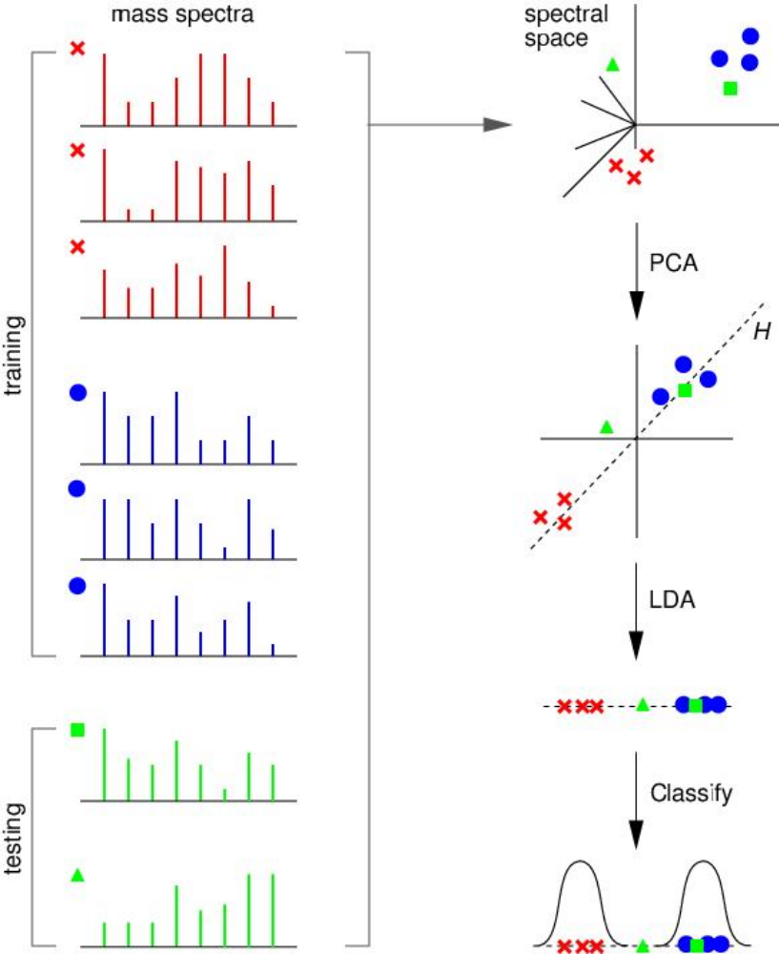

Figure 1

The general strategy of the proteomics program is to extract proteins from blood or tissue, analyze them with mass spectrometry to create patterns of protein fragments, sort through the patterns with an artificial intelligence computer program, and ultimately discover differences that will help distinguish, for example, cancer patients vs. healthy controls, or patients who will respond to therapy vs. those or who do not respond.

Q5 is based on a probablistic classification algorithm that employs principal componenets dimension-reduction and linear discriminant analysis using the spectra from either SELDI or MALDI-TOF mass spectrometry results as input. (Figure 1) It has already shown promise in being able to successfully distinquish between the spectra of cancerous vs normal tissue. This could be used to enhance the ability of physicians and oncologists to diagnose cancer based on the molecular signature for cancerous tissue and perhaps even monitor the effects of chemotherapy and be able to halt therapy earlier for those patients who are more responsive to it.

Business Justification

Death from cancer is the leading cause of death in the United States for people 45 and older regardless of race or gender. NIH has estimated that in 2004 the overall cost of cancer in the US was almost $190 billion. Early detection of cancer makes treatment less costly and more effective; controlling the length of treatment based on each individual's response to the therapy being applied also is less costly. Clearly any technology that can be developed to assist researchers in their development of treatments and physicians and oncologists in their treatment of patients will benefit society by lowering costs, improving quality of life and obtaining better outcomes.

Q5 will be designed as a standalone application that can be used to analyze spectra and as a "plug-in" that will be utilized as part of the overall proteomics workflow.

Project Description

Project Overview
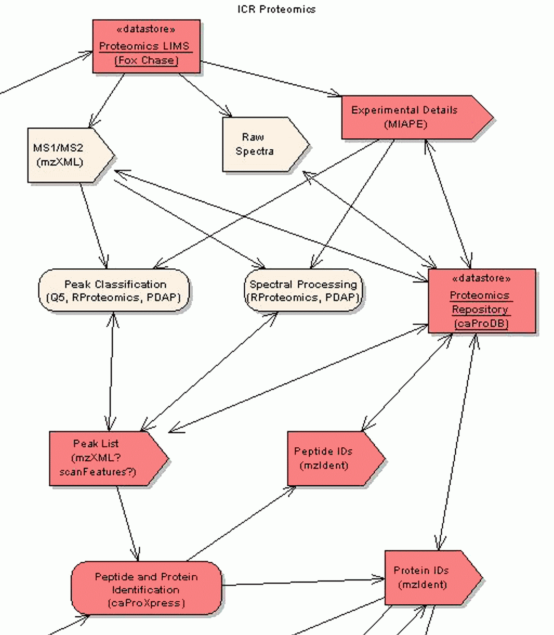
Figure 2
The objective of the Q5 application is to

Figure 2 shows the proposed proteomics workflow that incluldes Q5 for peak classification, and its relation / link to data in other systems/applications that are also part of the workflow. In this workflow, the raw data is stored in a Proteomics LIMS server and this data is then output into the mzXML data format. This data is then used as input into Q5, the output of which is a peak list.

Some examples of “real life” use cases that will eventually be realized in the Q5 system are given below. The Q5 Use Case Document provides more details on possible use cases and data elements.

- UC1
- UC2

Software Methodology and Design

A modified waterfall model will be used for designing software for all modules.

Q5 will be written in R. The UML model will be developed using Enterprise Architect.

The design of Q5 in R will be based on the original MatLab scripts that were used for the original paper that described this algorithm. The user interaction with Q5 will be by way of command line.

Figure 3 lists the general requirements for silver level and gold level caBIG compliance.

Silver Level Compliance | Gold Level Compliance
- Well-described APIs  - Standard terminologies  - Vocabulary/CDE Workspace  - Information models | All features of silver level compliance +  - Full compliance with caBIG vocabulary and terminology standards  - Interoperable with caBIG data grid architecture
Figure 3: caBIG Compliance Requirements

System Security
System security must handle two types of issues:

- User’s ability to view identified data. This is a regulatory issue and is associated with the IRB protocol (i.e. only users on the IRB protocol can see identified data).
- User’s access to datasets. This is a proprietary issue and therefore access to a dataset is assigned by the (PI) Principal Investigator of the protocol. The PI can give or revoke privileges to other users to access specified datasets for study.

To address both regulatory and proprietary concerns, system security in Q5 will be handled by local sites the security systems that are in place that comply with these concerns.

Related Projects

RProteomics -
caDSR – Cancer Data Standards Repository
CTMS Workspace projects – Provide direct link to clinical trials data
ICR Workspace projects- sample-based research data- analytical and genomic/proteomic annotation tools

Project Assumptions

The success of the Q5 effort requires:

- Willingness and capability of adopter to implement Q5 at its institution.
- Implementation of appropriate data confidentiality standards to satisfy HIPAA and local IRB standards as well as NIH and institutional guidelines for data and resource sharing.

System Challenges

Primary system (development) challenges include:
- Identification and definition of all CDEs used by Q5.
- Compatibility between RProteomics and Q5.
- Compatibility between Proteomics LIMS, being developed by Fox Chase, and Q5.
- Compatibility between TBPT, CTMS and ICR Workspaces’ projects with Q5.
- Identification of standard specimen preparation to reduce errors due to variance in this step.
- Identification of a standard output format for the result of peak classification.
- Performance: Ensuring that system works within acceptable limits of memory and speed constraints.
- HIPAA mandated confidentiality of patient information.

Secondary system (deployment) challenges include:
- Encouraging use of Q5.
- Approval of site’s IRB and Technology Transfer office to allow distributed data and materials sharing. For example, this can be done in separate arrangements: one IRB to share de-identified data and a second IRB and material transfer agreement before tissue is shared.

Project Constraints

The project will be conducted under the following constraints:

- The project scope will be maintained throughout each phase of the project with little or no change within a phase.
- The system design and application architecture will incorporate existing system components wherever possible in preference to creating totally new components.
- The design development process will ensure that the adopter actively participates in requirement gathering, review and testing phases.

Technical Constraints

The caBIG guiding principles and compatibility guidelines specify the following constraints:
- Requirements for grid accessibility and interoperability constrain the system to implement APIs in order to make the data accessible.
- Semantic interoperability requires that Q5’s object model be registered in the caDSR and that its data elements are defined using controlled vocabularies in the EVS

HIPAA requires the following constraint:
- System architecture must allow for separation of identified and de-identified data.

The following two tables list the hardware and software requirements for implementation of Q5. Note that the hardware table lists what is required as well as the amount recommended.

Hardware Constraints:
System Resources
Resource | Quantity |  | Name and Type
 | Recommended | Required

Server Side
CPU | 2 GHz | 1 GHz | CPU
RAM | 2 GB | 512 MB | Primary Memory
Hard disk | 10 GB | 2 GB | Secondary Memory

Client Side
CPU | 2 GHz | 1 GHz | CPU
RAM | 2 GB | 512 MB | Primary Memory
Hard disk | 10 GB | 2 GB | Secondary Memory

Software Constraints:
Software Element Name | Version | Type and Other Notes
Windows | 2000/XP | Operating system
Solaris | 5.8 or higher | Operating system
Linux | RedHat 9 or RedHat Enterprise ES/AS 2.1 or higher | Operating system
R | 2.1.0 | Application

Critical Success Factors

The following are critical success factors for the project:

- Identifying key users and stakeholders.
- The necessary resources, personnel and equipment, are available as required.
- Contribution/communication from all stakeholders in the system.

Risks and Risk Management

Primary risks include:

- Lack of detailed system requirements procured from Subject Matter Experts (SME) during the initial development phase.
- Lack of timely user participation during requirements gathering. Timely user involvement is critical to meeting project deadlines. This includes adopter sign off at key points (use cases, functionality and view).
- Lack of adequate resources on the development team. Dedication of adequate skilled personnel by each Project Team is critical to a successful project.
- caBIG security model not being mature enough for implementation.
- Accurate identification and definition of all CDEs used. To perform this task, Q5 will be limited by the current EVS and caDSR design. CDEs and concepts present in Q5 but absent from the caDSR and EVS, respectively, must be added to these systems in an expeditious manner.

Project Impact on Business Areas and Processes

There will be a definite internal and external impact on some working groups under the direction of the National Cancer Institute (NCI). The Project Team will determine the full impact on each working group. The following provides a brief summary of some of the likely impacts.

- Impact on NCICB by increasing connectivity among cancer researchers.
- Impact on Individual Cancer Centers with increased data sharing capabilities and facilitating more effective research.
- Impact on Overall Cancer Research Community by accelerating cancer research through coordination and data sharing among institutions.

In Scope/Out of Scope Functions

Purpose of This Section

This Section provides an overview of the functions and capabilities that are within the scope of the Q5 framework. The In Scope/Out of Scope functions establish a consistent expectation of what the project will and will not accomplish and in what phase the functionality will be developed and implemented.

In Scope/Out of Scope Functions

Detailed below are all the items that are to be included in the Q5 project along with projected time of completion.

Q5 Phase Timeline (release time from start)

- 3 Months from start
  - Design for Q5 completed
    - Prototype Requirements captured development
    - Submission of Use Cases outlining functionality
- 4 months from start
  - Working prototype
  - Deployment at Adopter Sites for testing and review

Scope
This project encompasses all development/design from project initiation up to a working Q5 at a Silver caBIG compatibility level. Gold level compliance is not in scope for this project.

Project Management

This project will be managed at two levels. First deliverables and milestones will be tracked in the cancer Management Portal (caMP). Second, detailed employee level of effort tracking and subtasks of deliverables will be tracked using Microsoft Project. All meetings will be documented, and notes will be submitted via (CVS) Concurrent Versions System and caMP. In addition, a monthly status report will be submitted detailing the month’s activities, major accomplishments and activities planned for the following month.

As described in the Statement of Work, the following documents will be deliverables in this project:

- Use Case Document- Details use cases for Q5 which will be implemented in this cycle.
- Risk Management Matrix- Identify the potential risks in the project and document the plan for managing these risks.
- Test Approach Document- Documents what approaches will be taken to assure requirements are met during unit testing and integration testing.
- Requirements Specification Document- Specifies the requirements Q5 will fulfill in this cycle (includes draft and final versions).
- Project Lessons Document- Lessons learned from this phase will be submitted to caBIG through CVS

General Considerations

Purpose of This Section

This Section outlines IT related considerations regarding the project and its implementation. The initial approach will be outlined and alternatives and recommendations will be discussed, where applicable.

Integration Considerations
Q5 will interact with the following systems:
- caTissue - This is where any and all data about the source of the specimen will be found.
- Proteomics LIMS – Access to MS
- MIAPE – Access to experimental details.

Conversion Considerations
N/A

Implementation Considerations
N/A

Other Considerations
N/A

Project Activities and Milestones

Activities/Tasks

Following is a preliminary list of tasks for Phase I and Phase II of the Project. This will be updated during Project Start-up.

Number | Task
1.0 | Project Management
1.1 | Enter deliverables and milestones described in Management plan into caMP
1.2 | Meeting notes, action items and attendance logs
1.3 | Monthly Status Report
1.3.1 | March Status Report
1.3.2 | April Status Report
1.3.3 | May Status Report
1.3.4 | June Status Report
1.3.5 | July Status Report
1.3.6 | August Status Report
1.3.7 | September Status Report
1.3.8 | October Status Report
1.3.9 | November Status Report
1.3.10 | December Status Report
1.3.11 | January Status Report
1.3.12 | February Status Report
2.0 | Project Deliverables
2.1 | Risk Management Matrix
2.2 | Report describing equipment and supplies
2.3 | Report summarizing accomplishments during Adopter visit
2.4 | Q5 code ported from Matlab to R
2.5 | Summary of findings from preliminary Q5 analysis of Adopter's data
2.6.1 | Draft Requirements and Specifications Document for caBIG Q5
2.6.2 | UML Class diagram for caBIG-compatible Q5
2.6.3 | Final Requirements and Specifications for caBIG Q5
2.6.4 | Q5 code incorporating standards for proteomics studies and Q5 code allowing interoperability with the proteomics LIMS
2.7 | Use case document, approved by Adopter
2.8 | Documentation of CDEs used by the system, including links to the CDEs
2.9 | Test Approach document
2.10 | Full source code for Q5, including user interface and application programming interface
2.11 | Document describing the Q5 API
2.12 | Report on Deployment of and Training on caBIG-compatible Q5, signed by Adopter.
2.13 | Completed Test Activity Logs
3.0 | Document project lessons learned
3.1 | Project Lessons Learned

Project Schedule

The project schedule will be maintained in the Q5 Project Plan.

