Q5 Software Overview
02/01/2006

Table of Contents

Table of Contents

Introduction to Mass Spectrometry 3
What is Q5? 5
Related Documents 7
Obtaining R and Loading Q5 8
Loading Q5 in the Windows R-GUI: 8
Loading the Q5 module: 9
Loading the dependency modules for Q5: 10
Q5 Functional Descriptions 13
q5 13
mzXML 15
normalize 16
pcaProject 17
pca 18

Introduction to Mass Spectrometry

Original Articles found at: http://www.muhlenberg.edu/depts/chemistry/webmaps/ms_int.htm

In mass spectrometry, a substance is bombarded with an electron beam having sufficient energy to fragment the molecule. The positive fragments which are produced (cations and radical cations) are accelerated in a vacuum through a magnetic field and are sorted on the basis of mass-to-charge ratio. Since the bulk of the ions produced in the mass spectrometer carry a unit positive charge, the value m/e is equivalent to the molecular weight of the fragment. The analysis of mass spectroscopy information involves the re-assembling of fragments, working backwards to generate the original molecule. A schematic representation of a mass spectrometer is shown below:

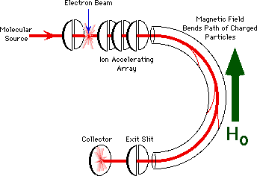
A very low concentration of sample molecules is allowed to leak into the ionization chamber (which is under a very high vacuum) where they are bombarded by a high-energy electron beam. The molecules fragment and the positive ions produced are accelerated through a charged array into an analyzing tube. The path of the charged molecules is bent by an applied magnetic field. Ions having low mass (low momentum) will be deflected most by this field and will collide with the walls of the analyzer. Likewise, high momentum ions will not be deflected enough and will also collide with the analyzer wall. Ions having the proper mass-to-charge ratio, however, will follow the path of the analyzer, exit through the slit and collide with the Collector. This generates an electric current, which is then amplified and detected. By varying the strength of the magnetic field, the mass-to-charge ratio which is analyzed can be continuously varied.

The output of the mass spectrometer shows a plot of relative intensity vs the mass-to-charge ratio (m/e). The most intense peak in the spectrum is termed the base peak and all others are reported relative to it's intensity. The peaks themselves are typically very sharp, and are often simply represented as vertical lines.
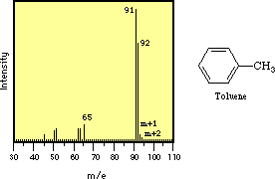
The process of fragmentation follows simple and predictable chemical pathways and the ions which are formed will reflect the most stable cations and radical cations which that molecule can form. The highest molecular weight peak observed in a spectrum will typically represent the parent molecule, minus an electron, and is termed the molecular ion (M+). Generally, small peaks are also observed above the calculated molecular weight due to the natural isotopic abundance of 13C, 2H, etc. Many molecules with especially labile protons do not display molecular ions; an example of this is alcohols, where the highest molecular weight peak occurs at m/e one less than the molecular ion (m-1). Fragments can be identified by their mass-to-charge ratio, but it is often more informative to identify them by the mass which has been lost. That is, loss of a methyl group will generate a peak at m-15; loss of an ethyl, m-29, etc.
The mass spectrum of toluene (methyl benzene) is shown below. The spectrum displays a strong molecular ion at m/e = 92, small m+1 and m+2 peaks, a base peak at m/e = 91 and an assortment of minor peaks m/e = 65 and below.
The molecular ion, again, represents loss of an electron and the peaks above the molecular ion are due to isotopic abundance. The base peak in toluene is due to loss of a hydrogen atom to form the relatively stable benzyl cation. This is thought to undergo rearrangement to form the very stable tropylium cation, and this strong peak at m/e = 91 is a hallmark of compounds containing a benzyl unit. The minor peak at m/e = 65 represents loss of neutral acetylene from the tropylium ion and the minor peaks below this arise from more complex fragmentation.
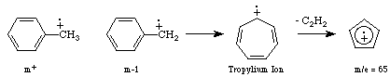

What is Q5?

The Q5 application is a probabilistic classification algorithm that employs principal components dimension-reduction and linear discriminant analysis.

Q5 has shown utility in disease classification of expression-dependent proteomic data from mass spectrometry of human serum. Q5’s ability to classify complex fragment mixtures was evaluated by testing its ability to discriminate the mass spectra of healthy vs. disease human serum samples. The two disease states examined in testing were ovarian and prostate cancer. Existing screening methods for both cancers carry a low positive predictive value (PPV). When detected early, the 5-year survival rate increases for both cancers.

Q5 outputs a classifier (discriminant) capable of classifying new mass spectra into one of the classes. The new spectra (called test spectra) that have not been seen by the algorithm and their classifications are unknown to the algorithm; the goal of the Mass Spectra Classification Algorithm (MSCA) is to determine the correct classification based on the classifier constructed from the training set. Classification verification is the testing process by which the discriminant is evaluated for its ability to correctly diagnose test samples. MSCAs can be characterized by the type of MS data processed, type of algorithm employed, and method of classification verification used.

Completeness of mass spectrum. Analysis may be performed on either complete or partial mass spectra. Complete mass spectra consist of the relative intensities of all m/z values acquired during MS data collection. This includes the relative intensities observed for all m/z values from 0 up to the upper limit of detection. An MSCA that processes complete mass spectra works with the entire recorded spectra: no values are “manually” excluded through preprocessing. When portions of a spectrum are excluded from consideration, we say a partial spectrum is generated.

Heuristic vs. Exact Classification Algorithms. Heuristic classification algorithms include approaches such as genetic algorithms, neural networks, and simulated annealing. These algorithms generally require multiple iterations to converge to a classifier; furthermore, the solution found by heuristic algorithms is not guaranteed to be optimal. In addition, many heuristic approaches are non-deterministic. Even when run on the same training set, the same non-deterministic algorithm often converges to a different discriminant. In contrast, MSCAs that utilize closed-form exact solutions (CFES) compute an exact solution using closed-form equations. CFES algorithms are computationally efficient; they are non-iterative and deterministic (i.e., always compute the same solution). Linear Discriminant Analysis (LDA), and thus Q5, are CFES algorithms.

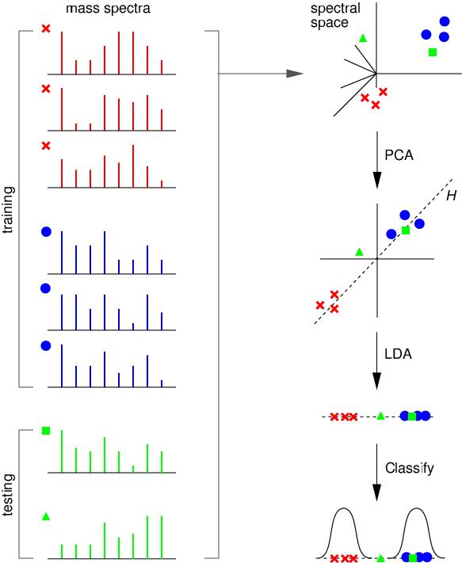

Related Documents
The current Q5 distribution contains a set of Matlab (Mathworks Inc, Natick, MA) functions. Q5 is presently written entirely in Matlab.
Reference: Ryan H. Lilien, Hany Farid, and Bruce R. Donald. "Probabilistic Disease Classification of Expression-Dependent Proteomic Data from Mass Spectrometry of Human Serum." Journal of Computational Biology, 10(6) 2003, pp. 925-946.

Obtaining R and Loading Q5

Loading Q5 in the Windows R-GUI:

In the R gui, ensure that the Bio-Conductor repository is set as well as the CRAN repository. To check this (or to enable this repository):

- Look under the packages menu for the “Packages” menu item. Select the menu item “Select repositories” sub-menu item

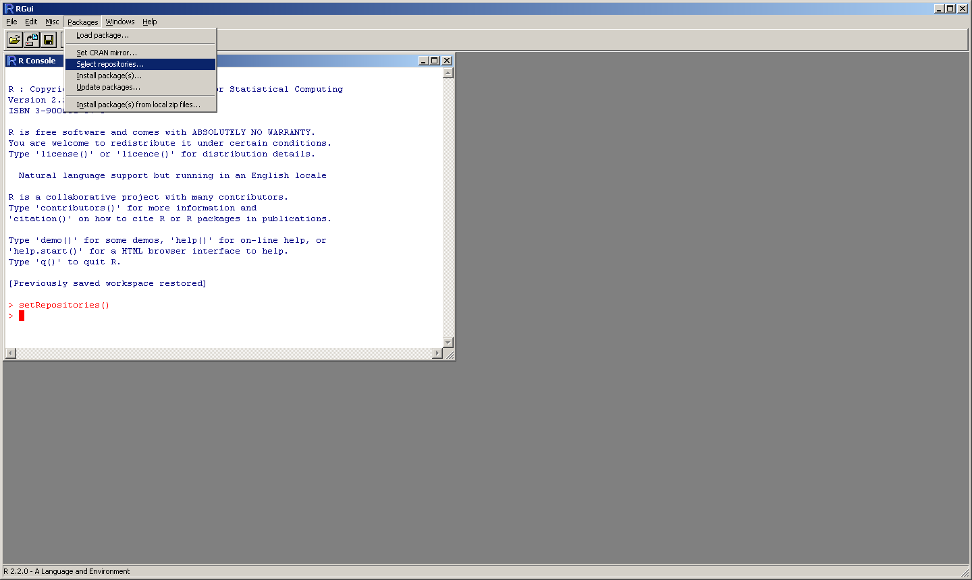

- Once selected, the following dialog will be displayed to the user:

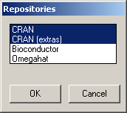

- Select the Bioconductor option as well as the CRAN options (if not already highlighted (or shift click to select range) and click the “OK” button. The user will be returned to the R script interface and the function setRepositories() will be displayed as the last function called.

Loading the Q5 module:

The first step is to load the Q5 script into the available modules for the R interface. Since Q5 is a local file, select the “Packages” menu item and the “Install package(s) from local files …” sub-menu item. Once selected a file dialog will be displayed and allow you to select the Q5 zip file. The interface will un-archive and install the package.

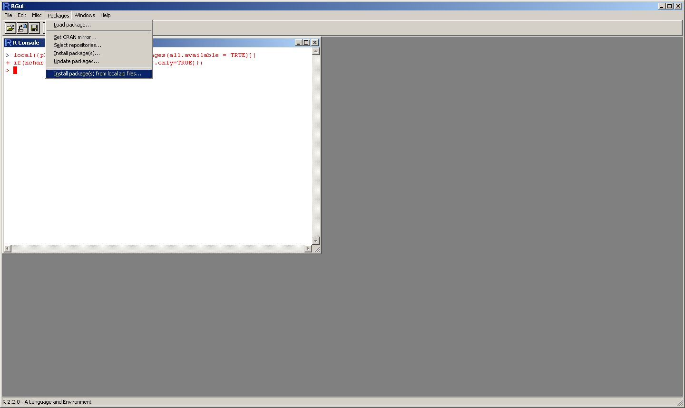

Loading the dependency modules for Q5:

install the needed packages if not already installed. To see what packages are available, simply click on the “Packages” menu item and then select the “Load Packages” sub-menu item. A list of all available packages similar to the figure will be displayed to the user:

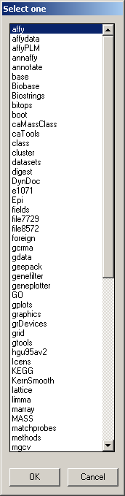

If you see the modules within the list you may select them to be loaded.

Note: If loading each module separately as opposed to Q5 loading them it is suggested that you load the modules in this order: PROcess, caMassClass, MASS, Q5

If the modules needed are not present in the list, click on the “Packages” menu item and select the “Install Package(s) …” sub-menu item.

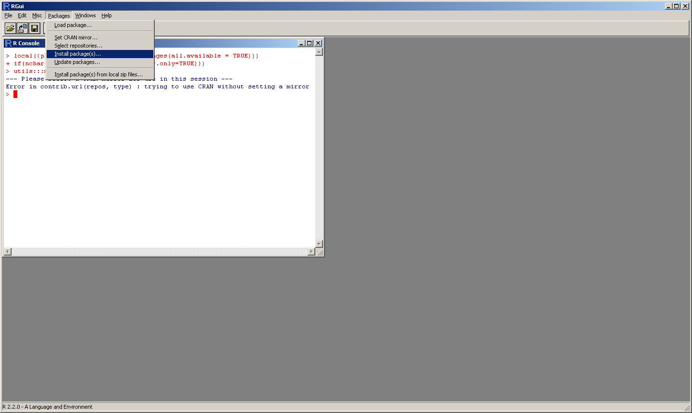

A list of mirrors will be displayed and the user should select the repository site closest to their physical location such as USA(CA1). Once selected the repository will be connected to and the available packages will be returned in a dialog to the user similar to the available packages dialog. Select the packages you wish to install and they should be installed and ready for use. Typically, the interface will display a MD5 Sum Check at the end of the installation of the package.

Sourcing the Q5 R script:

To source the Q5 script for running, simply click on the “File” menu and click on the “Source R Code …” dialog. A file dialog will be displayed and allow the user to navigate to the directory in which the script is placed and source the R file for running.

Loading the Dependency Modules for Q5:

Once the download and install is completed, you are now ready to load the necessary packages to run Q5. These may be done in two different manners:

  - If you have the PROcess, caMassClass and MASS packages previously loaded; loading the Q5 module will not call these and attempt to reload them.

  - If you have the modules installed but not yet loaded in your R session, simply select the “Packages” menu item and select the “Load Package ..” sub-menu item. A dialog will be displayed showing all available packages. Select the Q5 package and it will load all needed dependencies. Once this is done the command prompt for the R interface should be awaiting script input. To verify that Q5 has loaded properly, you may check it by typing “help(Q5)”. The help file for Q5 should immediately be displayed to the user if the modules have loaded properly.

Loading Q5 from the command-line R interface:

The command line interface (either non GUI Windows interface or *Nix versions) will use to following procedure:

source("http://www.bioconductor.org/biocLite.R")
biocLite("PROcess")
install.packages('caMassClass', repos="http://cran.fhcrc.org/")
install.packages('MASS', repos="http://cran.fhcrc.org/")

Note: You should choose the nearest server from
http://cran.r-project.org/mirrors.html and use that instead of
http://cran.fhcrc.org/.

Again, the installation can be verified by typing “help(Q5)” at the R prompt.

Q5 Functional Descriptions

q5
Purpose –Provides the main function for the script. Trains a disciminant on given training data and then assesses its predictive capacity with testing data. This is the function of the Q5 algorithm. Each of the functions it performs are accomplished by calling functions that are passed as parameters, this allows users to substitute their own functions for any of the steps in Q5 (with the exception of the statistical parameters generated).
Type - This is the main function that implements the Q5 algorithm.
Functional Description –Performs the Q5 algorithm in a flexible fashion that allows the user to alter its sub-functionality.
Subordinate –Four functions passed by the user. Provides default values that depend on pca, lda, pcaProject, and MASS:::predict.lda.
Dependencies - Requires the MASS package.
Preconditions –Requires two matrices of data, one for training, one for testing, requires two vectors that describe the classes of the data. Optionally takes four functions for dimensional reduction, discriminant construction, data projection, and class prediction. Optionally takes two filenames, one to output the statistics and one to write a plot of the eigenvalues as a png graphic.
Interfaces - q5(trainData, trainClasses, testData, testClasses, reductionFunction=pca, discriminantFunction=lda, projectionFunction=pcaProject, predictionFunction=MASS:::predict.lda, statfile=NULL, plotfile=NULL)
Takes two matrices of real numbers, one of training data, one of testing data. Takes two vectors of integers the label the class of each row in the two matrices, 1 indicates diseased state. Returns the generated discriminant, the estimated positive predictive value of the discriminant, the percentage of cases in the testing data that were correctly classified, the estimated sensitivity and specificity.
Graphics - Generates a plot of the eigenvalues. If plotfile is NULL, the plot is shown on the screen. If plotfile is the name of a file the plot is placed in that file as a png graphic.
Resources - None
Error Conditions –The function will fail with an error message if any of the passed objects are not of the correct type.
Example Implementation -

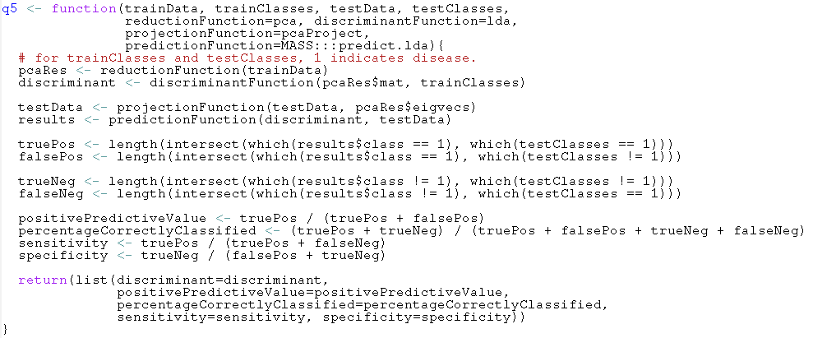

mzXML

- Purpose - The mzXML function loads a datafile from a user supplied string containing the path to an mxXML file. It returns a list of two values; "mass", the mass to charge ratio of each peak in th escan and "peaks" which are the intensities for each peak in the scan.
- Type - This is a conveneince function within the Q5 script for the user's use.
- Functional Description - Reads each scan in the file and appends its peaks and mass to charge ratios to separate items in a list.
- Subordinate - This function makes external calls to function read.mzXML in the caMassClass.
- Dependencies - Requires the caMassClass package.
- Preconditions - Requires a string describing the location of a local file in mzXML format. This function is called prior to executing q5.
- Interfaces - mzXML(filename)
- Graphics - This is a non-graphical routine.
- Resources - None
- Error Conditions - The function will fail with an error message on malformed mzXML. The function will also provide an error message if the user supplied string does not contain the path to a local mzXML file.
- Example Implementation –

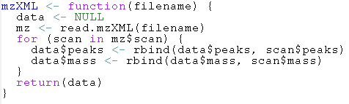

normalize

- Purpose – Normalizes the peak intensity matrix. This is not part of the main script but it provides a simple normalization for the convenience of users.
- Type - This is a function that can be called before q5 to normalize the data.
- Functional Description - The normalize function normalizes the peak intensities of a scan to the range [0, 1] using a standard linear transformation.
- Subordinate - This function makes no function calls to dependency packages.
- Dependencies – None.
- Preconditions - Requires a two dimensional matrix of real values
- Interfaces – normalize(mat)
- Graphics - None.
- Resources – None.
- Error Conditions – This function will fail with an error message if it doesn't receive a matrix of rank 2.
- Example Implementation -
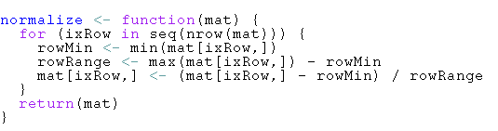

pcaProject

- Purpose – Projects data into the pca space on which the discriminant was defined.
- Type - This is a function that can be passed to q5 as the projectionFunction parameter.
- Functional Description – Multiplies the user supplied matrix by the user supplied eigenvectors.
- Subordinate – This function makes no function calls to dependency packages.
- Dependencies – None.
- Preconditions - Requires two two dimensional matrices of real values
- Interfaces – pcaProject(mat, eigvecs)
- Graphics - None.
- Resources – None.
- Error Conditions – This function will fail with an error message if it receives the wrong type of input. The size of the second dimension of the matrix (mat) must be equal to the size of the first dimension of the second matrix (eigvecs).
- Example Implementation –

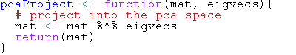

pca

The pca function performs principle components analysis on the given matrix.

- Purpose – Dimensional reduction of the data.
- Type - This is a function within the Q5 script with an exposed development interface.
- Function – Performs principle components analysis by singular value decomposition, taking the diagonal of the resultant matrix and multiplies this by the input matrix.
- Subordinate – None.
- Dependencies – Takes a two dimensional matrix of real values.
- Preconditions - Requires a two dimensional matrix of real values
- Interfaces – Performs principle components analysis by singular value decomposition, taking the diagonal of the resultant matrix and multiplies this by the input matrix.Returns the resultant matrix and the eigenvectors and eigenvalues of the matrix..
- Graphics - None.
- Resources – None.
- Error Conditions – This function will fail if it receives the wrong type of input with an error message.
- Example Implementation –

- 