Q5 Disease Classification by Mass Spectrometry Pattern Recognition #79761CBS10

DOCUMENT CHANGE HISTORY
Version Number | Date | Description
1.0 | November 2004 | Draft
1.1 | March 2005 | Added Sign-Off Page

Q5 Disease Classification by Mass Spectrometry Pattern Recognition #79761CBS10
Q5 R Module Release 1.0
Software Requirements and Specification Document
Version 1.0

[Insert approval date of document]

Document Change Record
Version Number | Date | Description
1.0 | [Insert approval date of document] | Initial draft document

TABLE OF CONTENTS

1.caBIG Software Requirements and Specification Template i
2.Introduction 1
2.1Related Documents 3
2.2Scope 3
2.2.1Identification 3
2.2.2System Overview 3
2.2.3Document Overview 6
2.3Reference Documents 6
3.Project Description 7
3.1Project Perspective 7
3.2Project Functions 7
3.3User Characteristics 8
3.4Constraints 8
3.5Qualification Provisions 9
3.6Assumptions and Dependencies 9
4.Requirements 10
4.1[heading tbd] 10
4.1.1[Further Category Designation] 11
5.System Architecture 12
6.Components 15
6.1[Name of application component] 15
8.[NOTES] 19
9.Sign off 20
9.1Approval 20
10.Appendix A – Acronym List 21
11.[Appendix B – Other Appendices] 22

Introduction
This SRSD captures the complete software requirements for the Q5 software and describes the design decisions, architectural design and the detailed design needed to implement the software. It provides the reader visibility in to the design and provides information needed for software support.
The Q5 application is a probabilistic classification algorithm that employs principal components dimension-reduction and linear discriminant analysis.
Q5 has shown utility in disease classification of expression-dependent proteomic data from mass spectrometry of human serum. Q5’s ability to classify complex fragment mixtures was evaluated by testing its ability to discriminate the mass spectra of healthy vs. disease human serum samples. The two disease states examined in testing were ovarian and prostate cancer. Existing screening methods for both cancers carry a low positive predictive value (PPV). When detected early, the 5-year survival rate increases for both cancers.
Q5 outputs a classifier (discriminant) capable of classifying new mass spectra into one of the classes. The new spectra (called test spectra) that have not been seen by the algorithm and their classifications are unknown to the algorithm; the goal of the Mass Spectra Classification Algorithm (MSCA) is to determine the correct classification based on the classifier constructed from the training set. Classification verification is the testing process by which the discriminant is evaluated for its ability to correctly diagnose test samples. MSCAs can be characterized by the type of MS data processed, type of algorithm employed, and method of classification verification used.
Completeness of mass spectrum. Analysis may be performed on either complete or partial mass spectra. Complete mass spectra consist of the relative intensities of all m/z values acquired during MS data collection. This includes the relative intensities observed for all m/z values from 0 up to the upper limit of detection. An MSCA that processes complete mass spectra works with the entire recorded spectra: no values are “manually” excluded through preprocessing. When portions of a spectrum are excluded from consideration, we say a partial spectrum is generated.

1

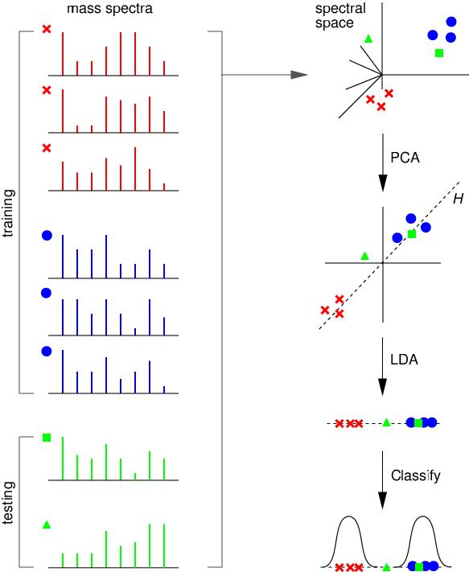

Heuristic vs. Exact Classification Algorithms. Heuristic classification algorithms include approaches such as genetic algorithms, neural networks, and simulated annealing. These algorithms generally require multiple iterations to converge to a classifier; furthermore, the solution found by heuristic algorithms is not guaranteed to be optimal. In addition, many heuristic approaches are non-deterministic. Even when run on the same training set, the same non-deterministic algorithm often converges to a different discriminant. In contrast, MSCAs that utilize closed-form exact solutions (CFES) compute an exact solution using closed-form equations. CFES algorithms are computationally efficient; they are non-iterative and deterministic (i.e., always compute the same solution). Linear Discriminant Analysis (LDA), and thus Q5, are CFES algorithms.

Related Documents
The current Q5 distribution contains a set of Matlab (Mathworks Inc, Natick, MA) functions. Q5 is presently written entirely in Matlab.
Reference: Ryan H. Lilien, Hany Farid, and Bruce R. Donald. "Probabilistic Disease Classification of Expression-Dependent Proteomic Data from Mass Spectrometry of Human Serum." Journal of Computational Biology, 10(6) 2003, pp. 925-946.
Q5 Use Case Scenarios - Q5 Project (2005)

Scope
The overall scope of the Q5 Disease Classification by Mass Spectrometry Pattern Recognition Developer Project / 79761CBS10 is to reproduce the Q5 algorithm currently implemented in the Matlab software, a proprietary software package, into the open source software environment of R (a GNU Project implementation of the proprietary S Plus software package developed originally at Bell Laboratories). The second thrust of this project is to make caBIG compatible the new implementation of Q5. This release also tackles the challenge of utilizing the Fox Chase LIMS server as a data feed as well as local datafiles.
For more information about the R software package please refer to the url: http://www.r-project.org/

Identification
Abbreviations:
- Q5 Software Project - Abbreviated reference to the "Q5 Disease Classification by Mass Spectrometry Pattern Recognition Developer Project / 79761CBS10
- OHSU - Oregon Health and Science University

System Overview
Q5 outputs a classifier (discriminant) capable of classifying new mass spectra into one of the classes( such as healthy vs. disease). The new spectra (called test spectra) that have not been seen by the algorithm and their classifications are unknown to the algorithm; the goal of the Mass Spectra Classification Algorithm (MSCA) is to determine the correct classification based on the classifier constructed from the training set.
The current adopter site for the software is targeted as Oregon Health and Science University and they will be performing the user acceptance and initial usage functions. The development group is composed of various members of the Computational Genetics Laboratory and other members of the Dartmouth Medical School.
The development site for the software will be located at the Norris Cancer Cotton Center located in Lebanon, N.H. and Dartmouth College with initial user testing and deployment at the OHSU site.
This development effort will utilize a "modified waterfall method" of software development with the SDLC phases being:
- Risk Analysis Assessment
- Base Analysis (Both system level and interfaces)
- Requirements gathering
- Development of use case scenarios
- Base prototype conversion of the current Q5 algorithm functionality
- Requirements release for final software development
- Development of test cases
- Implementation of the software for testing
- Execution of system test cases locally for validation
- Execution of use cases externally for validation
- Software release documentation and training

Software Development Life cycle Flow:

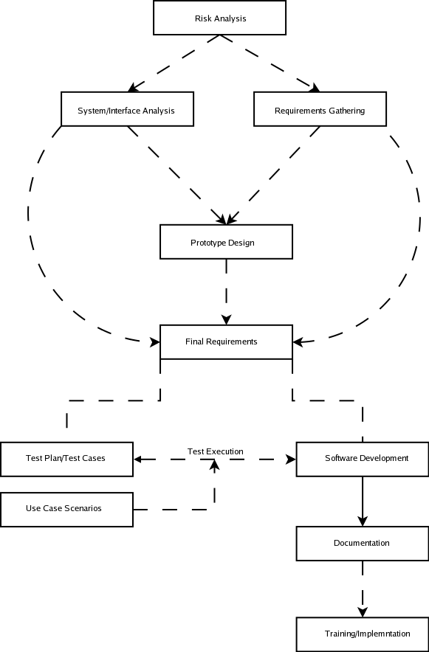
The Major Components of the R version of Q5 will consist of the following:
- Base Q5 algorithm developed as an R software module
- Reading of a standardized datafile of mass spectrometry data (mzXML, however, specifics to be defined)
- Output of a standardized format for analysis results (to be defined)
- Connectivity to the Fox Chase LIMS server located at Dartmouth Research Computing Resource as a mechanism for input/output source for the mass spectrometry data.

Document Overview
This SRSD captures the complete software requirements for the Q5 software release 1.0 as part of the Q5 Software Project.
This document should be considered as a mechanism to outline the requirements for design of the Q5 software. For detail regarding the algorithm itself, please refer to the original paper outlining the algorithm as referenced in section 2.1.
The remaining SRSD sections are organized as follows:
- Section 2. Project Description: Describes the general factors that affect the Q5 Software Project.
- Section 3. Requirements: Describes all the software requirements to a level of detail sufficient to enable designers to design a system to satisfy those requirements, and testers to test that the system satisfies those requirements.
- Section 4. Notes: Contains general information that aids in the understanding of this document.
- Appendix A. Acronym List: Defines the abbreviations used on the project.

Reference Documents
For additional project, and requirement specific information, refer to the following documents:
- Ryan H. Lilien, Hany Farid, and Bruce R. Donald. "Probabilistic Disease Classification of Expression-Dependent Proteomic Data from Mass Spectrometry of Human Serum." Journal of Computational Biology, 10(6) 2003, pp. 925-946.
- Q5 Project Use Case Scenarios

Project Description

Project Perspective

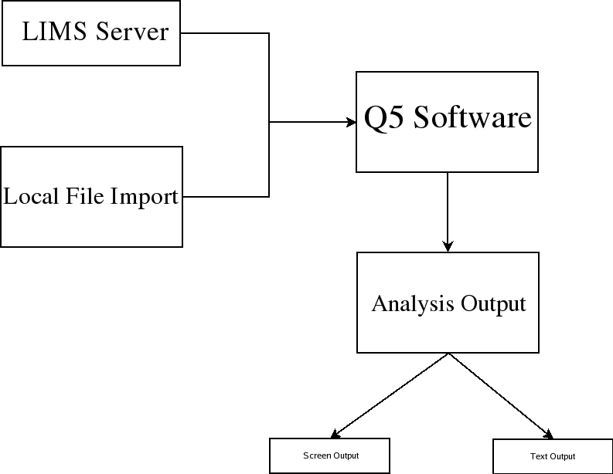
The structural architecture is outlined in the graphic depicted above. The Q5 software will run within the R Software framework as a module. This software package supports installations to Unix (and variants), Mac and Windows operating systems as to make it cross platform usable.

Project Functions
NCCC and Dartmouth have performed research on disease classification by spectrometry pattern recognition. The tie of clinical proteomics programs to patient diagnosis and the monitoring of treatments is in early stages of technology development and substantiation. Valid early detection protocols in identifying the presence or absence of cancerous cells will increase patient survival rates and extend their life expectancies by hastening appropriate management of treatable malignancies. Proteomic profiling of cancer cells exposed to experimental therapies will provide critical information in designing treatment regiments and discovering therapeutic targets. To address this challenge, researchers at Dartmouth have developed Q5, a Mass Spectrometry Classification Algorithm (MSCA) that is a combinatorially precise algorithm cast in closed-form equations and therefore provides a means to compute an optimized solution for disease classification. Q5 is designed to distinguish between plasma profiles of normal and disease-bearing individuals. Currently, Q5 is available as a Matlab application.

NCCC will apply an internally developed mass spectrometry pattern recognition tool, Q5, designed to distinguish between plasma profiles of normal and disease-bearing individuals. Ultimately, NCCC aims to deliver rapid disease classification method for dozens of neoplastic and other diseases through further development of Q5. Support for Q5 development with caBIG technologies and standards will facilitate the participation of institutions in data analysis. Q5 is a potentially important tool in following the pharmacokinetic status of cancer patients in chemotherapeutic treatment.

To date, the Q5 algorithm method has been developed, evaluated and applied by one research group at Dartmouth. The current implementation uses Matlab for statistical calculations. For this project, Q5 will (1) Be translated to open source; (2) Be deployed to the Adopter site(s) for analysis; (3) Be adapted to the caBIG architecture.

User Characteristics
The primary target user audience identified by the caBIG adopter (OHSU) site has been the role of a bio-statistician with assistance for software installation via a bio-informatics specialist.
Bio-statistics and bio-informatics personnel at OHSU will be evaluating the output of the analysis routines for accuracy.
Developers located at the Dartmouth site will be performing unit testing on code produced for the Q5 project.

Constraints
- External Software Dependencies
The R software Project page supports operating system releases for Max OS (System 8.6 to 10.2.x and above) as well as Linux and Microsoft Windows(95 and later). The source code for the R software is available for the software for compilation on additional platforms as well.
The R software was selected as a natural candidate due to the great number of inherent statistical functions already readily available to the language allowing possible additional statistical analysis of the results set via the use of the internal graphing functions. Finally, the compatibility of R to other toolsets and development languages might be used in structuring an "end to end" workflow for analysis of the data by the given site using the product.
Presently the only dependency is the inclusion of the MASS library to be installed for the R installation. This package can be picked up at the CRAN repository or can be installed with the following procedure:
http://cran.fhcrc.org/src/contrib/VR_7.2-16.tar.gz

- To use it, cd to its directory and execute: R INSTALL MASS

Data Standards:
- Q5 Data Input Format
The input format for the Q5 software has not been defined at this point but anticipating is that it be done soon. Strong consideration has been given to the mzXML format as it can be output by the LIMS server as well as the used by other caBIG sponsored products such as caMassClass, which could be a pre-processing software consideration.
- Q5 Data Output Format
The output format for the Q5 software at this point has not been stabilized outside of the current software version in Matlab which outputs the discriminants. The goal is to make this flexible but adhere to a standard that allows for flexibility and maintainability within the changing caBig infrastructure. Consideration of the widely used format of mzXML for the use by the Fox Chase LIMS server as well as the availability of XML parsers and viewers for Mass Spectrometry data in mzXML format for various platforms is the current consideration for the output format. This will be defined, finalized and documented within the next few weeks of the project.

- The selection of the R language for development was made based upon the inherent statistical functions within the language itself that are accessible to the end user and the fact that this software is open source and freely available to many platforms and in source format. This allows the potential for additional analysis and exploration of the end results by the user proficient in the R software. The only database interaction intended for the Q5 software is importing of spectra via the Fox Chase LIMS server.

Qualification Provisions
a. Demonstration: The operation of the system or component that relies on observable functional operation not requiring the use of instrumentation, special test equipment, or subsequent analysis.
b. Test: The operation of the system or component using instrumentation or other special test equipment to collect data for later analysis.
c. Analysis: The processing of accumulated data obtained from other qualification methods. Examples are reduction, interpretation, or extrapolation of test results.
d. Inspection: The visual examination of code, documentation, etc.
e. Special qualification methods: Any special qualification methods for the system, such as special tools, techniques, procedures, facilities, and acceptance limits.

Assumptions and Dependencies
[Identify all assumptions and dependencies regarding factors external to the project that may affect the requirements. For example:
- Prior installation of the R software environment on the local workstation including the R MASS library (see the constraints section within this document).
- The current version of R will configure and build under a number of common Unix platforms including cpu linux-gnu for the i386, alpha, arm, hppa, ia64, m68k, mips/mipsel, powerpc, s390, sparc , and x86_64CPUs,powerpc-apple-darwin, mips-sgi-irix, rs6000-ibm-aix, and sparc-sun-solaris.

Requirements
The Requirements categories outlined correspond to each functional area of the Q5 software and the software flow diagram.

Datafile Handling

Table 3.1-1: Data Handling Requirements
Req ID | Requirement Type | Requirement Description
1.1 | System | The system will allow the end user to import spectra from a local datafile located on the client workstation or network.
1.2 | System | The system will allow the end user to import spectra from a Fox Chase LIMS server.
1.3 | Interface | The system will display an error to the user if the datafile attempting to be imported is improperly formatted.
1.4 | System | The input datafile format will be mzXML. Specific input values to be mapped later for compliance to standard terminologies.
1.6 | System | The Q5 system will accept both Seldi-TOF and Maldi-TOF data formatted in the proper input format .
1.7 | System | The Q5 system will allow for database attribute acquisition by common ID value with the Fox Chase LIMS version.
1.8 | System | The system will allow the user to pass a parameter to the software to determine the number of eigen vectors to drop during analysis.
1.9 | System | The system will allow the user to determine the number of partitions to use for cross validation in the analysis. (Present open question to use CV or Bootstrapping)

Analysis Routines

Table 3.1-1: Analysis Routines Requirements
Req ID | Requirement Type | Requirement Description
2.1 | System | The Q5 system will allow the user to perform to indicate a datafile to be imported for use as a testing set to produce a reusable discriminant value for future analysis runs.
2.2 | System | The Q5 system will reduce the dimensional space for the data using PCA (Principle Components Analysis) within the software. This mechanism will be made visible to the user so that they can call this portion of the functionality from the R environment.
2.3 | System | Following PCA, the Q5 system will implement a LDA (linear discriminant analysis) method against the data. This mechanism will be made visible to the user so that they can call this portion of the functionality from the R environment.
2.4 | System | The Q5 system will perform cross validation on the dataset input into the software as a part of the analysis.

Analysis Output

Table 3.1-1: Analysis Output Requirements
Req ID | Requirement Type | Requirement Description
3.1 | System | The Q5 system will output various threshold graphs following the analysis.
3.2 | System | The Q5 system will output the disease classification from the analysis in a numerical value as well as the associated statistics (Classification Sensitivity, Classification Specificity, Percentage of Samples Classified, Percentage of Samples Correctly Classified and the Positive Predictive Value.) These terms will be reviewed in the caDSR and made more solid to caBIG specifications.
3.3 | System | The Q5 system will utilize the following output format (to be defined) ...

[NOTES]
None as of draft release.

Sign off

Approval

Architecture Workspace Rep Print Name Date
VCDE Workspace Rep Print Name Date
Adopter Rep Print Name Date

Appendix A – Acronym List
[Insert an alphabetical listing of all acronyms and abbreviations, and their meanings as used in this document.]
Term/  Abbreviation | Description
[Q5] | Q5 Disease Classification by Mass Spectrometry Pattern Recognition - #79761CBS10
[R] | R software Environment
DBA | Database Administrator
PM | Project Manager
RM | Requirements Manager
RTM | Requirements Traceability Matrix
SCM | Software Configuration Management
SDLC | Software Development Lifecycle
SDP | Software Development Plan
SE | Software Engineering
SEPG | Software Engineering Process Group
SM | Software Manager
SOP | Standard Operating Procedure
SPI | Software Process Improvement
SQA | Software Quality Assurance
SW | Software
TBD | To Be Determined
TM | Test Manager

[Appendix B – Other Appendices]
[Use appendices to provide information published separately for convenience in document maintenance (e.g., charts, classified data). As applicable, the main text of the document should reference each appendix where the data would logically fit within the document. Appendices may be bound as separate documents for ease in handling. Appendices shall be lettered alphabetically (A, B, etc.).]

