Use Case: Fetch Raw Data Files
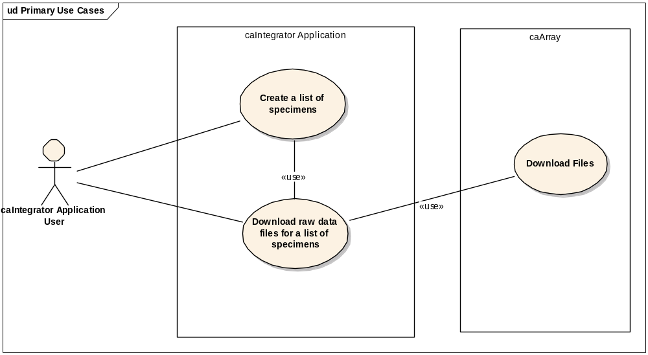
Actors:
- caIntegrator Application Public User
- caIntegrator Application Private User
Goal:
- After querying and performing analysis of Genomic data, The Actor would like to retrieve to download raw data files (CHP /CEL files) from the caIntegrator portal
Background:
- caIntegrator allows users to query and analyze preprocessed and normalized datasets from the translational portal. Based on sample/specimen identifier, caIntegrator users would like to download the associated raw data files directly from the caIntegrator portal.
Stakeholders and Interests:
- caArray is the center’s array data repository, caIntegrator team is in the process of submitting all associated CHP /CEL files to caArray
- caArray provides a API (application programmatic interface) to access files associated with an experiment
Preconditions:
- Actor is logged in and has been authenticated and authorized to view data for the selected samples/specimens
- Raw data files have been uploaded, validated and under access control in caArray. In other words, with proper credential, they are available for download.
- System performs an “Availability of Service” check to determine that the data repository is accessible.
- Actor saves a list of samples/specimens in caIntegrator applications by naming the list.
Basic Flow:
- Actor navigates to the download page by selecting the “Download” tab

- Actor focuses on the “Raw Data Files from caArray” section
- Actor selects a name of previously saved sample/specimen list
- Actor selects the name of the platform (ex: Affymetrix etc.)
- Actor selects the files types to download ( CEL, CHP, OTHER)
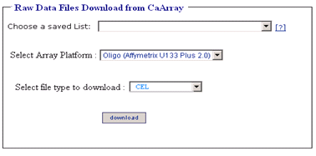
- Actor selects the “Download” button. A highlighted message will be displayed - “The download process must be completed within this session. Do not close your browser or logout, or you must start again”.
Extensions / Variations:
- The system verifies if raw data files exist for each of the samples/specimens in the user selected list in caArray. If any files are not present, the system notifies the Actor about the absence of those files with status of missing files such as “Not Available’, “Downloading Error” etc.
- System determines that an error has occurred during the download process or the data repository is inaccessible. The systems informs Actor of the status.
Post conditions:
- The system looks up the file names associated with the selected samples/specimens list.
- The system downloads the associated files from the caArray repository.
- The system labels the download package with the selected sample/specimen list name.
- The system displays the labeled download package on the Download page, along with relevant status.
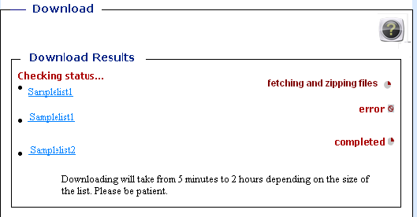
- The system bundles the downloaded files along with a manifest file which contains the mapping between samples/specimens and file names.
- The system creates a zip bundle with an appropriately labeled filename.
- The Zip Utility checks the total file sizes. If the zip file exceeds the limit (3GB typically), then the file will be fragmented and more than one zip file will be created.
- The system updates the status of the download bundle to “completed” and activates the hyperlink, prompting the user to download the bundle via HTTP.
- If the user activates the download button twice for a bundle while the same bundle is in the fetching and zipping status , then the system updates status as “error”.(In Rembrandt and other caIntegrator applications, "error" is a tooltip, which displays the exact error message when mouse over.)

Special Requirements:
- Data files can be very large (approx. 150 MB each)
- Download process may be memory and CPU intensive.
- If the user closes browser or ends their session by logging out, the file download process is cancelled and the user must start again.
- The user may navigate away from the Downloads page, and return during the same session to complete the download (as the download process is asynchronous).
- All generated files will be deleted from the system the user session expires when any of the follow occur: user logs off, closes the browser or session times out.
Open Issues/Risks:
- Use case assumes all associated data files have been uploaded, validated and under access control in caArray. In other words, with proper credentials, they are available for download.
- System needs to check for “Availability of Service”. Before allowing user to download files, the system needs to check if the repository is accessible.
- System needs to have a well defined error handling workflow. Possible errors:
  - “Unavailability of Service”
  - Missing or incomplete data files
  - Inadequate permission
  - System Timeout
  - System faults

Wire frames
Initial Download Page

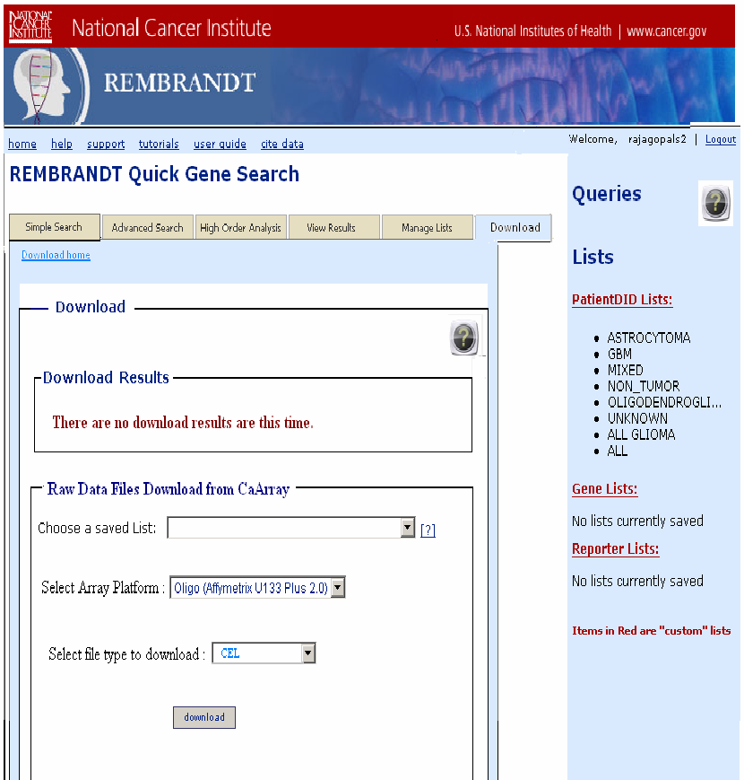
Download in Progress Page
