Nautilus data warehouse schema:
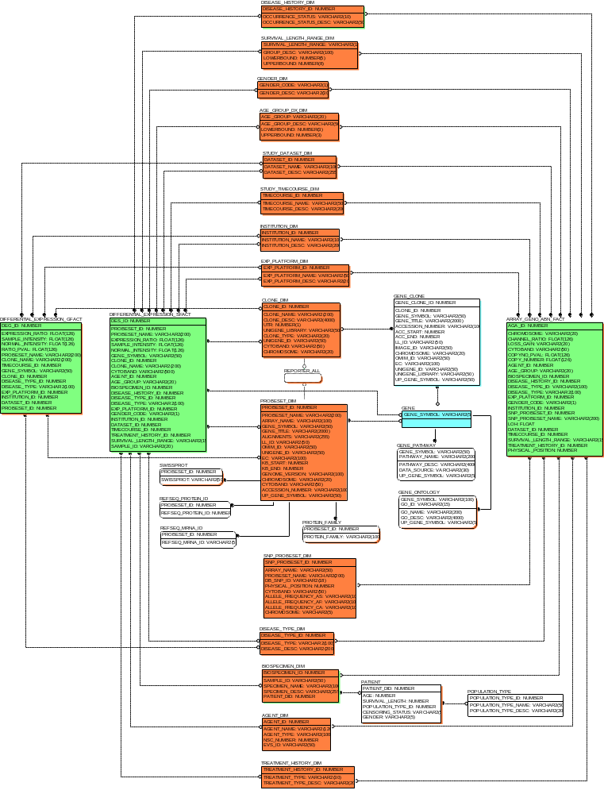

Look up tables:

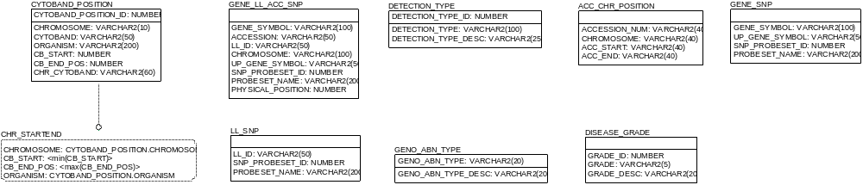

Staging table (Nautilusdev2):

