VIsual and Statistical Data Analyzer (VISDA)

UML Document (Task 2.5)

Document Change Record
Version Number | Date | Description
1.0 | May 30, 2005 | First Draft
1.1 | August 31, 2005 | Second Draft

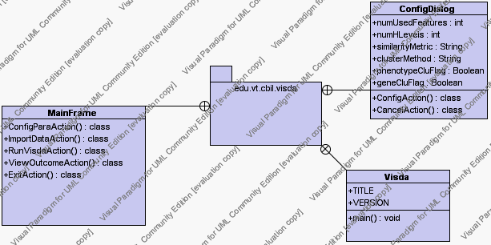
Figure 1. Class Diagram of Package edu.vt.cbil.visda

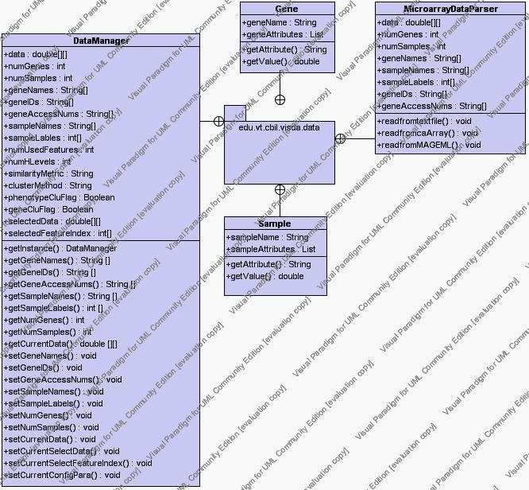
Figure 2. Class Diagram of Package edu.vt.cbil.visda.data

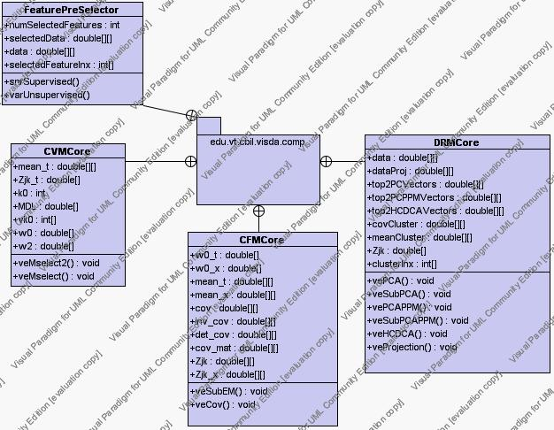
Figure 3. Class Diagram of Package edu.vt.cbil.visda.comp

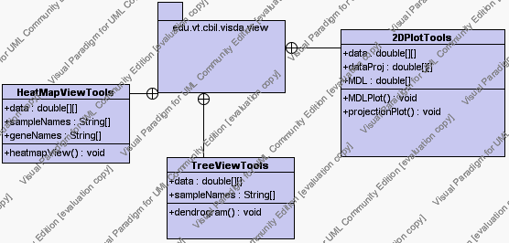
Figure 4. Class Diagram of Package edu.vt.cbil.visda.view

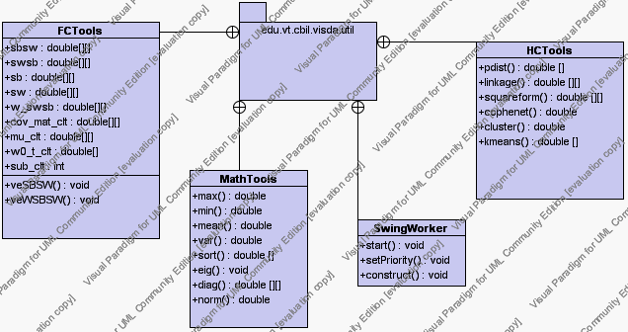
Figure 5. Class Diagram of Package edu.vt.cbil.visda.util

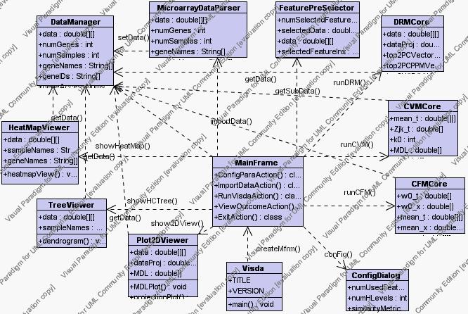
Figure 6. Class Diagram of Relationship

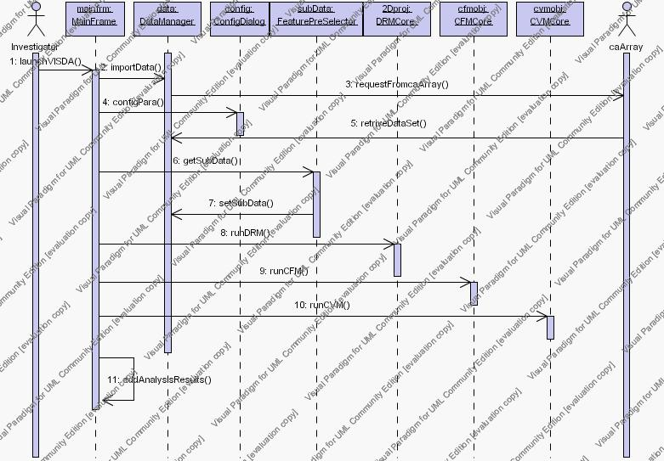
Figure 7. VISDA UML sequence diagram

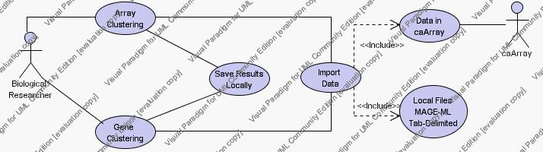

Figure 8. VISDA use case diagram

