An Integrated Multi-Scale Decision Support System for Reservoir Inflow Forecasting and Flood Risk Mitigation: Coupling Attention-Based Deep Learning, Tree-Based Ensemble Models, and Edge-AI Crowdsensing
Vo Nguyen An¹, Van Duc Hoang Tien¹, Pham Tan Khoa¹, Nguyen Thi Minh Anh¹
Advisors / Corresponding: Assoc. Prof. Dr. Vo Ngoc Duong¹, Dr. Nguyen Quang Binh¹, M.Sc. Pham Ly Trieu¹, M.Sc. Nguyen Trung Quan¹, M.Sc. Ngo Thanh Vu¹
¹Faculty of Hydraulic Engineering, University of Science and Technology – The University of Danang, 550000 Danang, Vietnam
Email: {111220022, 111220062, 111220041, 111220101}@sv1.dut.udn.vn | {vnduong, nqbinh, pltrieu, ntquan, nthvu}@dut.udn.vn
Abstract
Cascading reservoir operation and flood emergency response in mountainous river basins remain challenging due to steep terrains, rapid hydrological response times, and the lack of tightly coupled forecasting-operational-warning pipelines. This study presents an end-to-end, multi-scale Decision Support System (DSS) integrating hydrological artificial intelligence, rule-based operational dispatch, and crowdsourced edge computing across the Vu Gia – Thu Bon river basin in Central Vietnam. The core methodological contributions comprise: (1) A global Attention-driven Bi-LSTM architecture featuring a 240-hour Hindcast Encoder and an Autoregressive Decoder with a 7-quantile head (P5–P95) trained under a multi-component Hybrid Loss (Pinball + Peak-Aware MSE + Horizon Decay + Coverage Bonus); (2) Two complementary tabular ensemble models — a Quantile Regression Forest and an XGBoost model with a native quantile objective — trained as global, direct multi-horizon estimators across all 16 reservoirs, sharing the same 47-dimensional hydro-meteorological feature space as the LSTM encoder; (3) A mathematical formalization of Decision No. 1865/QĐ-TTg inter-reservoir dispatch rules coupled with 1D-Spline Z-V storage-elevation curves; (4) An Edge-AI computer vision module (YOLO Pose) utilizing geometric triangulation on standardized reference signposts for real-time crowdsourced flood-depth estimation.
Held-out evaluation across the 16-reservoir Vu Gia – Thu Bon cascade (2025 test period) shows the global Attention Bi-LSTM achieves a mean NSE of 0.40 across all reservoirs (0.63 when excluding one reservoir affected by documented telemetry data-quality issues), with individual reservoirs ranging up to 0.868 (Dak Mi 4) depending on catchment complexity and hydrological telemetry completeness — performance is shown to correlate strongly with water-level/outflow sensor data coverage, which varies from 11% to 67% across the cascade.
[PLACEHOLDER — insert one sentence reporting the Quantile Regression Forest and XGBoost mean NSE/KGE once the Kaggle training run (Section 3.5) completes, before this abstract is finalized for submission.]
An Edge-AI YOLO Pose module provides objective, real-time crowdsourced flood-depth estimation without exposing human surveyors to hazardous zones. The ecosystem is deployed in production across a WebGIS disaster-monitoring dashboard, cross-platform Mobile applications with offline emergency-shelter routing, a centralized Admin moderation dashboard, and a manually configured municipal Zalo Official Account channel, providing an operational blueprint for smart disaster management in tropical monsoon river basins.
Keywords: Flood Forecasting; Reservoir Inflow; Attention-based Bi-LSTM; Random Forest; XGBoost; Quantile Regression; Decision Support System; YOLO Pose; Vu Gia – Thu Bon Basin.
1. Introduction
Climate change combined with extreme meteorological events has dramatically increased the frequency and severity of catastrophic flooding in mountainous tropical catchments across Southeast Asia. In Central Vietnam, the Vu Gia – Thu Bon (VGTB) river basin represents a hydrological hotspot characterized by steep topography, narrow coastal plains, and concentrated precipitation during the typhoon season (October to December) where cumulative 24-hour rainfall frequently exceeds 500–800 mm.
To balance hydropower generation, dry-season water supply, and flood mitigation, cascading reservoir systems comprising 16 major dams (e.g., A Vuong, Dak Mi 4, Song Bung 4, Song Tranh 2) have been constructed across the VGTB basin. The operation of these multi-owner, multi-purpose reservoirs is legally governed by Prime Ministerial Decision No. 1865/QĐ-TTg. However, operationalizing these mandates in real-time crisis scenarios faces critical bottlenecks:
1. Limitations of Conventional Hydrological Models: Physically-based distributed hydrological models (e.g., MIKE-SHE, SWAT, HEC-HMS) require extensive parameter calibration, detailed bathymetric surveys, and soil moisture data that are scarce in developing regions. Conversely, standard lumped Long Short-Term Memory (LSTM) networks often rely on fixed Inverse Distance Weighting (IDW) rainfall interpolation, which fails to capture dynamic convective cloud shifts and spatial orographic rainfall gradients across rugged terrain.
2. Trade-off between Short-Term Reactivity and Medium-Term Strategic Planning: Deep learning sequence-to-sequence models excel at capturing multi-day nonlinear rainfall-runoff dynamics (12–24 h lead-times), yet can exhibit lag errors during sudden flood peaks, motivating complementary statistical or tree-based approaches for shorter horizons.
3. Decoupling of Inflow Forecasts from Reservoir Operational Dispatch: Most published literature terminates at hydrograph prediction without feeding inflows into real-time reservoir rule engines that strictly enforce flood-control water levels (MNDẬT), surcharge levels (MNGC), and downstream capacity thresholds.
4. Lack of Closed-Loop Ground Truth Verification: While hydrological forecasting operates upstream at the dam scale, disaster management authorities and downstream citizens lack real-time mechanisms to validate inundation depths on the ground without sending emergency crews into hazardous zones.
2. Study Area and Datasets
2.1 Geographical and Hydrological Setting
The study area is the Vu Gia – Thu Bon River Basin, encompassing an area of 10,350 km² across Quang Nam Province and Danang City (14°55' - 16°05' N, 107°15' - 108°24' E). The basin is partitioned into two main tributaries: the Vu Gia River in the north and the Thu Bon River in the south, both originating from the Truong Son mountain range (elevations up to 2,598 m) and discharging into the East Sea via the Han Estuary and Cua Dai Estuary. This study covers all 16 major cascading reservoirs regulated under Decision No. 1865/QĐ-TTg within this single basin; extension to neighboring river systems is identified as future work and is not evaluated in this paper.
2.2 Data Ingestion and Feature Engineering
A 4.25-year hourly dataset (January 2022 – March 2026) was constructed from three synchronized data pipelines: (1) Telemetered rainfall from 28 automatic rain gauges within the VNDMS / VRAIN network; (2) Hydrological dam telemetry (Z, Q_in, Q_out) retrieved from the Danang Open Data Platform (apiv2.danang.gov.vn) via a high-availability VPS proxy tunnel (the public API is only reachable from Vietnamese IP ranges); (3) Numerical Weather Prediction (NWP) reanalysis from the Open-Meteo ERA5 archive for atmospheric forcings (temperature, relative humidity, surface pressure, wind speed, ET₀). Reservoir water-level and outflow telemetry coverage is uneven across the cascade, ranging from 11% to 67% depending on the dam's SCADA reporting history; this is treated explicitly as a data-quality covariate in the Discussion (Section 4.1) rather than masked by interpolation alone.
Table 1. Overview of the 47-Dimensional Input Feature Space for Hydrological Machine Learning.
Feature Category | Dim | Representative Variables | Hydrological Rationale
Precipitation (P) | 18 | R(t), R_3h…R_168h rolling sums, R_intensity, R_std, lagged R(t-1..24) | Captures immediate storm impulses and antecedent moisture buildup.
Hydraulic Flow (Q) | 12 | Q_in(t-1), ΔQ_in, Δ²Q_in, rolling Q_(3..48h), rising flag, rain×inflow interaction, soil-moisture×inflow interaction | Accounts for baseflow momentum, wave acceleration, recession limb, and antecedent moisture–runoff coupling.
Reservoir State (Z, Q_out) | 6 | Water level Z(t), ΔZ_24h, mean Z_24h, outflow Q_out(t), ΔQ_out, outflow/inflow ratio | Models backwater storage retention and tailwater discharge constraints.
Meteorology (NWP) | 5 | ET₀, temperature, relative humidity, pressure, wind speed | Controls atmospheric evaporative demand and infiltration deficit.
Temporal Harmonic | 6 | sin/cos encoding of hour [0-23], day of year [1-365], month [1-12] | Captures diurnal convective cycles and seasonal monsoon shifts.
Total Feature Space | 47 | Unified multi-modal input matrix X_past ∈ R^(240 × 47) | Comprehensive physics-informed hydrological input vector.

3. System Architecture and Methodology
The proposed system establishes an end-to-end multi-tier pipeline connecting data acquisition, a dual-track forecasting engine (sequence-based deep learning and tabular ensemble models), legal dispatch logic, and multi-channel public dissemination.

Figure 1. End-to-end multi-tier system architecture: Data layer (VNDMS rain, SCADA dams, NWP ERA5), forecast engines (Attention Bi-LSTM + Quantile Regression Forest + XGBoost), rule-based dispatch layer (Decision 1865/QĐ-TTg + Z-V spline), and multi-channel application delivery.
3.1 Attention-Driven Bi-LSTM with Quantile Regression (Horizon 1–24h)
The hydrological neural network architecture incorporates the following modules:
1. Bidirectional Hindcast Encoder: Processes an antecedent 240-hour sequence X_past through a 2-layer Bi-LSTM with hidden dimension H = 128, producing contextual representations H_enc ∈ R^(240 × 256):
H_enc = [LSTM_fwd(x_t, h_(t-1)) || LSTM_bwd(x_t, h_(t+1))]
2. StationRainAttention Module (proposed, evaluation pending): rather than assigning static IDW weights w_i = d_i^(-p), a per-station attention layer has been implemented (station_attention.py) to dynamically weight individual rain-gauge contributions. This module is currently disabled by default in the production configuration pending a full dataset rebuild and end-to-end retraining; quantitative results for this component are reported separately once that retraining is complete and are not included in Section 4.
3. Autoregressive Forecast Decoder with 7-Quantile Output Head: Generates non-crossing probabilistic envelopes [P5, P10, P25, P50, P75, P90, P95] across lead-times t+1h to t+24h.
4. Multi-Component Hybrid Loss Function: the training objective combines a weighted pinball (quantile) loss, a peak-aware MSE term on the median forecast, an exponential horizon-decay weighting, and a coverage-violation penalty:
L_total = (1 − w_peak − w_cov)·L_pinball + w_peak·L_peak + w_cov·L_coverage
with w_peak = 0.15, w_cov = 0.05, horizon-decay rate λ = 0.02 applied per lead-time step
L_peak weights the median-quantile squared error by a normalized peak-emphasis factor √(y_t + 1), clamped to a maximum multiplier of 5, so that high-flow events receive proportionally larger gradient contributions without destabilizing training on low-flow periods; L_coverage penalizes observations falling outside the [P5, P95] interval.
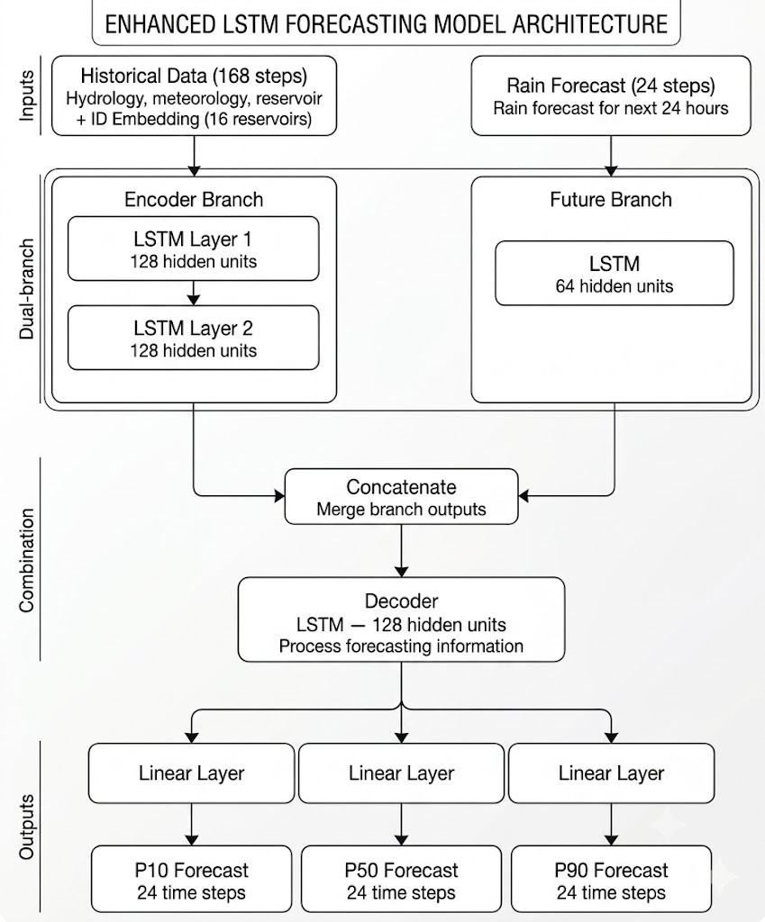
Figure 2. Deep neural network architecture: 240-hour Bidirectional LSTM Hindcast Encoder and Autoregressive Forecast Decoder with 7-Quantile probabilistic output head.
3.2 Complementary ARIMAX Formulation (Lead-Time 1–6h)
To maximize reactivity during immediate gate-opening maneuvers, an ARIMAX(p, 1, 0) model is formulated as a complementary ultra-short-term layer for primary flood-regulating dams (e.g., Song Tranh 2):
ΔQ(t) = Σᵢ φᵢ·ΔQ(t-i) + Σⱼ βⱼ·Rⱼ(t − L*) + c + ε(t)
where ΔQ(t) = Q(t) − Q(t−1), φᵢ are autoregressive coefficients, and Rⱼ(t − L*) represent non-overlapping lagged rainfall accumulators at basin concentration lag L* = 6h. This model is currently operationalized as an independently deployed forecasting service; formal reproducible benchmarking of its accuracy against the deep-learning and ensemble pipelines described in this paper — on the same held-out period and code repository — is in progress and will be reported in a follow-up study rather than with the preliminary figures used during initial service validation.
3.3 Rule-Based Reservoir Dispatch Engine (Decision 1865/QĐ-TTg)
The reservoir operation engine models hydraulic storage evolution via discrete differential water balance equations:
V(t+Δt) = V(t) + [Q_in̄(t) − Q_out̄(t)]·Δt − E(t), Z(t+Δt) = S_(Z-V)(V(t+Δt))
where S_(Z-V)(·) represents a cubic spline interpolation of the empirical elevation-storage curve. The dispatch logic implements the legal operational modes defined in Decision 1865/QĐ-TTg: (1) Pre-Flood Drawdown; (2) Downstream Flood Mitigation (restricting outflow when Ai Nghia > 8.0 m or Cau Lau > 3.0 m); and (3) Dam Structural Safety (opening spillway gates when Z(t) ≥ MNGC).
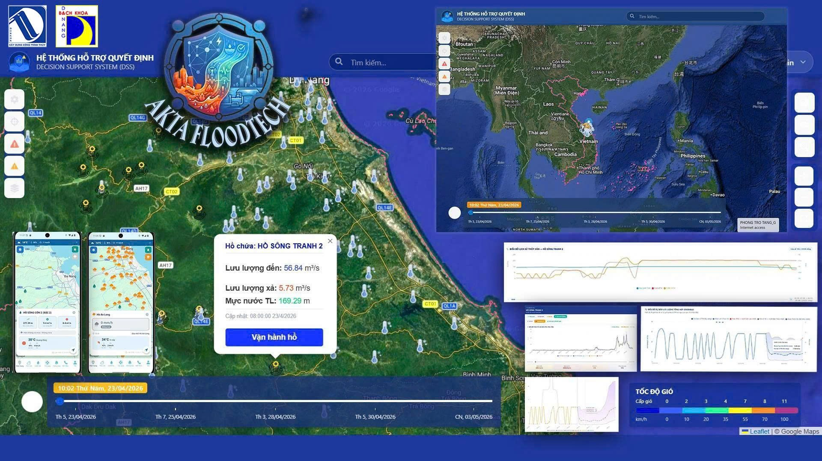
Figure 3. Inter-reservoir cascade dispatch workflow and coordination mechanism between upstream dams and downstream control points (Ai Nghia, Cau Lau) under Decision No. 1865/QĐ-TTg.
3.4 Crowdsourced Flood Depth Estimation via YOLO Pose Triangulation
To validate downstream inundation in real time, citizen-submitted photographs are processed by an on-premise YOLO Pose model detecting three key landmarks on standardized municipal traffic signposts: P1(x1, y1) at the top of the sign board, P2(x2, y2) at the bottom of the sign board, and P3(x3, y3) at the water-air intersection line on the pole.
The analytical inundation depth H_flood is computed via perspective-invariant Euclidean ratios:
d_sign = √((x2-x1)² + (y2-y1)²), d_water = √((x3-x2)² + (y3-y2)²)
h_exposed = H_sign × (d_water / d_sign) [cm], H_flood = H_pole − h_exposed [cm]
where H_sign = 70 cm and total pole height H_pole = 200 cm. Submissions with H_flood ≥ 10 cm and AI confidence > 0.75 are automatically approved and trigger neighborhood emergency broadcast alerts.
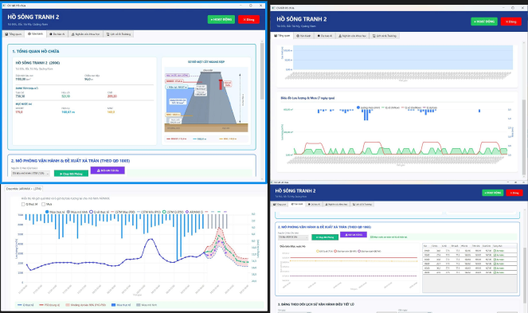
Figure 4. Edge-AI computer vision pipeline: 3-landmark YOLO Pose detection on standardized signposts, perspective Euclidean triangulation, flood depth calculation, and automated classification.
3.5 Tabular Ensemble Models: Quantile Regression Forest and XGBoost (New)
To complement the sequence-based Attention Bi-LSTM, two tabular gradient-boosting/ensemble models were developed as global, direct multi-horizon estimators: a Quantile Regression Forest (RF) and an XGBoost model trained with a native quantile objective (reg:quantileerror). Both models share the same 16-reservoir scope and the same 47-dimensional feature space described in Table 1, with reservoir identity encoded as a 16-dimensional one-hot feature, plus 6 oracle future-covariate features (instantaneous and 3h/6h/24h cumulative future rainfall, forecast temperature, forecast wind speed). During training, these future covariates take their true realized values (consistent with the teacher-forcing convention already used for the LSTM's autoregressive decoder); at inference time they are substituted with a live Open-Meteo forecast, so the model learns the rainfall→inflow response surface from complete historical data while remaining deployable under genuine forecast uncertainty.
Rather than a single sequence model, each of the 24 forecast horizons (t+1h … t+24h) is estimated by an independent model instance — 24 Quantile Regression Forests (each directly producing the full P10/P50/P90 triplet from its leaf-value distribution) and 72 XGBoost boosters (24 horizons × 3 quantiles). Training uses a strict 60% / 20% / 20% chronological split (train / validation / test, split by elapsed time rather than by sample count, to avoid future-to-past leakage), with an additional 1.5× sample-weight multiplier applied to observations falling in the flood season (September–January), compounding with existing peak-magnitude oversampling (top-5% of flood peaks → 2× weight, top-1% → 3× weight).
[PLACEHOLDER — Section 3.5 results: insert per-reservoir NSE/KGE/PICP for both RF and XGBoost, and the corresponding rows in Table 2, once the Kaggle training run completes. Do not submit this manuscript with this placeholder still present.]

