**Homework 0**

**Moodle Submission Deadline: 2020/09/22 (Saturday) 23:59**

**Problem 1: Multiplication of Polynomial Texts** ( **hw0_p1.py** )

In mathematics, a polynomial is an expression consisting of variables and coefficients, that involves only the operations of addition, subtraction, multiplication, and non-negative integer exponents of variables. An example of a polynomial of a single variable X, is $X^{2}-4X+7$. An example in three variables is $X^{3}+2X^{5}YZ^{2}-YZ+1$.

In this homework, your task is to write a program to allow a text-version multiplication of multiple polynomials. Specifically, the user is allowed to input a string that represents the multiplication of several polynomials. Then you program needs to generate the string of the resulting polynomials.

The input and output polynomial strings need to follow the following rules.

1. $n*X$ means $n$ is the coefficient, $X$ is the variable, and $n$ is the coefficient of variable $X$. In other words, coefficients are always placed before variables.
2. $X^n$ represents $X^{n}$, where $X$ is the variable, and $n$ is the exponent of $X$. That said, exponents are always placed after variables.
3. Polynomials with the same variables need to be put together by adding their coefficients, for example, $5*XY^2+3*XY^2$ should be $8*XY^2$.

Note that you can use only pure Python, i.e., you cannot use any package.

**Sample Input/Output:**



Bonus:

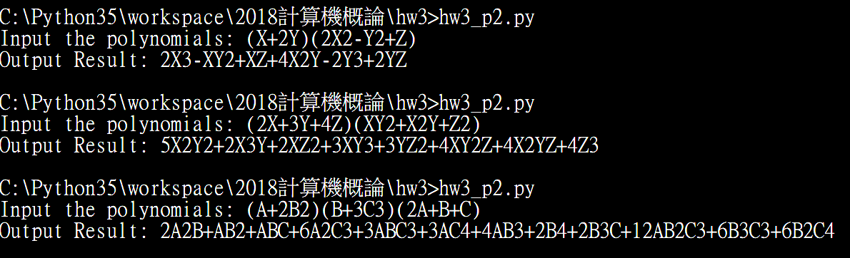

**Problem 2: Movie Data Analysis** ( **hw0_p2.py** )

In this homework, you are asked to write a program for answering the following questions based on IMDB Movie data (**IMDB-Movie-Data.csv**). You are required to write a function for answering each question. You may wang to use Python’s File reading, List, Dictionary, and Functions. You cannot use any packages. The output format of each question is free.

|  |  |
| --- | --- |
|  | **Question** |
| (1) | Top-3 movies with the highest ratings in 2016? |
| (2) | The actor generating the highest average revenue? |
| (3) | The average rating of **Emma Watson**’s movies? |
| (4) | Top-3 directors who collaborate with the most actors? |
| (5) | Top-2 actors playing in the most genres of movies? |
| (6) | Top-3 actors whose movies lead to the **largest** *maximum gap of years*?   |  | | --- | | *Example of “maximum gap of years”:*  Tom Cruise has movies: “Edge of Tomorrow” in 2014, “Mission: Impossible - Rogue Nation” in 2015, “Oblivion” in 2013, “Jack Reacher” in 2012, “Mission: Impossible III” in 2006, “Jack Reacher: Never Go Back” in 2016, “Rock of Ages” in 2012, “Mission: Impossible - Ghost Protocol” in 2011. **The maximum gap of years is 2016-2006 = 10** | |
| (7) | Find all actors who collaborate with **Johnny Depp** in *direct* and *indirect* ways   |  | | --- | | Example:  A collaborates with B B collaborates with C and D C collaborates with E and F D collaborates with A and G  All actors directly and indirectly collaborating with A include: [B, C, D, E, F, G, H]  G collaborates with H | |

**Important Notes**

This is a homework for each **person**. **You need to write comments to describe the meaning of each part in hw0_p1.py and hw0_p2.py.**

**How to Submit Your Homework?**

Before submitting your homework, please zip the files (**hw0_p1.docx** and **hw0_p2.py**) in a zip file, and name the file as “StudentID_hw0.zip”. For example, if your StudentID is H12345678, then your file name is: “H12345678_hw**0**.zip” or “H12345678_hw**0**.rar”. Then submit your file using NCKU Moodle platform [http://moodle.ncku.edu.tw](http://moodle.ncku.edu.tw/) .

**Have Questions about This Homework?**

Please feel free to visit TAs, and ask/discuss any questions in their office hours. We will be more than happy to help you.