**FRA ISSUES**

1. While we are doing Mapping of Range Officer, we are able to select multiple blocks as well as multiple Grampanchayat. However, once a Grampanchayt is selected for an range officer it should not be visible to other range officer for selection. Though the system is showing all the grampanchayt to each and every range officer, whether it is already mapped with another Range Officer. And Also Remove the Village option from edit user screen while doing Mapping of Range Officer. 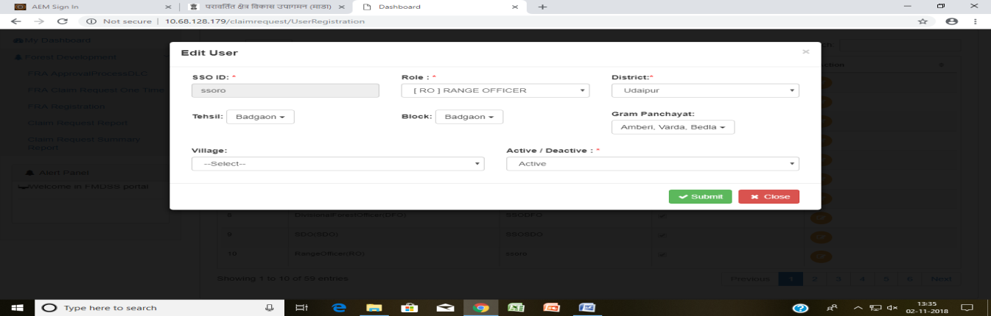

1. FRA Application should also be in Hindi language because many uses use Hindi language.
2. At each level, the pending applications in the level below should be seen. At this point, this visibility is only there at the district level login.
3. When we select individual in claim type then profile not working.  
   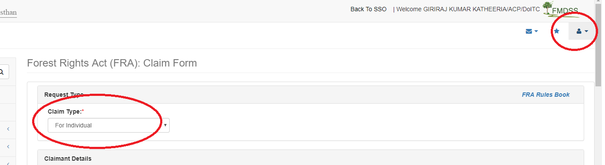
4. In view survey details -> add option to view KML file on Map which is uploaded by gramsabha
5. Provision to update SSO IDs in case of Transfer of any User
6. Add application view button to view full application details on report and request details form  
   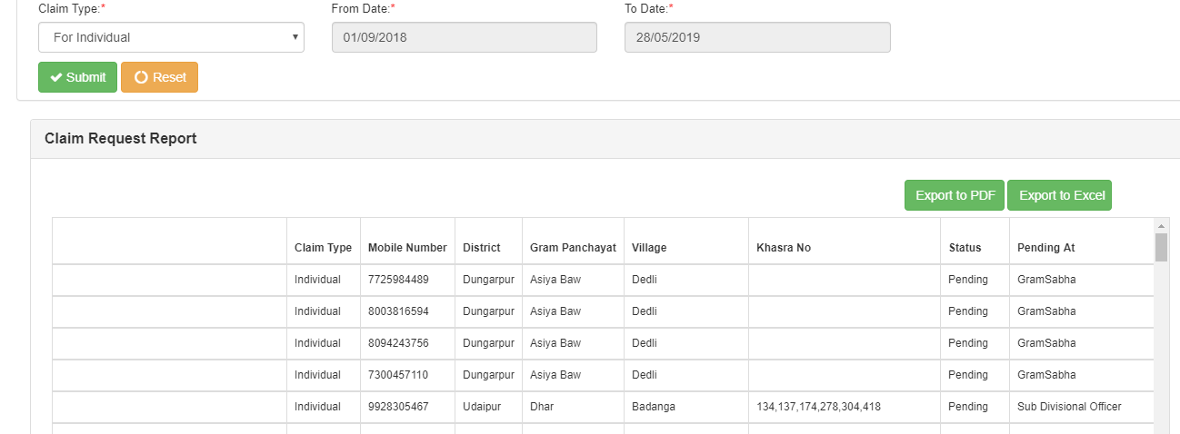  
   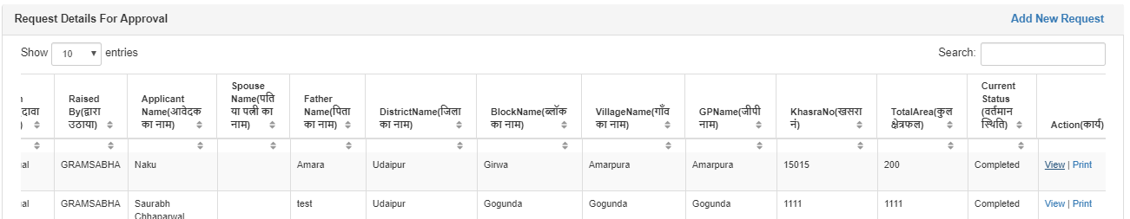

1. **Claim Request Summary Report** should be in PDF as well as excel format in proper format just like below image  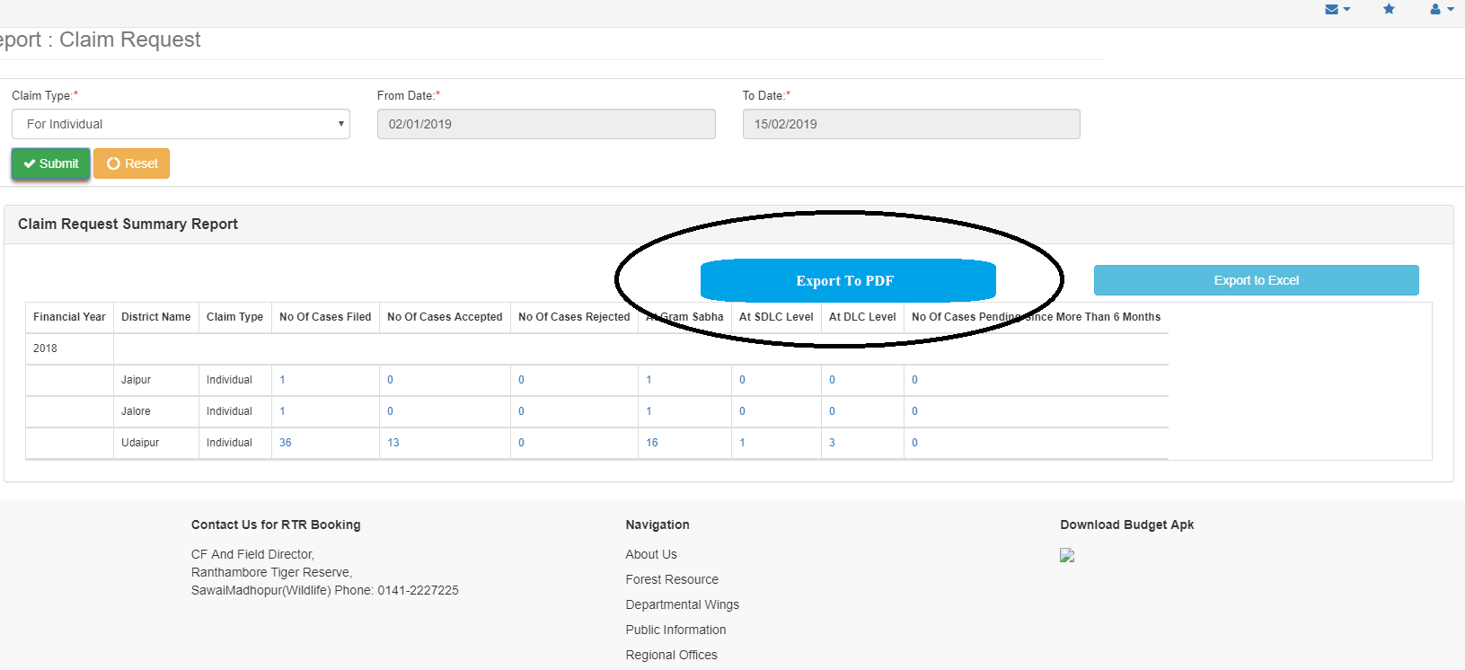

1. How to change old SSO user to new user on portal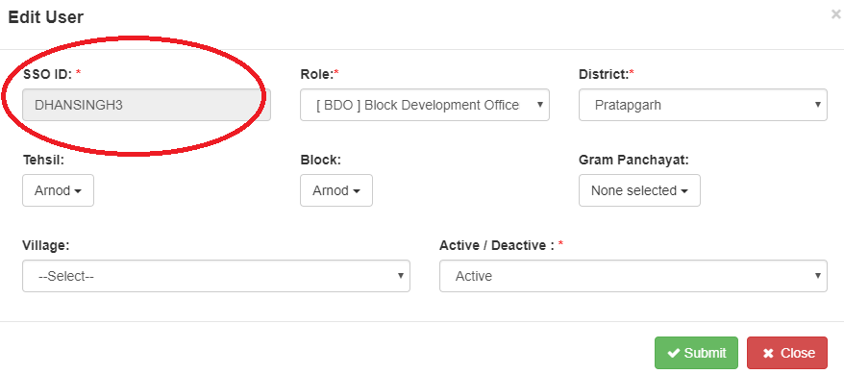
2. Change application name as tribal area development department   
   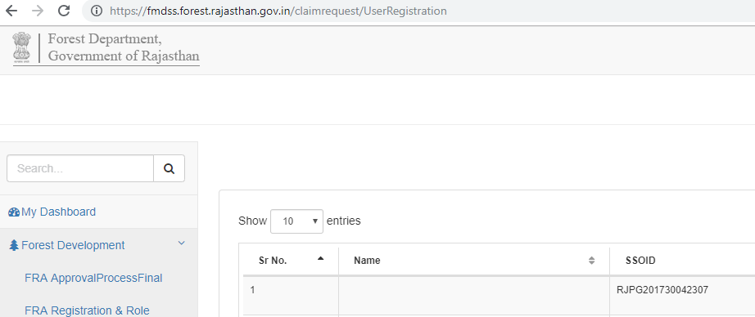
3. remove navigation RTR Booking, and add tad department contact information on footer part as <http://tad.rajasthan.gov.in/content/raj/tad/hi/home.html>  
     
   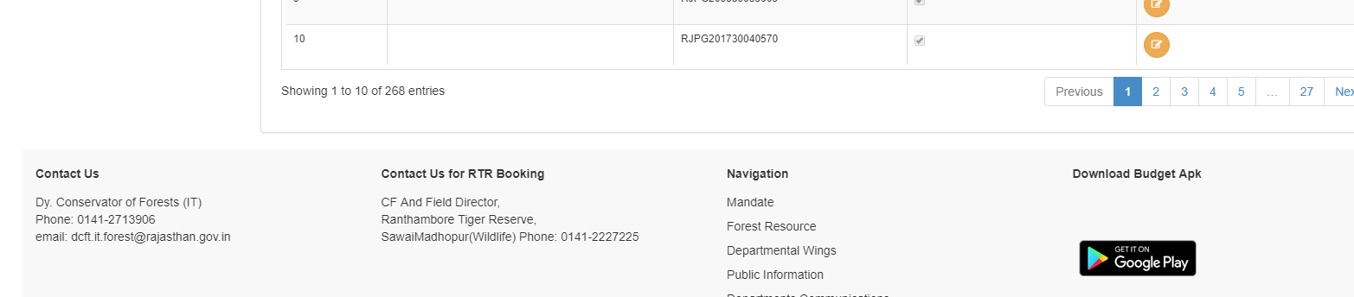

1. E-sign Check box not showing on first record.  
     
   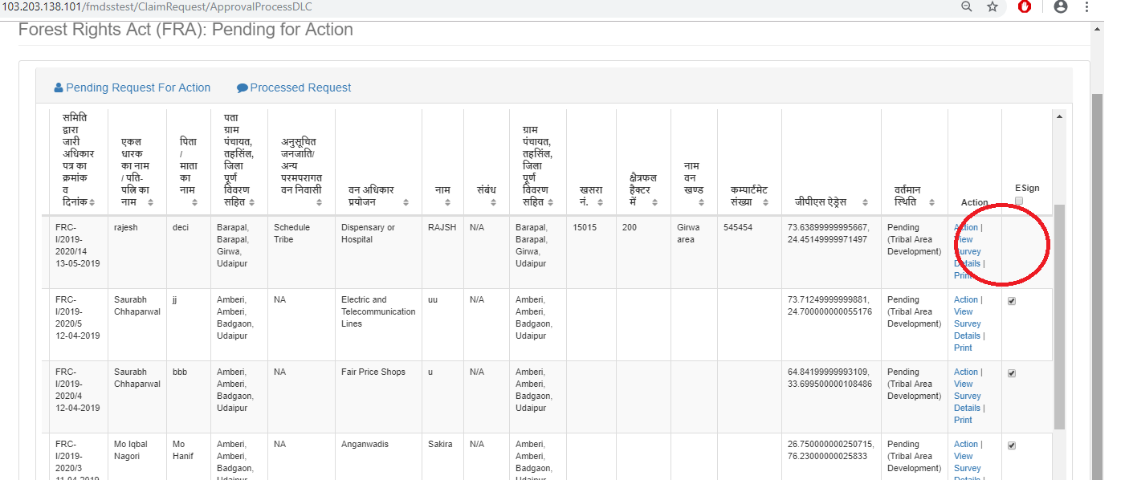
2. When generate patwari halka and forest report without land information following alert are occur  
   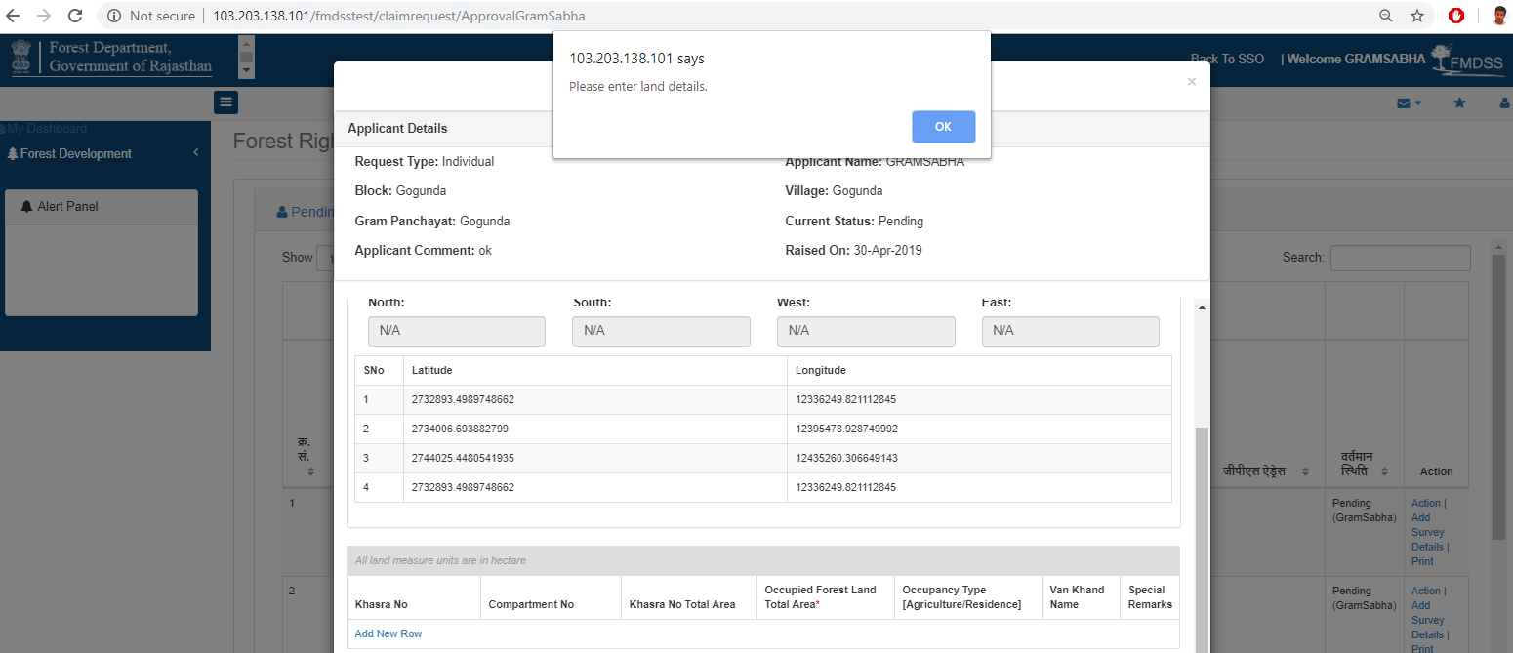
3. Application popup is not in proper way and please check the all popup in this application.
4. We need a specific dashboard for reviewing information easily.
5. We need intimation ( SMS , Email) at every level after Movement of application
6. On request details form Also have Search box upon the list so user can search the report data using (Claim Request ID, Date on Which, Claimant Name, Claim Type, Mobile Number, Khasra No, Status, Pending At).
7. Use charts to graphically present information (As like Pie chart, line chart and bar chart). In FRA Portal we can use information like FRA claim summery (Pending Count, in-progress Count, Approved count etc), Claim intimation information on dashboard.