Merrill Lynch

Knowledge Transfer Document

Version No. 1

RAW-06028620

2-1-2007

RAW-06028620

Knowledge Transfer Document

Version No. 1

 | NAME | SIGNATURE | DATE | COMPANY | JOB TITLE
Prepared By | Ravi Shankar C | Ravi Shankar C | 2-1-2007 | SCSL
Reviewed By | Sreekanth Ramakrishna | Sreekanth Ramakrishna | 4-1-2007 | SCSL
Approved By | Sathyanarayana Ramarathnam | Sathyanarayana Ramarathnam | 4-1-2007 | SCSL

VERSION HISTORY

Version No. | Date | Changed By | Changes Made
1 | 2-1-2007 | Ravi Shankar C | Created

Knowledge Transfer Document

Table of Contents

1. Introduction 5
Objective 5
2. Overview of the Application 6
Application Name 6
ITMS Number 6
Portfolio / Domain 6
Brief Description 6
Application Size in FP or KLOC 6
Tools being used 6
End User Details 7
Total users 7
Concurrent Users 7
3. Application Domain / Functional Knowledge 7
Application functionality in Detail 7
Reject MVDO: 9
Schematic flow diagram if any 11
Special considerations 11
Application Availability 12
Interview / Knowledge transfer Sessions details 12
4. Technical details 13
Modules/Sub-modules 13
Design 14
Database details 14
Standards 14
Batch Details 15
Online Details 16
Report Details 18
Interfaces 18
User Documentation 19
Details of Issues/Changes handled 19
Job flow charts 20
5. Production Support process 22
5.1 Support Window for Monitoring change/defect 22
5.2 Acknowledging the change/defect 22
5.3 Fixing or Closing the change/defect 22
5.4 Role of a Production Support team 22
6. Knowledge Transfer process 28
Handover of Documents – Status 28
Demo of application 28
DB walk-through 28
Design walk-through 29
Screen – DB/Table mapping 29
Promotion Process walk-through 29
Security and Access Details 29
7. Specific Information 29
Known Bugs 29
Knowledge base 29
Planned Upgrades 29
Licenses for ADS-I / Vendor Partner support team 30
8. Resource requirement details 30
Skills 30
Resources required for support 30
9. Exceptions / Notes 30
10. Annexure 30

Introduction

Objective

This document is intended to capture the understanding of the application gained by RAW support team during the Knowledge Acquisition phase. The objective is for Practice / Application support group Owners to assess the understanding, comfort level and effectiveness of the Knowledge acquisition phase and decide the readiness of proceeding to subsequent phases in the Knowledge acquisition phase gate review.

Project Intend

The purpose of the Research Analyst Workbench (RAW) System for Merrill Lynch’s Global Securities Research & Economics division (GSR&E or “Research”) is to implement an integrated platform for the creation and distribution of GSR & E’s research products. RAW is intended to provide critical flexibility in responding to regulatory demands, improved productivity and significant ongoing savings. In particular, it will allow the decommissioning of the majority of existing systems supporting the business, replacing them with the new System in a less complex and highly standardized environment.

Solution

The solution is a robust, comprehensive ‘Research Analyst Workbench’ system built with standard Microsoft’s .NET framework based architecture components. The system will facilitate straight-through processing all the way from authoring to compliance approval process to publication & distribution of the documents to various subscribers with a built-in automated workflow for efficiency. Authoring can be done through word. Microsoft Share point Portal server 2003 is the global repository for all documents. Feeds Bridge interface is used for the distribution of documents to Vendors and subscribers. Once validated, compliance personnel can either accept/reject the document. Custom workflow .Net components are used to regulate the complete workflow.

Overview of the Application

Application Name | NextGen

ITMS Number

Portfolio / Domain | Investment Banking, Securities

Brief Description | RAW Goals  - Reduce the costs incurred by Research for application development and support, user servicing, infrastructure management, and other technology-related activities;  - Increase the efficiency of analysts, analyst support staff, compliance, and operations communities through the automation of process workflows and the implementation of off-the-shelf, time-saving software tools and technologies;  - Eliminate the security risks that are present in the current Research applications;  - Improve Research’s ability to respond rapidly to the ongoing and future legal and regulatory requirements related to research, research analysts, and others;  - Establish a technology platform that will be reliable and will allow Research to respond to market and client needs by introducing new products significantly more easily and targeting distribution to individual clients and client segments; and  - Ensure that GSR&E has a technology framework that will facilitate better integration of research content with products produced by other parts of the organization.  RAW Technical Objectives  The system will fully meet the requirements of the business  - The system will provide a Microsoft office based tool for authoring research content and be built using products that analyst are most familiar with  - The system will have a minimal foot print on the user desktop to minimize the maintenance of the system on the desktop  - The system will be able to assemble content based on the content that is managed on the server which will minimize changes to the client side code when business logic changes  - The system will be built using off-the-shelf products when available which will minimize the use of custom code and leverage out-of-the box functionality when available.  - The system will be optimized for performance. Components will be designed to support caching and will minimize the overhead associated with data transport  - The system will be able to scale for enhanced performance. Adding more “front end’ servers will improve system performance.  - The system will be loosely coupled and adaptable to new technologies. The underlying changes to the business logic implementation will not affect the interface that the system provides to external layers  - The system will be easily manageable and provide visibility into the system functioning so that the system administrator can detect errors and take appropriate measures to fix the errors.  - The system will be configurable using the configuration parameters specified in the configuration files.

Application Size in FP or KLOC | Lines of Code | Function Points
Application Size in FP or KLOC | TBD | TBD

Tools being used | Type | Name | Version | Identified in Application Vitals questionnaire
Tools being used | Incident Management | Mercury QC-Client Driven | 1.0 | Yes  No
Tools being used | Release Management | Client Driven |  | Yes  No
Tools being used | Monitoring | Client Driven |  | Yes  No
Tools being used | Requirements | Rawats team site-Client Driven |  | Yes  No
Tools being used | Testing |  |  | Yes  No
Tools being used | Others (Please specify) |  |  | Yes  No

End User Details | Owners of the app;ication
Total users | 700
Concurrent Users | 700

Application Domain / Functional Knowledge

Application functionality in Detail | The Research Analyst Workbench Architecture will be based on 3-tier approach: the client tier, service tier and the database tier. The system will be developed using common components and use mostly out of box functionality and custom code when necessary. The System consists of 4 key subs systems: RAW Desktop, Core Services, Portal & Workflow and Distribution.

Schematic flow diagram (Process flow) | 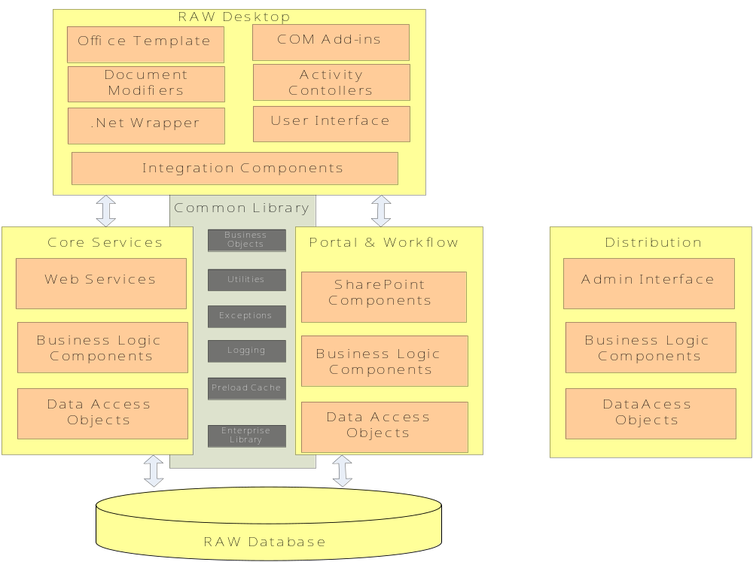

Special considerations | NA

Application Availability | - x 7  Production Support : 24 x 5

Interview / Knowledge transfer Sessions details

Description | Date Held | Attendees
FOMS Application in Business perspective | NA | NA

Technical details

3.1 RAW Desktop
This sub system consists of all the components that are deployed on the user desktop that implement RAW related functionality. The RAW desktop subsystem interacts with the Core services and Portal & Workflow sub systems. The Desktop sub system utilizes components that are included in the RAW common library.

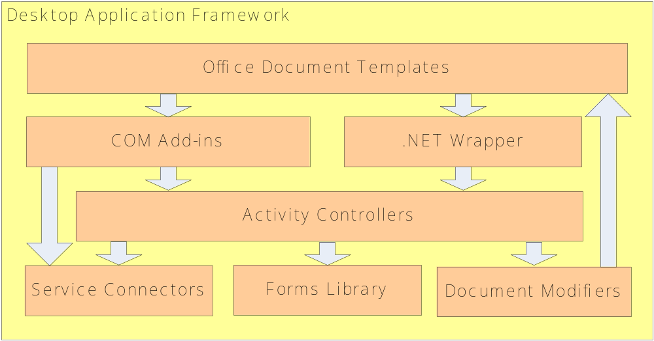

3.1.1 Desktop Application Framework
Applications running on the RAW desktop that require .NET support and RAW Core Services integration are based on common application architecture. It is not necessary for an individual application to implement every component of the framework and individual components may be shared across applications. For example, the Product Authoring Tool and Measure Builder applications share a common Service Connectors component, but implement separate Activity Controllers components.

3.1.2 Office Document Templates
MS Office document templates hold content, content rules, formatting information, and VBA programming code. Some templates hold programmatic references to a .NET wrapper that provides access to other .NET assemblies residing on the desktop.

3.1.3 COM Add-ins
COM Add-in components are .NET assemblies that are registered as Office COM add-ins and respond to Office application events. Additionally, this component may contain assemblies that implement the Office Smart Document and Smart Tag interfaces. COM Add-in components may bypass the Activity Controllers component and retrieve data directly from the Service Connectors component when no business logic is required.

3.1.4 .NET Wrapper
.NET Wrapper is a COM callable interface that allows VBA code in Office documents to access .NET assemblies. This component is the sole .NET reference used by COM clients and does not contain implementation code. All other .NET assemblies are not marked COM Visible. The .NET Wrapper version number remains static between production releases to preserve references from Office templates.

3.1.5 Activity Controllers
Activity Controllers coordinate all activities initiated from the Office document and encapsulate the business logic required by these activities. Examples of an “activity” are New Report, Enrich Document, and Display Document Information dialog. Individual classes are created in the Activity Controllers to support these activities and utilize the Document Modifiers, Service Connectors, and Forms Library components to implement them.

3.1.6 Service Connectors
Service Connectors connect the application to RAW Core Services such as web services. These components have no user interface and have the primary responsibility of sending and retrieving data used by the application. Service Connectors also provide data filtering, type casting, and server exception translation.

3.1.7 Forms Library
The Forms Library component includes all graphical user interface elements such as controls, dialog boxes, and wizards used by the application. These components will never connect directly to either the RAW server components or Office documents. Instead, these GUI components will always make calls to Service Connectors and Document Modifiers.

3.1.8 Document Modifiers
The Document Modifiers component directly manipulates and modifies the Office-based research documents by using Microsoft’s Primary Interop Assemblies (PIA’s) for Office. The PIA’s allow .NET code to manipulate documents using the Office object model. This assembly is the only .NET assembly within the authoring subsystem that has the ability to directly modify Office documents.

3.2 Core Services

The Core Services sub system mainly consists of all the server side business logic required for the RAW desktop sub system. This sub system also consists of all the functionality that is required to handle a document after it leaves the Workflow sub system before the document is sent to the Distribution sub system.
The Core services sub system consists of the following layers
- Web Services
- Business Logic
- Data Access

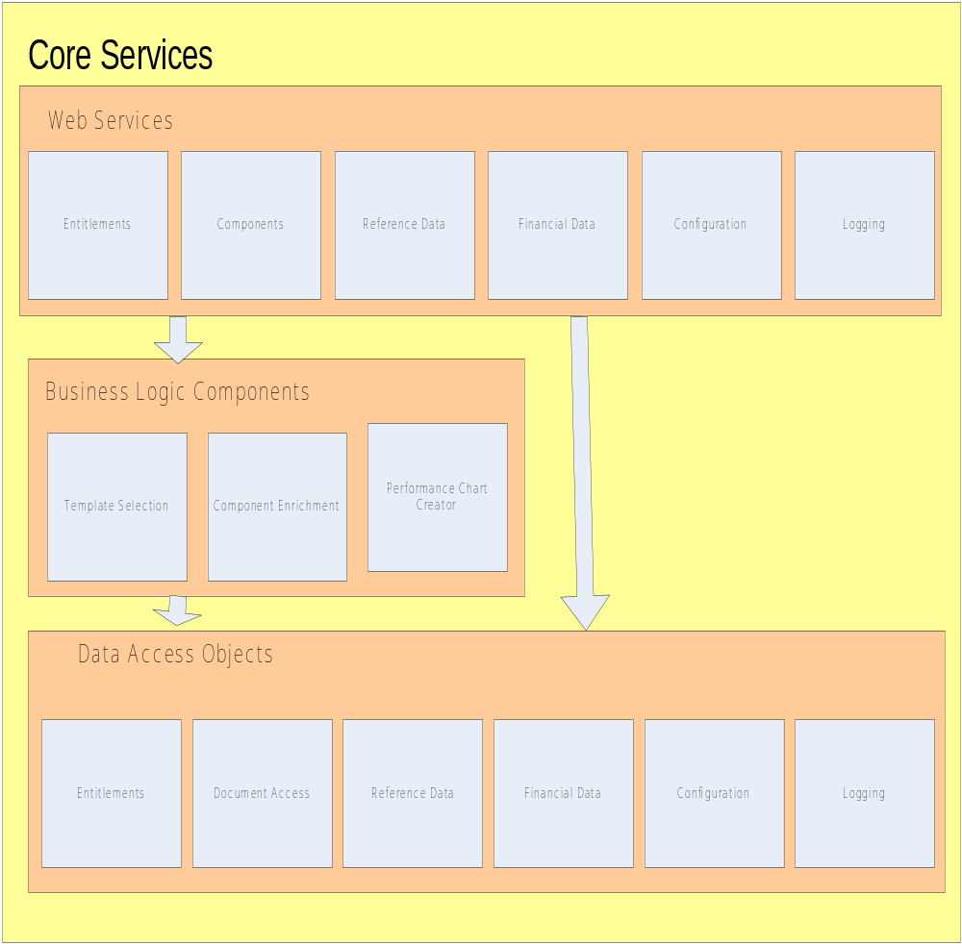

3.2.1 Web Services

The web services layer provides a set of method wrappers. The web services do not implement any business or processing logic. The web services layer handles authentication, logging of exceptions, and the re-throwing custom exceptions. The web service methods either call a data access object or a business logic component. The web services accept and return custom entity objects or arrays of custom entity objects.

a) Entitlements
The entitlements web service provides all data about a user’s entitlements and any data which is filtered by these entitlements. This would include data such as the list of entitlements assigned to a user, and the list of authors a user may author on behalf of.
b) Components
The components web service provides components to be inserted into a document. This would include components such as stock data blocks and performance charts

3.2.2 Business Logic

The business logic layer provides components for use in cases where there is complicated business logic, or data from more than one data source is involved. The defined business logic components are template selection, component enrichment, and chart creation.

3.2.2.1 Template Selection
The template selection component determines the appropriate document template based on the type of document and the document metadata.

3.2.2.2 Component Enrichment
The component enrichment component determines the appropriate WML component for a particular landing area, retrieves the WML component from SharePoint, retrieves the relevant market-data based on the document meta data and enriches the component with the market data

3.2.2.3 Performance Chart Creator
The chart creation component generates charts based on document metadata. It determines the appropriate chart, loads the market data, and generates the chart with the appropriate market data.

3.2.3 Data Access

The data access layer contains all of the data access objects. Data access objects handle all data access including document access. Data access objects simply retrieve and update data; they do not perform any complicated business logic. The defined data access objects are entitlements, documents, reference data, financial data, configuration and logging.

3.2.3.1 Entitlements
The entitlements component provides all data about a user’s entitlements to the entitlements web service. (See the entitlements web service above for more details).

3.2.3.2 Document
The document component provides methods to save and retrieve components in SharePoint. These include word document templates, complete word documents such as reports, and WML components such as data blocks. This component will act like a proxy for accessing data in SharePoint.

3.2.3.3 Reference Data
The reference data component provides methods to retrieve reference data. The reference data component does not update any data, all reference data is controlled by external systems. The reference data component will retrieve most of its data from RDR tables replicated to MS-SQL. Access to MS-SQL will be performed using the enterprise library data access component.

3.2.3.4 Financial Data
The financial data component provides methods to retrieve financial data. The financial data component does not update any data, all financial data is controlled by external systems. The financial data will be retrieved from systems such as IQ and Reuters 3000.

3.2.3.5 Configuration
The configuration component provides methods to retrieve and update configuration data. The reference data component will be stored in the MS-SQL RAW database. Access to MS-SQL will be performed using the enterprise library data access component.

3.2.3.6 Logging
The logging component will be used to store error and activity log information provided by client machines via the logging web service. This should not be confused with the general logging components used throughout the system. By storing the client logs on the server we will be able to provide a unified view of errors and activities across the entire system.

3.2.4 Entity Object Factories

Entity Object Factories will be used by the data access layer to bind data from the Data Access Layer to custom entity objects. There will be one generic object factory to bind data to simple types via reflection. Custom object factories will be created for more complex types. An example would be the Person Entity Object factory, which would convert a dataset of person records into an array of person objects. Because person objects include collections of roles and groups a custom mapping may be required. This entity object factory would be used by all data access calls which return arrays of type Person, such as returning the list of analysts a user can author on behalf of, or the list of potential secondary certifiers.

3.3 Portal & Workflow

This sub system consists of all the components required to mange the RAW portal system, business logic to manage the document state and document metadata, business logic to manage the workflow of the document. This sub system also handles the functionality required to implement Admin and reporting functionality.

3.3.1 SharePoint Portal Server

SharePoint is used to support creation, collaboration, and publishing of research documents according to the high-level business workflow.
Windows SharePoint Services (WSS) site collection and two distinct SharePoint Portal Server (SPS) Portal installations are used for RAW. A WSS Site collection is maintained for Analyst Collaboration (WSS), a “published research” SPS portal, and a “document archive” SPS portal (for historical purposes only).
Enlisting the following SharePoint features used for RAW
- Extensive usage of WSS Sites collection with the custom site definitions
- Use of Topic Areas (for navigable discovery) and Search (for full-text and metadata-based discovery)
- Implemented the Search functionality in portal using SPS Out-of-Box
- Versioning of the Document Library
- Usage of SPS Taxonomies in document library
- Customized use of SPS Event Handlers
- Usage of SPS Security concepts
- Extensive use of Out-Of-Box Web Parts

3.3.1.1 General Approach
One Windows SharePoint Services (WSS) site collection and two distinct SharePoint Portal Server (SPS) Portal installations are employed for the RAW solution. There is a WSS site collection for Analyst Collaboration, a “published research” SPS portal, and a “document archive” SPS portal (for historical purposes only).

3.3.1.1.1 Analyst Collaboration (WSS)
A WSS site collection will be employed to store work-in-progress documents in Word/other formats as follows:
- There is one team site per analyst group with one document library per team site
- An analyst team have read/write access to their team site only
- Compliance and Operations have read/write access to all analyst group team sites
- Legal have read-only access to all analyst group team sites

The following is the Document library structure in SharePoint to support Analyst sites:

WSS
Equity [Discipline]
Templates
Product Group Profiles
WML Components--- Folder per family
Team John Doe[Team name]
Product Profile Metadata
Custom Products
Products

3.3.1.1.2 Published Research (SPS)
A “published research” portal will be used to store published documents in PDF (and other formats) as follows:
- Documents are searched via SharePoint full-text search
- There is a very simple topic area structure for RAW for browsing (browse areas by industry, then folders by company and year, then filter by metadata)
- No WSS sites will be employed in the “published research” portal
- Document Library/Search Mapped Metadata:
  - Analyst – the name of the analyst who authored the document
  - Document Type – breaking news, comment, etc
  - Région – Americas, Pacific Rim, Japan, etc
  - Ticker
  - Industry
  - Focus
  - Discipline

3.3.1.1.2 Document Archive (SPS)
A “document archive” portal is used to store the history of published documents as follows:
- Documents can be searched via SharePoint full-text search
- There is be a very simple topic area structure for RAW for browsing (browse areas by industry, then folders by company and year, then filter by metadata)
- No WSS sites is employed in the “document archive” portal
- Document history includes each significant milestone (submitted, compliance approved, and released) and is saved in the area document libraries

3.3.1.1.3 Physical Document Storage (Published Research and Archive Portals)
Documents are stored in the portal using a single document library per industry area. The industry areas are sub areas of discipline areas, which all fall under a “Published Documents” area. Within the document library, the folder structure are broken down by company and then by year.

3.3.2 Distribution
The Distribution sub system consists of all the components required to manage the document distribution to external vendors. This contains the business logic to distribute documents based on vendor entitlements, and the business logic required to assemble the content based on the vendor specific format.

3.3.3 RAW Common Library
The common library will contain all the components that are commonly used by the RAW system. Some of key components include enterprise library application blocks, utility classes, logging and common exceptions. These components can be packaged and deployed on any of the sub systems

3.4 Admin Tool

The Admin tool provides functionality to manage the distribution components through a user interface. Some of the key functionality of the tool includes the following.
- Create and manage Profiles (Product and Group profiles)
- Status reporting – View Failed/Processing/Processed requests
- View the status of incoming feed request from applications
- Cancel/Recall/Resend a feed request
- View the status of outgoing feeds to vendors
- Cancel/Recall/resend an outgoing feed
- View the content that was sent to a Vendor
- View the Feeds based on a Vendor
- Search for a Feed

3.5 Reporting

The Reporting subsystem contains the components that provide support for all RAW reporting including canned reports and custom reports. The same reporting system is leveraged to provide both business reporting and system management and operations reporting. The components of this system are a RAW Reporting Website which provides web-based access to reports and a third-party reporting product to provide the actual reporting engine.
All RAW system and business data is stored within Microsoft SQL Server and the Reporting system leverages this fundamental part of the design by using Microsoft’s SQL Server Reporting Services as the reporting engine for this subsystem.

Database details | Database  In addition to the databases utilized by SharePoint, the RAW application is supported by three additional SQL Server 2000 databases.  - RDR Replication Database – contains data replicated from RDR  - RAW Application Database – contains application specific data  - RAW Reporting Database – contains data from the application database and SharePoint structured to support reporting  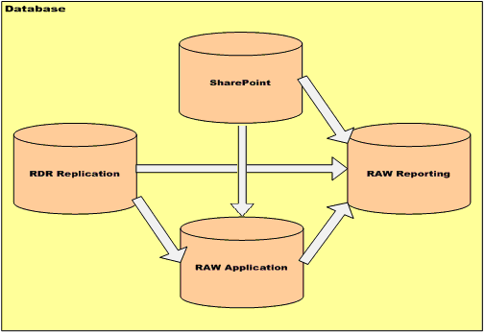  RDR Replication Database  The RDR Replication Database contains a subset of data from the RDR system that is required to support RAW. The database is populated by a one-way replication process that copies data from RDR to the RDR Replication Database.  The RDR database in RAW will contain the exact replica of the RDR tables. The data from RDR will be replicated periodically into the RDR replication tables. RDR tables contain data in completely normalized format which are designed to support RDR transactional system. The data attributes that are required for RAW from the RDR tables is very minimal compared to the entity attributes that RDR captures for each entity it supports in the RDR application.  The data required for RAW for entities are stored in generic and multiple tables. To avoid complex SQL queries to retrieve the data from the original RDR tables, Views will be created for each entity with just the data this required for RAW. The RAW stored procedures will be using the RDR views to retrieve the data related to the entities in RDR.  RAW Application Database  The RAW Application Database contains data used to support the Authoring and Portal subsystems. This includes data replicated from the RAW views contained in the RDR Replication Database. The replicated views provide RDR information such as instruments, issuers, and analysts. The database also stores information about documents and users that cannot be easily retrieved from SharePoint. The RAW application only directly accesses the RAW database. Any data from RDR or SharePoint needed by RAW will exist in the RAW database either as a table or as a view. The database is designed to support merge replication. This allows for the possibility of installing local instances of the RAW Application Database in remote office locations.  SharePoint  The SharePoint database will support the SharePoint portal. The database will be only be used by SharePoint. Direct database access may be used in certain cases where there is a significant performance improvement. In those cases views into the SharePoint database will be added to the RAW database.  RAW Reporting Database  The RAW Reporting Database contains data from the RAW Application Database and the SharePoint database that is de-normalized to facilitate reporting. This database is used by SQL Server Reporting Services components that use the database to generate reports.  Data from the RDR Database, RAW application database and data from the SharePoint portal application will be “pushed” to the Reporting database as documents are updated in the portal using the document library event handler. The data will be stored in flat tables for easy access and to support reporting performance. The amount of data pushed to the reporting database will vary based on the status of the document.  Database Authentication  Access to RAW databases is through integrated Windows authentication. The domain account used by servers to access the database will be assigned the RAW Application role. All database access rights will be granted via the RAW Application role. No rights will be specifically granted to users.

User Documentation | http://rawats.rsch.ml.com

Details of Issues/Changes handled | < Give details of Production support Issues and enhancement requests handled during the knowledge acquisition phase >

Production Support process

Support Window for Monitoring change/defect
MS Exchange Server

Acknowledging the change/defect
MS Exchange Server

Fixing or Closing the change/defect
MS Exchange Server

Role of a Production Support team
    - Acknowledging request
    - Fixing issue
    - Intimating the requester on the status

Knowledge Transfer process
Handover of Documents – Status
  Document | Available | Received
  Business Requirements | Yes No | Yes No
  Functional Specifications | Yes No | Yes No
  E-R Diagrams | Yes No | Yes No
  High Level Design | Yes No | Yes No
  Low Level Design | Yes No | Yes No
  Data Flow Diagrams | Yes No | Yes No
  Data Dictionary | Yes No | Yes No
  Process Flow | Yes No | Yes No
  Program Specifications | Yes No | Yes No
  Naming conventions/  Coding Standards | Yes No | Yes No
  Unit Test Plans/  Specifications | Yes No | Yes No
  Integration Test Plan/  Specifications (In Test Director) | Yes No | Yes No
  System Test Plan/  Specifications (In Test Director) | Yes No | Yes No
  Application Manuals | Yes No | Yes No
  User Manuals | Yes No | Yes No
  Training Material | Yes No | Yes No
  Installation/ Deployment Manual | Yes No | Yes No
  Operations / Production support Guide | Yes No | Yes No

Demo of application | Date Completed | Attendees
Demo of application | NA

DB walk-through | Date Completed | Attendees
DB walk-through | NA

Design walk-through | Date Completed | Attendees
 | NA

Screen – DB/Table mapping | Date Completed | Attendees
 | NA

Promotion Process walk-through | Date Completed | Attendees
Promotion Process walk-through | NA

Security and Access Details | Name | Access Granted to the team
Security and Access Details | Database(s) | Yes No
Security and Access Details | Tools | Yes No
Security and Access Details | Screens / Functions | Yes No
Security and Access Details | Regions (Development, Test, Production) | Yes No  Only for DEV and QA region access is granted
Security and Access Details | User-ids for the support team | Yes No
 | Special information | NA

Resource requirement details

Skills | Dot NET framework 1.1, C#, VB.NET, ASP.NET, SharePoint Portal, VBA,  SQL Server, XML, XSLT

Resources required for support | Three

