

**CONSUMER VIEW USER GUIDE**

Version: 1.2

Dated: 27th July 2018

**Table of Contents**

|  |  |
| --- | --- |
| 1. Overview | Page 3 |
| 1. Tariff Definitions | Page 4 |
| 1. Mandatory Options Selection | Page 5 |
| 1. Tariff Product Type Selection | Page 7 |
| 1. Filter Selection (Optional) |  |
| * 1. Price Filter | Page 8 |
| * 1. Total Data Capping | Page 8 |
| * 1. Validity | Page 9 |
| * 1. Unlimited Calls | Page 10 |
| * 1. Daily Data Capping | Page 11 |
| * 1. Talktime | Page 12 |
| * 1. ISD Packs / Roaming Packs | Page 13 |
| 1. Advance Filters | Page 13 |
| 1. Results Pane | Page 15 |
| 1. Sorting Options | Page 16 |
| 1. Download Options | Page 16 |
| 1. Tariff Product Comparison | Page 17 |
| 1. Feedback | Page 18 |

**Overview**

TRAI has launched the consumer view to enable the consumers to search and compare various tariff products as per their requirements. The consumer view enables the consumers to select a combination of various criteria and view the details of matching tariff products as per their selected criteria.

The consumer view provides the consumers with a platform where they can find the tariff product details of all the operators, view the tariff products based upon a selection criteria of their choice, and compare more than one products of a similar tariff product type from one or more operators. Besides, it also has the provision of downloading the tariff product details in excel as well as machine readable XML format.

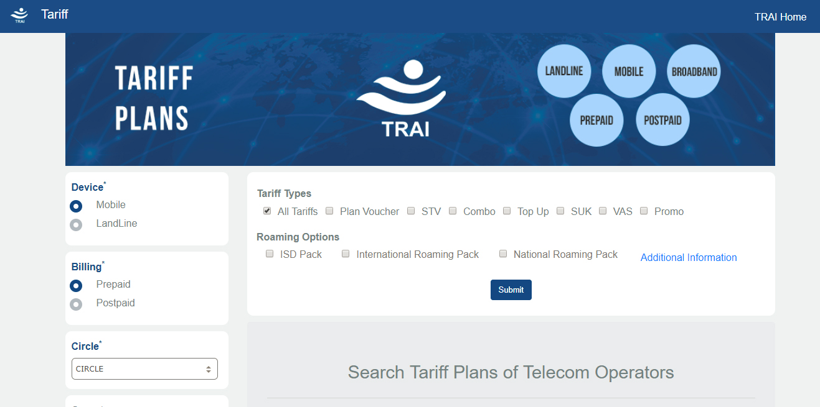

**Tariff Definitions**

Following are the details pertaining to the various tariff product types :

**Plan Voucher**: - “Plan Voucher” means a paper voucher or electronic voucher that enrolls a consumer into a tariff plan.

**STV**: - “Special Tariff Voucher” or “STV” means a paper voucher or electronic voucher, which on activation alters one or more items of applicable tariff in the consumer tariff plan for a particular period in terms of limited or unlimited usage of voice calls, SMS or Data but does not provide any monetary value.

**Combo Voucher**: - “Combo Voucher” or “CV’ means a paper voucher or electronic voucher which on activation alters one or more items, for a particular period, in the tariff plan of the consumer and adds monetary value to the prepaid account of the subscriber.

**Top Up**: - “Top Up Voucher” means a paper voucher or an electronic voucher providing additional monetary value to the prepaid consumer without any restriction in terms of validity or usage.

**SUK**: - The Start-Up Kit shall not contain any Plan Voucher or Special Tariff Voucher or Combo Voucher. Provided that the service provider may provide to a consumer a tariff plan as part of the Start-Up Kit and such tariff plan shall cease to apply to such consumer on activation of a Plan Voucher.

**VAS**: - “Value Added Services” means services which are offered to add value to the core services, the core services being voice calls, voice or non-voice messages and facsimile transmission.

**Mandatory Options Selection**

The mandatory options section is as highlighted in the snapshot given below :

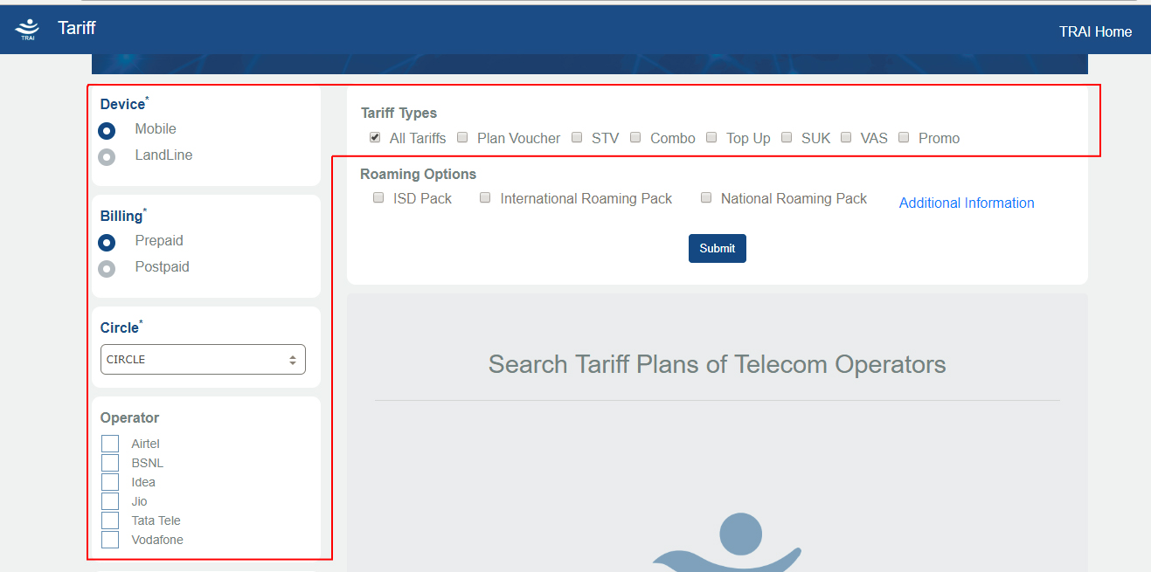

There are 5 mandatory options to be selected in order to view the tariff products. These options are :

1. **Device**  
   The user needs to select whether he wants to view tariff products related to mobile or landline. By default, the ‘Mobile’ options will be selected. In case the consumer wants to view the tariff products for landline, he needs to click the ‘Landline’ option.
2. **Billing**The consumer needs to select whether he wants to view tariff products related to prepaid or postpaid. By default, the ‘Prepaid’ options will be selected. In case the consumer wants to view the tariff products for postpaid, he needs to click the ‘Postpaid’ option.This option will be available only if the user has opted for ‘Mobile’ related tariff products. If the consumer has selected ‘Landline’, the ‘Prepaid / Postpaid’ options will not be available.
3. **Circle**This option is to select the Circle (Licensed Service Area) for which the consumer wishes to view the tariff products. The consumer will need to select a circle from the dropdown list. In case the consumer submits his selection without selecting a circle, he will be prompted with a message box that he needs to select a circle in order to proceed further.
4. **Operator**This option is to select the Operator (Telecom Service Provider) for which the consumer wishes to view the tariff products. The consumer can select a particular operator from the checkbox list if he wants to see the tariff product details for a particular operator only. If the consumer wants to view the tariff product details of all the operators, he needs to select the option titled ‘All Operators’ from the drop down list.   
     
   There is also a provision to select more than one operators (if the user wants to view tariff products for selective operators only). The user can select the checkboxes of those operators for which he wishes to view the tariff products. Please note that the operators that are not available in the selected circle will not be displayed, i.e. the consumer will not be able to select such an operator whose services are not available in the selected circle.
5. **Tariff Type(s)**This option is to select one or more tariff types for which the consumer wishes to view the tariff products. The consumer can select one or more checkboxes to view the details of selected tariff product types. The user can also select ‘All Tariffs’ checkbox if he wishes to view tariff products for all the valid tariff types.  
     
   The consumer will need to select at least one tariff type check box. In case the consumer submits his selection with no tariff type selected, he will be prompted with a message box that he needs to select a tariff type in order to proceed further.

**Tariff Product Type Selection**

The tariff product type section is as highlighted in the snapshot given below :

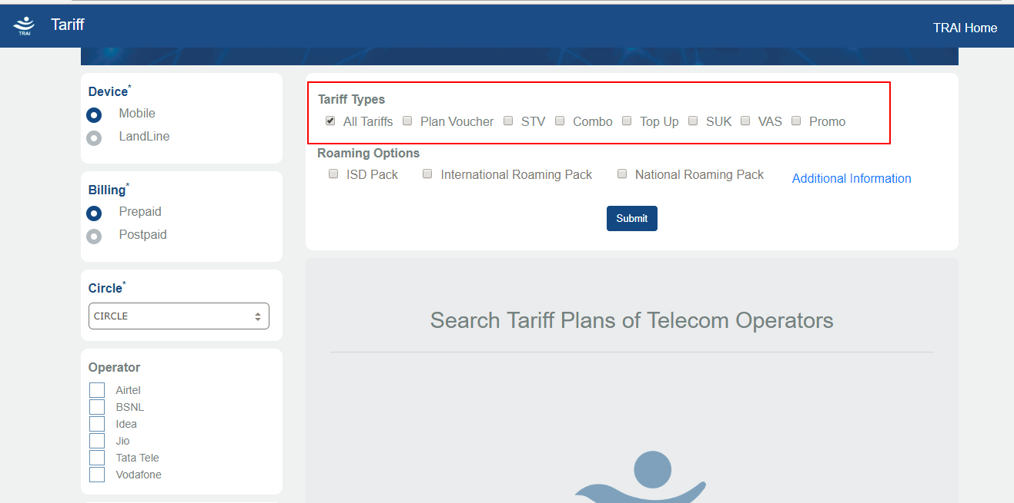

This section displays the list of tariff product types, each with a check-box besides it. The very first option titled ‘All Tariffs’ is selected by default. The consumer can select one or more tariff product types, as per the tariff products for which he wants to view the tariff product details.

This list of tariff product types is dynamically dependent upon the mandatory options of ‘Mobile / Landline’ and ‘Prepaid / Postpaid’, i.e. changing these options will change the tariff product type list options.

In order to make it more user friendly, the complete name of each of the tariff product type has been provided as a tooltip, i.e. when the consumer brings his mouse over a tariff product type, he will get to see a tooltip with the complete tariff product type name. E.g. when the consumer brings the mouse over the ‘SUK’ option, he will get to see a tooltip with ‘Start Up Kit’ written on it.

**Filter Selection (Optional)**

The consumer view has been empowered with a host of filter options which can enable the consumer to shortlist his selection to a select few records, which would enable him to have a better focus on the tariff products matching his requirements.

The various filter options are as given below :

* **Price**

The consumer can select a price range for which he wants to view the tariff products. The consumer can use the slider option to select the suitable price range. In case the price range that the consumer is looking for is beyond the minimum and maximum values of the slider (as displayed in the boxes below the slider by default), the consumer can also manually enter the minimum and maximum values of the suitable price range in the boxes below the slider.

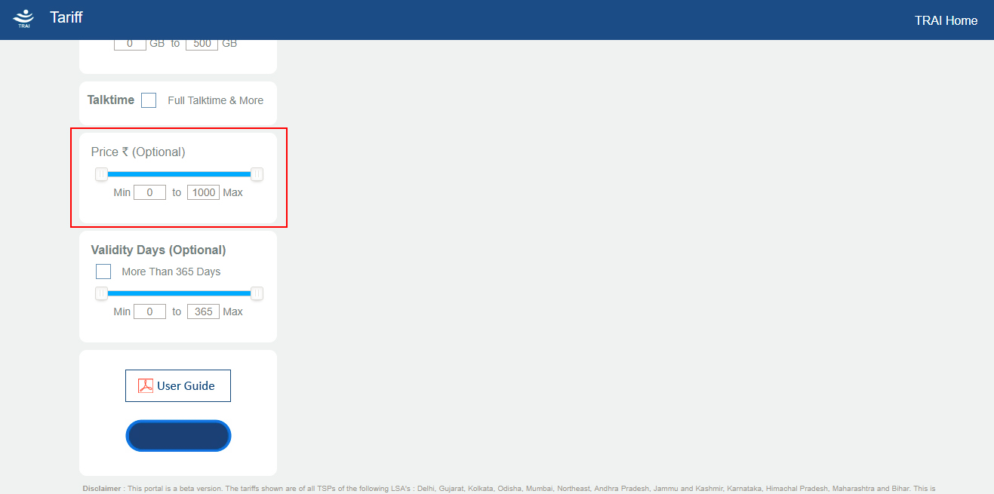

* **Total Data Capping**

If the consumer has specific data requirements, he can select the option(s) of 2G Data, 3G Data and 4G Data, and set the minimum and maximum values of the slider as per his data requirements.

In case the data range that the consumer is looking for is beyond the minimum and maximum values of the slider (as displayed in the boxes below the slider by default), the consumer can also manually enter the minimum and maximum values of the suitable data range in the boxes below the slider.

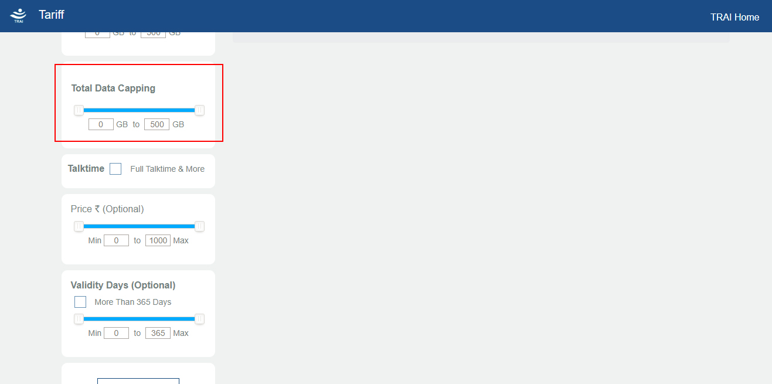

* **Validity Days**

The consumer can select the suitable validity range by setting the slider values in the validity section. The validity has to be in days.

In case the validity range that the consumer is looking for is beyond the minimum and maximum values of the slider (as displayed in the boxes below the slider by default), the consumer can also manually enter the minimum and maximum values of the suitable validity in the boxes below the slider.

In case the consumer wants to view only those tariff products for which the validity is greater than 365 days, the consumer can just select the checkbox titled ‘More Than 365 Days’ that is provided above the validity slider.

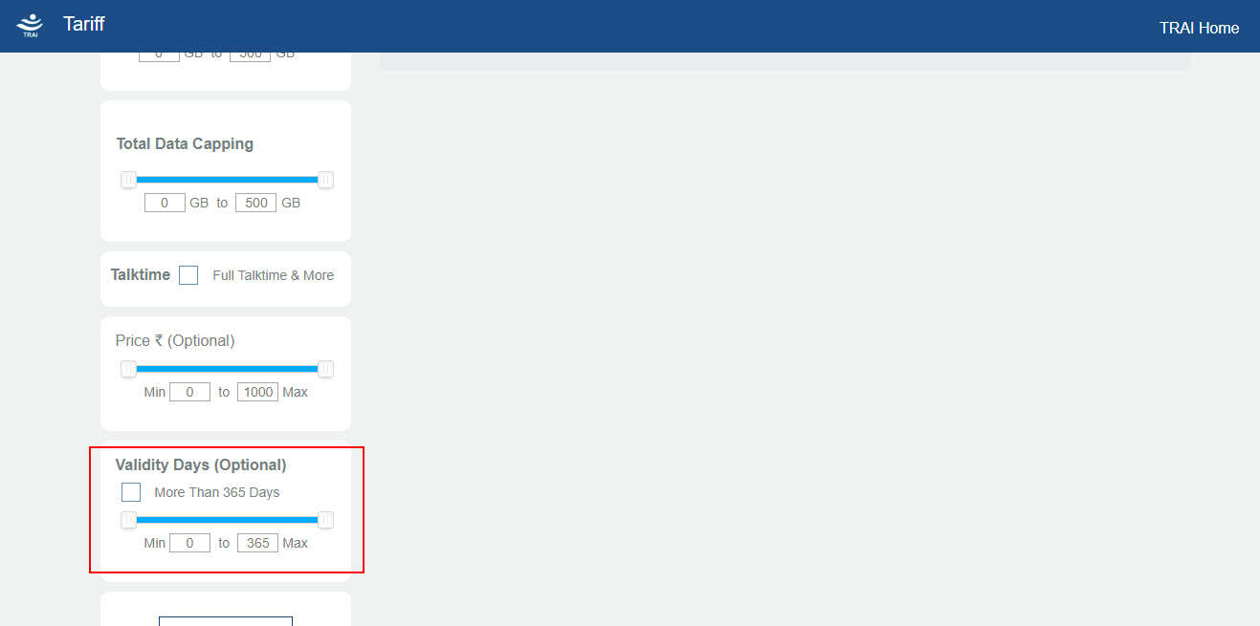

* **Unlimited Calls**

In case the consumer wants to view only those tariff products which offer unlimited local, STD or roaming calls, he can set the appropriate selection in this filter section by checking the respective check boxes.

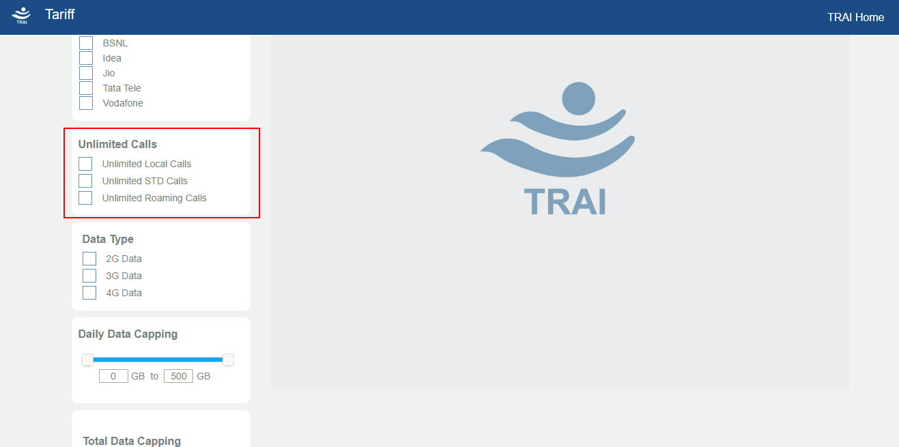

* **Daily Data Capping**

This filter gives the consumer an option to view the tariff products that offer a daily data capping. The consumer can select whether he wants to view tariff products with daily data capping for 2G Data, 3G Data or 4G Data.

After making this selection by checking the appropriate checkboxes, the user can select whether he wants to view tariff products with daily data capping by setting the slider values.   
  
In case the daily data capping range that the consumer is looking for is beyond the minimum and maximum values of the slider (as displayed in the boxes below the slider by default), the consumer can also manually enter the minimum and maximum values of the suitable daily data capping in the boxes below the slider.

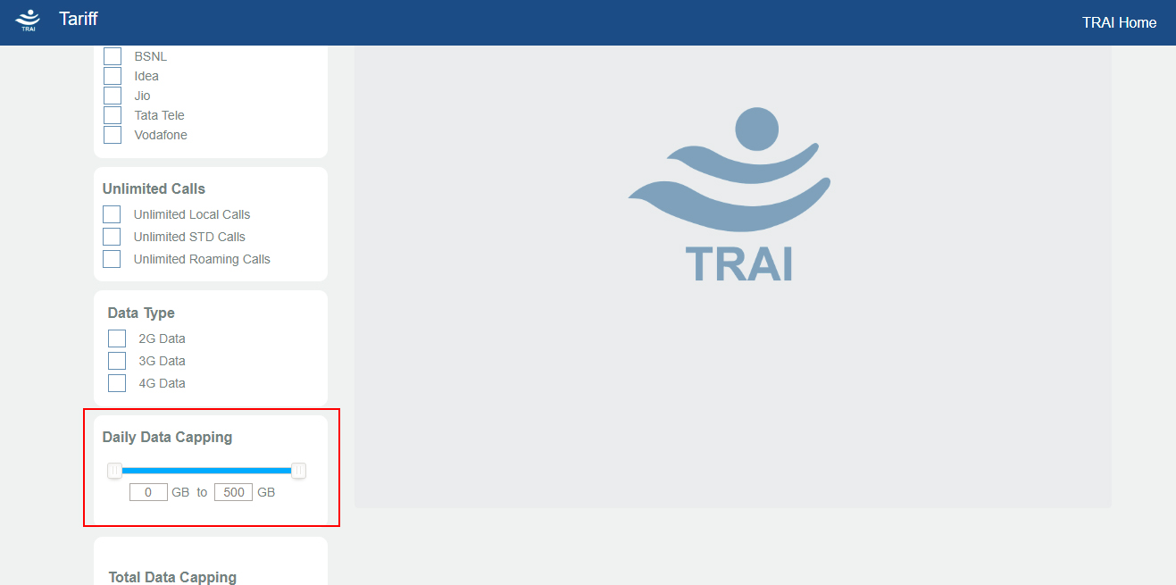

* **Talktime**

Through this filter, the consumer can select to view only those tariff products which offer full talk time or more. If the consumer checks the checkbox titled ‘Full Talktime & More’, only those tariff products will be displayed that offer full talktime or more.

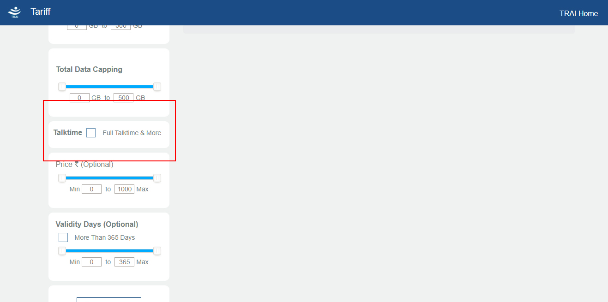

* **ISD Packs / Roaming Packs**

If the consumer wants to view only ‘ISD Pack’ product types, he needs to check the checkbox titled ‘ISD Pack’

If the consumer wants to view only ‘International Roaming Pack’ product types, he needs to check the checkbox titled ‘International Roaming Pack’

If the consumer wants to view only ‘National Roaming Pack’ product types, he needs to check the checkbox titled ‘National Roaming Pack’

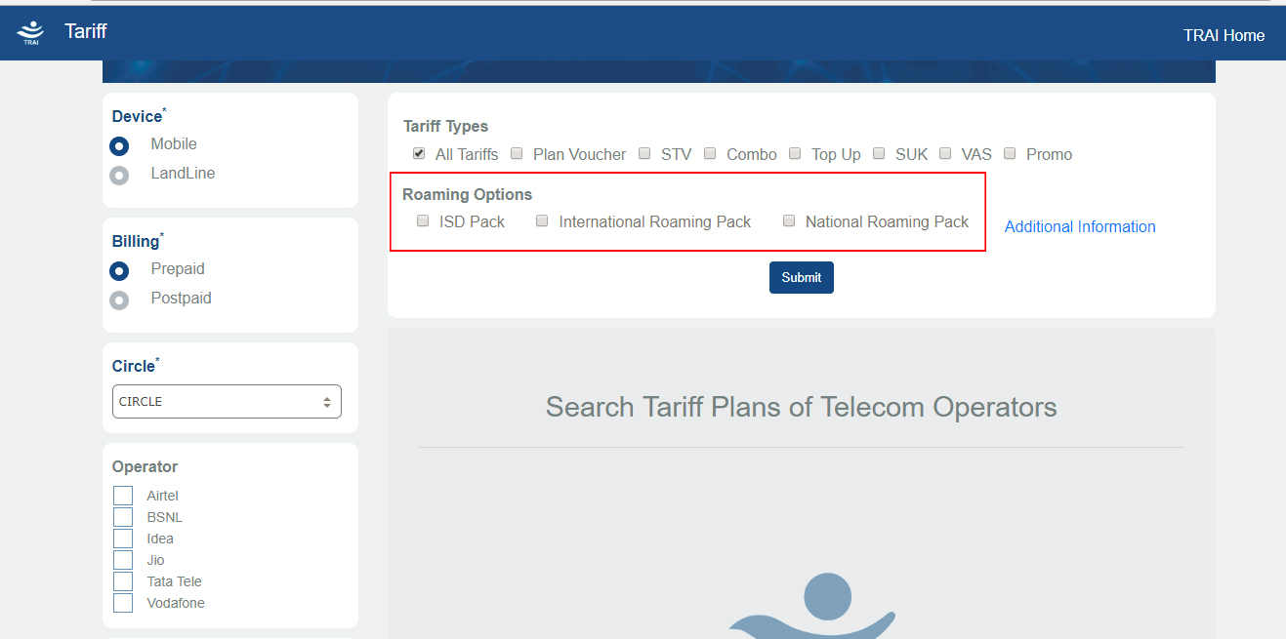

**Advance Filters**

Apart from the standard filter options, there is an additional option of advance filters, that can be used by consumers to further shortlist their result sets by applying these advance filters. These options can be viewed by clicking on thee ‘Additional Information’ link. These advance filters have been divided into 4 sub-categories viz. ‘Local Calls’, ‘STD Calls’, ‘SMS’ and ‘Roaming Calls’.

The ‘Local Calls’ segment offers multiple checkboxes to the consumer so that he can select ‘Peak’ or ‘Off Peak’ options for ‘On-Net’ or ‘Off-Net’ Local Call call related tariff products.

The ‘STD Calls’ segment offers multiple checkboxes to the consumer so that he can select ‘Peak’ or ‘Off Peak’ options for ‘On-Net’ or ‘Off-Net’ STD Call call related tariff products.

The ‘SMS’ segment offers multiple checkboxes to the consumer so that he can select ‘On-Net’ or ‘Off-Net’, or ‘International’ SMS call related tariff products.

The ‘Roaming Calls’ segment offers two checkboxes to the consumer so that he can select ‘Local Outgoing’ or ‘STD Outgoing’ roaming call related tariff products.

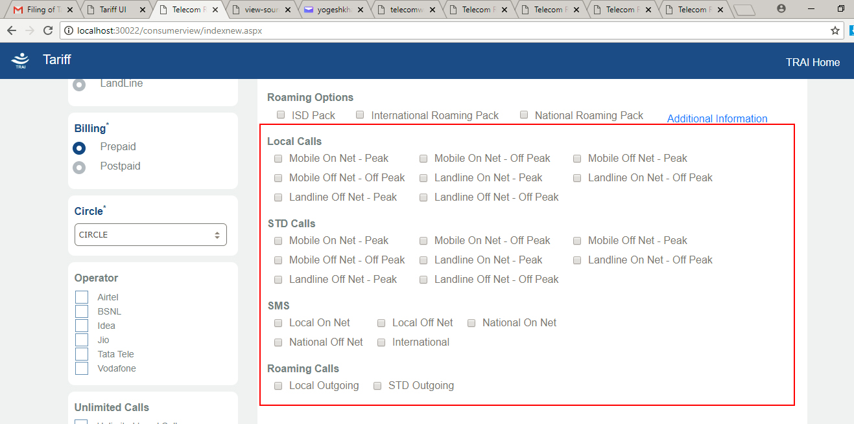

**Results Pane**

After making the appropriate selections, the consumer will push the ‘Submit’ button provided below the filters section. This will bring up a summary pop-up with the details of the parameters as selected by the consumer. The consumer can either press the ‘Confirm’ button (to view the results), or the ‘Cancel’ button (to go back and change the selection parameters. If the user clicks the ‘Confirm’ button, it will display the results pane below the ‘Submit’ button.

The results pane first displays the sorting options, and then number of matching records and the total number of records. Thereafter, it displays the ‘Compare’ and ‘Reset Filters’ buttons on the right side and two icons, one each for excel and XML on the right side. Each of these icons can be clicked by the consumer to download the result set in the respective format.

For each of the records, the logo of the respective TSP is displayed, along with the tariff summary of the tariff product. Below this, the complete result set of the tariff products matching the consumer’s selection parameters are displayed in a tabular format. The various columns of the results display table are :

1. Product : Displays the name of the tariff product type.
2. Price : Displays the price of the respective tariff product.
3. Talktime : Displays the talktime in Rs. for the respective tariff product.
4. Validity : Displays the validity (in days) of the respective tariff product.

In the ‘Tariff Summary’ column, below the summary details, there is a downward arrow link. Clicking on this link will bring up a popup enumerating the primary parameters of the respective tariff product in a tabular format.

The result pane display is as per the snapshot given below :

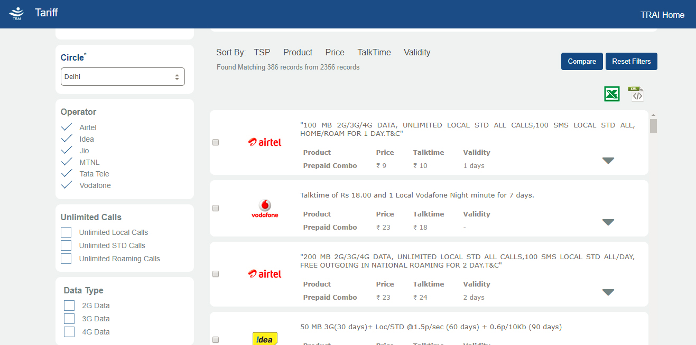

**Sorting Options**

The user can sort the result set as per various options viz. TSP name, tariff product type, price, talktime and validity.

**Download Options**

At the top of the results pane, there are two icons on the right side. The first icon (excel logo) can be clicked by the consumer to download the complete details of all the tariff products displayed in the results pane in an excel file.

The second icon (XML icon) can be clicked by the consumer to download the complete details of all the tariff products displayed in the results pane in machine readable XML format.

**Tariff Product Comparison**

Besides each tariff product name in the ‘Product’ column, there is a checkbox. The consumer can check multiple checkboxes of the same product type (maximum 5) to compare the selected tariff products in a separate window.

The consumer can check the checkboxes belonging to multiple operators, but the tariff product type needs to be same for the comparison. After the selection, when the consumer clicks on the ‘Compare’ button, a new window will automatically open up, with the comparison display of the selected tariff products in a tabular format.

There are 5 comparison parameters, namely ‘Price’, ‘Talktime’, ‘Validity’, ‘Daily Data Capping’ and ‘Total Data Capping’. By default, all these parameters will be checked, and the comparison table will display the comparative values for all these parameters. If the consumer unchecks a particular parameter checkbox, the row displaying the specific parameter values will be removed from the table. The consumer can bring back the row by checking the unchecked checkbox, if required.

The last row of the comparison table displays a ‘More’ icon for each of the columns. Clicking on this will bring up a table below the comparison table. This table will consist of the important parameters of the selected record.

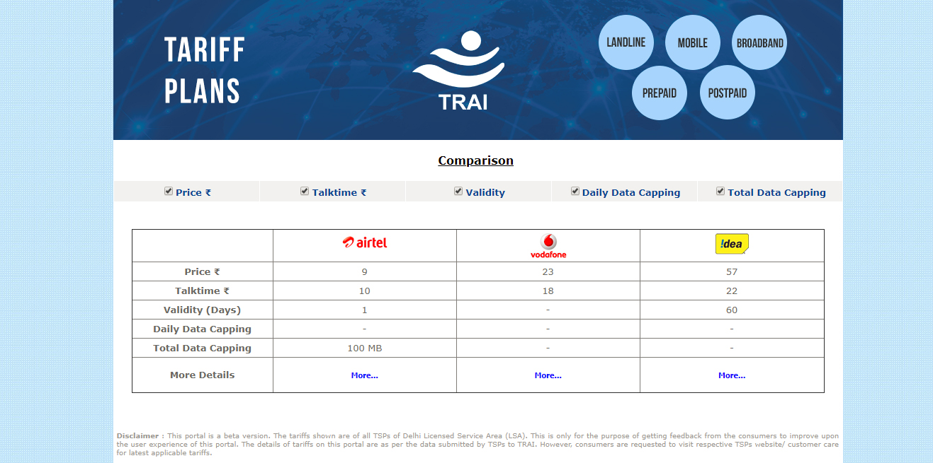

**Feedback**

The consumers can send across their valuable feedbacks that can help TRAI improve the consumer view portal. For this purpose, a ‘Feedback’ button has been provided below the tariff product types. Clicking on this button will open a new window with the feedback form.

In order to submit a feedback, a consumer will need to enter his mobile number and press the ‘Generate OTP’ button. The consumer will receive an OTP on the entered mobile number, which needs to be entered in the text box titled ‘OTP’. The consumer also needs to fill in his name and his comments, and press the submit button.

