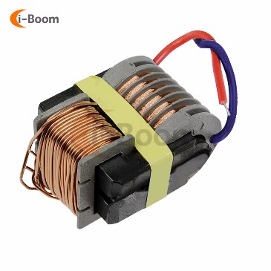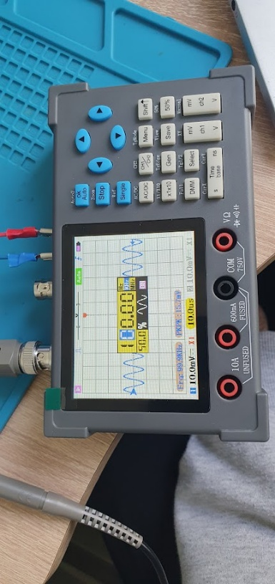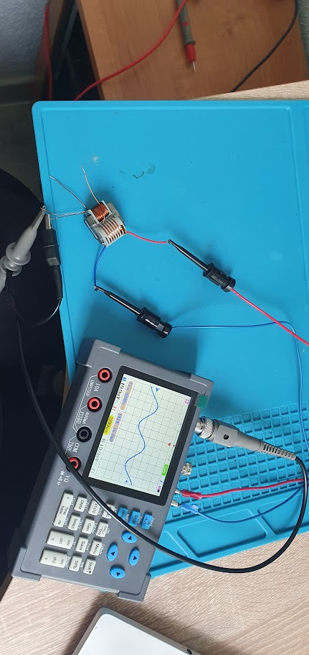

|  |  |  |  |  |
| --- | --- | --- | --- | --- |
| Link:<https://aliexpress.ru/item/1005004788425890.html?spm=a2g2w.orderdetail.0.0.3c104aa6HaXW6l&sku_id=12000030490441927> | | | | |
| Size: **29×24x18mm** | | | | |
| Transformer power would be between **(3...10 W)** considering the wire diameter and core dimensions | | | | |
| **Coil** | **Primary** | | **Second** |
| Resistance | 0.8R | 0.6R | 0k908 |
| Wire diameter | 0.2 mm | 0.2 mm |  |
| Amplification factor | ~1:175 at 1 kHz (respectively ~1:160 at tens of kHz) | ~1:150 at 1 kHz (respectively ~1:140...1:145 at tens of kHz) |  |
| Reverse connection voltage | 14 mV AC | 16.5 mV | IN:2.45V 1k Hz AC sin |
| 15.7 mV | 17.2 mV | IN:2.49V 50k Hz AC sin |
| 15.3mV | 17.6 mV | IN:2.49V 100k Hz AC sin |