**Patterns of Transformation in 17th-Century Mechanics**

Domenico Bertoloni Meli

Indiana University, Bloomington[1]

**Introduction**

The 17th century witnessed striking transformations in the science of mechanics: whereas Renaissance authors of the previous century were primarily concerned with restoring and extending the achievements of Antiquity, following largely in the same track, 17th-century practitioners brought mechanics to radically new domains, such as the mathematical investigation of motion in its many manifestations. I have recently argued that the objects or devices employed in the 17th century are a key tool for documenting and investigating such transformations in a way that reflects the contemporary practice of mathematicians and natural philosophers: levers, inclined planes, pendulums, springs, and strings were employed in a variety of fashions, both practical and theoretical, to open new areas of research and conceptualize difficult problems.[2]

In this essay I wish to extend and refine my earlier reflections by identifying some patterns of transformation in this extraordinarily rich and complex area, studying similarities and differences in the creative and original methods employed by practitioners in exploring new domains. Such patterns are potentially fertile territory for bridging historical and philosophical themes to do with research practices on the one hand, and methodological and cognitive aspects on the other.[3]

I have identified three types of transformations. My first set of examples can be characterized as “unmasking”, namely the recognition that apparently complex and elaborate objects or devices can be shown to consist of simple known ones in disguise, as in a metaphorical removal of a veil or a mask. In these cases simple visual inspection—at times with minimalist interventions—enabled the reduction of several seemingly intractable cases to established ones. The term “unmasking” captures the minimal intervention required in these cases.

The second set of examples considers cases which were not so straightforward, but rather required some degree of intervention and elaboration: the issue was not simply to point to a different way of looking at an object by metaphorically removing a veil or a mask, but to perform a series of operations—in line with my characterization of thinking with objects, either mentally or experimentally, with thought and real experiments—leading from one object or device to another. In this case I use the term “morphing” to capture these creative transformations. Whereas the process of unmasking appears better defined, the cases of morphing we shall encounter constitute a more varied class and involve a broad range of procedures.

The third and last set includes transformations involving the removal of material constraints through a process of mental abstraction or “dematerialization”: the same proportions or relations valid for the constrained case were supposed to remain valid also in the unconstrained one. Such cases signal the transformation of mechanics from a science of machines to a more abstract discipline based on abstract principles and laws. At the end I shall attempt some preliminary conclusions stimulated by some questions for further research. While neither my previous work nor the present essay pretend to be exhaustive, I hope to have provided a sufficiently broad analysis to grasp some of the main trends following which mechanics was transformed. If my work were to stimulate further historical and philosophical reflections in this area, one of its aims would have been fulfilled.[4]

**(1) Unmasking**

Although he was by no means the first to try to account for more complex devices in terms of the balance, Guidobaldo dal Monte occupies a special position in the late 16th century for the rigor and commitment with which he pursued the program of “reducing” all simple machines to the lever. The verb “reducere” was used at the time in Federico Commandino’s translation of Pappus of Alexandria and consisted in showing through a geometrical diagram that a simple machine amounted to a lever in different garb. Since Archimedes had established the doctrine of the lever in rigorous axiomatic form in *On the equilibrium of planes*, by adopting this approach dal Monte sought to extend in unproblematic fashion this area of mechanics to all simple machines, a task he undertook in the 1577 *Mechanicorum liber*. An illustrative example of his approach can be found in the case of the winch, which dal Monte showed to be a lever with bent arms. A rope is wrapped around the cylinder AB so that by turning the handles H, F, N, etc., weight K is raised (figure 1). The force on the handles is represented by the attached weights G or M. Here dal Monte identifies the arms of the lever as the radii CF and CB, C being the fulcrum. By pushing on F, N, etc., we can raise the weight K with a smaller weight M, albeit more slowly than by pulling it directly. The lever as seen by dal Monte has disjointed arms, namely CB is always parallel to the horizon, whereas CF may rotate around C. Notice that even in this simple case the identification of the lever occurs not in the actual material device but in its geometrical representation, shown in cross section.[5]

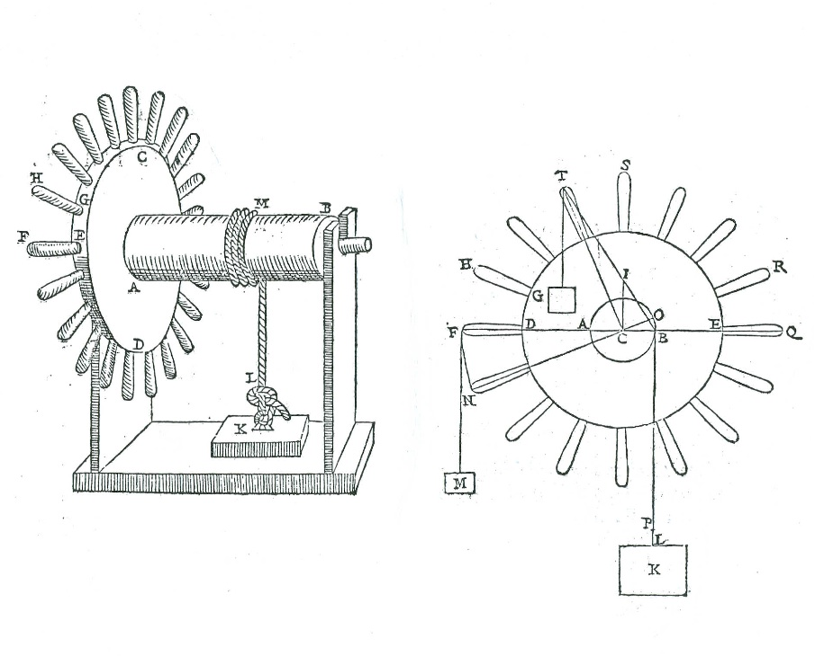

**Figure 1: Guidobaldo dal Monte, winch or wheel and axle as a lever**

Other mathematicians eagerly adopted this approach deployed—though not invented—by dal Monte and employed it in a variety of areas. For example, Galileo’s new science of the resistance of materials, which he put forward in the 1638 *Discorsi intorno a due nuove scienze*, relies on the identification of a beam or cantilever as a lever with bent arms: the structural similarity with the case of dal Monte’s winch is apparent, in that here too a seemingly complex object is shown to be a lever in disguise. Galileo tried to determine the resistance of a beam ABCD (see figure 2) infixed at right angles in a wall, or cantilever, by means of the lever. B is its fulcrum, BC one of its arms, BA the other at right angles to it. The moment of the weight E in C is counterbalanced by the moment of the resistance to breaking of the beam, proportional to the number of fibers in its base or to the area of the cross section. Since the fibers are equally spaced, they work as if they were all in the middle point of AB, by analogy with a system of weights. Thus in conclusion the resistance to breaking is as the cross section times half the height. The fact that one of the arms of the lever is actually perpendicular to the horizon is peculiar: Galileo had to argue that the role of the weights on the left side is taken by the fibers of the beam. Thus, although in response to a request for clarifications from Giovanni Battista Baliani he argued that everything occurs as in the lever, there were also some subtle differences that readers at the time found confusing and pointed out.[6]

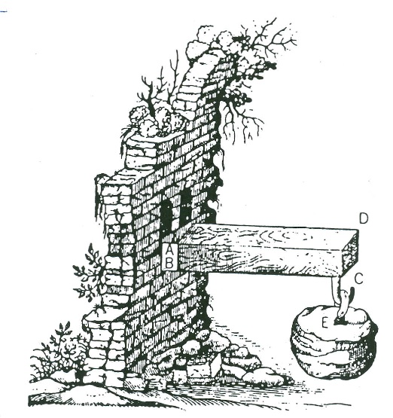

**Figure 2: Galileo, beam as a lever**

There is no doubt in my mind that Galileo wished to proceed along similar lines in other areas too, such as the science of motion. However, while at Padua if not before, he realized that he needed different principles and struggled for the rest of his life to give the science of motion a secure foundation. He relied on thought and real experiments in order to justify his postulate, and at a later stage he offered a proof based on mechanical principles. Within the science of motion, however, I believe that he followed the process of “unmasking” in the transition from falling to projected bodies: Galileo showed that the violent motion of a projectile in a parabolic path concealed the natural motion of a falling body, to which a horizontal projection was added: lurking inside the parabola was the familiar odd-number rule of free fall, which could be revealed by a rather straightforward process related to the drawing of the parabola. Moreover, as Galileo had explained at the end of the second day of the *Discorsi*, parabolas can be drawn by inked balls rolled on an inclined plane, thus the material apparatus leads directly to the geometrical diagram. In this way projectile motion appeared as a variant of free fall, since both belonged to the same category. This achievement was of extraordinary significance: whereas traditionally natural and violent motions were considered to be different in nature, Galileo had shown them to be variants of each other. This example is quite significant in my study in that it shows that the process of “unmasking” extended to other areas besides the lever: once new branches of mechanics were established through whatever means, “unmasking” provided a secure way to extend a result to a new domain even if it could not be drawn back to the lever. Notice, however, that in this case the process of unmasking was not immediate, one did not just “see” a falling body: rather, its nature was recognized by a simple mathematical property, the odd-number rule. In figure 3, Galileo shows uniformly accelerated motion *bogln* lurking inside the trajectory *bifg* of a projectile, where *bo*, *og*, *gl*, *ln*, are as 1, 3, 5, 7. The horizontal line *ab* represents a plane or line supporting the body, but at *b* the support ends and the body begins to fall. The prolongation of *ab*, *bcde* represents the flow of time. Galileo can switch from a spatial representation to a graph involving time because in uniform motion the distances are as the times.[7]

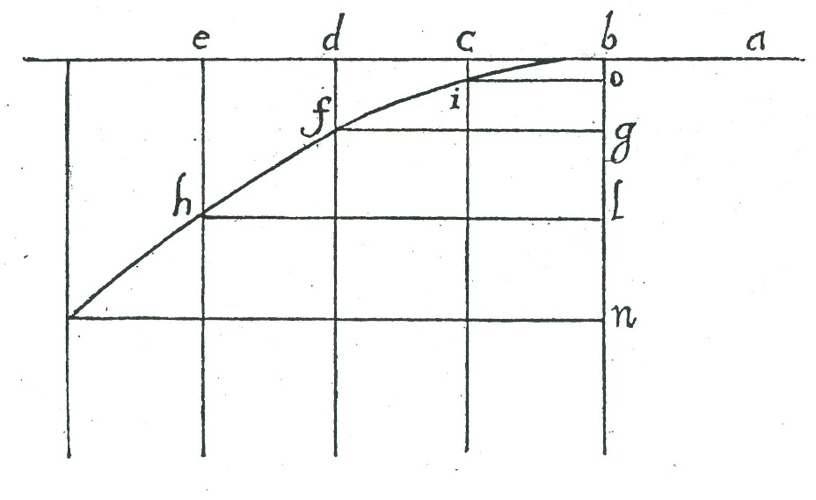

**Figure 3: Galileo, parabolic motion and free fall**

Whilst Galileo had shown that there was no difference in kind between falling and projected bodies, it was Newton who showed that there was no difference in kind between projected and orbiting bodies. His diagram of a projectile fired from the top of a mountain with increasing power, until it enters into orbit, complements and extends Galileo’s diagram we have just seen. In figure 4 projectiles shot from a high mountain V fall at increasingly larger distances D, E, F, G. If the initial speed is sufficiently high, the projectile becomes an orbiting body. Objects that Galileo had seen as different in kind, such as projectiles and orbiting bodies, were shown by Newton to be variants of each other. Newton, however, never published this diagram, which appeared only in a posthumous 1728 edition of an earlier draft of his work with didactic purposes, *The System of the World*. This episode highlights that by the end of the 17th century proofs were provided through different means involving more elaborate mathematical tools. In this case, however, the identification appears slightly more elaborate than the simple unmasking, in that it is necessary to draw a number of auxiliary trajectories showing the desired result through a process akin to a thought experiment. Thus this case, while complementing the previous one, points to the need for more powerful tools involving a more active intervention than simple displaying.[8]

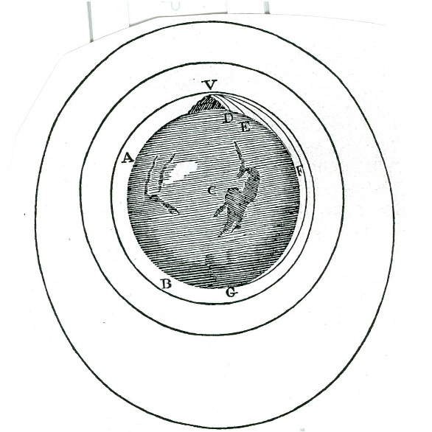

**Figure 4: Newton, orbiting bodies and projectiles**

Other cases of “unmasking” concern river flow, which could be seen as analogous to a body on an inclined plane, or alternatively to a pierced cistern, just to mention one example. My aim here is not completeness, however, but rather the characterization of a method of practicing mechanics.[9]

**(2) Morphing**

The approach of “unmasking” had the advantage of appearing quite rigorous and unproblematic. On the other hand, as we have seen for Galileo’s transition from statics or equilibrium to motion, it was rather rigid and could not be applied to many cases, thus rendering it not very effective and versatile. For example, following Pappus, dal Monte tried to apply it to solve the problem of the equilibrium conditions for a spherical body on an inclined plane, though his solution appeared problematic. When Galileo tackled the same problem, he wished to adopt the same approach, by unmasking a lever. However, matters turned out to be more complex and he had to draw an auxiliary portion of the diagram in order to attain his result: the issue was not simply one of unmasking, but involved constructing a balance with bent arms that was not originally there and reasoning on the peculiar equilibrium conditions of a body on the bent arm of the balance perpendicular to the inclined plane. In this case the notion of “morphing” captures better the slightly more elaborate procedures than those involved in mere “unmasking”, though there seems to be a smooth transition between these two processes. In figure 5, Galileo argued that the balance is in equilibrium in the initial position *cad*. If one arm is moved to *s* or *r*, the body in *s* or *r* is not allowed to move along *ef*, as when it was in *d*, but rather when in *s* it would move initially along *gh*, and when in *r* along *tn*. The body at *r* or *s* exerts less force to descend and this decrease can be determined by means of the perpendicular to *cad*. A body in *s*, for example, would act as if it were at a distance *ap* from the fulcrum in *a*. The body would descend along *ef* more readily than along *gh* and along *gh* more readily than along *tn*, in the same ratio as it is heavier at *d* than at *s* and at *s* than at *r*. On the basis of simple geometry joined with his views about motion and force, Galileo could conclude that the same heavy body would descend vertically with greater force than on an inclined plane in proportion as the length of the incline is to the height of the perpendicular.[10]

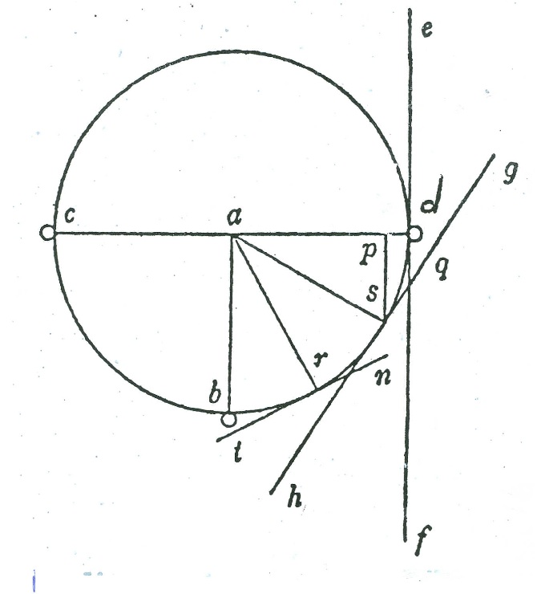

**Figure 5: Galileo, inclined plane and balance**

Another instance of “morphing” involves Galileo and his disciple Benedetto Castelli, who made of the motion of fluids a key area of his research within the Galileo School. In his 1612 *Discorso* on bodies in water, Galileo discussed the equilibrium of water in a siphon: this case could be seen as an example of morphing in its own right, in that Galileo argued that a siphon is nothing but a balance in disguise. The process of recognition, however, involved something more than mere unmasking. In figure 6, water in the two containers EIDF and ICAB is in equilibrium if it is at the same level, regardless of their cross-section. According to Galileo, the system works like a balance wherein a small motion of the water in the large container, to QO for example, makes the water in the thin container rise in the same time from L to AB. The speeds are inversely as the cross sections, but since the cross sections are as the weights in GD and LC, the speeds are inversely as the weights, just as in the balance. Therefore the different speeds compensate for the different weights and the moments are equal.[11]

I would like to use Galileo’s siphon to tackle another case, that of water flowing in a river. Although Castelli did not actually refer to Galileo’s example, I am quite convinced that the similarity between the two cases warrants my discussion of them together, especially because Castelli was heavily involved in the debates about buoyancy from the very beginning of the dispute with the Aristotelians and the 1612 *Discorso*. In his 1628 treatise *Della misura dell’acque correnti*, Castelli argued that since water is not compressible, the quantity of water flowing through two cross sections A and C of the same river in a steady state must be the same (figure 7): therefore the speeds of the water through the two cross sections are inversely as the cross sections themselves. It is easy to see that Castelli’s river is a straighten version of Galileo’s siphon: in both cases the same relation holds. This case is especially interesting in that it involves a shift from equilibrium to motion.[12]

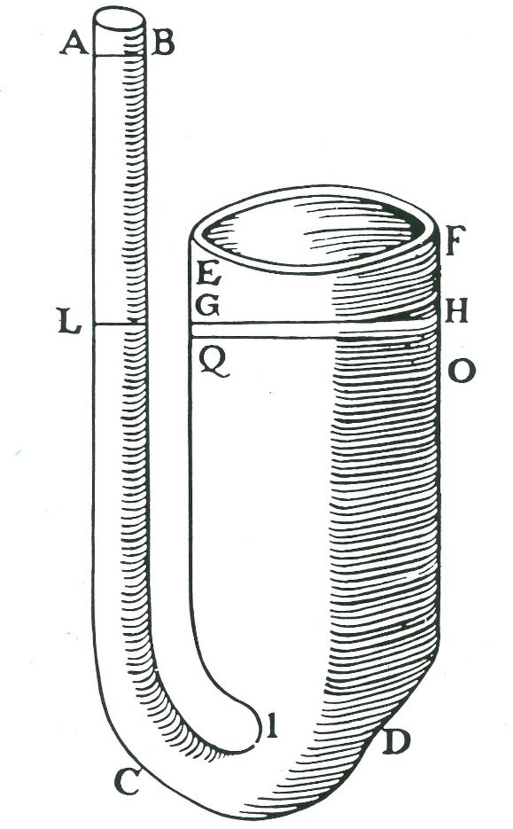

**Figure 6: Galileo’s siphon**

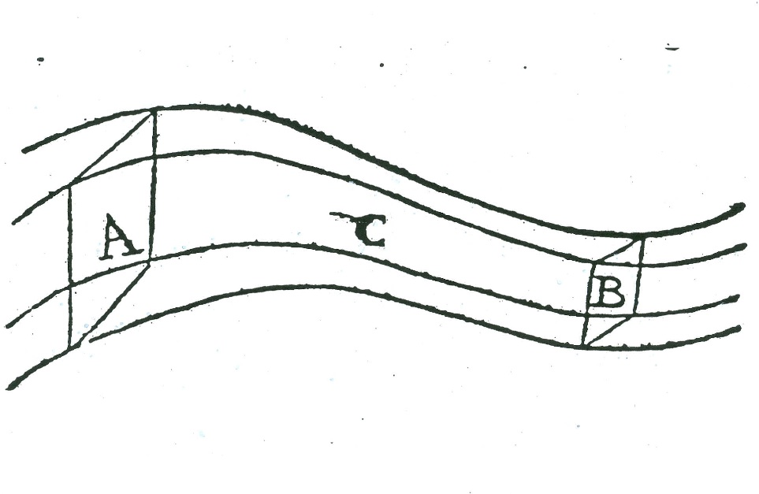

**Figure 7: Castelli’s river**

Yet another instance involving the science of waters is the efflux problem from a pierced cistern, studied by Evangelista Torricelli, who took over as mathematician—though not philosopher—to the Grand Duke of Tuscany on Galileo’s death. Torricelli wished to determine the speed with which water flows out of the hole at the base of the container, a problem initially mentioned by Castelli in his book. At first sight the solution does not look straightforward or easy to determine: moreover, speeds cannot be easily measured. Torricelli, however, managed to conceptualize the problem in a different fashion through an experiment and the application of a well-know property. He directed the jet upwards and found empirically that it reached very nearly to the height of the water inside the container. Further, it is a well known property of projectile motion that the speed depends only on the height, speeds are the same at the same heights: hence the speeds of the water spurting from the container and of the falling jet at the same level must be the same. By seeing the water jet as a projectile and experimentally determining the height it reaches, Torricelli was able to morph the problem of efflux from a pierced container to one of projectile motion, which he could solve. More specifically (see figure 8), he arranged for the water jet squirting out at B to be projected upwards and showed that it almost reached the level AD of the water in the tank. Since in falling to E after having reached its maximum height C the jet goes through the same degrees of speed as in rising, at E the water must have the same speed it had in B when coming out of the orifice; hence the water can be imagined to fall inside the container almost as if it were a body falling in air and its speed in B is as the square root of the height of the water in the vessel.[13]

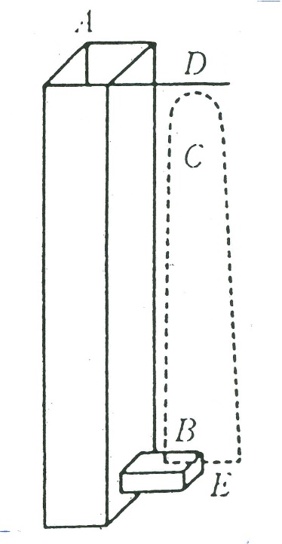

**Figure 8: Torricelli’s pierced cistern**

The last example I consider in this section can be characterized as a boundary case. In the 1673 *Horologium oscillatorium*, Huygens established that cycloidal cheeks, forcing the bob to move along a cycloidal path, render oscillations isochronous. It was only after the treatise was published, apparently, that Huygens inquired about exactly which property of the cycloid makes oscillation isochronous: what he found was that in each point of the bob’s cycloidal path, the force is proportional to the displacement. In figure 9, for a body placed at any point of an inverted cycloid ABC, the component of its weight BKG tangent to the curve is proportional to the length of the cycloidal arc BIA from the cycloidal vertex to the body. Of course, this is the same relation that applies to a vibrating spring, one that has since become known as Hooke’s law. Thus in a sense Huygens was able to morph a cyloidal pendulum into a spring. This process occurred through higher mathematics rather than purely visual tools or simple experiments: the geometrical diagram by itself yielded no visually obvious solution. Thus this case marks a significant point of transition towards the 18th century, when higher mathematics, especially analysis and differential equations, took center stage and replaced a more intuitive and geometrical approach.[14]

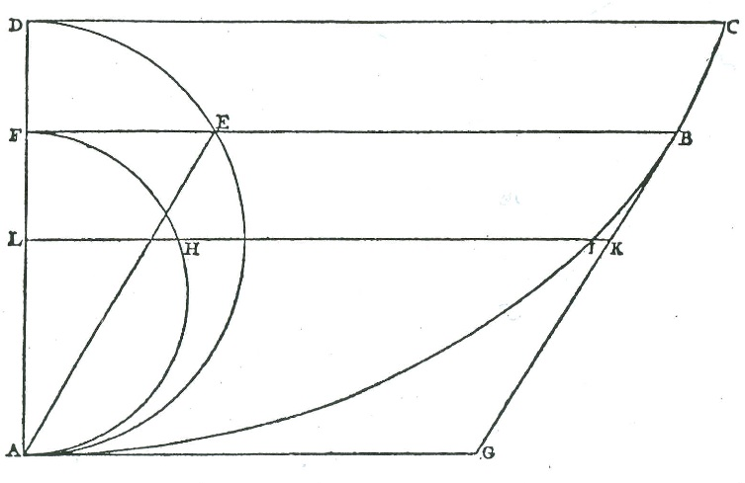

**Figure 9: Huygens’s cycloidal pendulum**

**(3) Dematerialization**

An additional category of transformations with a notable process of abstraction involves the removal of material constraints. In some instances relations between variables were established relying on material supports: for example, in the balance, the equilibrium conditions involved the combination of the weights of the bodies and their distances from the fulcrum. The resulting proposition, well known since Antiquity, was that the balance is in equilibrium if the weights are inversely as those distances. Alternatively, following the pseudo-Aristotelian *Quaestiones mechanicae*, if one imagined the balance to rotate around its fulcrum, the equilibrium conditions could be formulated by stating that the weights are inversely as their speeds, which are proportional to the distances. In this way Galileo introduced the notion of *momento delle velocità*, or *moment of the speeds*, a magnitude resulting from the weights and speeds taken conjointly: thus the balance is in equilibrium if the moments are equal.[15]

A number of 17th-century natural philosophers and mathematicians, such as Isaac Beeckman, Christiaan Huygens, and Christopher Wren, took the balance as a springboard to investigate the collision of bodies through the process of “dematerialization”. At first this strategy may seem peculiar, since two bodies in equilibrium on a balance seem conceptually and visually quite different from two colliding bodies. This surprising transformation was attained by employing the analogy of machines and the magnitude resulting from the combination of weight and speed. Beeckman considered the collision between two equal bodies, one of which is at rest, and argued that they would move together after the impact with half the speed of the impinging body, as in simple machines, where the same force raises double a weight with half the speed of a single weight. In the case of bodies whose speeds are inversely as their weights, Beeckman argued that the bodies would come to rest, explaining that his view was inspired by the balance: “Sic etiam ratiocinandum de bilance”. It seems that the idea of a competition between two bodies served as a conceptual tool whether the bodies were joined by a material constraint or whether they were colliding. Visually too both Huygens and Christopher Wren adopted a style of representation for colliding bodies closely linked to the balance, with the two bodies R and S at the extremes and their center of gravity *a* in the middle (see figure 10).[16]

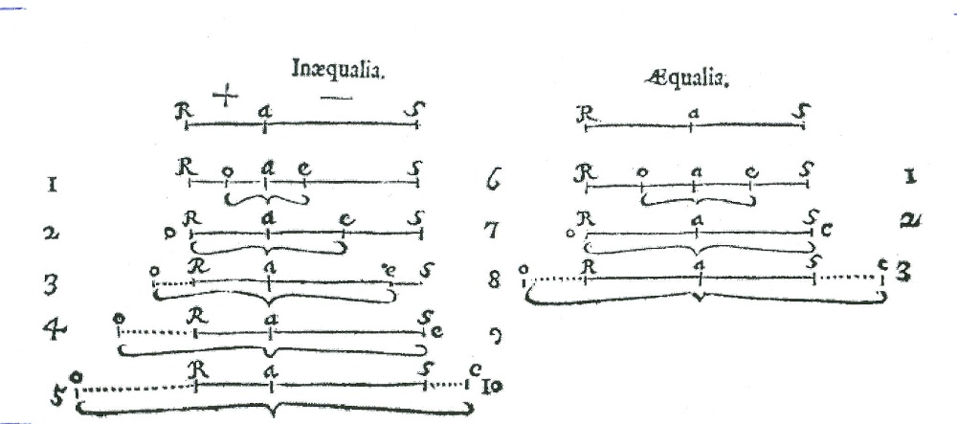

**Figure 10: Huygens and Wren on impact and the balance**

A second instance involves a development of Torricelli’s principle. In the last few years of Galileo’s life, Torricelli was close to his mentor and worked with him and Vincenzo Viviani on systematizing and extending the new science of motion. Torricelli was especially concerned with providing more solid axiomatic foundations to Galileo’s construction: in his 1644 *De motu* he posited a new postulate stating that two connected heavy bodies cannot move by themselves unless their common center of gravity descends. He illustrated his postulate with examples of simple machines such as balances, pulleys, and inclined planes. Two connected bodies could be seen as one single body and it seemed legitimate and intuitive to claim that that body could not move by itself unless its center of gravity descended.[17] In his study of impact, however, Huygens adopted a variant of Torricelli’s principle, stating that converting the speeds of colliding bodies from horizontal to vertical, their common center of gravity cannot rise as a result of the impact. Given that pendulums were the privileged experimental device to investigate collision, the conversion of horizontal speeds to the vertical appeared quite natural. Moreover, there existed an established tradition in mechanics of mentally tying and rescinding falling bodies in order to study the role of weight on the speed of fall: both Giovanni Battista Benedetti and young Galileo had recourse to such thought experiments. The editors of Huygens’s *Oeuvres* argue that this way of reasoning led Huygens to the conservation of *vis viva* for hard bodies. In this case too we witness interesting transformations: Torricelli considered the possible descent of bodies, Huygens wished to deny their ability to rise as a result of impact. Moreover, Torricelli’s system was constrained, since he explicitly stated that his bodies were connected. By contrast, Huygens rescinded that connection and considered the case of two colliding bodies not connected to each other.[18]

Yet another instance of dematerialization occurred in the debates at the Royal Society on the conceptualization of celestial motions, especially those of the Earth and Moon. John Wallis and Robert Hooke argued that the Earth and Moon were connected, though it was unclear how. The issue had arisen from Wallis’s attempt to refine Galileo’s theory of tides by considering not simply the Earth alone, but rather the Earth-Moon system rotating around the common center of gravity. Following the previous example of astronomer Jeremiah Horrocks, Hooke conceptualized orbital motion with the help of a conical pendulum, whose bob would represent the orbiting body. He argued that the analogy was not perfect, because in the case of the conical pendulum the retaining force increased if the displacement increased, whereas the retaining force of the sun was likely to decrease with distance. We witness here an especially nice example in which the pendulum is used to establish an analogy but also differences. The interplay between material constraint and orbital motion worked both ways: in order to defend Wallis’s claims, Hooke attached a smaller pendulum to the bob of the large one, in order to illustrate the motions of the Earth and Moon. Presumably the thread of the additional smaller pendulum represented the force connecting the Earth and the Moon, although the analogy involving the common center of gravity appears less than perfect.[19] In this case too it appears that the reliance on a constrained system like the pendulum in order to account for an unconstrained one arouse suspicions and debates.

The next case I wish to consider ties together the most material and fundamental device and the most abstract one: the lever was used by several mathematicians to study celestial motions. Johannes Kepler talked of planets being pushed by the rays of the sun, acting as a lever; Giovanni Alfonso Borelli too identified a radial component in orbital motion and referred to several material devices, including the lever, to visualize and conceptualize orbital motion; lastly, Gottfried Wilhelm Leibniz imagined planets to be pushed by a vortex around the sun and to move at the same time in radial motion along a ruler or a rigid rotating straight line. While the circular motion had a material support in the form of a rotating vortex, the rotating ruler was entirely fictitious; still, it enabled Leibniz to write equations of motion along the radius and to conceive of the planet as subjected to an inward and an outward tendency counterbalancing one another along that radius. Thus in this case too a material constrain was used as part of the conceptual scaffolding and then discarded; the outcome was a study of orbital motion based on the combination of a circular and radial motion. In figure 11, the planet is carried by the rotating radius O1M, O2M, O3M and at the same time toward to sun at O.[20]

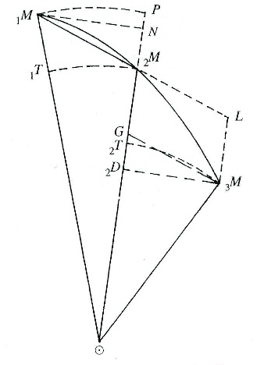

**Figure 11: Leibniz’s radial motion for orbiting bodies**

A particularly interesting instance developing and extending the case of collision occurs in Newton’s *Principia mathematica*, in the discussion of the third law. The law states:[21] “To any action there is always an opposite and equal reaction; in other words, the actions of two bodies upon each other are always equal and always opposite in direction”. A corollary to this law states: “The common center of gravity of two or more bodies does not change its state whether of motion or of rest as a result of the actions of the bodies upon one another”. It is easy to recognize here the case of collision among bodies that we have discussed above; indeed, Newton proved the third law “insofar as it relates to impacts and reflections” with pendulum experiments. However, Newton’s law and corollary were more general: “This law is valid also for attractions, as will be proved in the next scholium”. In the scholium Newton dealt with the case of attractions by means of real and thought experiments. The former consisted in placing pieces of lodestone and iron in vessels floating in water, and showing that they will join and stay at rest, without one driving the other forward: thus in this case Newton relied on magnetism to prove his point. The latter involved a thought-experiment: Newton imagined to slice the Earth into two unequal parts. Once again, if the third law did not hold and they attracted each other unequally, the Earth would yield to the greater weight and move in that direction indefinitely. Thus while Beeckman, Huygens, and Wren relied on dematerialization in moving from the balance to collision, Newton moved one step further in considering the third law of motion and the conservation of the state of rest or uniform rectilinear motion of the center of gravity for a system of bodies interacting with or without collisions, thus without any contact at all, as in a case of “dematerialization squared”.

**Concluding remarks**

This study has provided a fine-grained analysis of some of the transformations of mechanics in the 17th century. The cases we have discussed instantiate the processes of unmasking, morphing, and dematerialization, providing concrete examples of each and offering at the same time a more detailed understanding of those transformations. Seen together, the processes I have identified strengthen and refine the claim that objects provide a useful perspective from which to study the transformations of mechanics. Moreover, they highlight the intersection between cognitive and methodological aspects on the one side, and historical ones on the other.

The lever—or balance—was a common starting point in many cases. Among those discussed here, the winch, the beam, the siphon, the inclined plane, colliding bodies, and orbiting bodies were all tackled with conceptual tools derived from it. At the receiving end, orbiting bodies were a common object of study starting from projectiles, the conical pendulum, and the lever.

The cases we have studied present a broad spectrum of approaches raising a number of historically and philosophically relevant issues: While some transformations were rather straightforward, others look sufficiently daring as to raise questions: in which cases were they seen as problematic? What was the role of geometrical diagrams and of mathematics more broadly in the three categories? Lastly, can one provide a more detailed periodization and conceptualization of the transformations of 17th-century mechanics by identifying patterns of those transformations?

Space prevents me from addressing these questions fully here; however, I shall gesture toward some answers while leaving much for further study. Although it may prove hard to identify contemporary perceptions, some readers’ ease or unease with certain transformations suggests that they were perceived as belonging to different groups. For example, Baliani failed to see a lever in Galileo’s beam; since the French Minim Marin Mersenne questioned Torricelli’s treatment of the efflux problem, arguing that the first few drops of water exiting the pierced cistern had not fallen from the water surface, he presumably saw Torricelli’s procedure as questionable and different from dal Monte’s reduction of the winch to the lever. The usage of the conical pendulum to study orbital motion was questioned at the Royal Society, and Newton challenged Leibniz’s approach to orbital motion based on a rotating ruler as leading to inconsistencies.

The role of mathematics in the three different cases shows quite interesting patterns too. Geometrical diagrams were crucial to unmasking and morphing, though in the case of cycloidal motion their role was supplemented by a heavy dose of higher mathematics. The very processes of unmasking and morphing were visual and relied on seeing the transformation of one object into another. Overall, geometric diagrams appear less helpful in the process of dematerialization, which calls for greater abstraction.

Lastly, overall cases of unmasking and morphing seem to have been used from an earlier phase already with dal Monte and young Galileo, whereas dematerialization was employed at a slightly later stage. All three patterns I have identified, however, were applied with increasing sophistication throughout the 17th century. The usage of Torricelli’s principle in the study of collision, the identification of common properties in cycloidal and elastic oscillations, and Newton’s as well as Leibniz’s analyses of orbital motion were not the outcome of a merely visual analysis. More powerful and abstract techniques were becoming increasingly significant in the course of the century, moving away from a mostly geometrical and visual age. For this reason, I have argued that Huygens’s reliance on higher mathematics in the study of cyloidal and elastic oscillations in 1675 and Newton’s failure to publish the diagram showing the identity of projectiles and orbiting bodies—an identity that he established through different means—mark a new way to tackle mechanical problems, one in which more abstract mathematical methods became central.

Notes

1. I am grateful to the participants of he Bergamo conference for their helpful comments and suggestions, especially to George Smith and Michael Friedman, who offered valuable suggestions on how to develop my thoughts. I am grateful to Jochen Büttner, who read a draft of this paper and helped me clarify my thoughts during several conversations. I wish to thanks several of my colleagues who offered helpful suggestions on earlier drafts, especially Colin Allen and Amit Hagar.
2. Bertoloni Meli, *Thinking with Objects: The Transformation of Mechanics in the Seventeenth Century* (Baltimore: Johns Hopkins, 2006, hereafter *TwO*).
3. For some useful literature see: Jochen Büttner, “Big Wheel Keep on Turning”, *Galilaeana*, **5** (2008), 33-62, especially 39n12. Jochen Büttner, “The Pendulum as a Challenging Object in Early-Modern Mechanics”, in Walter Roy Laird and Sophie Roux, eds, *Mechanics and Natural Philosophy before the Scientific Revolution* (Dordrecht: Springer, 2008), 223-37. Susan Leigh Start and James R. Griesemer, “Institutional Ecology, ‘Translation’, and Boundary Objects: Amateurs and Professionals in Berkeley’s Museum of Vertebrate Zoology, 1907-1939”, *Social Studies of Science*, **19** (1989), 387-420. Hans-Jörg Rheinberger, *Toward a History of Epistemic Things: Synthesizing Proteins in the Test Tube* (Stanford: Stanford University Press, 1997). Mary S. Morgan and Margaret Morrison, eds, *Models as mediators. Perspectives on natural and social science* (Cambridge: Cambridge University Press, 1999). Peter Galison, *Einstein's Clocks, Poincare's Maps: Empires of Time* (New York: Norton, 2003). Soraya de Chadarevian and Nick Hopwood, eds, *Models. The third Dimension of Science* (Stanford: Stanford University Press, 2004). Nancy J. Nersessian, Creating Scientific Concepts (Cambridge, Mass.: MIT Press, 2008).
4. As George Smith reminded me, Jakob Bernoulli’s work on the center of oscillation combines a variety of techniques, starting from unmasking levers. Bertoloni Meli, *TwO*, 295 and n.12.
5. Guidobaldo dal Monte, *Mechanicorum liber* (Pesaro: gerolamo Concordia, 1577), 106v. *Mechanics in Sixteenth-Century Italy. Selections from Tartaglia, Benedetti, Guido Ubaldo, & Galileo* (Madison: University of Wisconsin Press, 1969), tranlsated and annotated by Stillman Drake and Israel E. Drabkin, 318. Bertoloni Meli, *TwO*, 24-5.
6. Galileo Galilei, *Discorsi*, in *Opere*, edited by Antonio Favaro, (Florence: G. Barbèra, 1890-1909, reprinted 1968), 20 vols, vol. 8, 156-8. Matteo Valleriani, “The Transformation of Aristotle’s *Mechanical Questions*: A Bridge Between the Italian Renaissance Architects and Galileo’s First New Science”, *Annals of Science*, **66** (2009), 183-208. Bertoloni Meli, *TwO*, 92-3, 117.
7. Galileo Galilei, *Discorsi*, in *Opere*, vol. 8, 272-3. Bertoloni Meli, *TwO*, 101-2.
8. Isaac Newton, *The System of the World* (London, 1728, reprinted in *Principia*, tranls. by Andrew Motte and Florian Cajori, Berkeley: University of California Press, 1932), 549-626, at 551. Bertoloni Meli, *TwO*, 285-6.
9. For these cases I refer to *TwO*, chapter 6.
10. Galileo Galilei, *De motu antiquiora*, in *Opere*, vol. 1, 298. Galileo Galilei, *On Motion and on Mechanics* (Madison: University of Wisconsin Press, 1960), translated with introduction by Stillman Drake and Israel E. Drabkin, 65. Bertoloni Meli, *TwO*, 54-5.
11. Galileo Galilei, *Discorso*, in *Opere* vol. 4, 77-8. Bertoloni Meli, *TwO*, 82-3.
12. Benedetto Castelli, *Della misura dell’acque correnti* (Bologna: per gli hh. del Dozza, 16603, originally published in Rome, 1628), 19. Cesare Maffioli, *Out of Galileo. The Science of Waters 1628-1718* (Rotterdam: Erasmus, 1994), 37-51. Bertoloni Meli, *TwO*, 84-5.
13. Evangelista Torricelli, *Opera geometrica. De motu* (Florence: Massa and de Landis, 1644), 191-4. Maffioli, *Out of Galileo*, 82-3. Bertoloni Meli, *TwO*, 128-9.
14. Michael Mahoney, "Huygens and the Pendulum: From Device to Mathematical Relation", in Herbert Breger and Emily Grosholz, eds., *The Growth of Mathematical Knowledge* (Dordrecht: Kluwer, 2000), 17-39. Bertoloni Meli, *TwO*, 242, 310.
15. Paolo Galluzzi, *Momento. Studi Galileiani* (Rome: Ateneo e Bizzarri, 1979). Bertoloni Meli, *TwO*, 82.
16. Isaac Beeckman, *Journal* (The Hague: M. Nijhoff, 1939-53), 4 vols, ed. by Cornelis de Waard, vol. 3, 133-4. Christopher Wren, “Lex naturae de collisione corporum”, *Philosophical Transactions*, **3** (1669), 867-8. Bertoloni Meli, *TwO*, 150, 227-40, at 235.
17. Torricelli, *De motu*, in *Opere*, vol. 2, 105. Bertoloni Meli, *TwO*, 119.
18. Christiaan Huygens, *Oeuvres complètes* (La Haye: Martinus Nijhoff, 1888-1950),

    22 vols, vol. 16, 21-5 and 95n10. Bertoloni Meli, *TwO*, 45-7, 63, 232-3.
19. Thomas Birch, *The History of the Royal Society of London* (London: A. Miller, 1756-7, reprinted Hildesheim: G. Olms, 1968), 4 vols, vol. 2, 90-2. John Wallis, “An Essay Exhibiting his Hypothesis about the Flux and Reflux of the Sea”, and the following “Appendix”, *Philosophical Transactions*, **1** (1666), 263-89. James A. Bennett, “Hooke and Wren and the System of the World: Some Points towards an Historical Account”, *British Journal for the History of Science*, **8** (1975), 32-61, at 43-9. Bertoloni Meli, *TwO*, 218-9.
20. Domenico Bertoloni Meli, *Equivalence and Priority* (Oxford: Oxford University Press, 1993), 130.
21. Isaac Newton, *The Principia. Mathematical Principles of Natural Philosophy. A new translation by I. Bernard Cohen and Anne Whitman assisted by Julia Budenz* (Berkeley: University of California Press, 1999), 417,421, 424-30.