Anatomical Information Science
Barry Smith^{1,2}, Jose L.V. Mejino Jr.³,
Stefan Schulz⁴, Anand Kumar², and Cornelius Rosse³

¹Department of Philosophy, University at Buffalo, Buffalo, NY 14260, USA
²Institute for Formal Ontology and Medical Information Science, Saarland University, Saarbrücken, Germany
³University of Washington, Seattle, USA
⁴Freiburg University Hospital, Freiburg, Germany

phismith@buffalo.edu
akumar@ifomis.uni-saarland.de
mejino@u.washington.edu
rosse@u.washington.edu
stschulz@uni-freiburg.de
Abstract. The Foundational Model of Anatomy is a map of the human body. Like maps of other more familiar sorts, including the map-like representations we find in familiar anatomical atlases, it is a representation of a certain portion of spatial reality as it exists at a certain instant of time. But unlike other maps, it comes in the form of a sophisticated ontology of its object-domain, comprising some 1.5 million statements of anatomical relations between some 70,000 anatomical kinds. It is distinguished from other maps, further, in that it represents not some specific portion of spatial reality (say: Leeds in 1996), but rather the generalized or idealized spatial reality associated with a generalized or idealized human being at some generalized or idealized instant of time. It will be our concern in what follows to outline the approach to ontology that is represented by the FMA as the basis for a new type of anatomical information science, and to draw from this some implications for our understanding of spatial ontologies in general.
- The Foundational Model of Anatomy
The Foundational Model of Anatomy (FMA) is a computer-based representation of the entities and relations which together form the phenotypic structure of the human organism [,]. It provides a qualitative spatial reference system for the human body that is designed to be understandable to human beings and also to be navigable by machine-based systems. It is intended as a general-purpose resource, which can be used by any biomedical application that requires anatomical information, from radiology (in supporting automatic image analysis) to pharmacokinetics (in representing the pathways of drugs as they are absorbed by, distributed through, metabolized in and excreted from the body).
The FMA began its life as a classification of anatomical entities called the University of Washington Digital Anatomist Vocabulary. In recent years it has grown from a list of terms linked by is_a and part_of relations, sophisticated spatial-structural ontology of the human organism at all biological salient levels of granularity and comprehending some 1.5 million statements of ontological relations between some 70,000 anatomical universals. The acronym ‘FMA’ is currently used in the biomedical informatics community both for this ontology and also for its representation in computerized form within the Protégé 2000 frame-based ontology editing environment [Error: Reference source not found,]. The Structural Informatics Group at the University of Washington, which developed and maintains the FMA, has itself initiated work within the framework of the DARPA’s Virtual Soldier Project on two complementary ventures, called PRO and PathRO, for ‘Physiology’ and ‘Pathology Reference Ontology’, respectively [].
- Canonical Anatomy
The distinction between canonical and instantiated anatomy was first proposed for the FMA [] and an analogous distinction does not exist in geospatial science. Many features of the type of spatial information science realized in the FMA will therefore be unfamiliar to those working on spatial representation and reasoning with a primary focus on the geospatial domain. In particular, where geospatial maps deals in every care with specific instances (specific with portions of the surface of the earth), the FMA deals not with the instances, the individual human beings, whose bodily organization has been investigated over the centuries with the aid of surgical dissection, radiological imaging, and other techniques, but rather with a certain (‘canonical’) idealization thereof (actually with two idealizations, corresponding to the male and female adult human beings, respectively). The FMA is a collection of generalizations deduced from the qualitative observations of the normal human body which have been refined and sanctioned by successive generations of anatomists and presented in textbooks and atlases of structural anatomy.
- Types of Relations

We concern ourselves here only with continuant entities, which is to say, entities such as lungs (or cities) which endure through time while undergoing changes of various sorts. [] We can distinguish a number of distinct types of relations between continuant universals which can be employed in the construction of an ontology like FMA [Error: Reference source not found,].

1) is_a relations, linking one universal to another (more general) universal in a subsumption hierarchy;
examples: liver is_a organ, lacrimal lake is_a anatomical cavity
2) static physical relations between continuant universals;
examples: lobe of liver part_of liver, nuclear membrane adjacent_to cytoplasm
3) relations between universals instantiated at different stages in the development of an organism;
examples: zygote derives_from ovum, adult transformation_of child.

Cross-cutting all of these are distinctions between:

a) relations involving canonical instances of anatomical universals within the canonical organization of the human body;
b) relations involving also non-canonical instances of canonical anatomical universals or involving instances of pathological anatomical universals (for example wounded knees or amputation stumps) within the organization of the human body;
c) relations involving entities (implants, food, etc.) imported into the human body;
d) relations involving entities (tissue samples, excreta, etc.) exported from the human body.

The FMA itself focuses overwhelmingly on relations of types 1a) and 2a) [Error: Reference source not found]. Relations of type 3a) are covered in [Error: Reference source not found]. In what follows we expand our scope to include also relations of other types, drawing on recent work involving the FMA’s developers and representatives of other influential research groups in bioinformatics, and summarized in [, ].
- Boundaries
A further apparent distinction between the geospatial and anatomical domains from an ontological perspective turns on the fact that, where anatomy embraces within its purview primarily three-dimensional entities such as cells, organs and whole organisms, geospatial ontologies are focused on the two-dimensional entities which form the surface of the earth. Spatial reasoning has been correspondingly concerned with the movement of objects across this surface or with land-use, soil-type, forest-coverage, and similar patterns. Closer inspection reveals, however, that both anatomical and geographic information science are required to deal with entities in all spatial dimensions. Thus the FMA deals not only with material objects but also with both fiat and bone fide boundaries of two, one and zero dimensions, [,] and a geospatial ontology like that which underlies the Spatial Data Transfer Standard (SDTS) [] comprehends many three-dimensional universals (called ‘entity types’) such as fumerole, grave, mount and trough.
While the FMA deals primarily with material objects and their boundaries, it also deals with portions of body substances (e.g. of water, urine, or menstrual fluid) and with the body spaces (cavities, conduits) which these occupy [,]. GIS similarly deals not only with material geographic objects such as mountains and forests, but also with non-material geographic objects (such as rivers and lakes) having some of the features of containers or conduits. In an extended sense it deals also with the substances (primarily portions of fresh and salt water) which occupy these.
Considerable progress has been made on the geospatial side, not only in the standardization of geospatial terminology, but also in the development of formal theories and tools for both quantitative and qualitative spatial reasoning [,,,,,]. Such tools rest primarily on reasoning with the fixed spatial regions on the surface of the earth with which spatial objects can be associated in systematic fashion. Analogous tools are more difficult to develop in the domain of anatomy because of the elasticity of the human body as contrasted with the earth as base reference object [Error: Reference source not found]. On the other side, however, geospatial ontology is less advanced than anatomy in that it has nothing like the formal sophistication in its treatment of ontological relations and nothing comparable to the coverage in terms of number of universals treated which is manifested by the FMA. Thus the SDTS comprehends only some 100 entity types.
- The Proper Treatment of Relations in Ontologies
We can conceive ontologies for present purposes as controlled, structured vocabularies designed to support the integration of data and information deriving from heterogeneous sources. An ontology like that of the FMA is structured through assertions of the form ‘A relation B’ (where ‘A’ and ‘B’ are terms in the FMA vocabulary and ‘relation’ stands in for ‘part_of’ or some similar expression). Such assertions express general statements about the corresponding universals, which correspond to the sorts of statements found in scientific textbooks. To link such ontologies to reality, however, we need to take account not only of the universals described in scientific theories but also of the corresponding instances or tokens which we find about us in reality, and this means that we need to deal not only with universal–universal relations commonly treated of in work in ontology, but also with instance–universal and instance–instance relations [Error: Reference source not found].
Thus for instance the thesis according to which lobe of liver part_of liver, which expresses a universal-universal relation, gets its reference to reality in virtue of the fact that it is in part a thesis about instances, to the effect that:

every canonical instance of the universal lobe of liver is a part (in the instance-level, i.e. in the standard mereological, sense of ‘part’) of some instance of the universal liver.

Note the all–some structure of this assertion, which is copied also in parallel universal-universal assertions involving other spatial relations such as adjacency, attachment and continuity [5,].
- Instances and Classes
As already noted, one important distinction between geospatial and anatomical spatial reasoning turns on the different roles which universals (types, kinds, classes) and instances play in each. In the geospatial domain we are interested primarily in instances and in the associated data and map-like representations. In the anatomical world universals play a much more important role in virtue of the fact that we have increasing amounts of scientific knowledge about the ways in which universals on the coarse-anatomical levels are connected to the universals at finer grains, down to the level of molecules. Thus where the question of which universals need to be distinguished by an anatomy ontology was once resolved by visual inspection, scientific anatomy rests nowadays on empirical research in the domain of genetics. The parts of the body demarcated on the basis of phenomenology can be acknowledged as genuine anatomical structures only after it has been demonstrated that there are structural genes whose coordinated expression in the development of organisms of the corresponding type brought forth the relevant instances. Hence the FMA in its full version must contain a place also for developmental transformations.
- Anatomical Entities
Four upper-level universals of the FMA are: anatomical structure, substance, space, and boundary.
Anatomical structures are material entities such as organisms, organs, cells, and biological macromolecules, which have their own inherent three-dimensional shapes.
Body substances are for example portions of blood, water, urine or menstrual fluid. The portion of blood in your right ventricular cavity at some specific time has a shape which it inherits from the relevant surrounding container.
Body spaces are immaterial anatonomical entities (cavities, orifices, conduits), whose shape, again, is inherited from the relevant surrounding anatomical structure. They are distinguished from spatial regions in that they are parts of organisms, which means that they move from one spatial region to another with the movements of their hosts.
Anatomical boundaries are of two sorts, here called ‘fiat’ and ‘bona fide’. They are distinguished from anatomical entities in the other three classes by the fact that they are of lower dimension, and stand in a relation of boundary dependence upon some relevant anatomical structure or landmark.
- Anatomical Structures
Mereotopologically speaking, anatomical structures are marked by the fact that they are maximally self-connected, which means that they have their own complete three-dimensional connected bona fide boundaries. Virtually all anatomical structures, however, are marked by connections, enclosing conduits of various sorts, to neighboring anatomical structures. To take account of this fact we thus require in the reading of ‘maximally self-connected’ that the corresponding portions of fiat boundaries – which are very small in relation to the total boundary of an entity – should be ignored when applying the definition of ‘anatomical structure’. (‘Fiat boundary’, here, signifies a boundary in a continuant entity which corresponds to no physical discontinuity (or bona fide boundary) in the entity itself but rather to a delineation which is drawn by human beings for some other reason. [Error: Reference source not found])

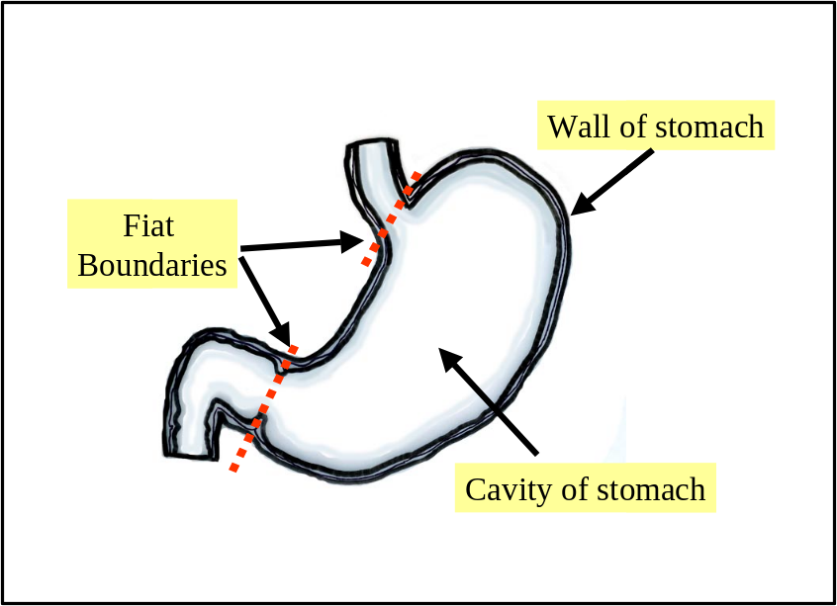
Figure 1. The stomach

Which ‘small portions of fiat boundaries’ we can ignore in specifying anatomical structures is not a trivial matter. Consider the small portions of fiat boundaries we need to delimit an anatomical structure such as the stomach or kidney (see Figs. 1 and 2). The stomach, we might think, would be an unproblematically fiat entity, because it is merely a segment of a certain tubular continuum containing also e.g. the esophagus and the small and large intestines. Certainly there are specific changes within the mucosal and muscular layers which go to form the wall of the stomach and esophagus at the junction between the two, and there is a specific sling of muscle around this junction. But these provide only bona fide landmarks for the drawing of that part of the fiat boundary which extends across the relevant cavity. Anatomical structures, at those places on their surface where they are demarcated by fiat boundaries, must be demarcated by landmarked fiat boundaries in this sense.
In the case of the kidney we have an anatomical structure that is separated from its surroundings by small sections of fiat boundary, but in such a way that the fiat boundary in question is located in a non-fiat entity (the urinary tract), which overlaps mereologically with the anatomical structure in question (Figure 2).

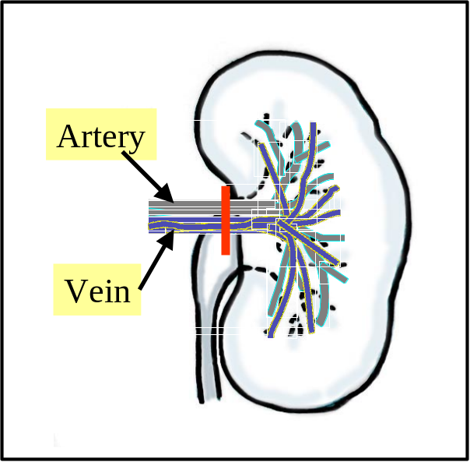
Figure 2. The kidney in relation to the arterial and venous systems
- Fiat Boundaries and Partitions
Fiat boundaries come in two types: those which demarcate physical anatomical entities (for example the plane of the esophagogastric junction, which demarcates the esophagus from the stomach) and those which demarcate anatomical spaces (for example the plane of the pelvic inlet, which demarcates the abdominal from the pelvic cavity). This talk of ‘planes’ draws attention to the fact that, just as in the geospatial realm in the case of, say, the borders of Colorado or Manitoba, it is often a mark of anatomical fiat boundaries that it has a geometrically regular shape.
In addition to anatomical structures in the technical sense of the FMA, we need to recognize also:

1. fiat parts of anatomical structures (for example the fundus of the stomach), which are not complete;
2. fiat aggregates of anatomical structures (for example the aggregate of the upper and lower limbs), which are not connected.

The presence of both fiat and bona fide boundaries allows the FMA in addition to do justice to the fact that one and the same anatomical structure can be partitioned in different ways []. The stomach can be decomposed in one context into its fundus, body and pyloric antrum and in another into its wall and cavity. The FMA sees the former as a fiat partition into regional parts, the latter as what it calls a ‘compositional partition’ into constitutional parts []. While constitutional parts are genetically determined, regional parts – for example the lobes of the liver or ear – are defined in part by arbitrary landmarks or coordinates. One thesis which we can advance is that there is only one demarcation of the human body into bona fide parts (thus that all bona fide demarcations at all levels of granularity will be consistent with each other – the mereotopological organization of the body would then in this sense be hierarchical).
- Connectedness and Continuity
The body is a highly connected entity. Indeed, if we leave aside the cells floating free in blood and other body substances, then practically all anatomical structures are connected to other anatomical structures through different kinds of continuities or junctions. [Error: Reference source not found]
Two anatomical structures are connected when one flows continuously into the other. As we see in Figure 2, however, anatomical structures may also be connected in the stronger sense that they share certain parts in common.
The FMA analyzes the relation of connectedness in terms of three different kinds of relations: continuous_with, attached_to (muscle to bone) and synapsed_with (nerve to nerve and nerve to muscle – a special type of attachment relation obtaining at the level of granularity of axons and dendrites).
Two continuants are continuous on the instance level if and only if they share a fiat boundary. A continuant is self-connected if and only if any division of the entity yields parts which are continuous. The relation of continuity on the instance level is of course always symmetric. On the class level however, this is not the case. To see why not, consider the relation between the lymph node and the lymphatic vessel. Each lymph node is continuous with some lymphatic vessel, but there are lymphatic vessels (e.g. lymphs and lymphatic trunks) which do not stand in continuous connection to any lymph nodes.
Attachment, too, is symmetrical on the instance level. On the class level, however, attachment is an asymmetrical connectivity relation between two or more anatomical entities. Consider the junction depicted macroscopically in Figure 3, which shows a bone and a muscle, which consists of a tendon, and a muscle belly. (On the microscopic level there are collagen fibers, muscle fibers and bone matrix.) The bone itself is quite well delimited. It ends where the bone matrix ends. The same applies to the muscle fibers which are – due to their contractile elements – clearly demarcated from the bone. But collagen fibers cross all these boundaries. One fiber might overlap with the muscle fascia and the tendon, while another overlaps with the tendon and the bone. Muscle and bone can be separated only by severing the fibers in question.

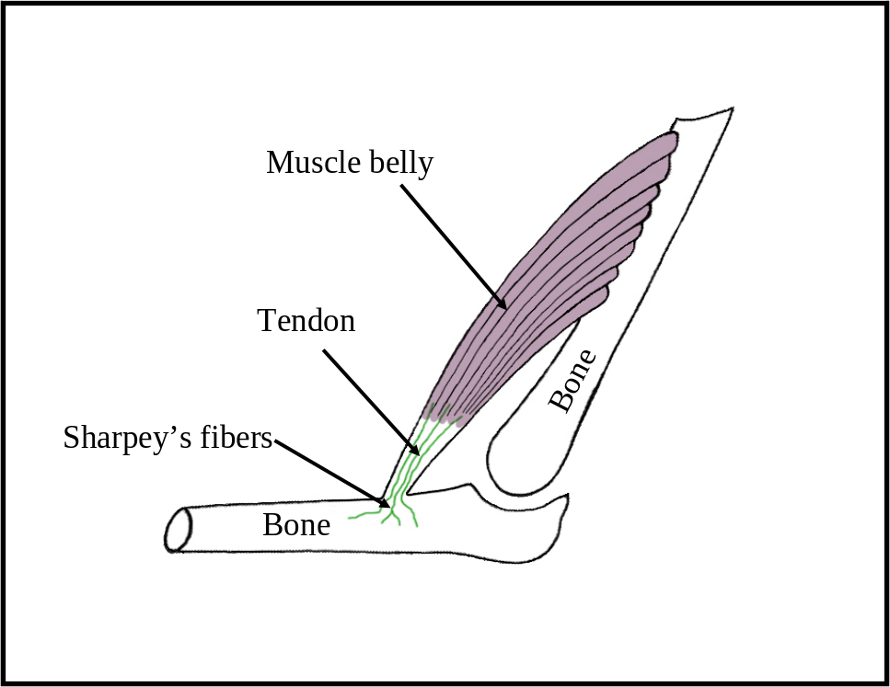

Figure 3. An anatomical junction

Attachment on the universal-level is an asymmetrical connectivity relation between two or more anatomical entities. An example from the FMA is:

distal tendon of the biceps brachii muscle attached_to tuberosity of the radius bone. While the corresponding instances have their own bona fide boundaries, the distal tendon comes into intimate contact with a circumscribed area of the bone, where extensions of its collagen fiber bundles (the Sharpey’s fibers in Figure 3) penetrate the bone and intermingle with the bone’s own matrix. The tendon may thus be separated from the bone only by severing Sharpey’s fibers.
- Location and Containment
In addition to the relations of instantiation (between an instance and a universal) and parthood (between one continuant instance and another continuant instance), the FMA contains also a treatment of location. To understand location formally, we associate with the human body a collection of spatial regions (relative places in Donnelly’s terms) []) and define a function which assigns to each anatomical entity c and time t the corresponding spatial region r(c, t) which c exactly occupies at t. We can then, following Donnelly, define the relation of location for anatomical entities as follows: []

c located_in d at t =def. r(c, t) part_of r(d, t) at t

On the level of universals we have:

C located_in D =def for all c, t, if c instance_of C at t then there is some d such that d instance_of D at t and c located_in d

Trivially, by this definition, all parts of anatomical structures are located in the corresponding wholes. A second type of location relation distinguished in the FMA is that of containment, which holds between material anatomical entities (body substances and anatomical structures) and the anatomical spaces in which they are contained. For example: the right lung is contained in the right half of the thoracic cavity; a Ca⁺⁺ ion is contained in an intracellular space in a heart muscle cell.
If we move away from canonical anatomy, then we encounter cases where, for example, a lobe of a liver is removed from a donor and transplanted into a hepatectomized patient. There is then an instance of the universal lobe of liver which is for a certain time not a part of any instance of liver. However, even when such non-canonical cases are taken into account, it still does have to be true that every instance of lobe of liver stands in an instance level parthood relation to some instance of liver at some time (more precisely still: every instance of lobe of liver stands at the initial moment of its existence in such a relation to some instance of liver). Moreover, during the time in which the lobe in process of removal is still located in the interior of the original host body, it is contained in a cavity created by the surgeon for the purposes of this removal, and likewise during the process of insertion into the new host.
Two entities may thus be related in terms of parthood only in a certain phase of their simultaneous existence. It is for this reason that parthood relations between continuants on the instance level must be indexed by times [6]. This is not specific to living systems. For example, a screw can be part of an engine and it can then be substituted by another, replacement screw. In contrast to artifacts, however, biological objects are engaged in a constant exchange of matter with their environment, so that here many parthood relationships are short-lived. Moreover, the dynamic phenomena of matter exchange [] suggest that there must be relations intermediate between parthood and containment, realized for example in digestion (absorption) and excretion, when portions of food move from being contained in the oral cavity to being absorbed through the intestines). When food is degraded into sugars, amino acids and fatty acids, those portions of such substances in the lumen of the stomach are contained therein, while those that have traversed the epithelium are now parts of either the cells or blood.
- Criteria of Parthood
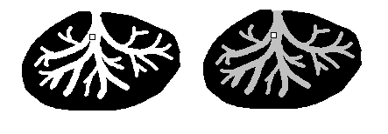
An account of the processes in question must accordingly give some room to the existence of transitions between containment and parthood. How, given the above, are we to distinguish genuine parthood relations from the mere spatial inclusion of occupied regions which is the relation of mere location as defined above? Is an embryo part of, or merely located in, a uterus? Is a bolus of food part of, or merely located in, a digestive tract? Is an oxygen molecule part of, or merely located in, a lung? We here offer five kinds of criteria which may be of assistance in providing answers to such questions.
Figure 4: Gland with internal duct

1. Genetics: The parts of the body should be of the same genetic origin as the body itself. Thus the embryo, on this criterion, is not a part of the body of the mother. This criterion faces problems, however, in application for example to oxygen or nitrogen molecules in the body (since these do not have a genetic origin) or to the mitochondria found in nearly every cell of the body (which have their own DNA).

2. Sortality: If continuant c is part of continuant d, then c and d must be of the right sorts to make this possible (they must instantiate appropriate universals). Thus if d is an organism, then it is ruled out that a should be an artifact (e.g., a heart pacemaker, a bullet), or a second whole organism (a symbiont, parasite, prey, embryo or fetus).

3. Life Cycle: Unless this is already ruled out by sortal constraints, we can infer from the fact that c is located in d during the whole of the life cycle of d, that c is part of d (thus the right ventricle of the heart is part of the heart for this reason).

4. Dependence: If c is located in d, then we have that c is also part of d whenever d could not exist without c (it is for this reason that the brain is part of the body).

5. Function: We can infer parthood from location, finally, where an object c, located in a second object d, has a function whose exercise is essential to d’s survival. The functioning of the heart is essential for the survival of the whole human being in this sense body, and a volume of blood is essential to the survival of the brain as functioning organ. (A volume of urine, in contrast, is not essential in the same sense to the survival of the bladder, and hence the urine is not counted as part of the bladder.) This criterion faces problems in application for example to the thumb (is the thumb essential to the survival of the hand?) or of the kidney and of those other organs supplied to the body in pairs [].
- Holes and Other Superficialities
A further family of problems connected with the location relation in anatomy turns on the fact that the boundaries of the objects with which we have to deal may themselves be difficult to specify. Thus many anatomical objects are sponge-like; they are replete with vessels, capillaries, cavities, holes and ducts of various sorts. A clear delimitation of an anatomic object is therefore essential for making any assertion about location.
Consider Figure 4, which depicts a small square object located in a duct inside a (stylized) gland. Is the object also located in the gland itself, or rather in the exterior surrounding space? The answer to this question depends on whether we admit spaces as parts of anatomical objects in a case such as this.
The range of problematic borderline cases connected with surface structures is depicted in Figure 5. Of the white and grey volumes falling below the (rough) line of demarcation of the surface of the body in question, which are parts of the exterior of this body and which are parts of the object? Typical examples are the surface structures (crypts and villi) in the intestinal mucosa.
Analogous puzzles arise also in connection with spatial discontinuities. Accessory spleens such as are illustrated (again in stylized fashion) in Figure 6 can be found in more than 10% of the population. This phenomenon can be accounted for in two ways, either by admitting one discontinuous object with three parts (which is how the FMA handles it), or by admitting three distinct objects which combine in the exercise of a certain function. This phenomenon has far-reaching consequences for example when describing tumors. (Is a breast cancer with a metastasis in the brain still a breast cancer, for example.)
In sum, the specification of anatomical part, location and connection relations, and also of the degree of spatial overlap between anatomical structures, is often problematic because the relevant spatial extensions are difficult to delimit, because the relevant anatomical entities continuously lose and gain parts and continuously exchange matter with their environment.

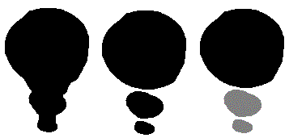

- Non-Canonical Anatomy
Figure 6: Normal spleen (left); accessory spleens (right)
Figure 5: Problematic surface structures

The FMA is a representation of canonical anatomy, which means that its individual variables range over those adult male and female human beings who satisfy the corresponding generalizations as these appear in textbooks of structural anatomy. By appealing to the device of specifying different ranges of variables, we can modify the scope of the FMA to represent generalizations belonging to the different branches of anatomy, for example to canonical human beings at various stages of embryological development, and even to organisms in other species. It can allow us also to represent the generalizations governing the anatomical variants yielded by the presence of, for example, coronary arteries or bronchopulmonary segments, which deviate from canonical anatomical patterns of organization in various well-understood ways. Here we conclude with some brief remarks on the proper treatment of pathological structures within an ontology like FMA.
While the universal colon as it appears within the FMA comprehends only instances of normal colons (however the term ‘normal’ is to be defined), if the FMA ontology is to serve as a basis also for non-canonical anatomy then it must have the facility to have this range of instances extended to include also abnormal colons. We then within the framework of pathological anatomy with results, have:

abnormal colon is_a colon

and also:

colon carcinoma pathological structure part_of abnormal colon

Moreover (recalling our ‘all–some’ reading of the class-level relation part_ofabove), we also have:

colon carcinoma pathological structure part_of colon

Every colon carcinoma is part of some colon, even though not every colon has some colon carcinoma as part.
We also have

abnormal colon transformation_of colon
colon with carcinoma is_a abnormal colon
colon with carcinoma transformation_of normal colon

where C transformation of D is defined as obtaining whenever C and D are continuant universals which are such that every instance of c was also an instance of d at some earlier time in its existence [6].
- From Anatomical Information Science to Spatial Information Science
In cartographic terms, canonical anatomy would correspond to a map of an idealized portion of geographic reality (an idealized city, an idealized lake, an idealized continent). Corresponding to actual maps (of actual cities or actual continents) is instantiated anatomy, which comprehends anatomical data about actual human beings, data of the type that might be recorded in a clinical record or captured in a radiographic image. Instantiated anatomy deals with individual, living, human subjects, but in a way which relies on the categories or kinds isolated in canonical anatomy.
The normative discipline of canonical anatomy has no direct counterpart in the geospatial domain. For while, certainly, there are healthy and unhealthy cities, it is not the case that all healthy cities have a more or less identical groundplan. Moreover, there is no counterpart of the contemporary evidence-based discipline of medicine in the geospatial domain, and thus no counterpart of its central organizing discipline of canonical anatomical science (and thus no scientific interest in, for example, maps of ideal cities). But for this reason, too, there is no counterpart of pathological anatomy in the domain of geospatial science, which is to say: no science of the determinate ways in which geospatial entities such as cities or lakes depart from some normative ideal case. There is no counterpart, either, of the ways in which human anatomy can be related to the anatomy of other species as a basis for the detection of what may be medically relevant homologies [].
As things stand, geospatial information science is characterized by the existence of a large mass of spatially referenced instance data and of powerful systems for reasoning with and representation of this data, combined with a treatment of the corresponding universals which is relatively impoverished from the theoretical point of view.
Moreover the SDTS contains within its list of attributes no terms for what we might think of as disorders of its entity types, as contrasted with some 900,000 terms included in SNOMED-CT, the systematized nomenclature of clinical terms maintained by the College of American Pathologists []. The existence of the FMA means that anatomical information science rests on an impressive tool for the treatment of anatomical universals, even though both the associated instance data and the tools for reasoning with such instance data are still impoverished. Some progress is being made on the side of instance-level anatomical information science. Again, however, the problems of elasticity, movement, and growth of bodily organs present considerable obstacles to the development of corresponding tools for spatial reasoning. [] With the development of genomics-based individualized medicine, and with associated increases in sophistication of electronic health records, the imbalance between class- and instance-based anatomical data will in the coming years be gradually resolved. Corresponding tools for representation and reasoning with anatomical instance data will thus increasingly be needed, [] and we can anticipate that the FMA will play an indispensable role in their development.
Acknowledgements
This paper was written under the auspices of the Wolfgang Paul Program of the Alexander von Humboldt Foundation, the European Union Network of Excellence on Medical Informatics and Semantic Data Mining and the Volkswagen Foundation under the auspices of the project “Forms of Life.”
References

?. http://sig.biostr.washington.edu/projects/fm/
?. Rosse, C., Mejino, J. L. V. Jr. A Reference Ontology for Bioinformatics: The Foundational Model of Anatomy. J Biomed Informatics, 2003; 36:478-500.
?. Noy, N. F., Mejino, J. L. V. Jr,, Musen, M. A. and Rosse, C. Pushing the Envelope: Challenges in Frame-Based Representation of Human Anatomy. Data and Knowledge Engineering 48 (2004) 335-359.
?. Cook, D. L., Mejino, J. L. V. Jr., Rosse, C. Evolution of a Foundational Model of Physiology: Symbolic Representation for Functional Bioinformatics. Proceedings MedInfo 2004: 336-340.
. Rosse, C., Mejino, J. L., Modayur, B. R., Jakobovits, R., Hinshaw, K. P., Brinkley, J. F. Motivation and Organizational Principles for Anatomical Knowledge Representation: The Digital Anatomist Symbolic Knowledge Base. J Am Med Inform Assoc 1998; 5: 17-40.
?. Grenon, P. and Smith, B. SNAP and SPAN: Towards Dynamic Spatial Ontology, Spatial Cognition and Computation, 4: 1 (March 2004), 69–103.
?. Mejino, J. L. V. and Rosse C. Symbolic modeling of structural relationships in the Foundational Model of Anatomy, in U. Hahn (ed.), Proceedings of KR-MED 2004 (First International Workshop on Formal Biomedical Knowledge Representation), 48-62.
?. Donnelly, M., Bittner, T., and Rosse, C. A Formal Theory for Spatial Representation and Reasoning in Biomedical Ontologies. IFOMIS Reprints 2005: 1.
?. Smith, B., Ceusters, W., Klagges, B., Köhler, J., Kumar, A., Lomax, J., Mungall, C., Neuhaus, F., Rector, A., Rosse, C. Relations in Biomedical Ontologies. Forthcoming in Genome Biology.
?. Smith, B. On Drawing Lines on a Map, in Andrew U. Frank and Werner Kuhn (eds.), Spatial Information Theory. A Theoretical Basis for GIS (Lecture Notes in Computer Science 988), Berlin/Heidelberg/New York, etc.: Springer, 1995, 475–484.
?. Smith, B. and Varzi, A. C. Fiat and Bona Fide Boundaries, Philosophy and Phenomenological Research, 60: 2, March 2000, 401–420.
?. US Geological Survey Spatial Data Transfer Standard (SDTS) Information Site (http://mcmcweb.er.usgs.gov/sdts/)
?. Casati, R. and Varzi, A. C. Holes and Other Superficialities, Cambridge, MA: MIT Press 1994.
?. Donnelly, M. On Parts and Holes: The Spatial Structure of the Human Body, in: M. Fieschi, E. Coiera, and Y. J. Li (eds.) Proceedings Medinfo, 2004, 351-356.
?. Cohn, A. G., Bennett, B., Gooday, J. and Gotts, N. Qualitative Spatial Representation and Reasoning with the Region Connection Calculus, Geoinformatica 1, 1997, 1-44.
?. Smith, B. Mereotopology: A Theory of Parts and Boundaries. Data and Knowledge Engineering 1996; 20: 287-303.
?. Bittner, T. Axioms for Parthood and Containment Relations in Bio-Ontologies. KR-MED 2004: Workshop on Formal Biomedical Knowledge Representation, 2004; 4-11.
?. Donnelly, M. Layered Mereotopology. Proc IJCAI 2003, 1269-1274.
?. Casati, R. and Varzi, A. C. Parts and Places: The Structures of Spatial Representation, MIT Press, Cambridge, 1999.
?. Schulz, S. and Hahn, U. Mereotopological Reasoning about Parts and (W)holes in Bio-Ontologies. Proceedings of FOIS, New York: ACM Press, 2001: 198-209.
?. Smith, B. and Rosse, C. The Role of Foundational Relations in the Alignment of Biomedical Ontologies. Proc. Medinfo 2004; 444-448.
?. Bittner, T. and Smith, B. A Theory of Granular Partitions. In: Foundations of geographic information science, London: Taylor & Francis, 2003.
?. Mejino, J. L. V., Jr, Agoncillo, A.V., Rickard KL, Rosse C. Representing Complexity in Part-Whole Relationships within the Foundational Model of Anatomy. Proc AMIA Symp. 2003;450-454.
?. Donnelly, M. Relative Places. In A. Varzi and L. Vieu (eds.) Formal Ontology in Information Systems. Proceedings of the Third International Conference (FOIS-04), 2004 249-260.
?. Donnelly, M. A Formal Theory for Reasoning about Parthood, Connection, and Location. Artificial Intelligence 160 (2004) 145-172.
?. Cohn, A. G. Formalizing Bio-Spatial Knowledge, in: Proceedings of the International Conference on Formal Ontology in Information Systems; ACM Press, New York, 2001, 198-209.
?. Johansson, I., Smith, B., Munn, K., Tsikolia, N., Elsner, K., Ernst, D. and Siebert, D. Functional Anatomy: A Taxonomic Proposal, Acta Biotheoretica, forthcoming.
?. Travillian, R. S., Rosse, C. and Shapiro, L. G. An Approach to the Anatomical Correlation of Species through the Foundational Model of Anatomy. Proc AMIA Symp 2003; 669-673.
?. http://www.snomed.org
?. Pilgram, R., Fletcher, P. T., Pizer, S. M., Pachinger, O. and Schubert, R. Common Shape Model and Inter-individual Variations of the Heart using Medial Representation. Submitted to IEEE Transactions on Medical Imaging.
?. Ceusters, W. and Smith, B. Tracking Referents in Electronic Healthcare Records. Submitted.

