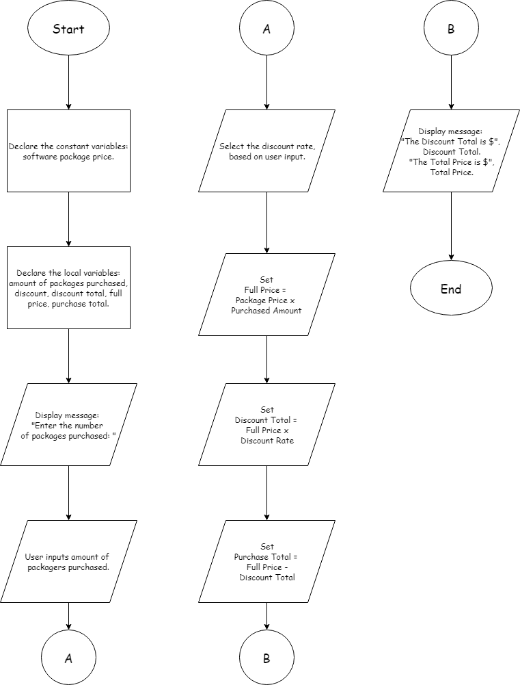

## PSEUDOCODE

* Declare the constant variable: Software Package price. The variable will be called “**PACKAGEPRICE**”.
* Declare the local variables: the full price, the number of packages purchased, discount rate, discount total, the purchase total.
* Prompt the user for input: “**Enter the number of packages purchased:** “. The number must be converted to an integer.
* Select the discount rate based on the number of packages purchased. The rates are 10%, 20%, 30%, and 40%. This will be set as variable “**discount**”.
* Calculate the discount amount. Set the discount total by using full price multiplied by discount.
* Calculate the total amount by taking the full price subtracted by the discount total.
* Display the Discount Amount and the Total Amount.

## IPO

|  |  |  |
| --- | --- | --- |
| Input | Processing | Output |
| Packages purchased | Prompt user for number of packages purchased. | Display: Discount Amount. |
| Full price | Calculate full price. | Display: Total Amount. |
| Discount rate | Calculate discount total. |  |
| Discount total | Calculate purchase total. |  |
| Purchase total | Set discount rate. |  |
|  | Set full price. |  |
|  | Set discount total. |  |
|  | Set purchase total. |  |

## DESK CHECK

Examples: 10, 60, 200.

Declare the package price constant.

Declare the variables: amount purchased, discount, full price, discount total, purchase total.

Ask user for packages purchased.

Select the discount rate based on packages purchased, set as “discount” variable.

Calculate the full price.

Calculate the discount total.

Calculate the purchase total.

Display the Discount Total.

Display the Purchase Total.

|  |  |
| --- | --- |
| Declare the package price variable | PACKAGEPRICE = 99 |
| Declare the variables | fullPrice = 0, amountPurchased = 0, discount = 0, discountTotal = 0, purchaseTotal = 0. |
| Ask user for number of packages purchased | 10 |
| Program calculates the discount rate | 0.1 |
| Calculate full price | 990 |
| Calculate discount total | 99 |
| Calculate purchase total | 891 |
| Display the discount total | $99.00 |
| Display the purchase total | $891 |

|  |  |
| --- | --- |
| Declare the package price variable | PACKAGEPRICE = 99 |
| Declare the variables | fullPrice = 0, amountPurchased = 0, discount = 0, discountTotal = 0, purchaseTotal = 0. |
| Ask user for number of packages purchased | 60 |
| Program calculates the discount rate | 0.3 |
| Calculate full price | 5940 |
| Calculate discount total | 1782 |
| Calculate purchase total | 4158 |
| Display the discount total | $1782.00 |
| Display the purchase total | $4158.00 |

|  |  |
| --- | --- |
| Declare the package price variable | PACKAGEPRICE = 99 |
| Declare the variables | fullPrice = 0, amountPurchased = 0, discount = 0, discountTotal = 0, purchaseTotal = 0. |
| Ask user for number of packages purchased | 200 |
| Program calculates the discount rate | 0.4 |
| Calculate full price | 19800 |
| Calculate discount total | 7920 |
| Calculate purchase total | 11880 |
| Display the discount total | $7920.00 |
| Display the purchase total | $11880.00 |

## Output Example

